Supplementary File 10

List of primers and probes used for qPCR validation of DNA microarray results

Gene coding for | Type | 5'-3' sequence
Calnexin | Forward | GTCAAGCCAGATGACTGGAT
 | Reverse | GGTACATACTCGGGCTCATCA
 | Probe | AAGATGCCCCTGCTAAGATTCCAGAT
TATA-box binding protein associated factor 11 | Forward | CTGACGGAGACGCAGATG
 | Reverse | GTCTTCCCTTTCAACTGTTGTTA
 | Probe | CCTCCGCTGCAGCTTCTTTCAAGT
amyloid beta A4 protein-like | Forward | AGTACCTACTGATGGCAATG
 | Reverse | TCATGTGCATGTTCAGTCT
 | Probe | CTGCTGGCTGAACCCCAG
beta-2-microglobulin | Forward | GCGCTACTCTCTCTTTCTG
 | Reverse | TTTCCATTCTCTGGTGGAT
 | Probe | ACTCCAAAGATTCAGGTTTACTCACG
Chemokine (C-X-C motif) ligand 10 | Forward | TGTTAATCCAAGGTCTTTAG
 | Reverse | TCTTCTCACCCTTCTTTTT
 | Probe | ATTATTCCTCCAAGTCAATTTTGTCC
tenascin C | Forward | ACGAGGTGTCCCTCATCTC
 | Reverse | AACACGTCGAAGGTTCCT
 | Probe | CGCAGAGGCGACATGTCAAGCAACC
glial fibrillary acidic protein | Forward | TTCCTCAAGAACCGGATCT
 | Reverse | CTGGCTGCCTATAGACAGAA
 | Probe | TCTCCAGATCCAGACGGGCC
complement component 3 | Forward | GACTTGATGATCTGCTCAAT
 | Reverse | GAGCCAGGAGTGGACTATT
 | Probe | TACTCGTCAAAGTCATTGGACAGC
gamma-aminobutyric acid (GABA) A receptor, alpha 2 | Forward | GAACTGGCCATCGAGCAGAT
 | Reverse | TTCAACCCTTTCGCATTGTC
 | Probe | CAACGAGTCACTCCTGCGCCCG
glutamate receptor, ionotropic, AMPA 1 | Forward | CATGCAGCAGTGGAAGAATAG
 | Reverse | TCACCTTCACCCCATCGTA
 | Probe | ACCACACTCGGGTGGACTGGAAAAGACCC
Calbindin 1 | Forward | TTATTCTTCTCGCACAGATC
 | Reverse | GAGTTCAATAAGGCTTTTGA
 | Probe | CATTTTCATCTATGTATCCATTGCCG

Validation of WNV-ND transcriptome

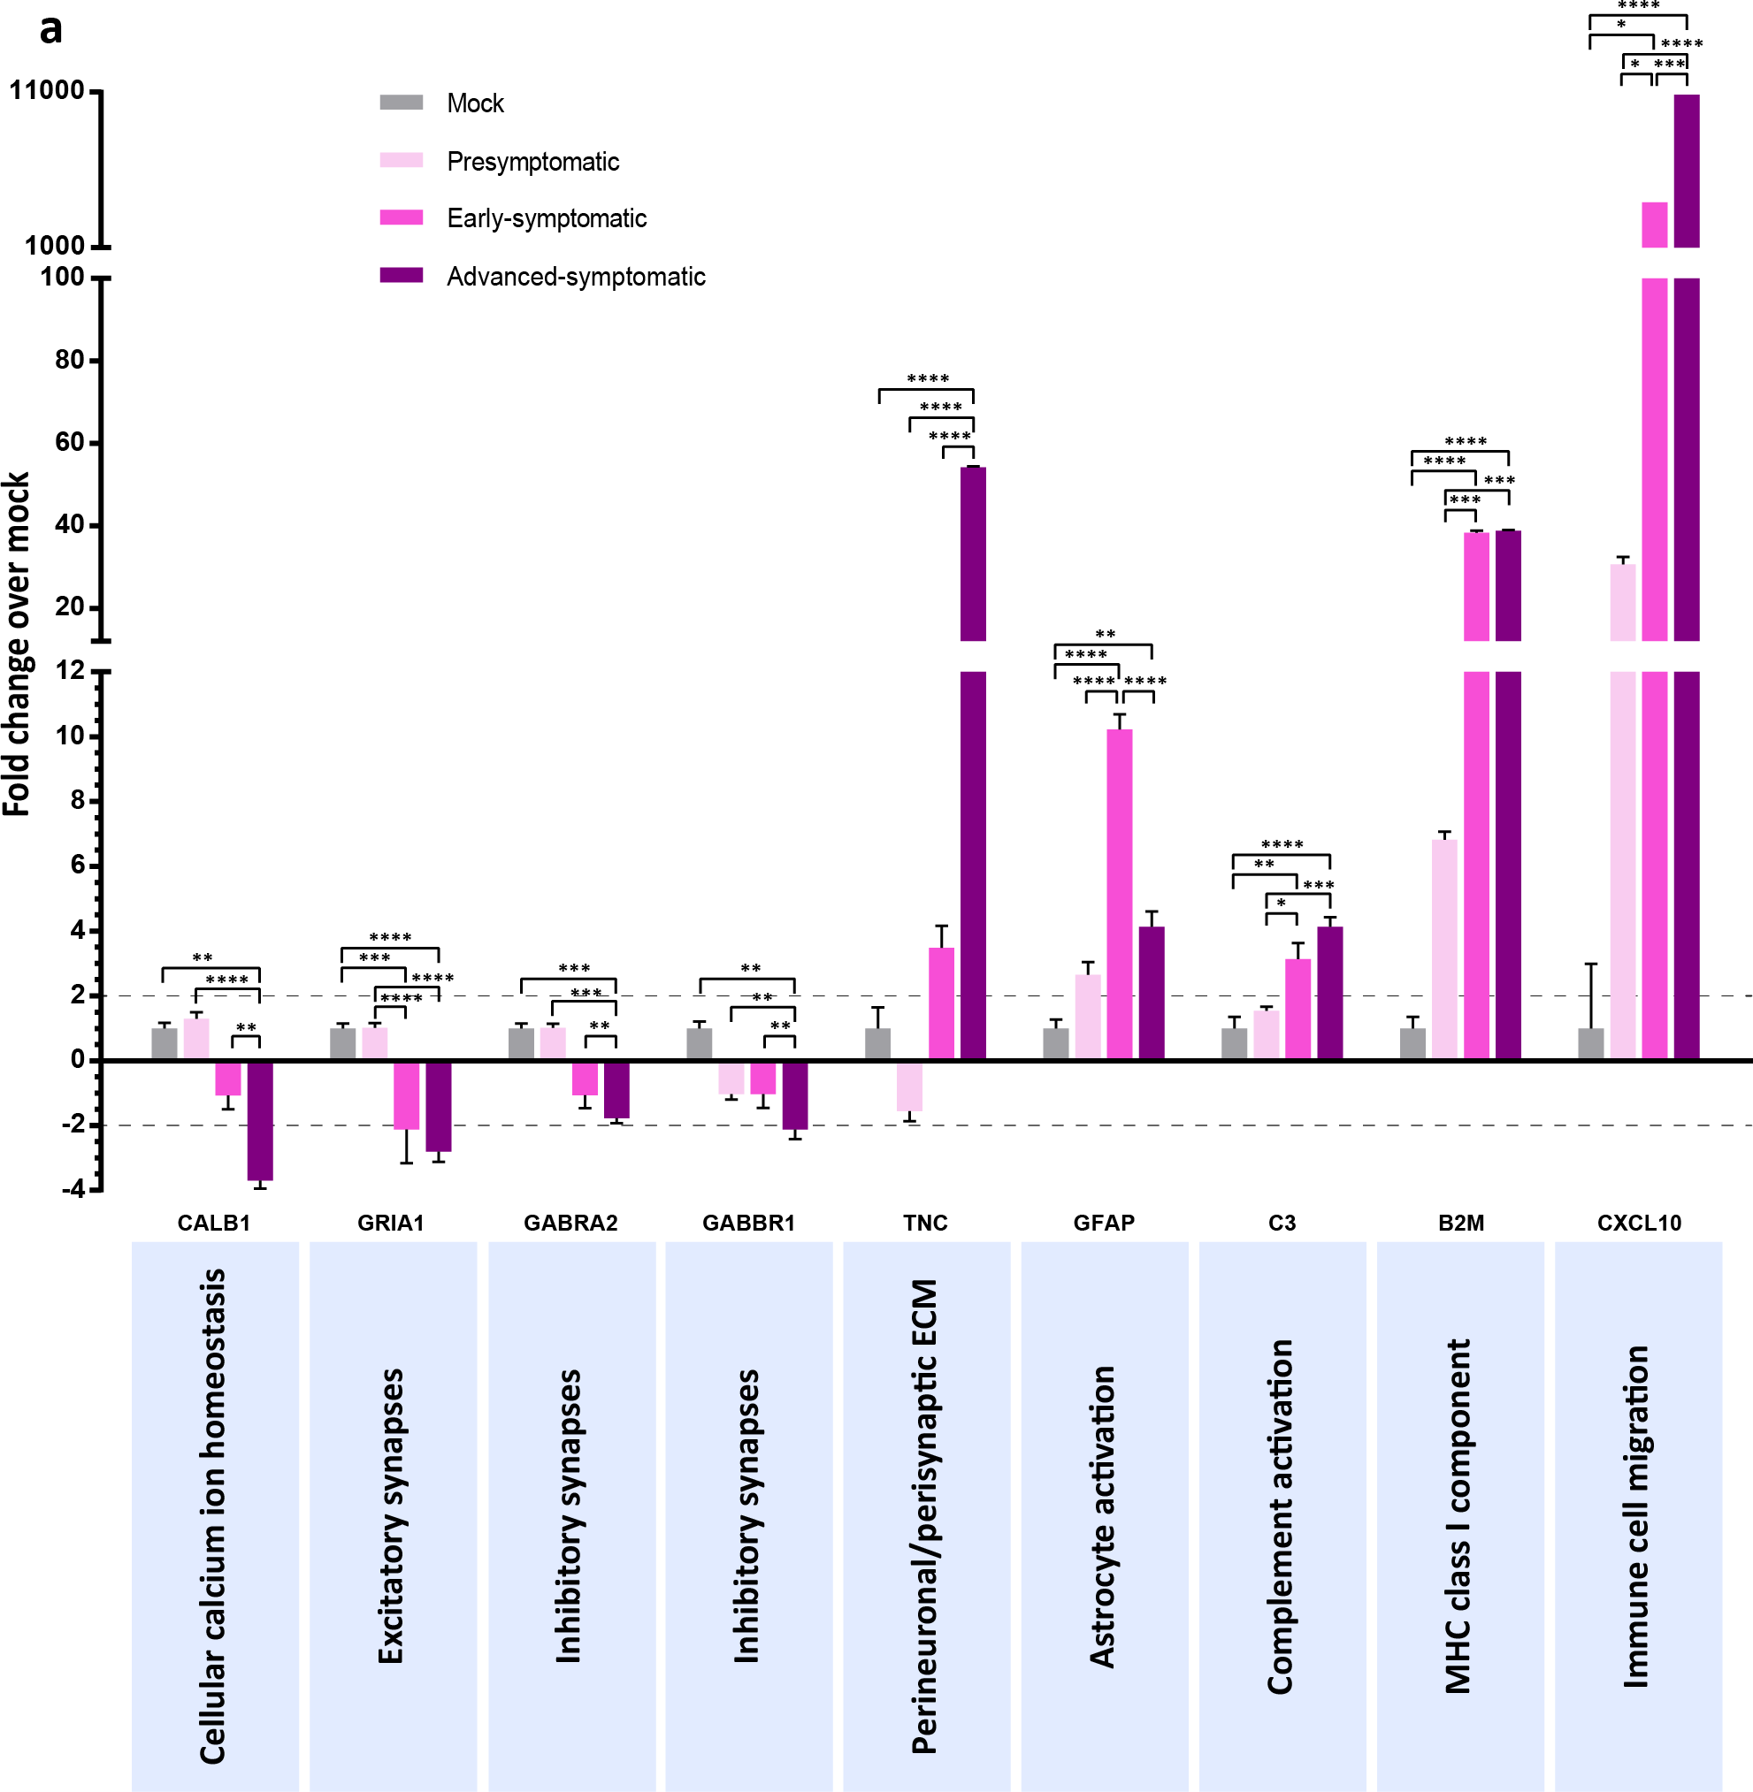

Validation of WNV-ND transcriptome at the levels of RNA expression and affected biological processes. (a) The levels of expression of select genes by qPCR in the cerebella of NHPs at the presymptomatic (3 dpi; n=3), early-symptomatic (7 dpi; n=3), and advanced-symptomatic (9 dpi; n=3) stages of WNV-ND relative to mock (n=3). Only statistically significant differences are indicated by brackets: *p<0.05, **p<0.01, ***p<0.001,
****p<0.0001 by one-way ANOVA. Error bars, STDEV. Dashed lines indicate the chosen fold change cutoff for the differentially expressed genes in the microarray data. Biological processes to which each select gene was mapped are shown below each gene symbol. ECM, extracellular matrix.

