Supplementary File 8
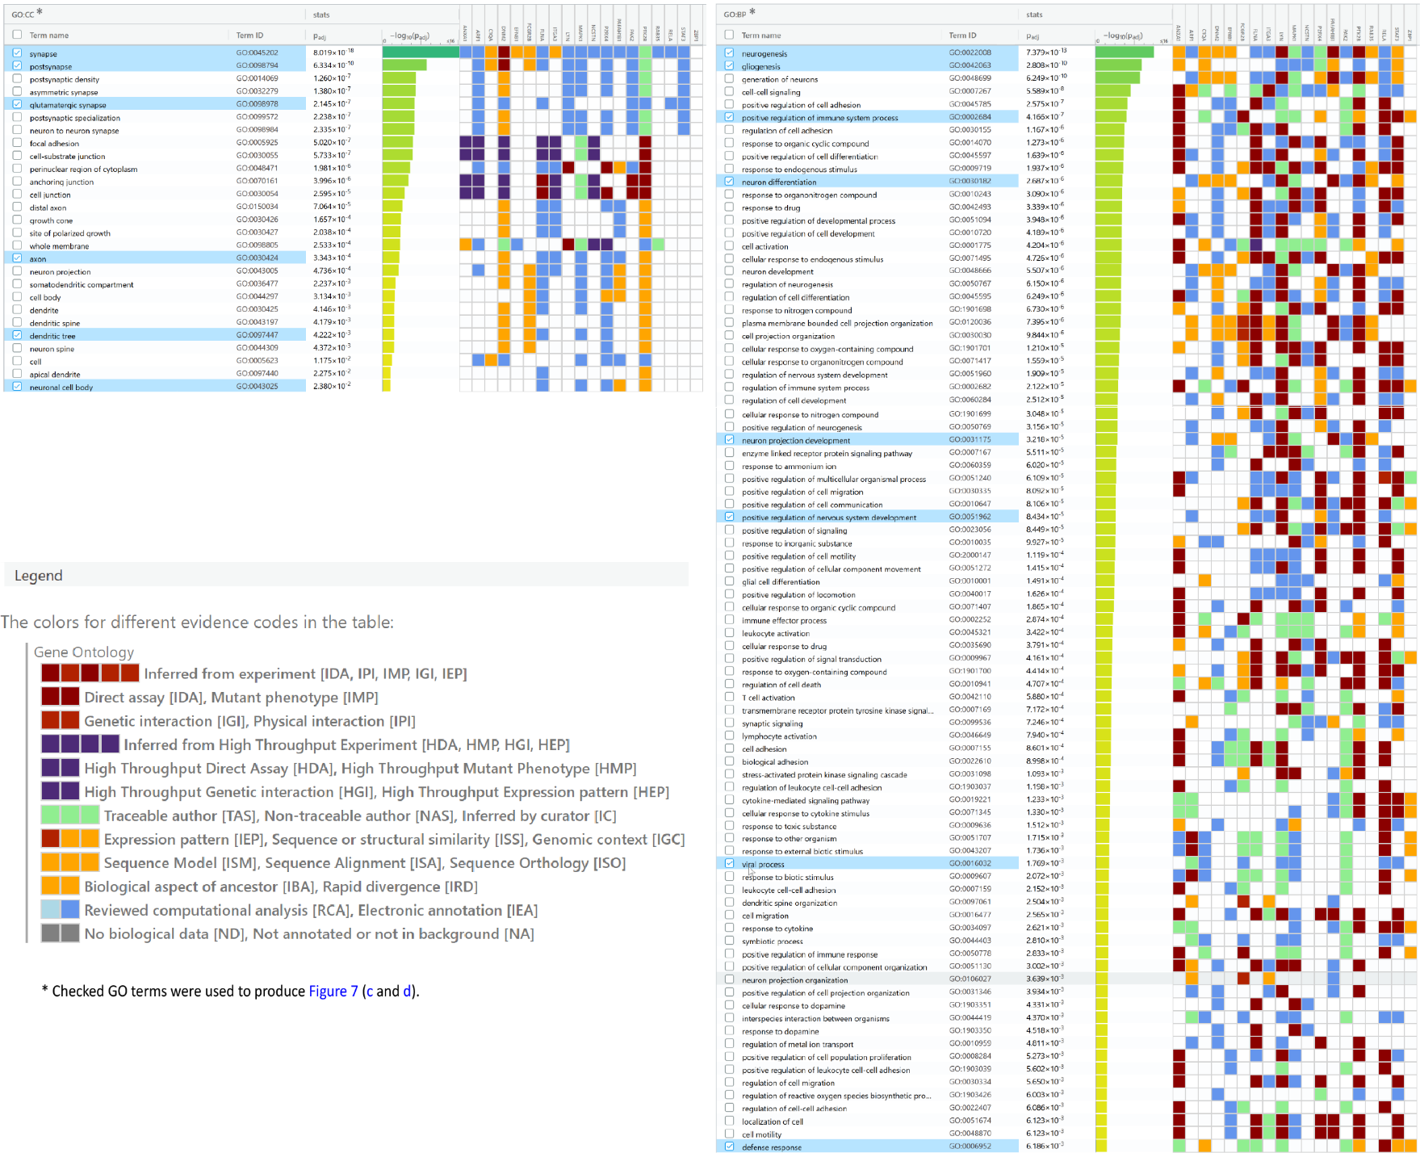
Upregulated immune-neural-synaptic pleiotropic DEGs: significantly enriched CC and BP GO terms

Downregulated immune-neural-synaptic pleiotropic DEGs: significantly enriched CC and BP GO terms
