Figure 1–Source Data 1. Raw western blot images for Figure 1B and Figure 1E.
TU8988T B9, MiaPaCa2 M12, HPAC H7: GFAT1
TU8988T B9, MiaPaCa2 M12, HPAC H7: VINCULIN (VNC)

TU8988T tumors: GFAT1
TU8988T tumors: VNC
Figure 3–Source Data 1. Raw western blot images for Figure 3C-E.
O-GlcNAc
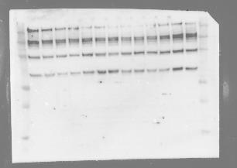

WT TU8988T
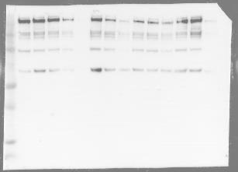
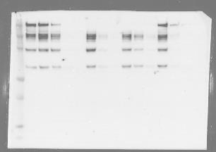

TU8988T B9 TU8988T D10

VNC
WT TU8988T

TU8988T B9

TU8988T D10

Figure 5–Source Data 1. Raw western blot images for Figure 5.
NAGK
Lane ID for “Figure 5A”
- WT TU8988T
- TU8988T NAGK KO sg1
- TU8988T NAGK KO sg2
- WT MiaPaCa2
- MiaPaCa2 NAGK KO sg1
- MiaPaCa2 NAGK KO sg2

1 2 3 4 5 6

1 2 3 4 5 6

GFAT1

ACTIN
1 2 3 4 5 6
1 2 3
1 2 3
1 2 3

NAGK GFAT1 ACTIN
Lane ID for “Figure 5A continued”
- WT HPAC
- HPAC NAGK KO sg1
- HPAC NAGK KO sg2

Lane 1: TU8988T
Lane 2: GFAT1
Lane 3: ACTIN

GFAT1 NAGK

ACTIN

98
198
Vinculin

62
49
38
28

NAGK

62
49
38
98
198
28
Vinculin

GFAT1

O-GlcNAc Vinculin

NAGK
GFAT1 (probed first)
Figure 1–Source Data 2. Raw western blot images for Figure 1–Figure Supplement 1D,E.

GFAT1 short

GFAT1 long
Actin

Figure 5–Source Data 2. Raw western blot images for Figure 5–Figure Supplement 1N.
191
97
64
51
39
28
191
97
64
51
39
28

O-GlcNAc GFAT1

191
97
64
51
39
28
191
97
64
51
39
28

NAGK VINCULIN

