Correlation of interferometric contrast and molecular mass.
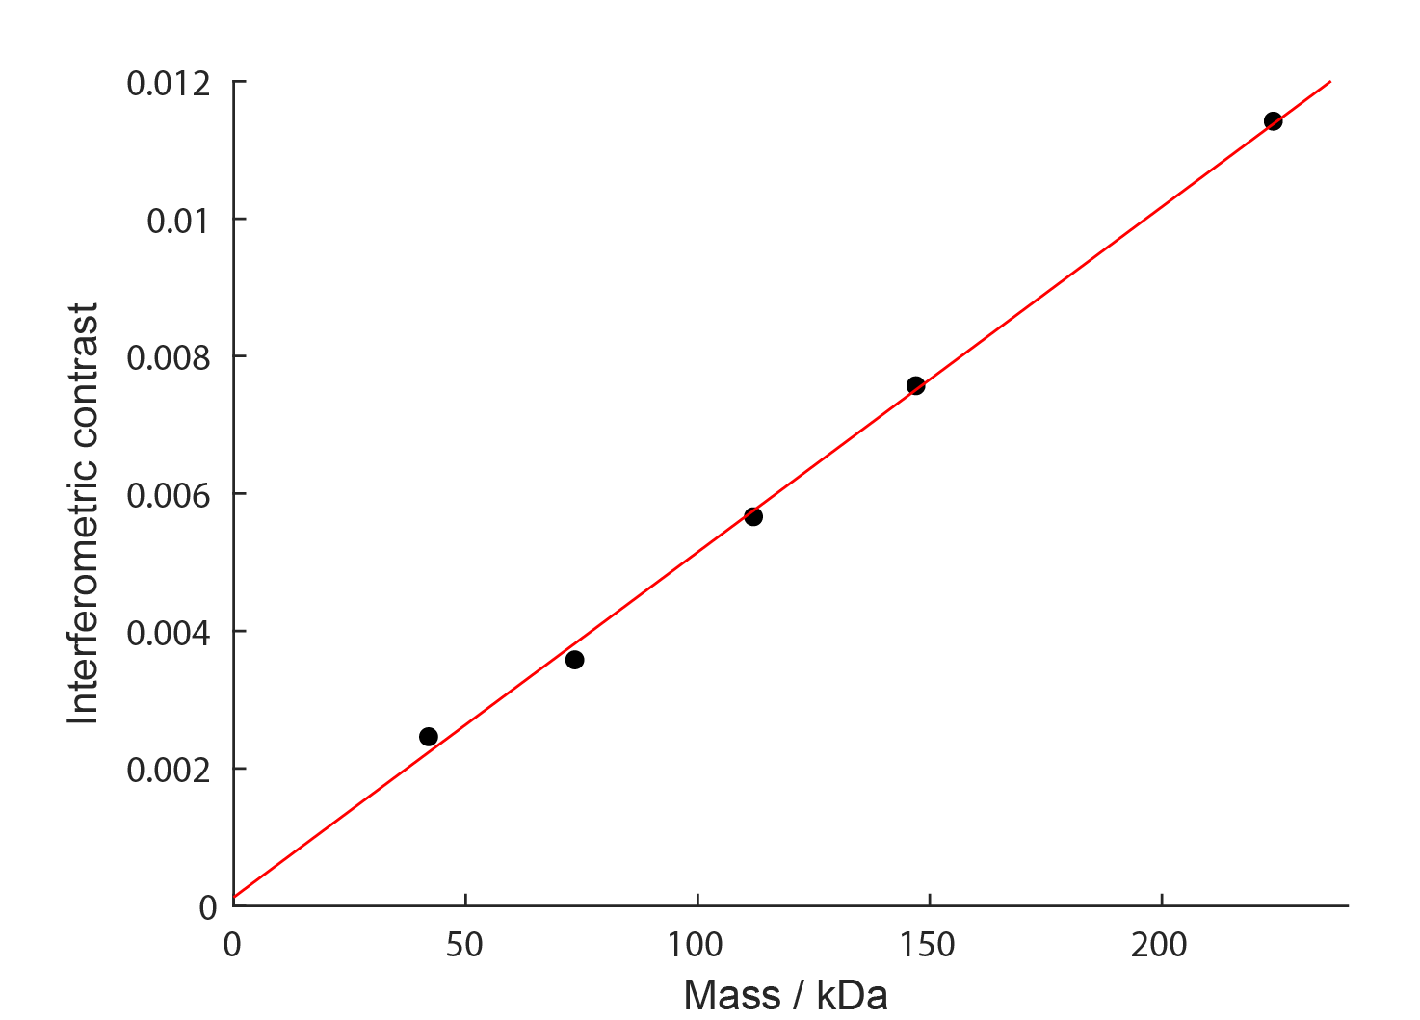

The interferometric contrast signal of landing molecules was converted into molecular mass based on the signal of standard proteins with known mass (here: protein A – 42 kDa, alcohol dehydrogenase dimer and tetramer – 73.5 and 147 kDa, β-amylase dimer and tetramer – 112 and 224 kDa).

