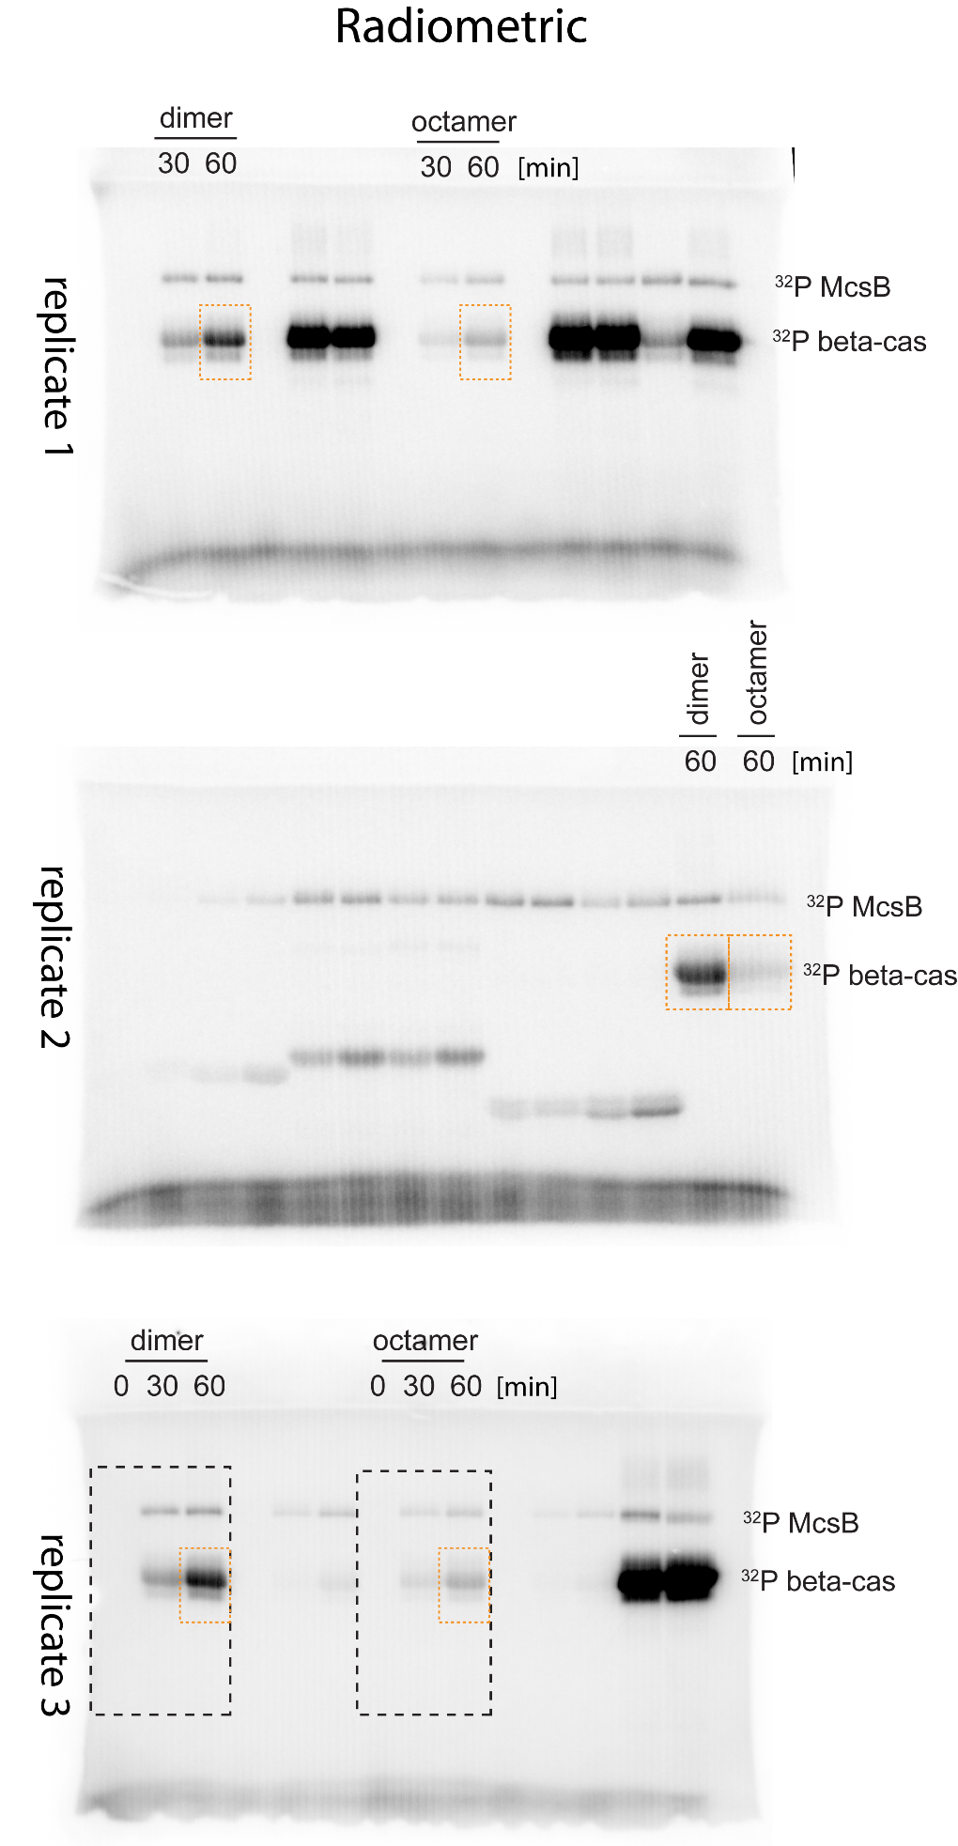
Figure 4b

Black boxes indicate the part shown in the main figure

Orange boxes indicate the bands used for quantification

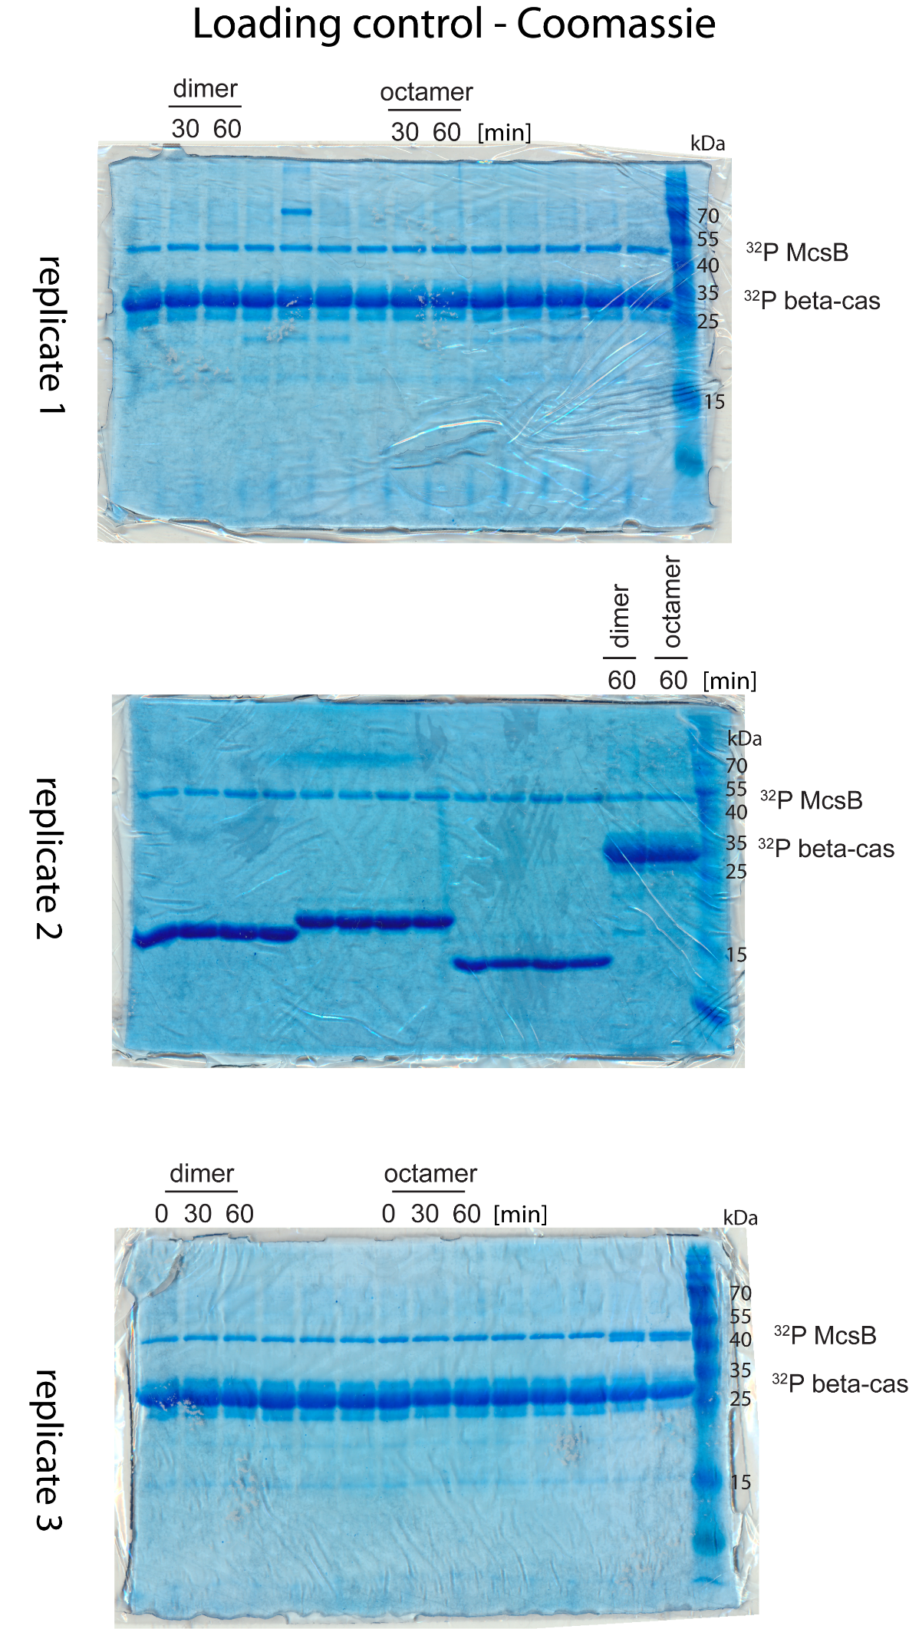

Figure 4c

