SOURCE DATA

Source Data Table 1. Mutual Algorithm Criteria Table

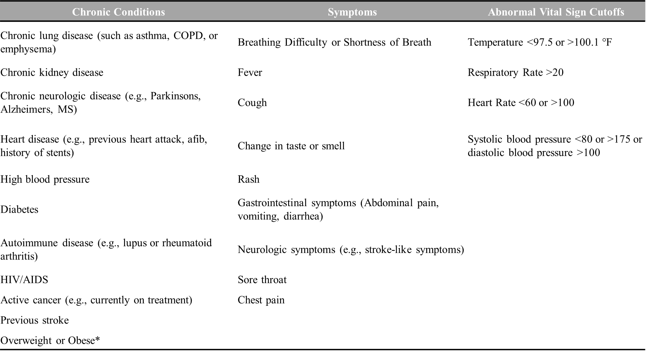
*documented obesity or overweight for height <99th percentile

