Supplementary File 6A
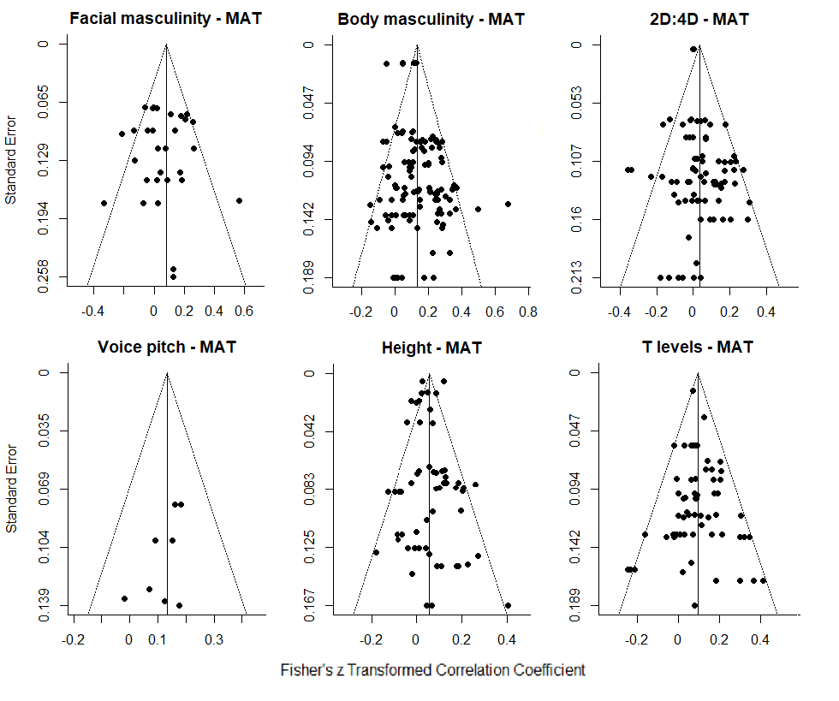
Funnel plots of effect sizes for mating measures (MAT). T = testosterone.

Supplementary File 6B
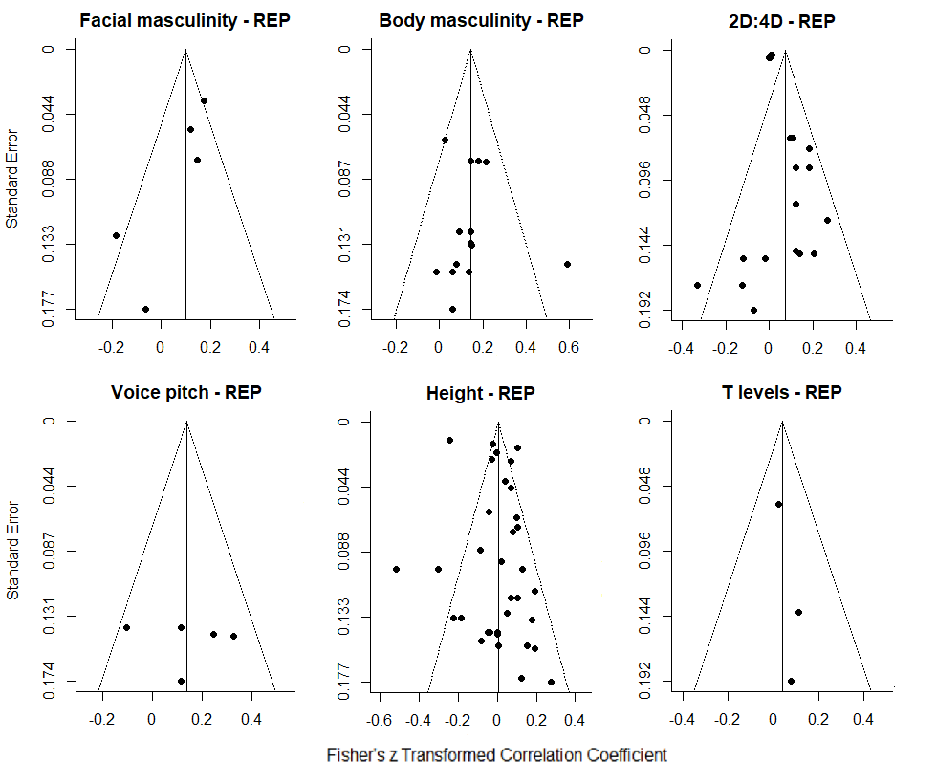
Funnel plots of effect sizes for reproductive measures (REP). T = testosterone levels.

