Human  homologs | Protein name  (ORF name) | Localization | Intrinsic residue solubility along amino acid sequence | Intrinsic solubility score | Mitochondria targeting sequence
 |  | Amount of TMDs
ATP5B | Atp2  (YJR121W) | peripheral IM | 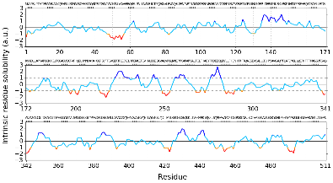 | 0.4783 | N-terminal cleavable presequence
 |  | 0
ATP5L | Atp20  (YPR020W) | IM | 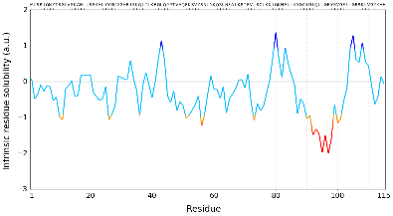 | 0.9556 | N-terminal non-cleavable sequence
 |  | 1
COX7C | Cox8  (YLR395C) | IM | 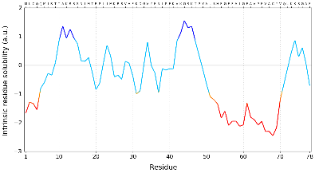 | -0.2763 | N-terminal cleavable presequence
 |  | 1
COX6B1 | Cox12  (YLR038C) | IMS | 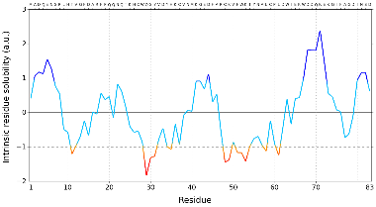 | 1.2939 | Cystein motifs
 |  | 0
UQCRFS1 | Rip1  (YEL024W) | IM | 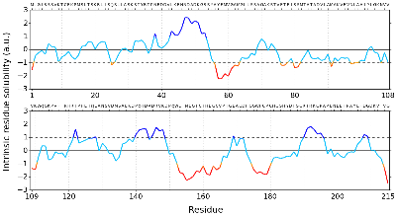 | 0.4783 | N-terminal cleavable presequence
 |  | 2
UQCRH | Qcr6  (YFR033C) | IMS | 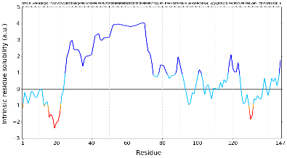 | 4.1091 | Unknown
 |  | 0
UQCRQ | Qcr8  (YJL166W) | IM | 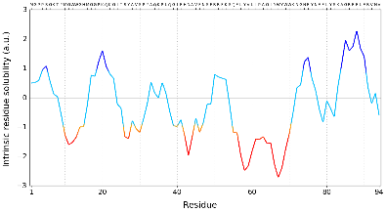 | 0.0079 | N-terminal non-cleavable sequence
 |  | 1
UQCRC1 | Cor1  (YBL045C) | IM | 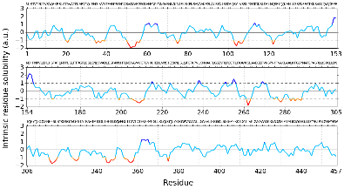 | 0.3800 | N-terminal cleavable presequence
 |  | 0

