Raw unedited labeled Western blot images

Figure 1H |  | Control |  |  |  | Yap8SA
 |  | 1 | 2 | 3 |  | 4 | 5 | 6
Active Yap

GAPDH

Figure 1H |  | Control LV |  |  | caYap8SA
 |  | 1 | 2 | 3 | 4 | 5 | 6
Total Yap

GAPDH

Figure 1L |  |  | cahErbb2 |  |  | Control LV |  |  | caCtnnb1
 |  | 1 |  | 2 | 3 | 4 | 5 | 6 | 7 | 8 | 9
ß-catenin

GAPDH

Figure 1N | cahErbb2 |  |  |  | Control LV |  |  | Ccnd2 OE
 |  | 1 | 2 | 3 | 4 | 5 | 6 | 7 | 8 | 9
CyclinD2 | 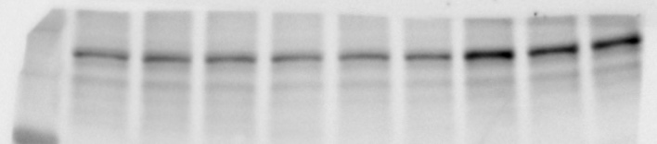
GAPDH

Figure 4A | Control LV |  |  |  | carErbb2 |  |  | cahErbb2
 |  | 1 | 2 | 3 | 4 | 5 | 6 | 7 | 8 | 9
pAkt  Erk | 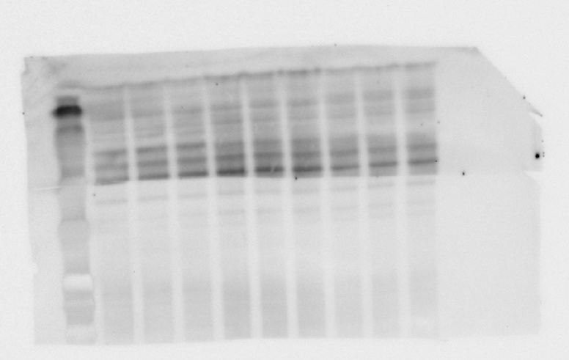
Akt

GAPDH
pErk

Figure 4F | Control LV |  |  |  | carErbb2 |  |  | cahErbb2
 |  | 1 | 2 | 3 | 4 | 5 | 6 | 7 | 8 | 9
pmTOR  pS6 | 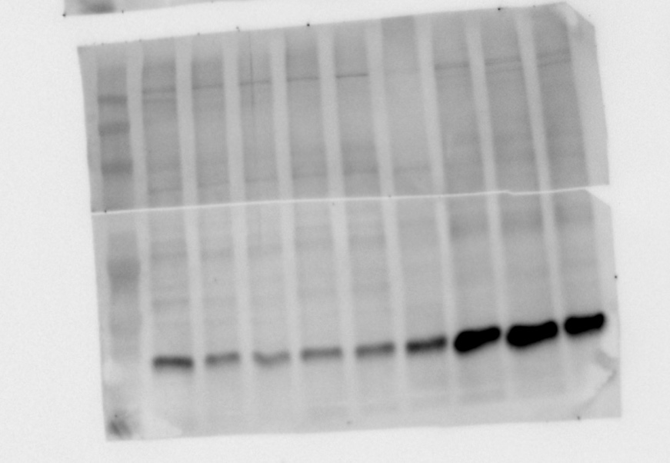
GAPDH

