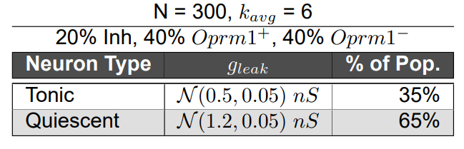
Table 1: Network parameters for in silico preBӧtC network

