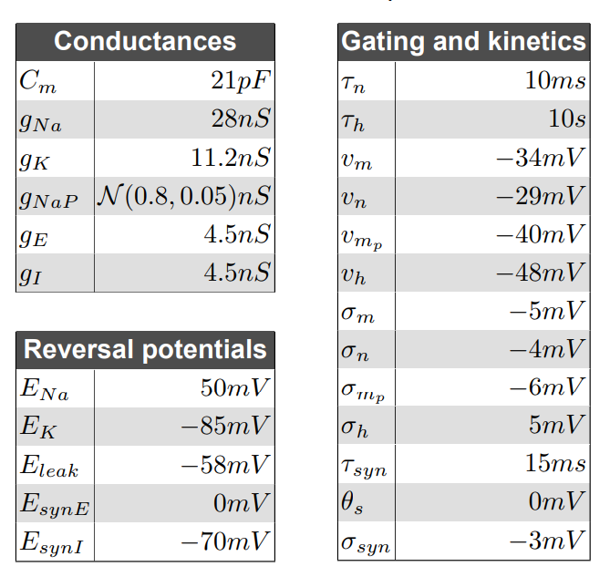
Table 2: Cellular parameters for in silico preBӧtC neurons

