Figure 2 | a
TmrAB in liposomes |  |  | Bound CP6F
µM |  |  | %
 |  |  | Mean | SD
0.0000 |  |  | 0.00 | 2.66
0.0025 |  |  | 23.95 | 1.95
0.0250 |  |  | 50.23 | 2.48
0.0500 |  |  | 67.16 | 1.90
0.1250 |  |  | 86.81 | 1.95
0.2500 |  |  | 91.77 | 3.69
0.3750 |  |  | 95.92 | 2.63
0.5000 |  |  | 94.60 | 2.74
Empty liposomes |  |  | Bound CP6F
µM |  |  | %
 |  |  | Mean | SD
0.5000 |  |  | -6.19 | 9.90
TmrAB in liposomes |  |  | Bound CP12F
µM |  |  | %
 |  |  | Mean | SD
0.0000 |  |  | 0.00 | 0.48
0.0025 |  |  | 21.56 | 0.75
0.0250 |  |  | 55.19 | 1.11
0.0500 |  |  | 68.59 | 2.85
0.1250 |  |  | 78.78 | 1.92
0.2500 |  |  | 87.50 | 2.60
0.3750 |  |  | 94.67 | 0.98
0.5000 |  |  | 100.00 | 1.49
Empty liposomes |  |  | Bound CP12F
µM |  |  | %
 |  |  | Mean | SD
0.5000 |  |  | -0.19 | 0.41

Figure 2 | b
TmrAB in liposomes |  |  | Bound CP13F
µM |  |  | %
 |  |  | Mean | SD
0.0000 |  |  | 0.00 | 2.96
0.0025 |  |  | 13.77 | 2.41
0.0500 |  |  | 46.57 | 2.38
0.1250 |  |  | 72.25 | 5.37
0.2500 |  |  | 85.91 | 2.78
0.5000 |  |  | 88.99 | 4.37
Empty liposomes |  |  | Bound CP13F
µM |  |  | %
 |  |  | Mean | SD
0.2500 |  |  | 3.65 | 2.10
TmrAB in liposomes |  |  | Bound CP14F
µM |  |  | %
 |  |  | Mean | SD
0.0000 |  |  | 0.00 | 3.33
0.0005 |  |  | 13.49 | 2.37
0.0050 |  |  | 26.27 | 3.32
0.0250 |  |  | 55.22 | 2.38
0.0500 |  |  | 77.37 | 4.94
0.1000 |  |  | 85.31 | 5.50
0.2000 |  |  | 93.45 | 3.18
Empty liposomes |  |  | Bound CP14F
µM |  |  | %
 |  |  | Mean | SD
0.2500 |  |  | -5.24 | 2.64

Figure 2 | c
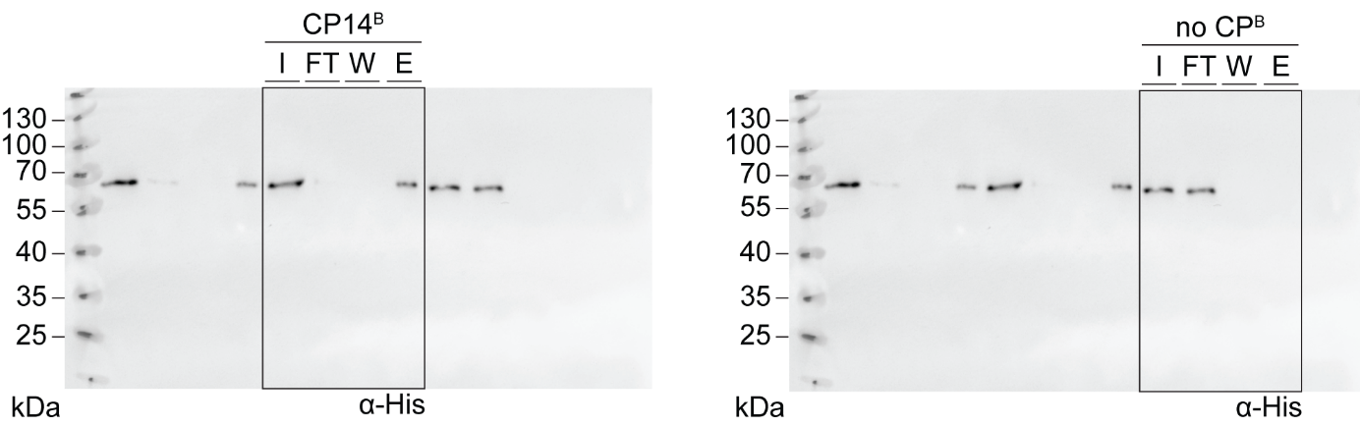

Figure 2 | d
