Figure 2 | supplemental figure 1 |  | a
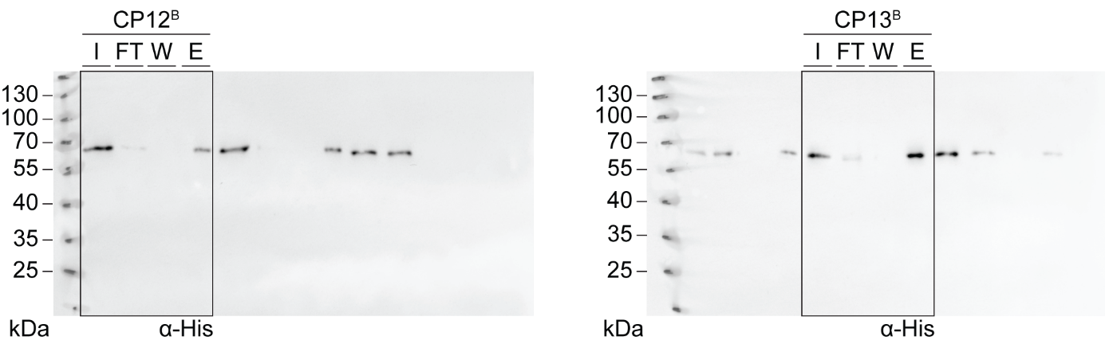

Figure 2 | supplemental figure 1 |  | b
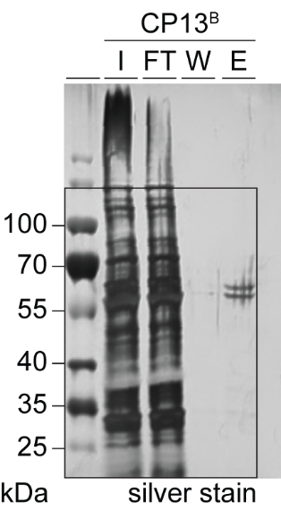

Figure 2 | supplemental figure 1 |  |  | d
 |  |  | Fluorescence anisotropy
CP6F |  |  | Mean | SD
CPF |  |  | 0.0222 | 0.0004
TmrAB |  |  | 0.1093 | 0.0017
SDS |  |  | 0.0146 | 0.0008
 |  |  | Fluorescence anisotropy
CP12F |  |  | Mean | SD
CPF |  |  | 0.0250 | 0.0006
TmrAB |  |  | 0.1604 | 0.0011
SDS |  |  | 0.0265 | 0.0006
 |  |  | Fluorescence anisotropy
CP13F |  |  | Mean | SD
CPF |  |  | 0.0252 | 0.0005
TmrAB |  |  | 0.1217 | 0.0004
SDS |  |  | 0.0310 | 0.0014
 |  |  | Fluorescence anisotropy
CP14F |  |  | Mean | SD
CPF |  |  | 0.0267 | 0.0008
TmrAB |  |  | 0.1410 | 0.0065
SDS |  |  | 0.0311 | 0.0011

