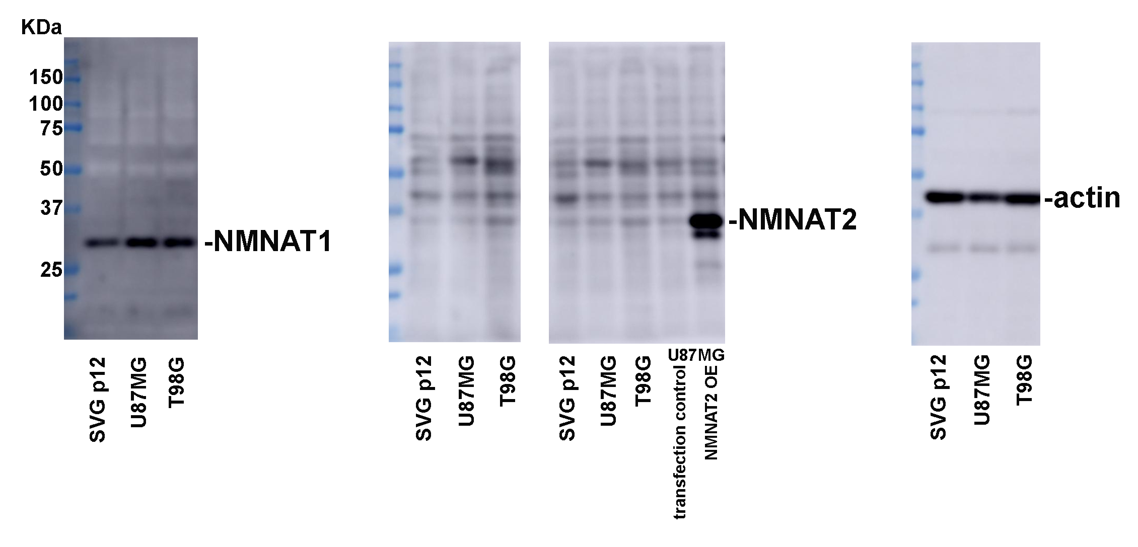
Figure 3-figure supplement 3-source data 1
Proteins were extracted from cells were probed for NMNAT1, NMNAT2 and β-actin and quantification. β-actin was used as internal control.

