Figure 2 - Source data 1. Uncropped images of western blots

Figure 2-source data 2
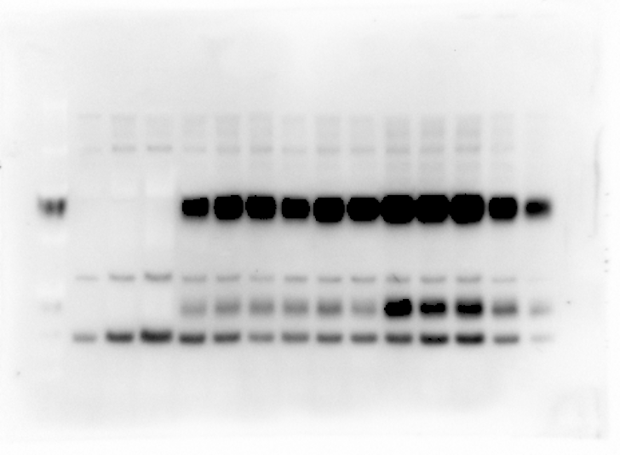
SiPIP2;7-FLAG
Rieske

Figure 2-source data 3
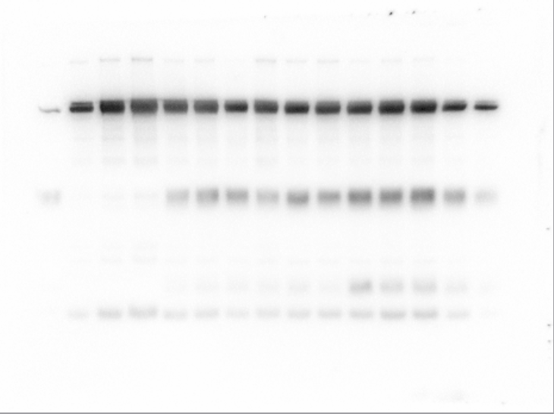
PEPC

Figure 2-source data 4
CA

Figure 2-source data 5
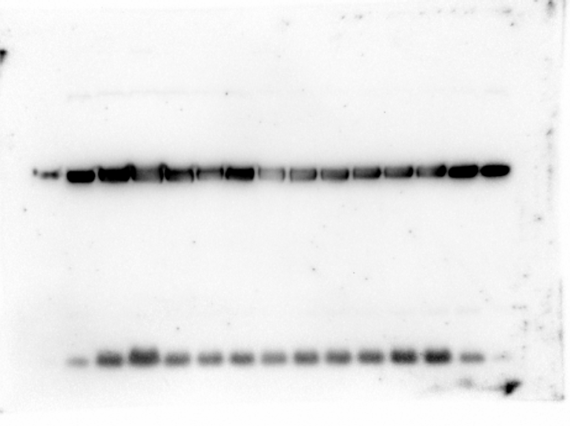
RbcS

