Source data and legend for source data

Figure 1-figure supplement 2A_PRMT1_source data_source data
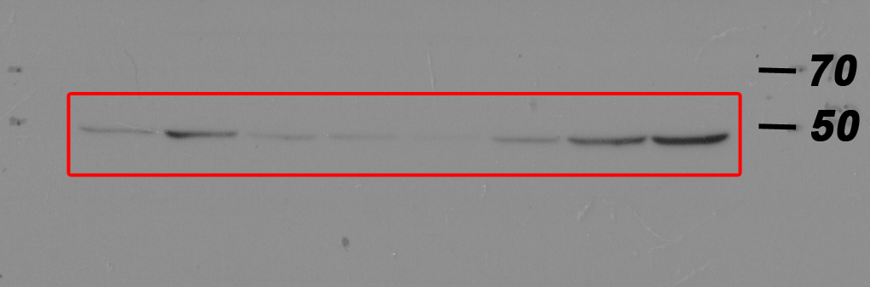
Western blot analysis of PRMT1 protein levels in non-metastatic human cancer cell line (MCF7) and highly metastatic human cancer cell lines (MDA-MB-231, MDA-MB-435, MIA-PaCa2, PC9, HCCLM3, SW620 and PC3).

Figure 1-figure supplement 2A_CYP11A1_source data
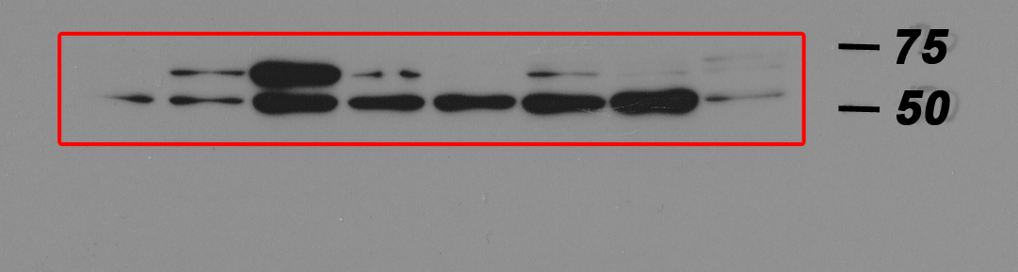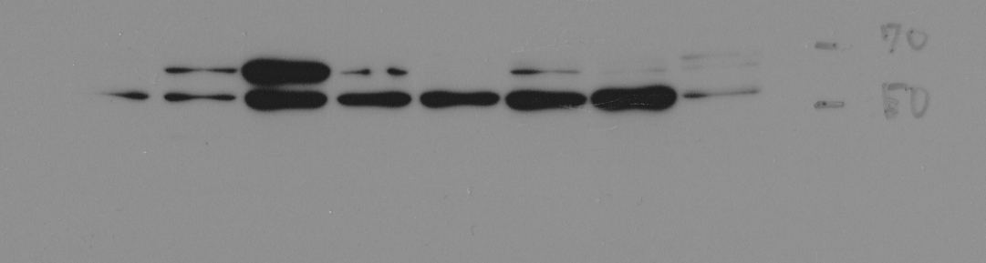
Western blot analysis of CYP11A1 protein levels in non-metastatic human cancer cell line (MCF7) and highly metastatic human cancer cell lines (MDA-MB-231, MDA-MB-435, MIA-PaCa2, PC9, HCCLM3, SW620 and PC3).

Figure 1-figure supplement 2A_β-actin_source data
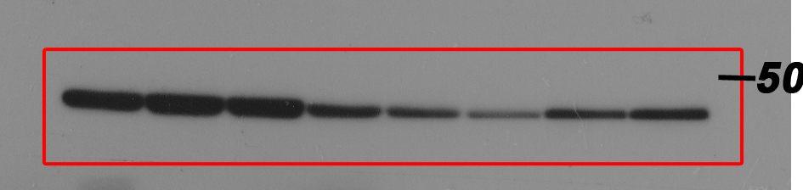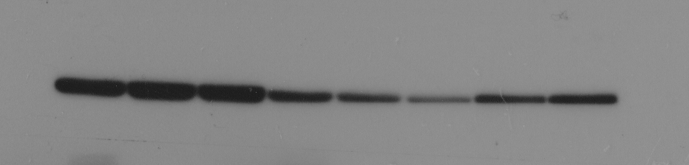
Western blot analysis of β-actin protein levels in non-metastatic human cancer cell line (MCF7) and highly metastatic human cancer cell lines (MDA-MB-231, MDA-MB-435, MIA-PaCa2, PC9, HCCLM3, SW620 and PC3).

Figure 1-figure supplement 2A _PRMT1_source data
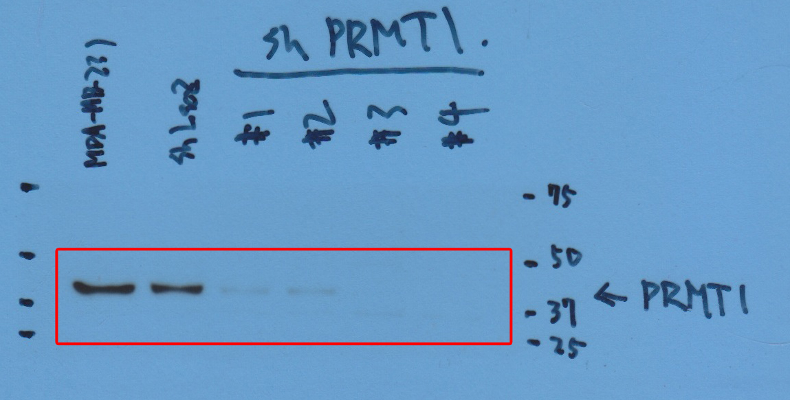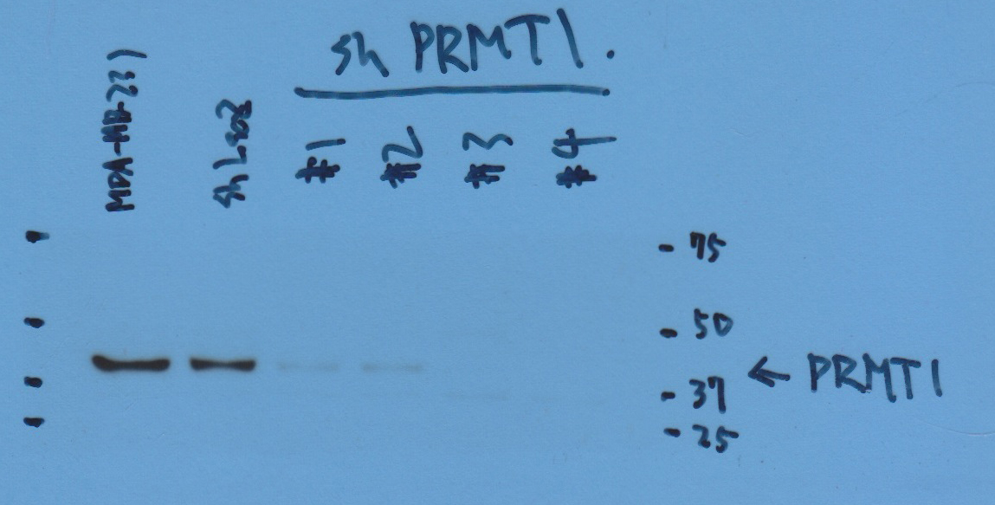
Western blot analysis of PRMT1 protein levels in sub-clones of MBA-MB-231 cells which were transfected with either a control shRNA targeting LacZ or one of four independent shRNAs targeting PRMT1 (clone #1 to #4).

Figure 1-figure supplement 2A_β-actin _source data
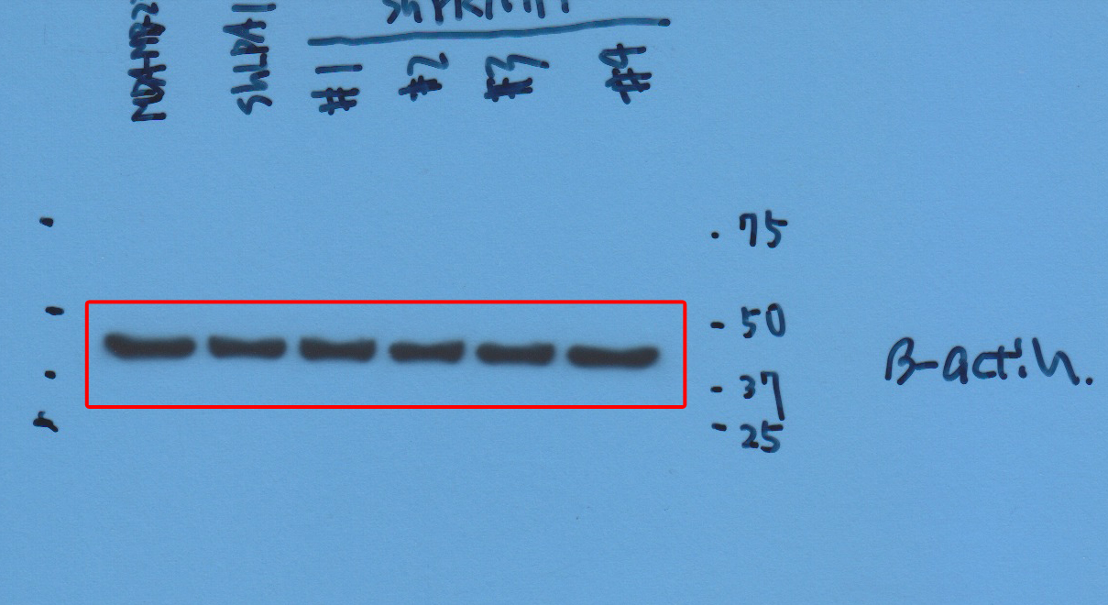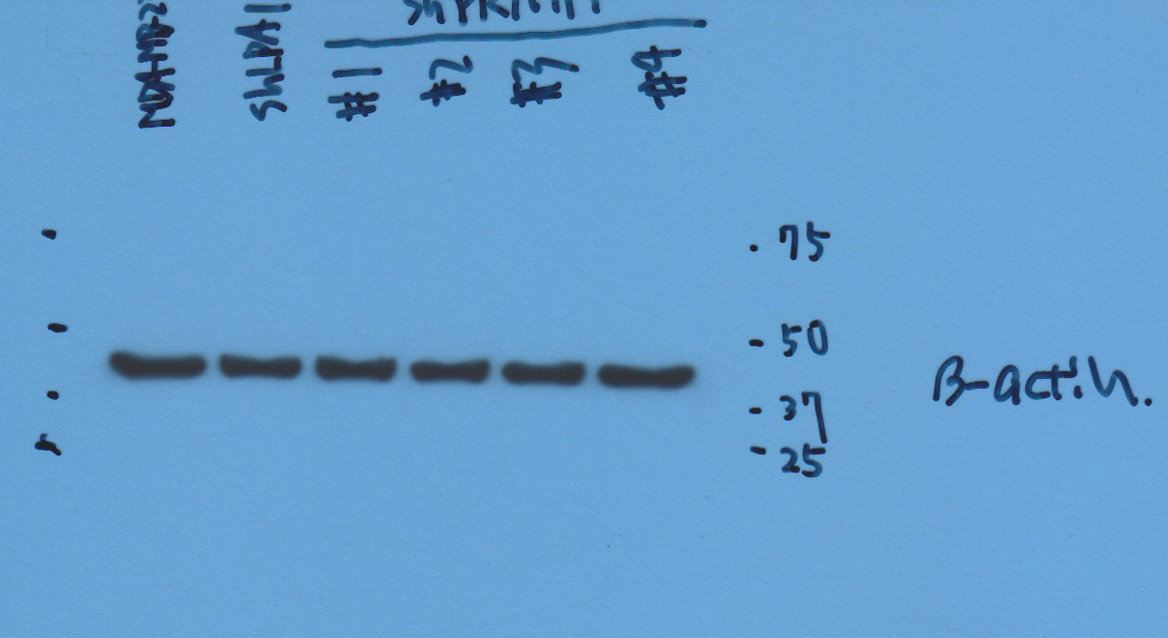
Western blot analysis of β-actin protein levels in sub-clones of MBA-MB-231 cells which were transfected with either a control shRNA targeting LacZ or one of four independent shRNAs targeting PRMT1 (clone #1 to #4).

Figure 1-figure supplement 2A_CYP11A1_source data
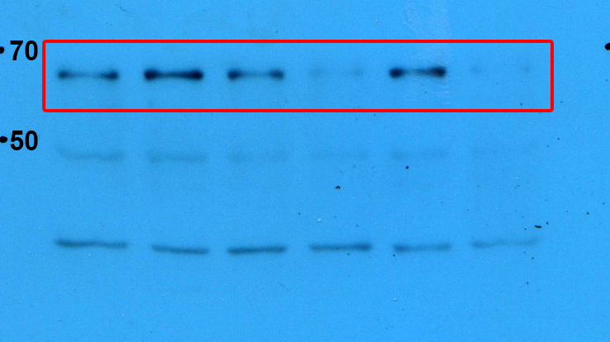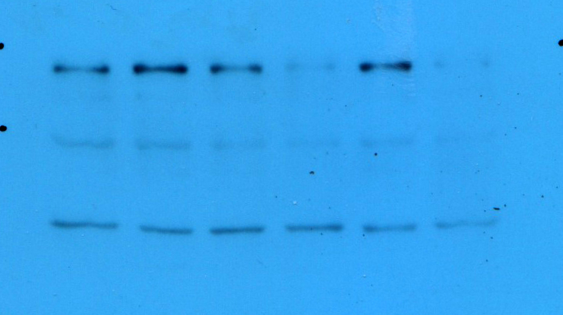
Western blot analysis of CYP11A1 protein levels in sub-clones of MBA-MB-231 cells which were transfected with either a control shRNA targeting LacZ or one of four independent shRNAs targeting CYP11A1 (clone #1 to #4).

Figure 1-figure supplement 2A_ β-actin_source data
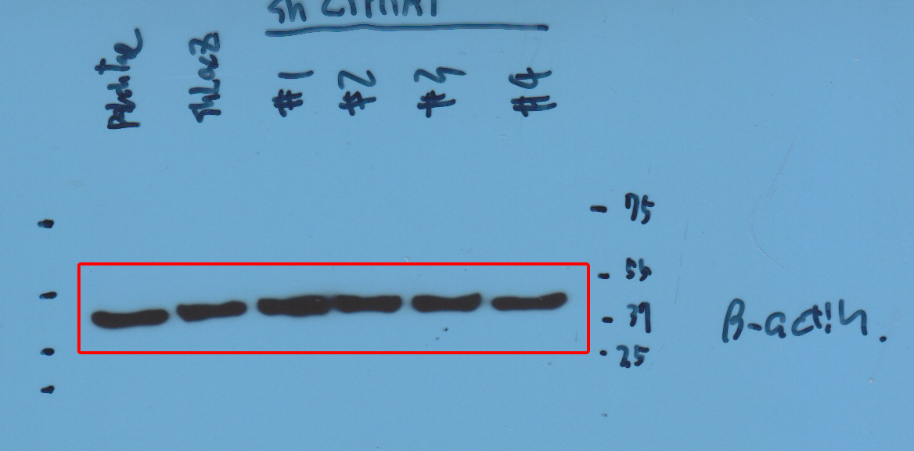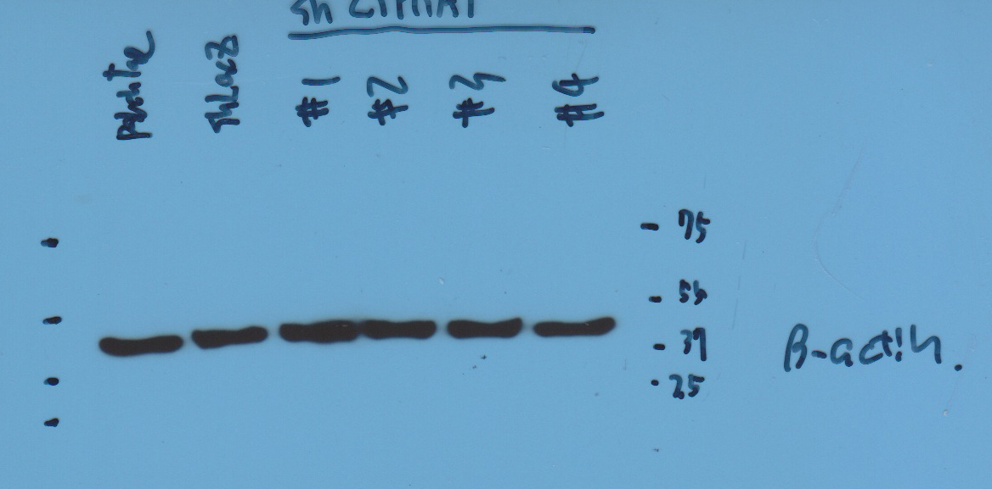
Western blot analysis of β-actin protein levels in sub-clones of MBA-MB-231 cells which were transfected with either a control shRNA targeting LacZ or one of four independent shRNAs targeting CYP11A1 (clone #1 to #4).

Figure 2A_HRT2C_source data
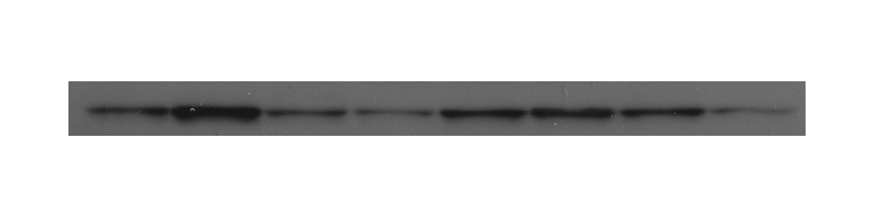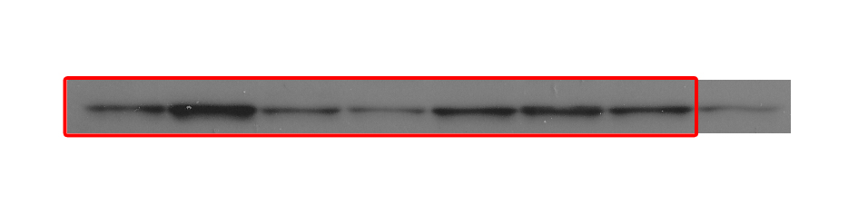
Western blot analysis of HRT2C protein levels in non-metastatic human cancer cell line, MCF7 (breast) and highly metastatic human cancer cell lines, MDA-MB-231 (breast), MDA-MB-435 (melanoma), MIA-PaCa2 (pancreas), SW620 (colon) and PC3 (prostate).

Figure 2A_GAPDH_source data
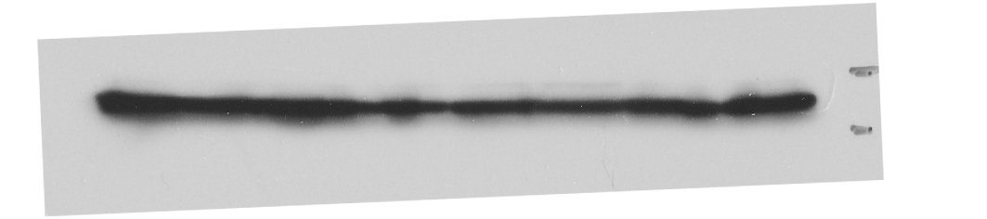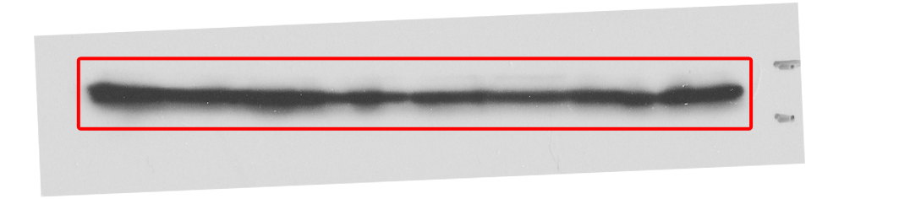
Western blot analysis of GAPDH protein levels in non-metastatic human cancer cell line, MCF7 (breast) and highly metastatic human cancer cell lines, MDA-MB-231 (breast), MDA-MB-435 (melanoma), MIA-PaCa2 (pancreas), SW620 (colon) and PC3 (prostate).

Figure 2-figure supplement 1B_DRD2_source data
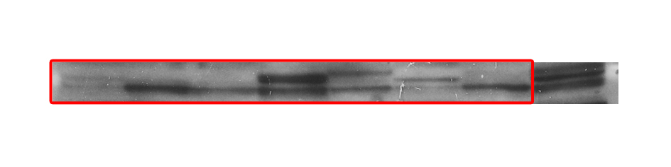
Western blot analysis of DRD2 protein levels in non-metastatic human cancer cell line, MCF7 (breast) and highly metastatic human cancer cell lines, MDA-MB-231 (breast), MDA-MB-435 (melanoma), MIA-PaCa2 (pancreas), PC3 (prostate) and SW620 (colon)

Figure 2-figure supplement 1B_GAPDH_source data
Western blot analysis of GAPDH protein levels in non-metastatic human cancer cell line, MCF7 (breast) and highly metastatic human cancer cell lines, MDA-MB-231 (breast), MDA-MB-435 (melanoma), MIA-PaCa2 (pancreas), PC3 (prostate) and SW620 (colon)

Figure 4C_E-cadherin in MCF7_ source data
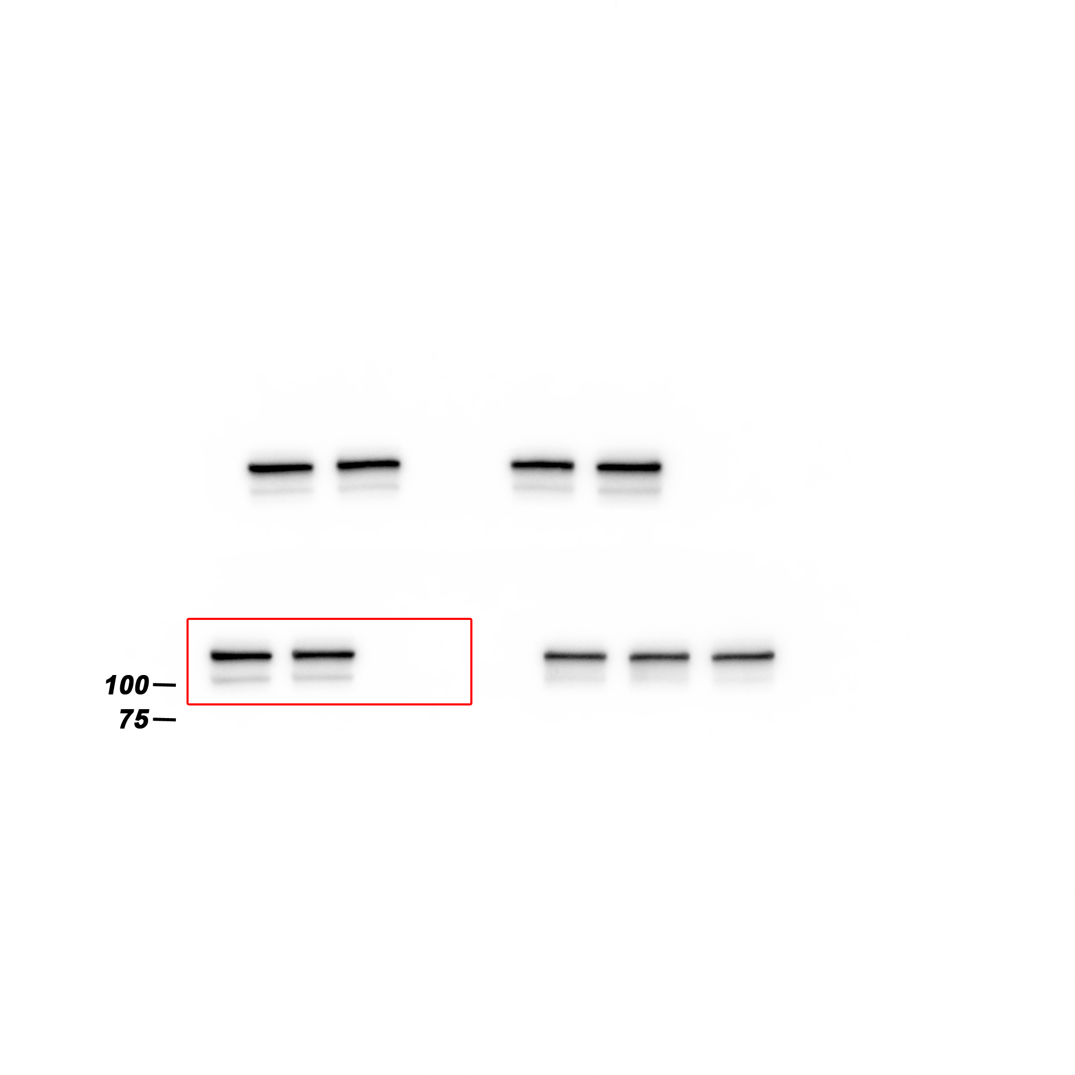
Western blot analysis of E-cadherin protein levels in MCF7 cells expressing either the control vector or HTR2C.

Figure 4C_EpCAM in MCF7_ source data
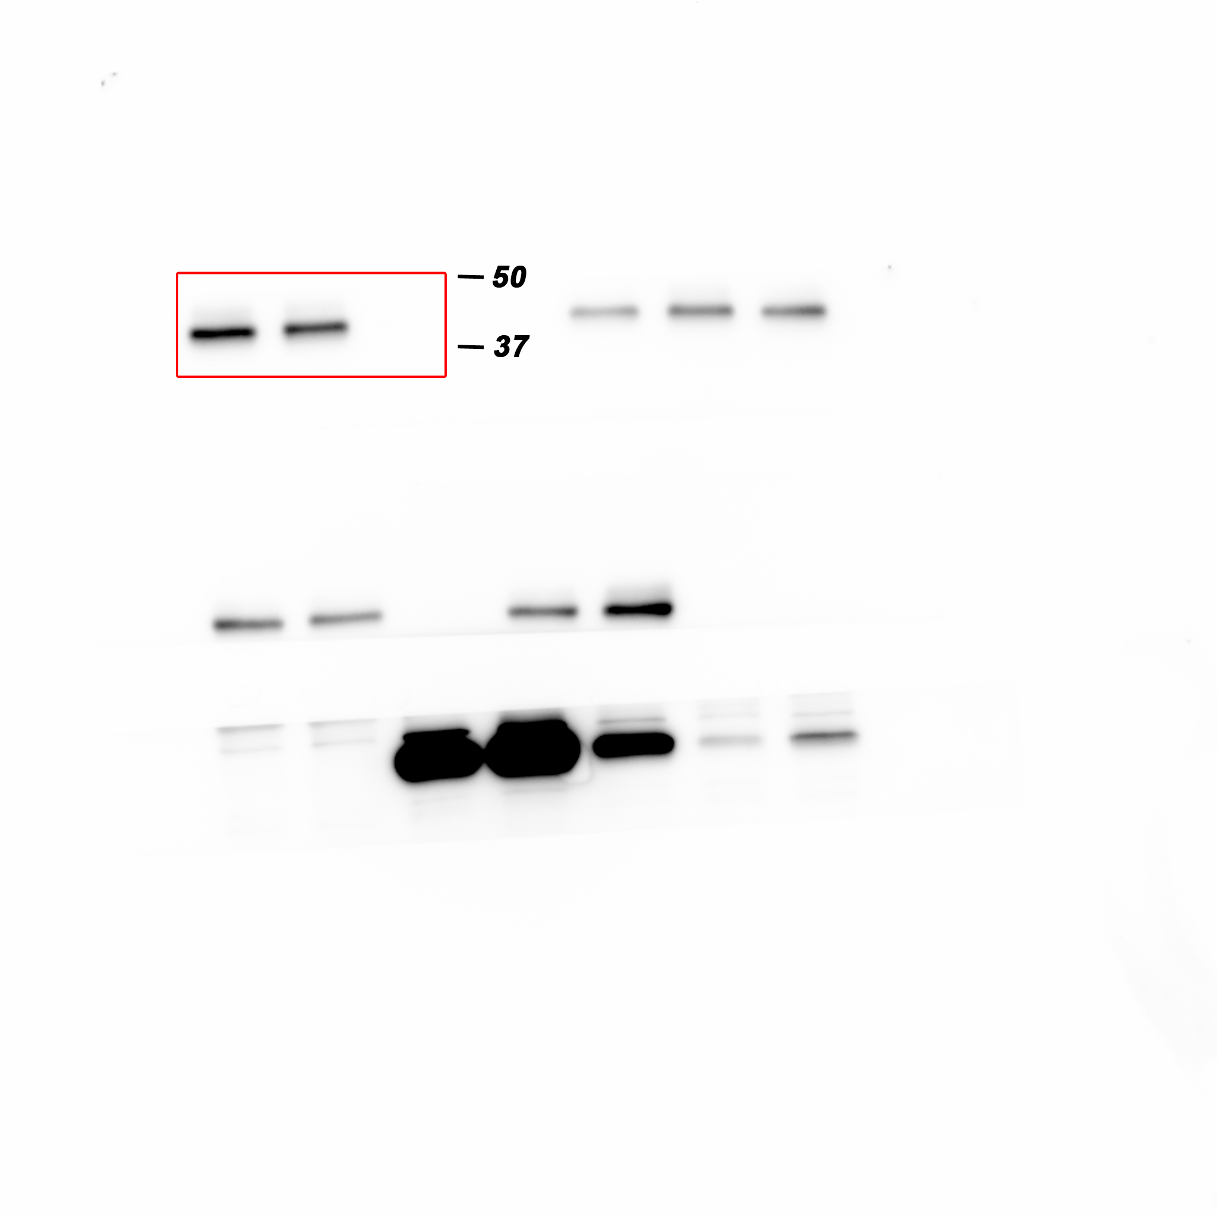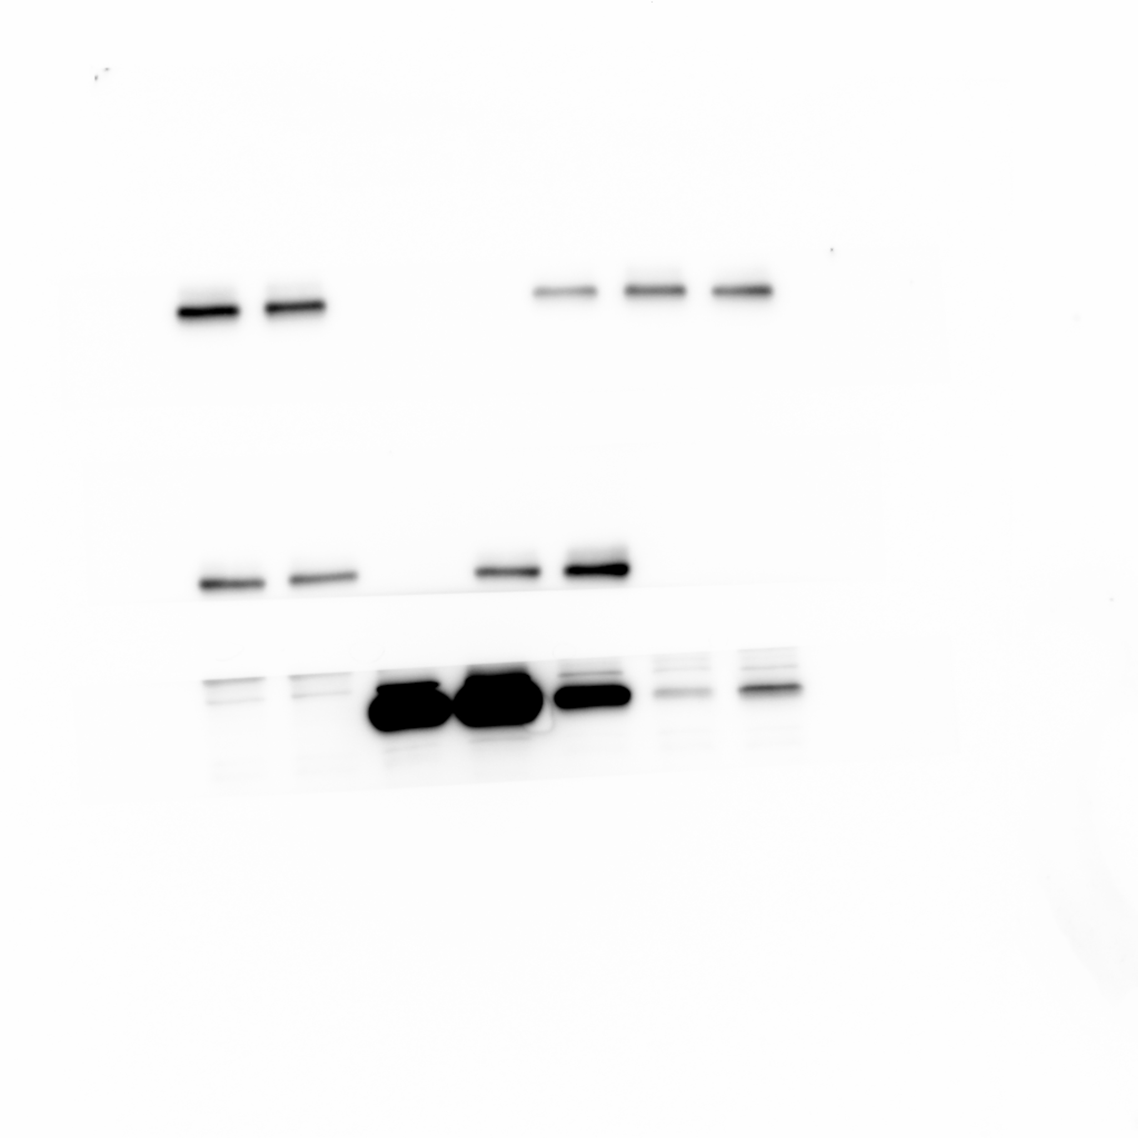
Western blot analysis of EpCAM protein levels in MCF7 cells expressing either the control vector or HTR2C.

Figure 4C_Vimentin in MCF7_ source data
Western blot analysis of Vimentin protein levels in MCF7 cells expressing either the control vector or HTR2C.

Figure 4C_N-cadherin in MCF7_ source data
Western blot analysis of N-cadherin protein levels in MCF7 cells expressing either the control vector or HTR2C.

Figure 4C_ZEB1 in MCF7_ source data
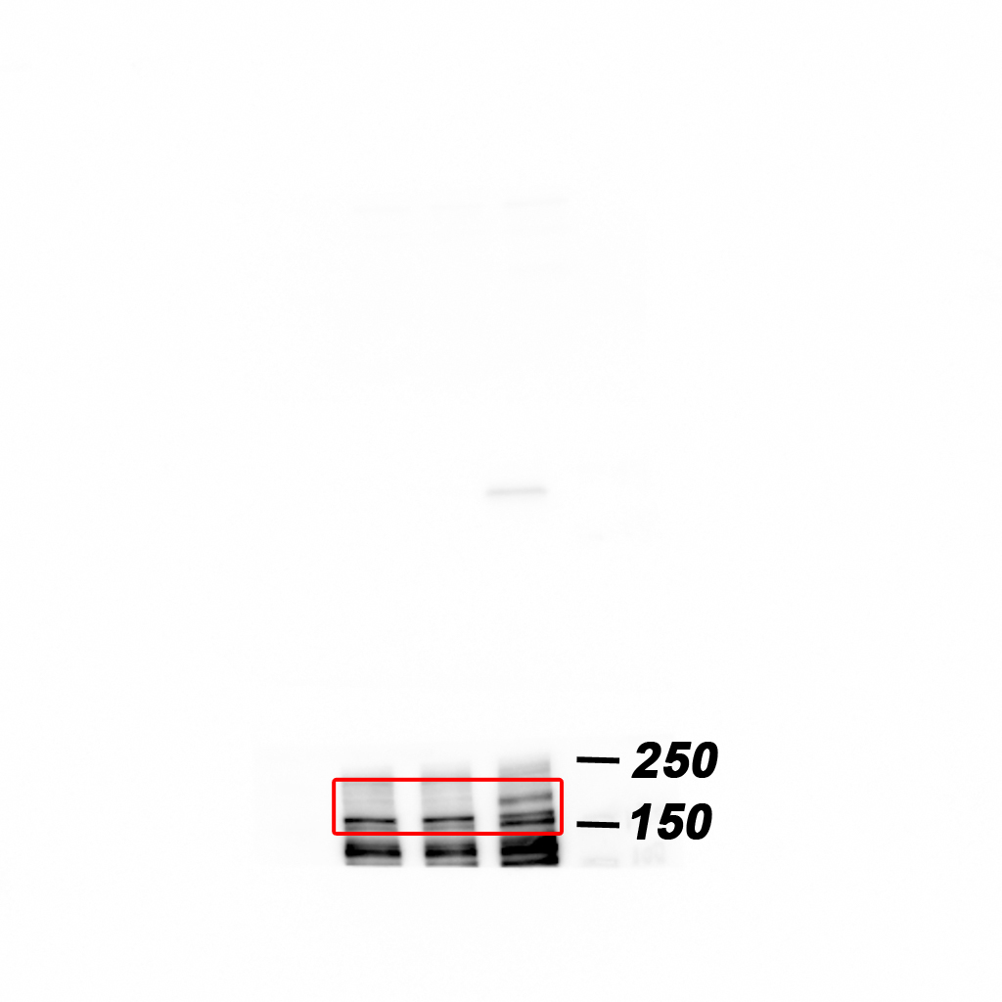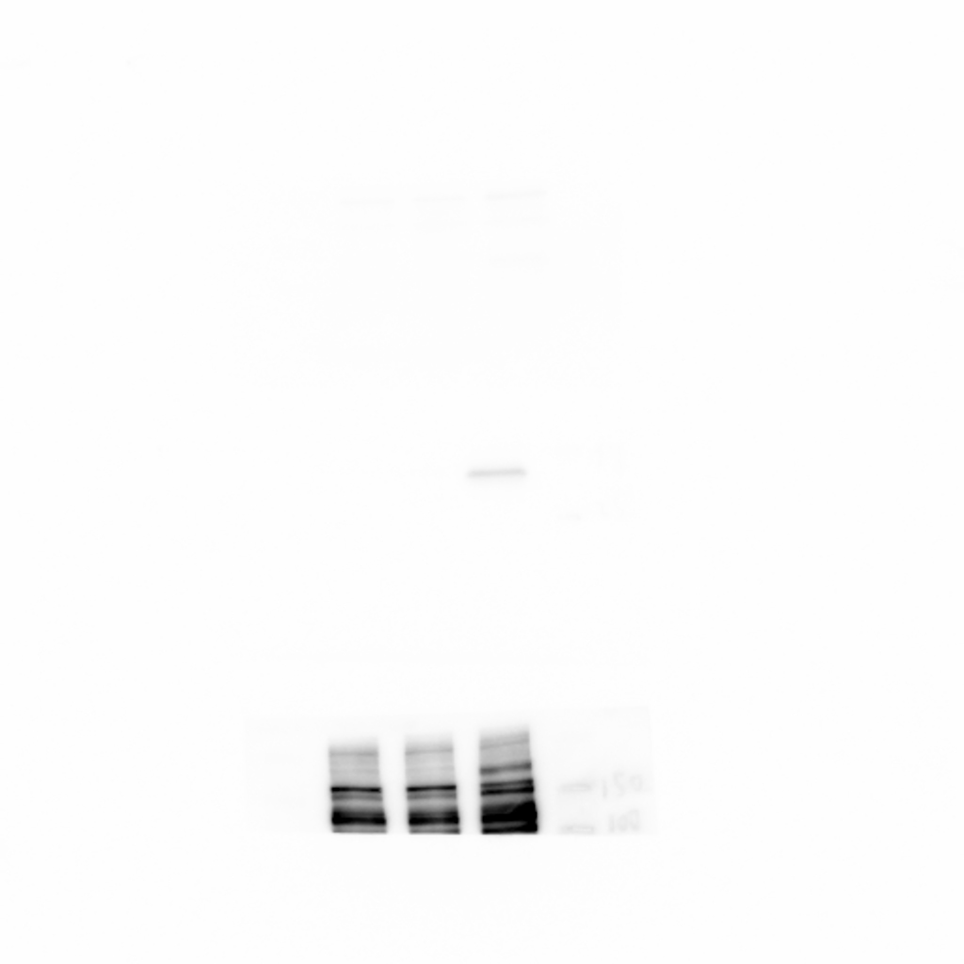
Western blot analysis of ZEB1 protein levels in MCF7 cells expressing either the control vector or HTR2C.

Figure 4C_HRT2C in MCF7_ source data
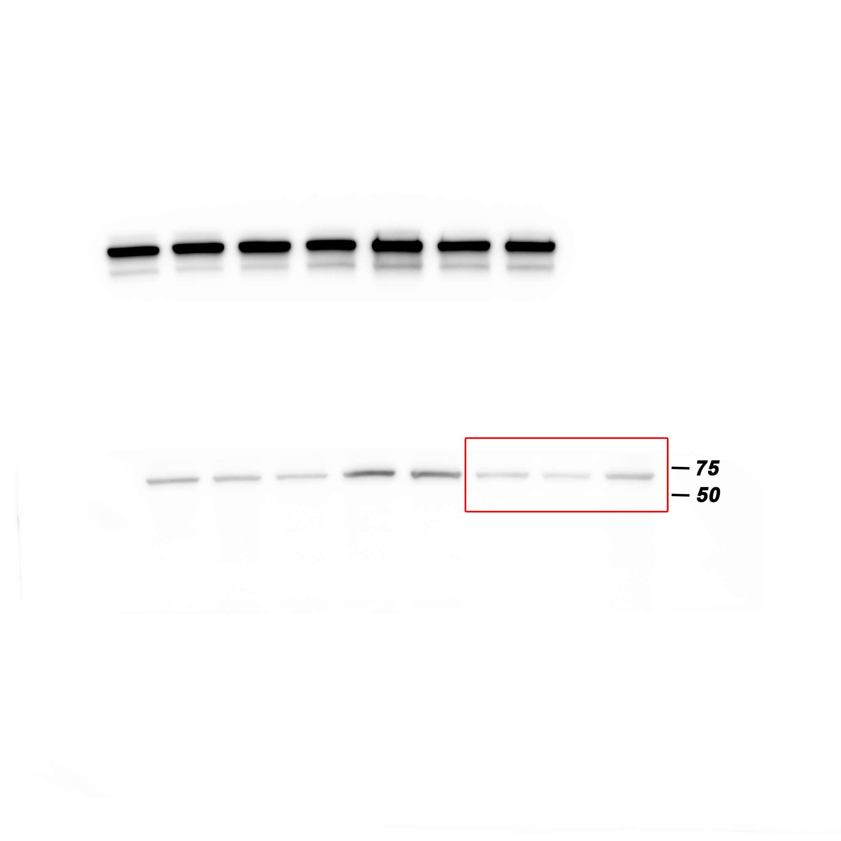
Western blot analysis of HRT2C protein levels in MCF7 cells expressing either the control vector or HTR2C.

Figure 4C_GAPDH in MCF7_source data
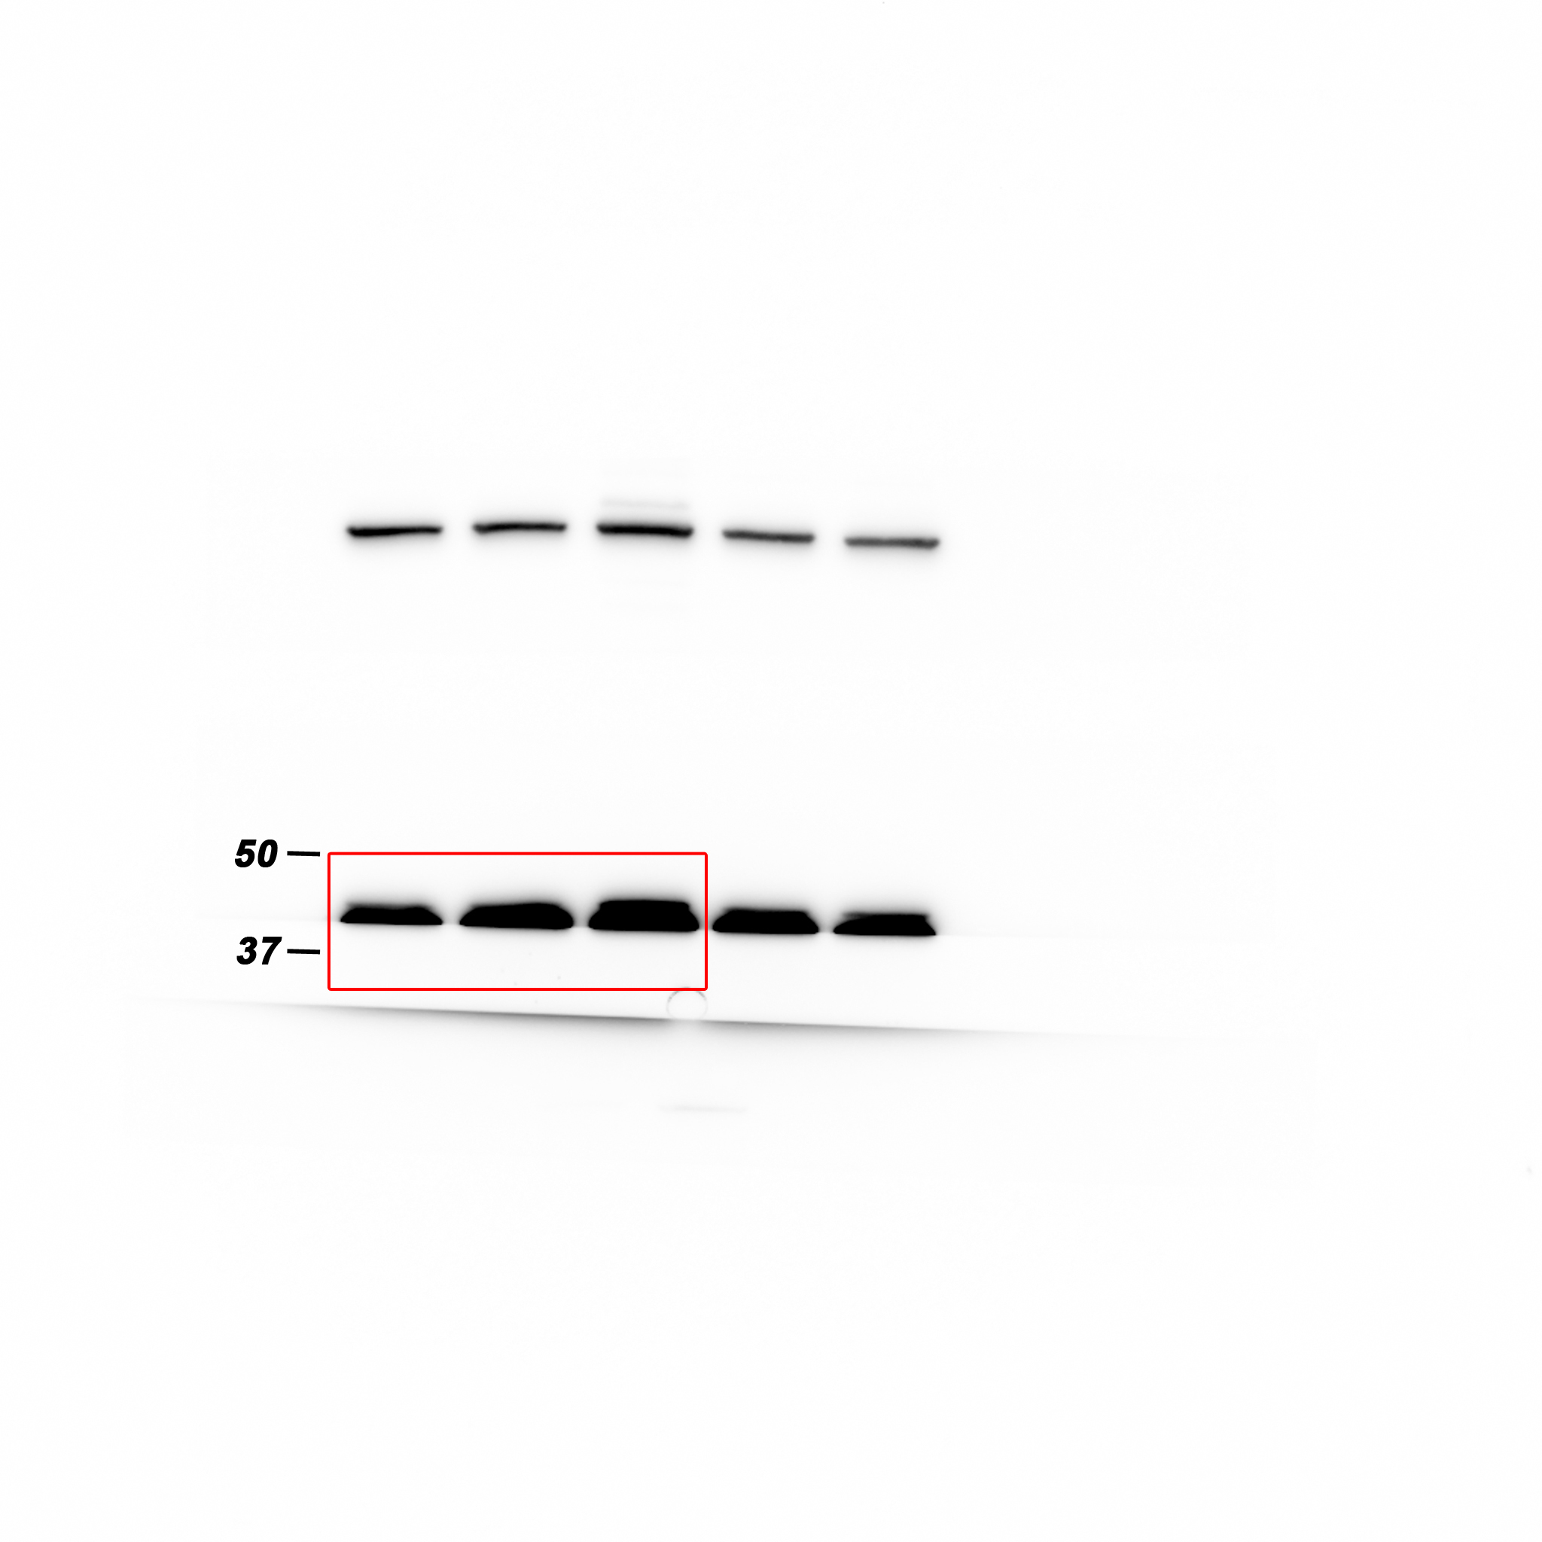
Western blot analysis of GAPDH protein levels in MCF7 cells expressing either the control vector or HTR2C.

Figure 4C_E-cadherin in HaCaT_source data
Western blot analysis of E-cadherin protein levels in HaCaT cells expressing either the control vector or HTR2C.

Figure 4C_EpCAM in HaCaT_source data
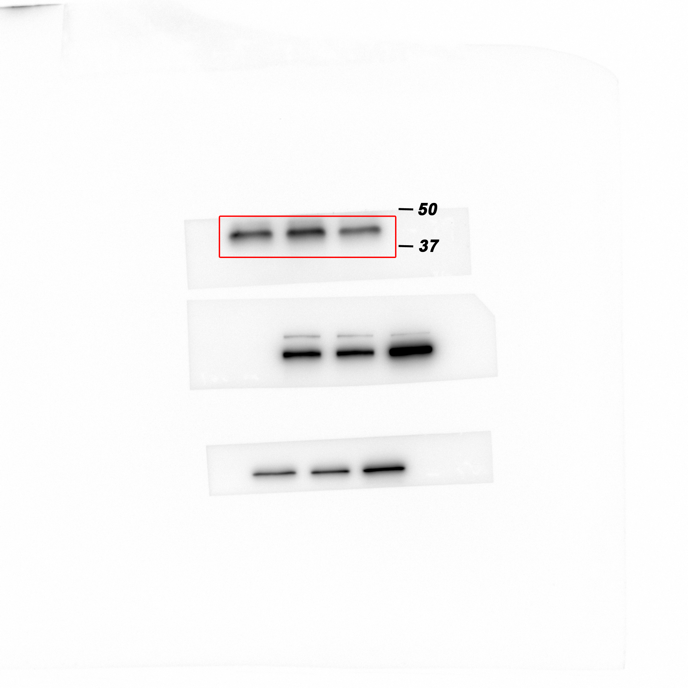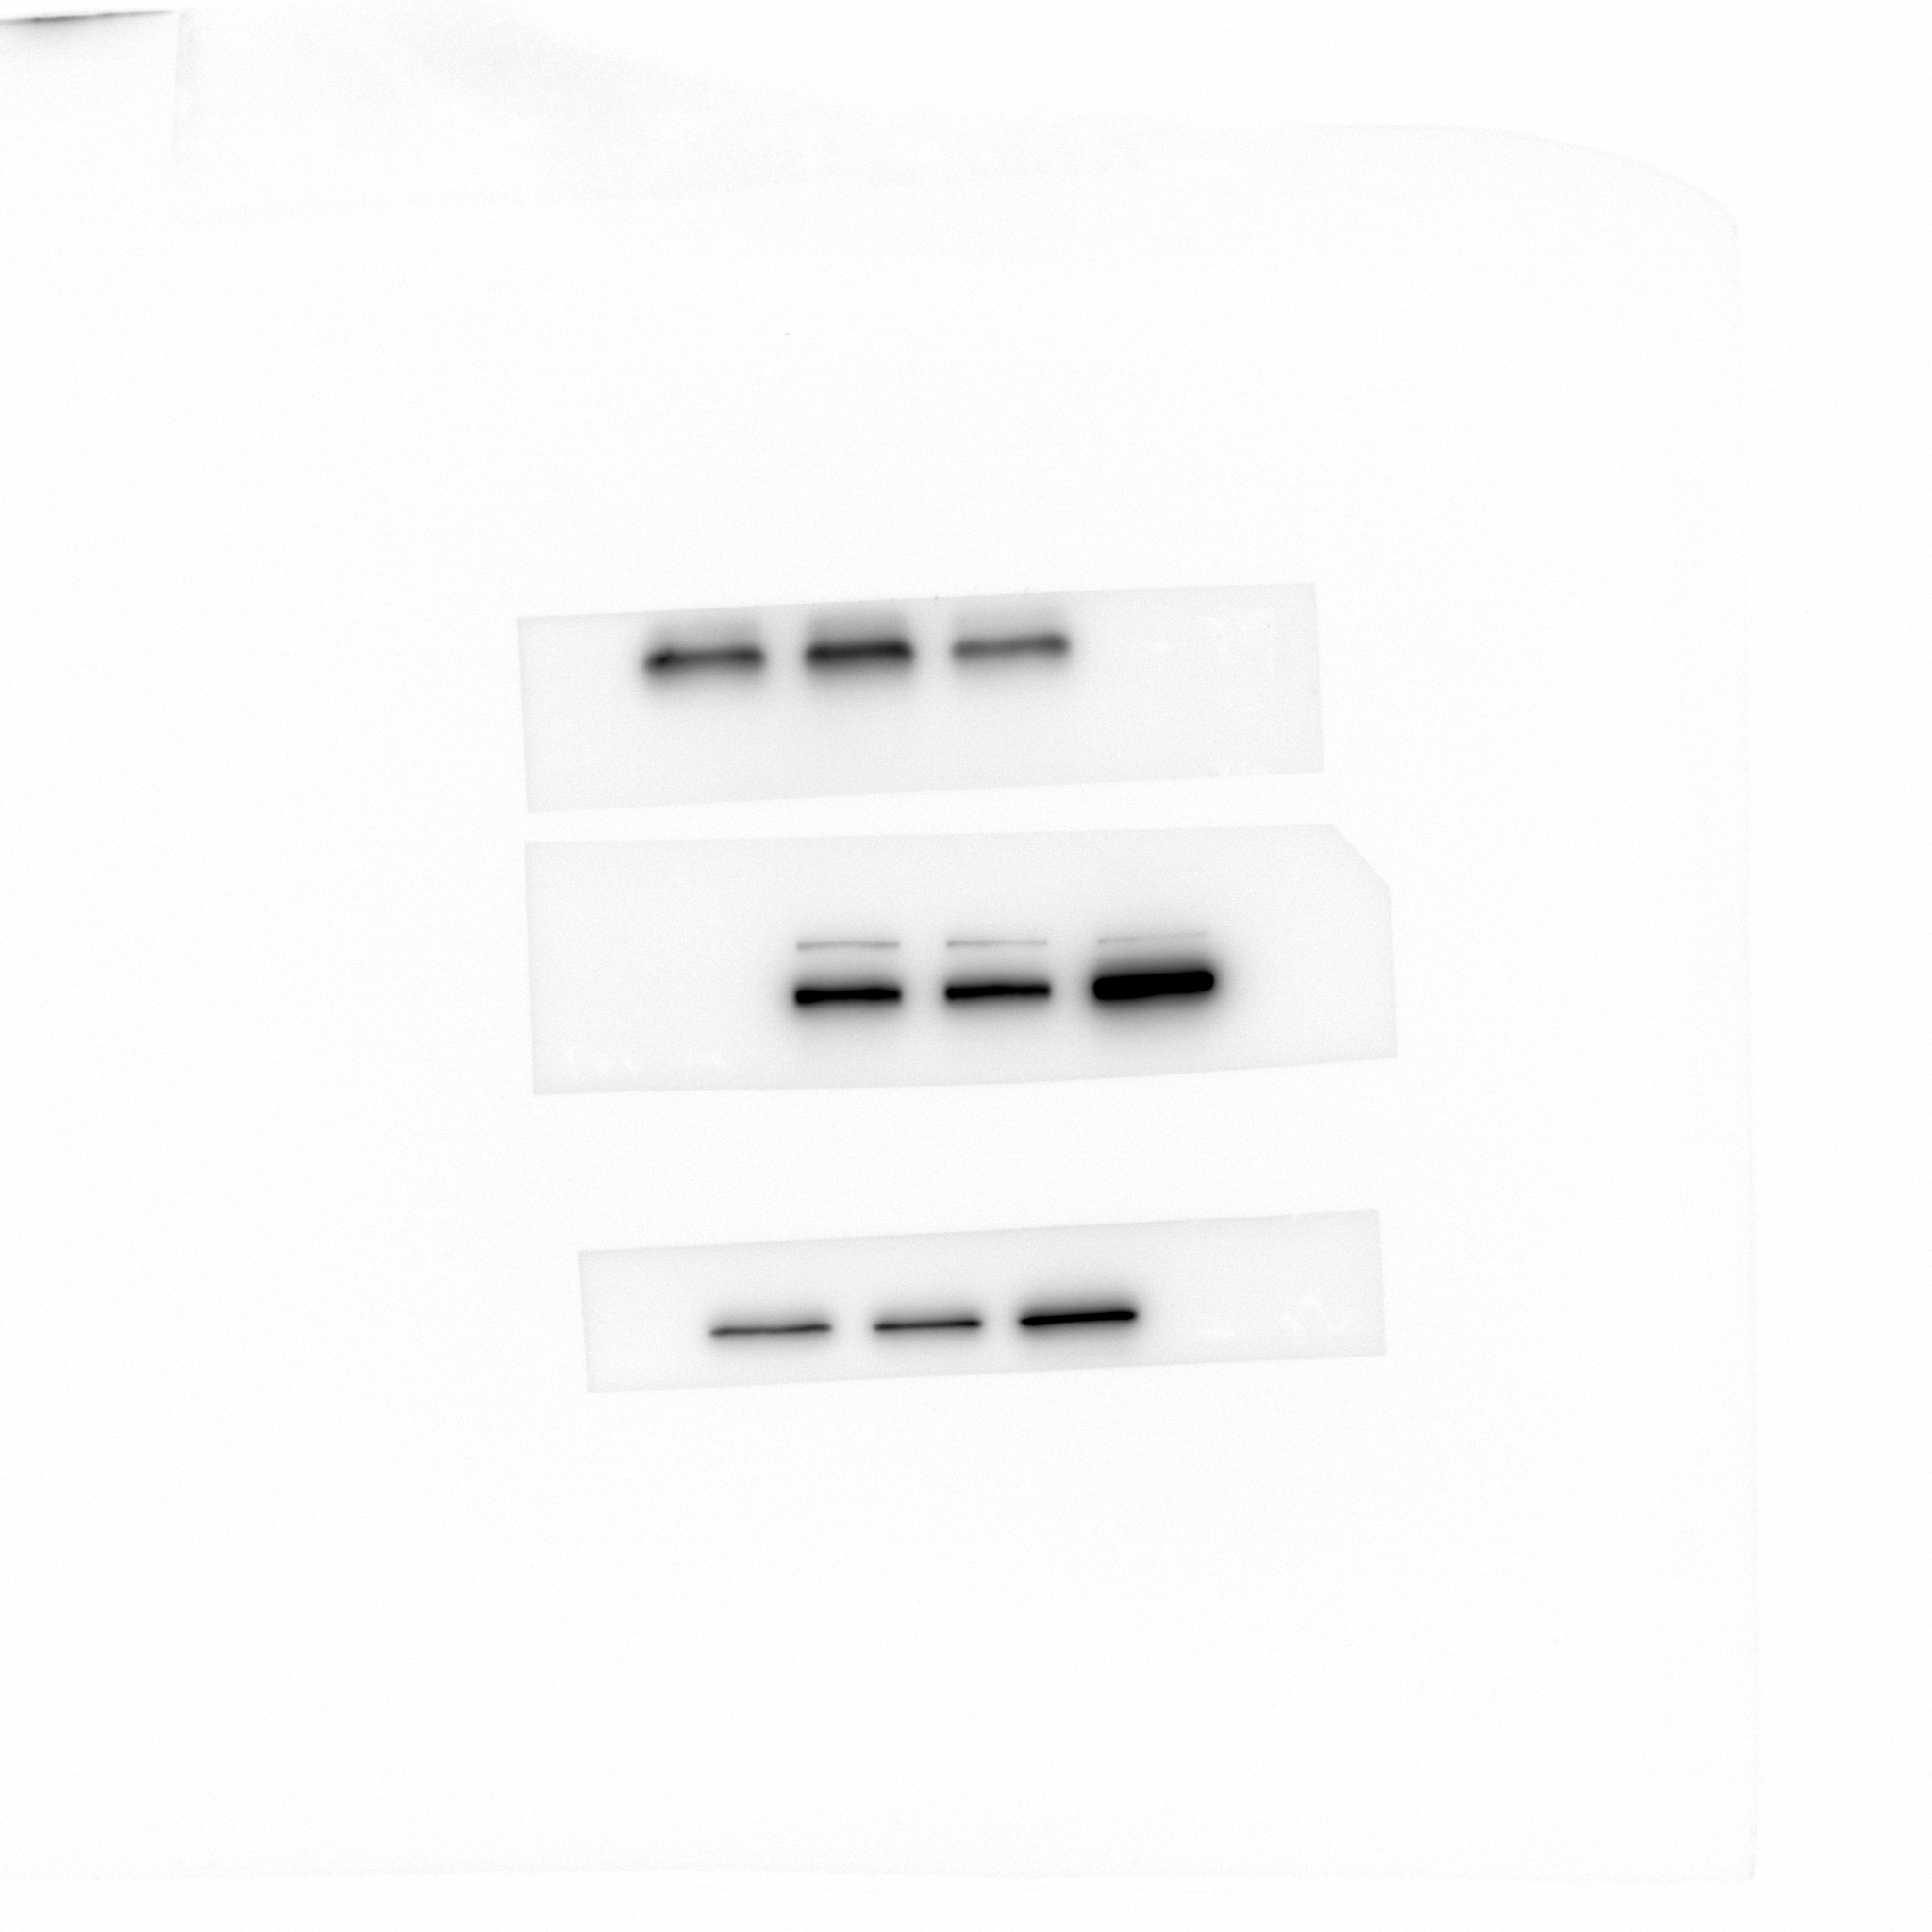
Western blot analysis of EpCAM protein levels in HaCaT cells expressing either the control vector or HTR2C.

Figure 4C_Vimentin in HaCaT_source data
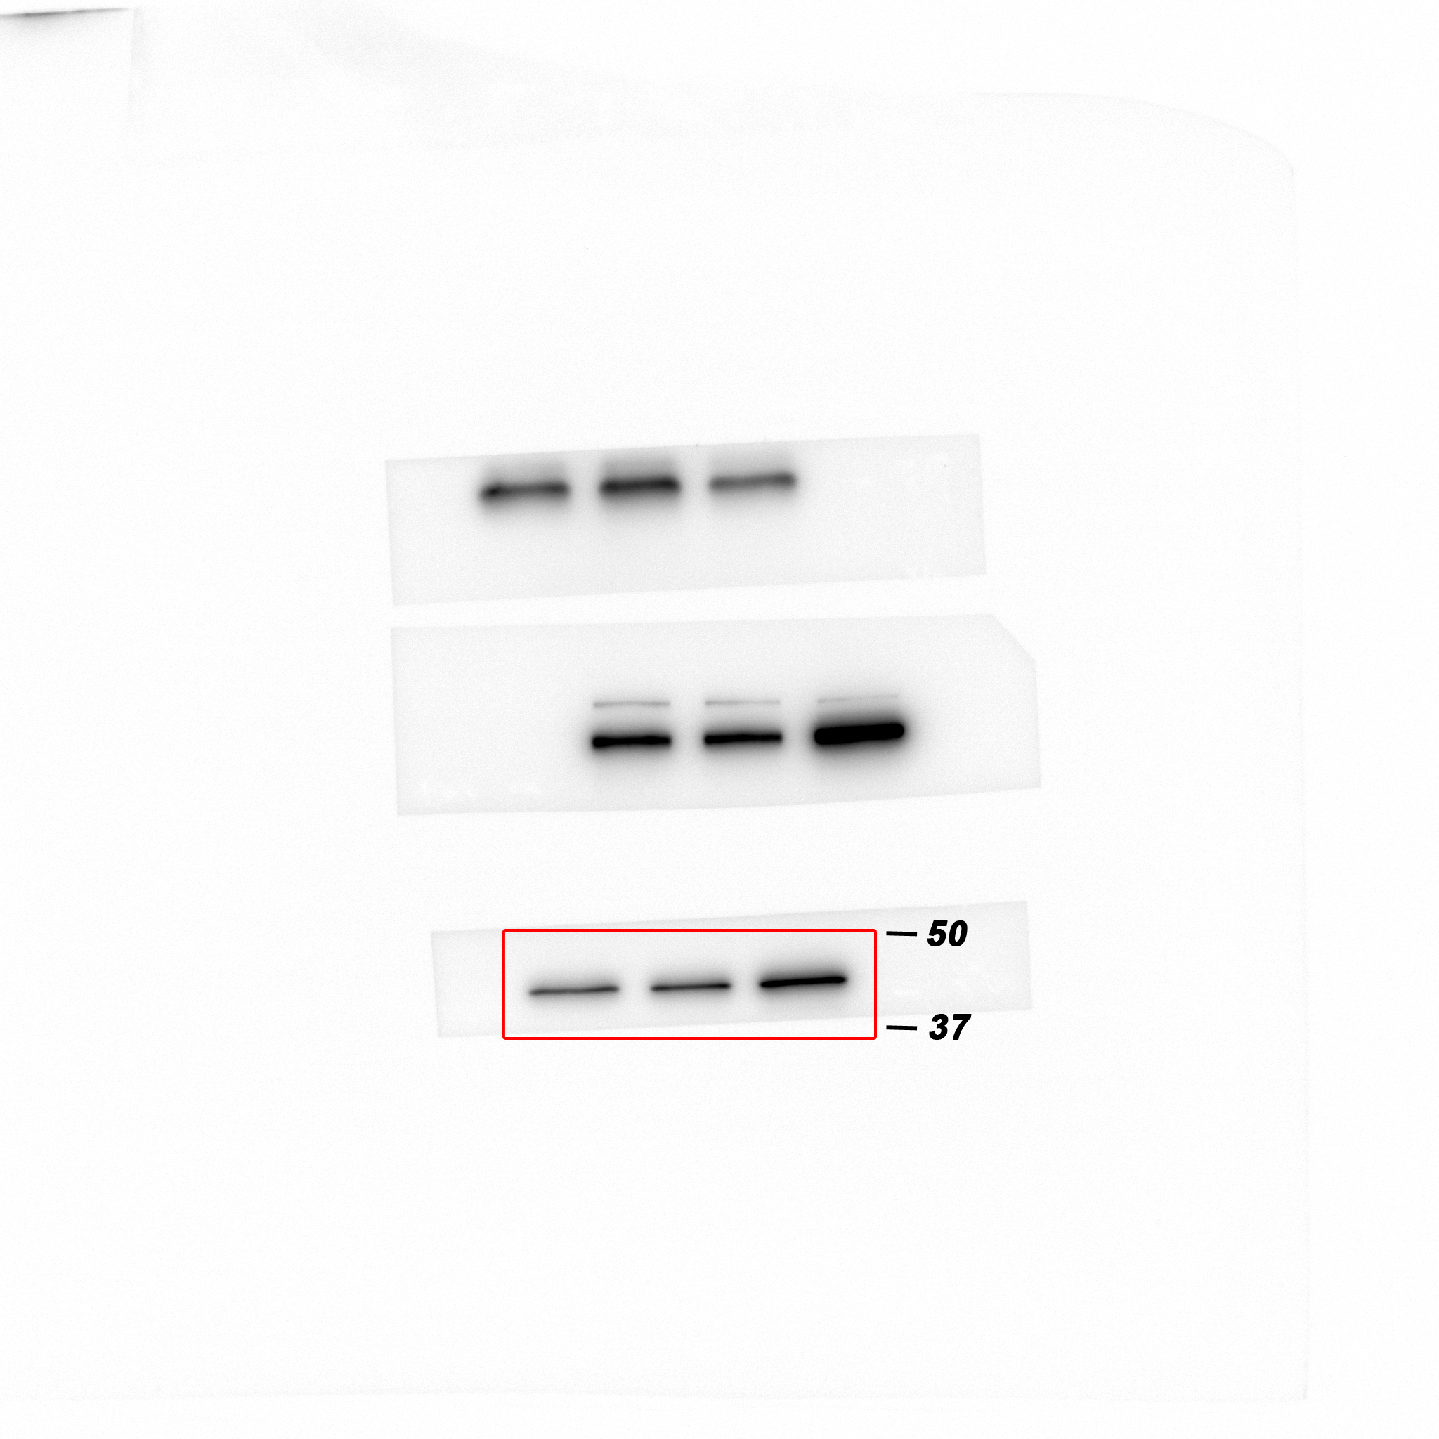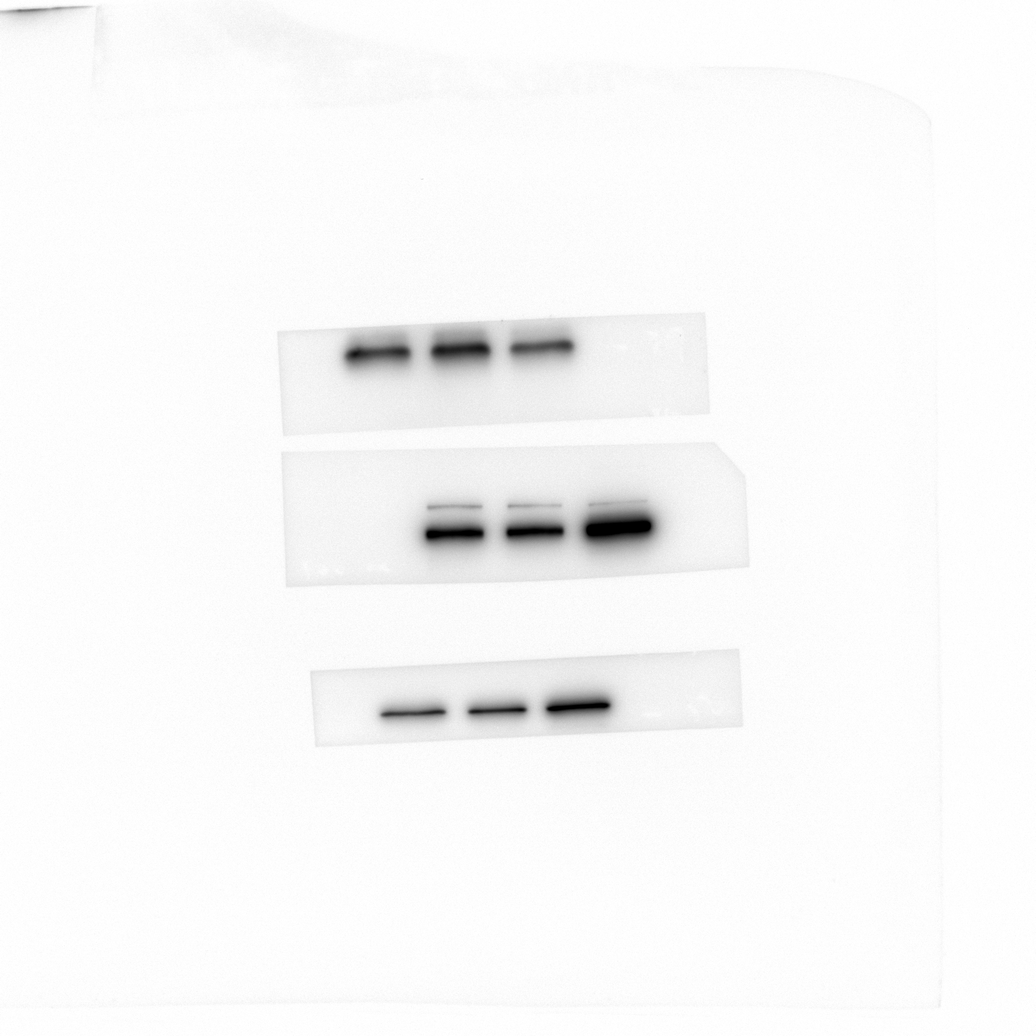
Western blot analysis of Vimentin protein levels in HaCaT cells expressing either the control vector or HTR2C.

Figure 4C_N-cadherin in HaCaT_source data
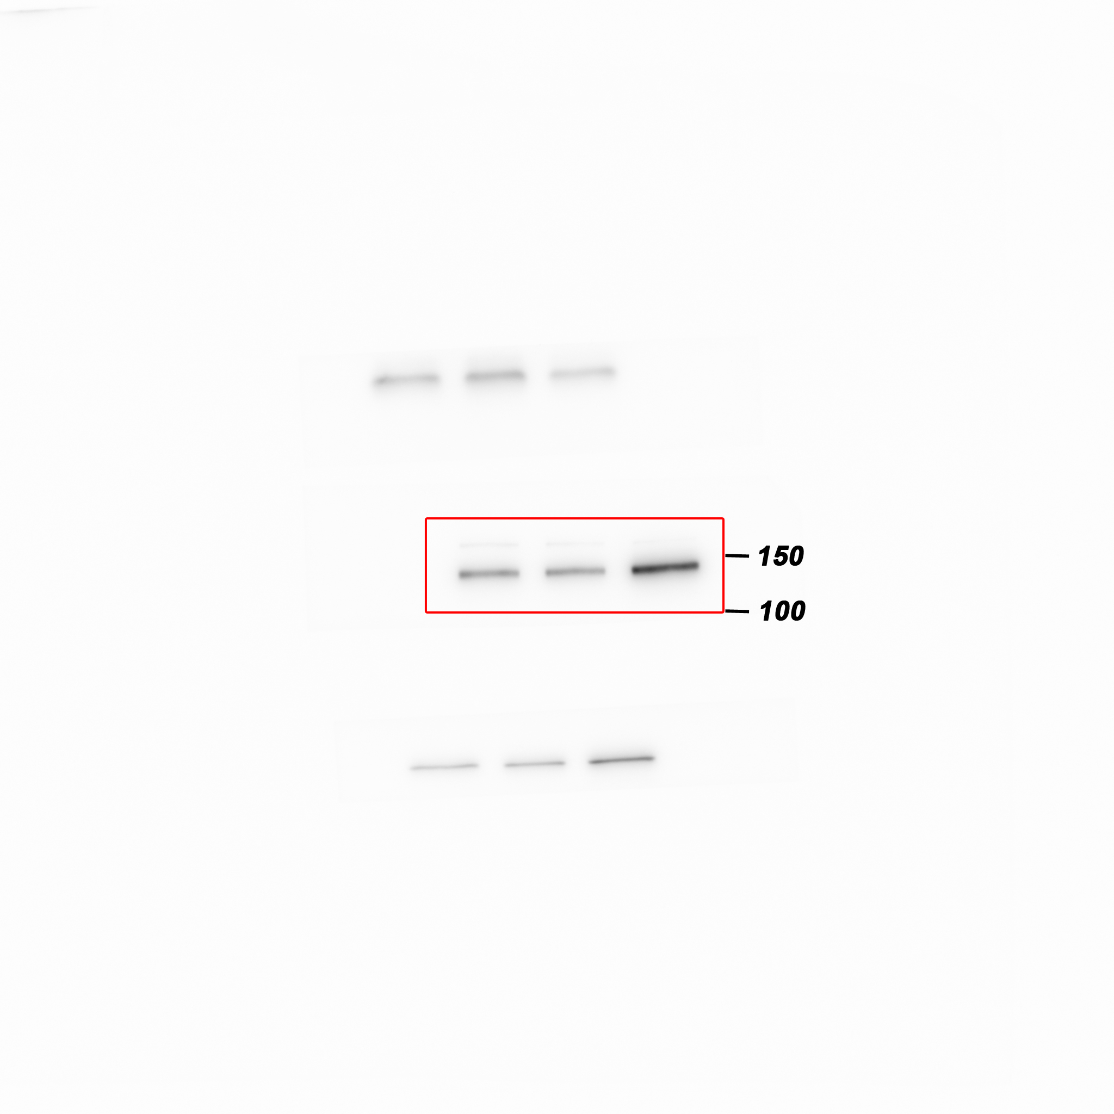
Western blot analysis of N-cadherin protein levels in HaCaT cells expressing either the control vector or HTR2C.

Figure 4C_ZEB1 in HaCaT source data
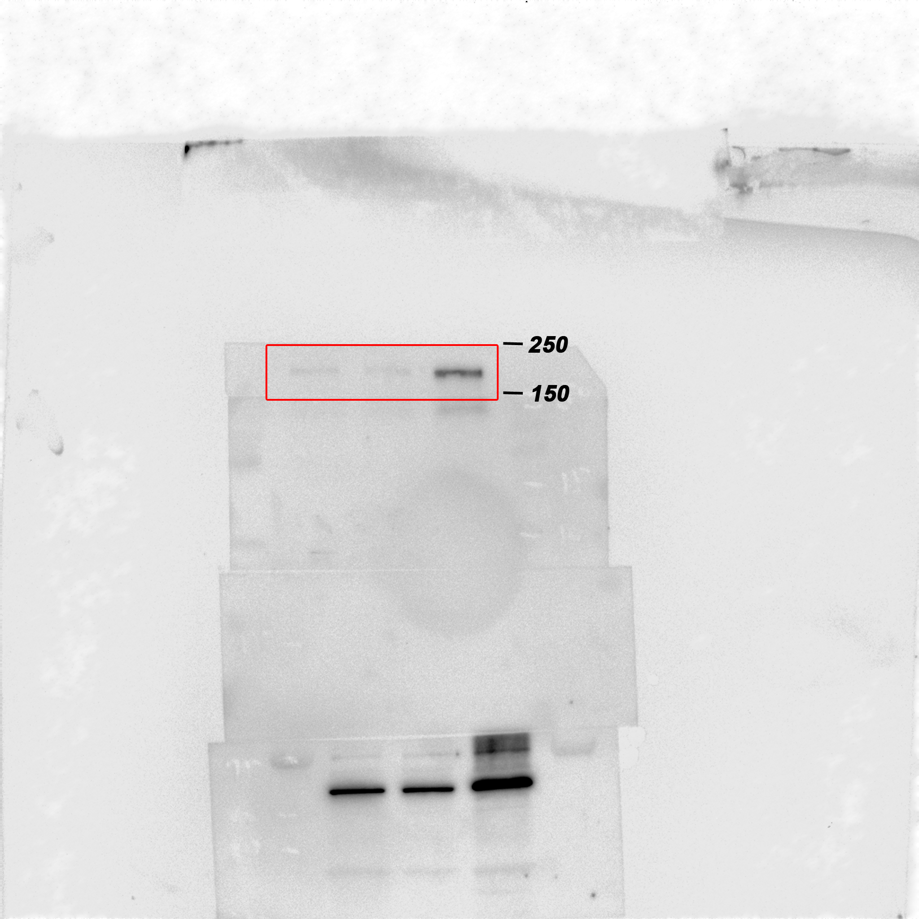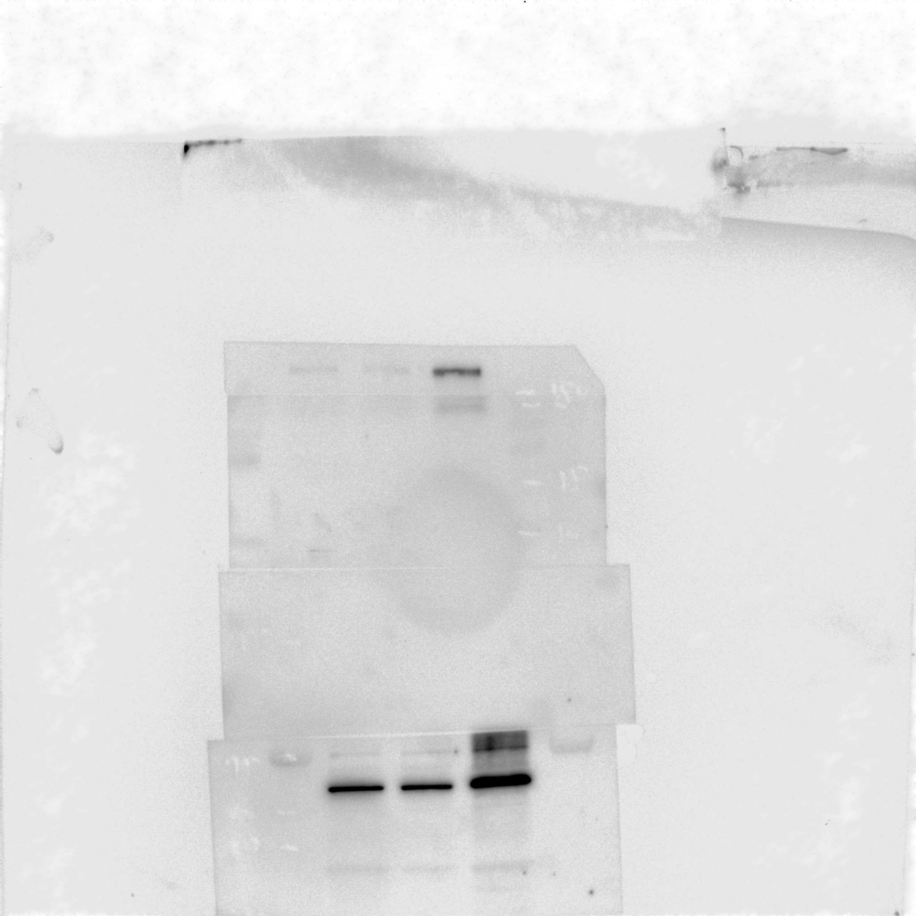
Western blot analysis of ZEB1 protein levels in HaCaT cells expressing either the control vector or HTR2C.

Figure 4C_HRT2C in HaCaT_source data
Western blot analysis of HRT2C protein levels in HaCaT cells expressing either the control vector or HTR2C.

Figure 4C_GAPDH in HaCaT_source data
Western blot analysis of GAPDH protein levels in HaCaT cells expressing either the control vector or HTR2C.

Figure 5C_E-cadherin_source data
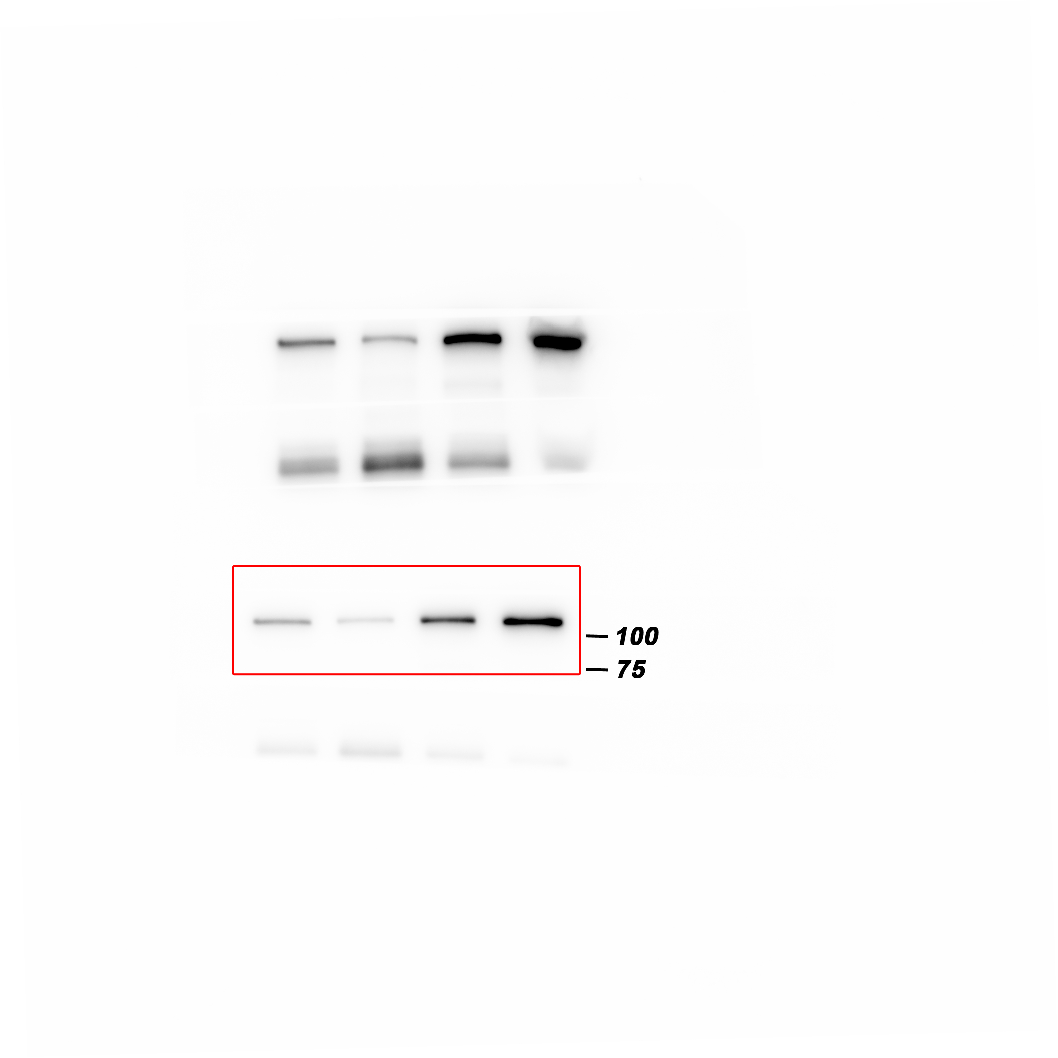
Western blot analysis of E-cadherin protein levels in whole cell lysate of 4T1 primary tumors from either vehicle or Pizotifen-treated mice.

Figure 5C_ZEB1 _source data
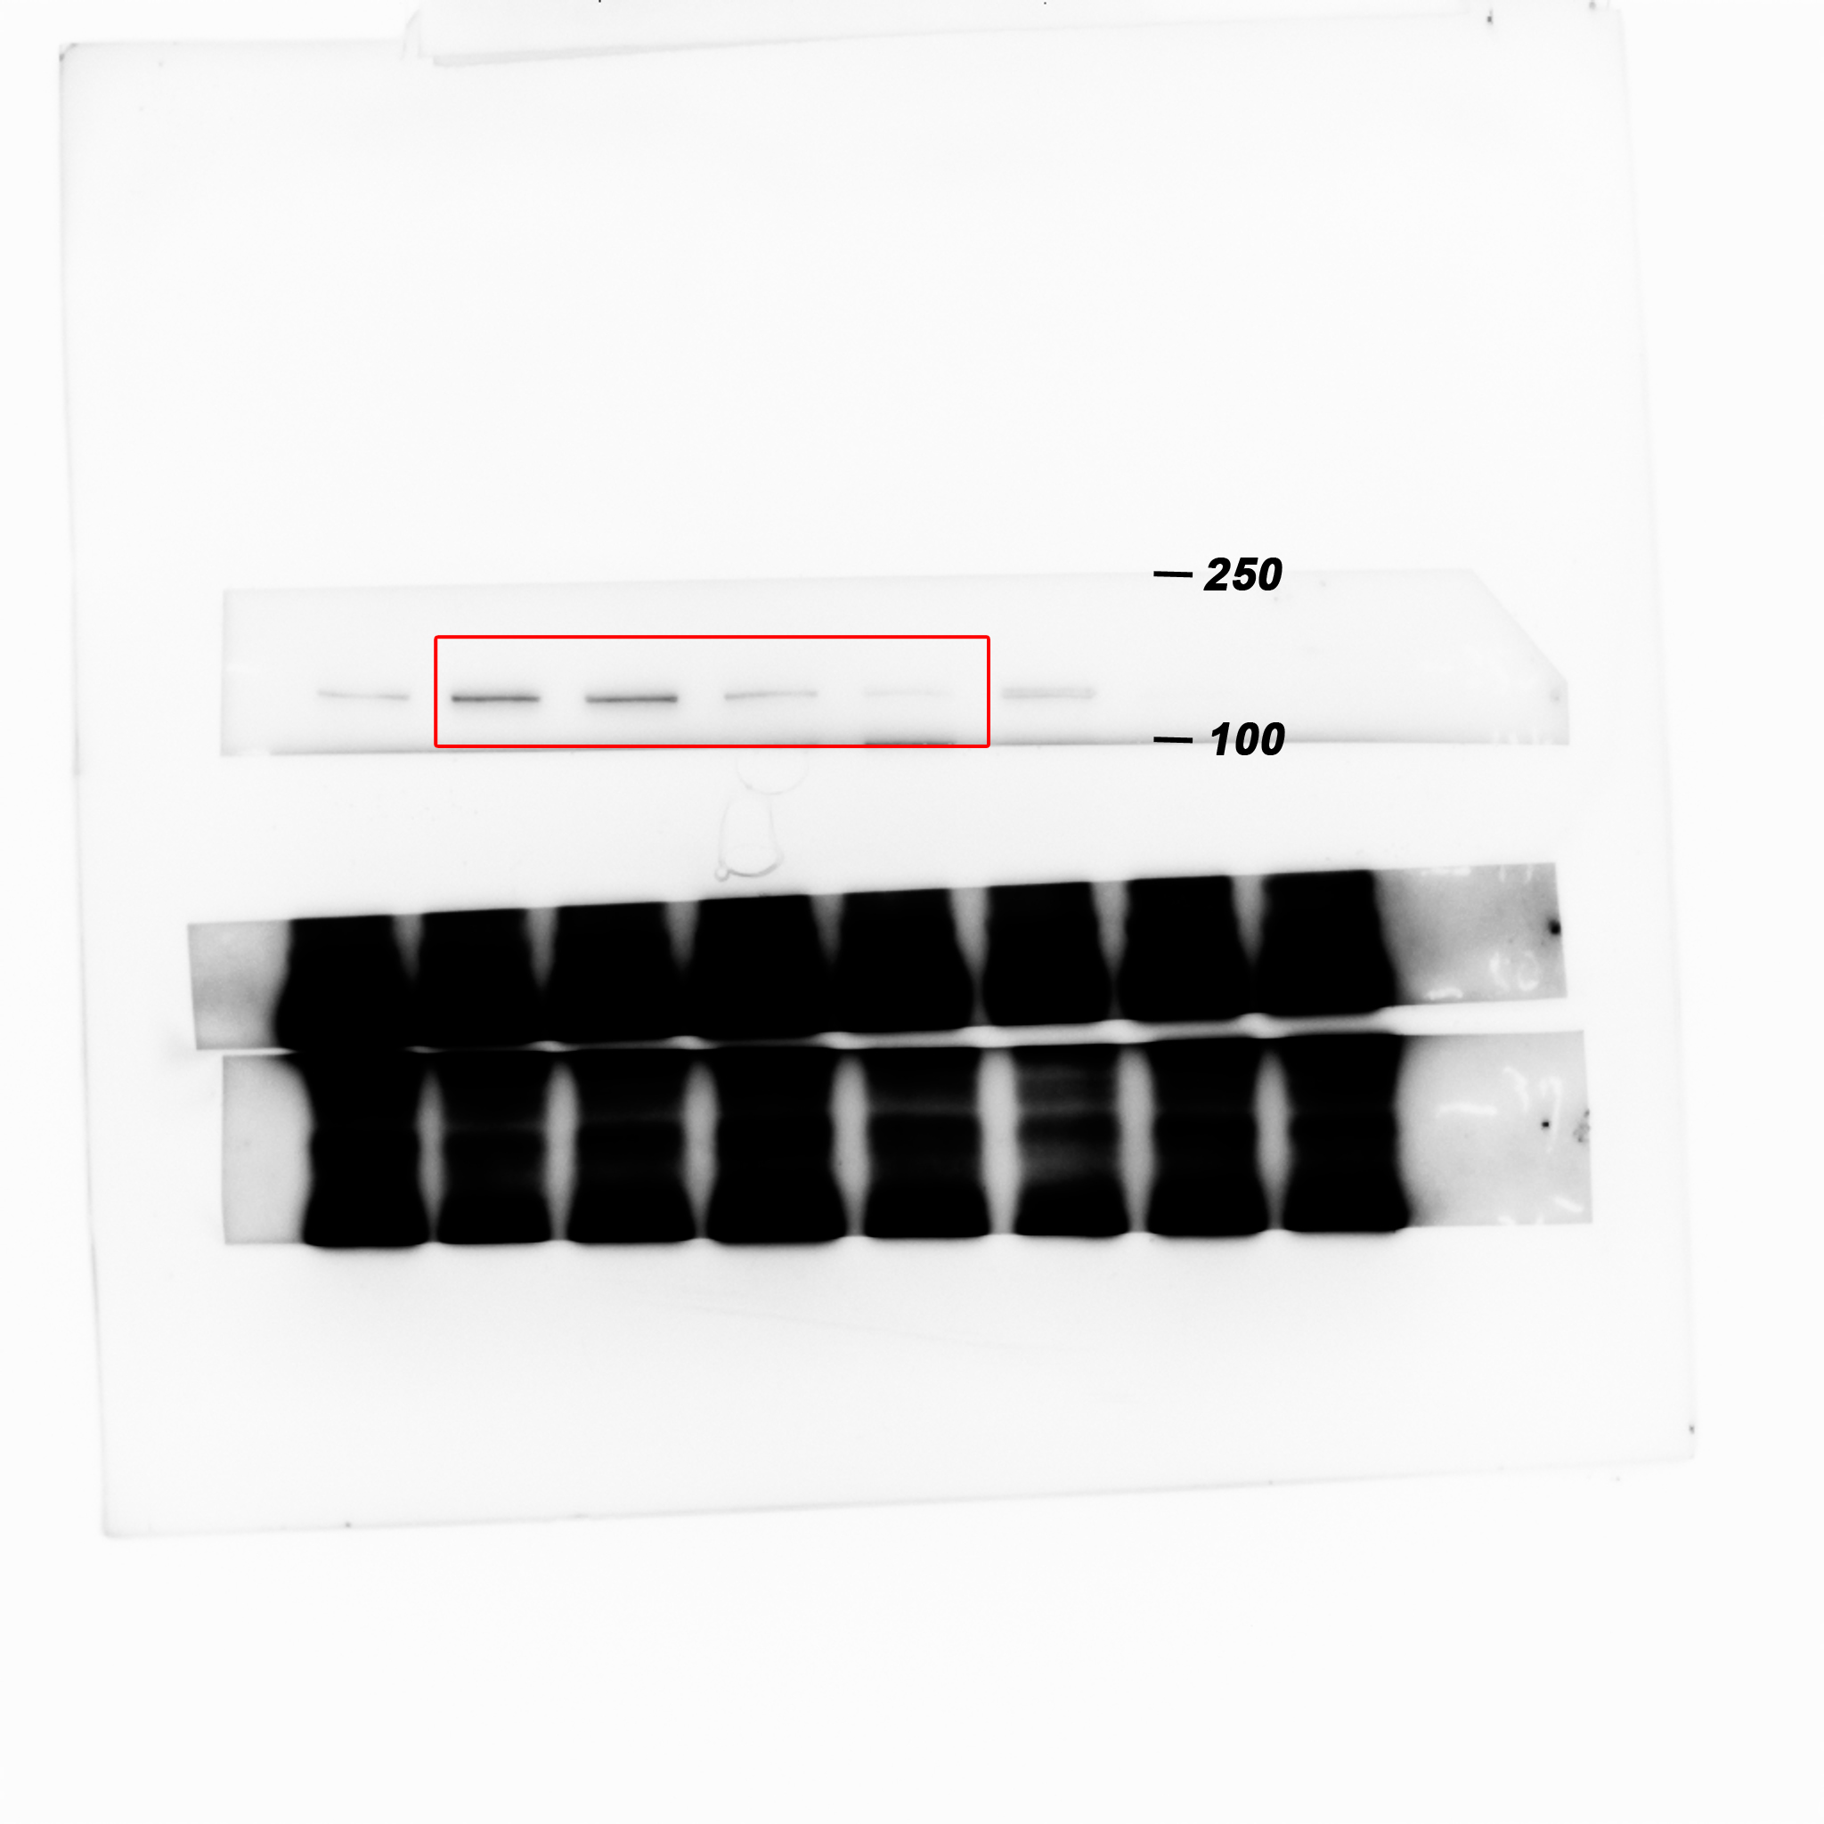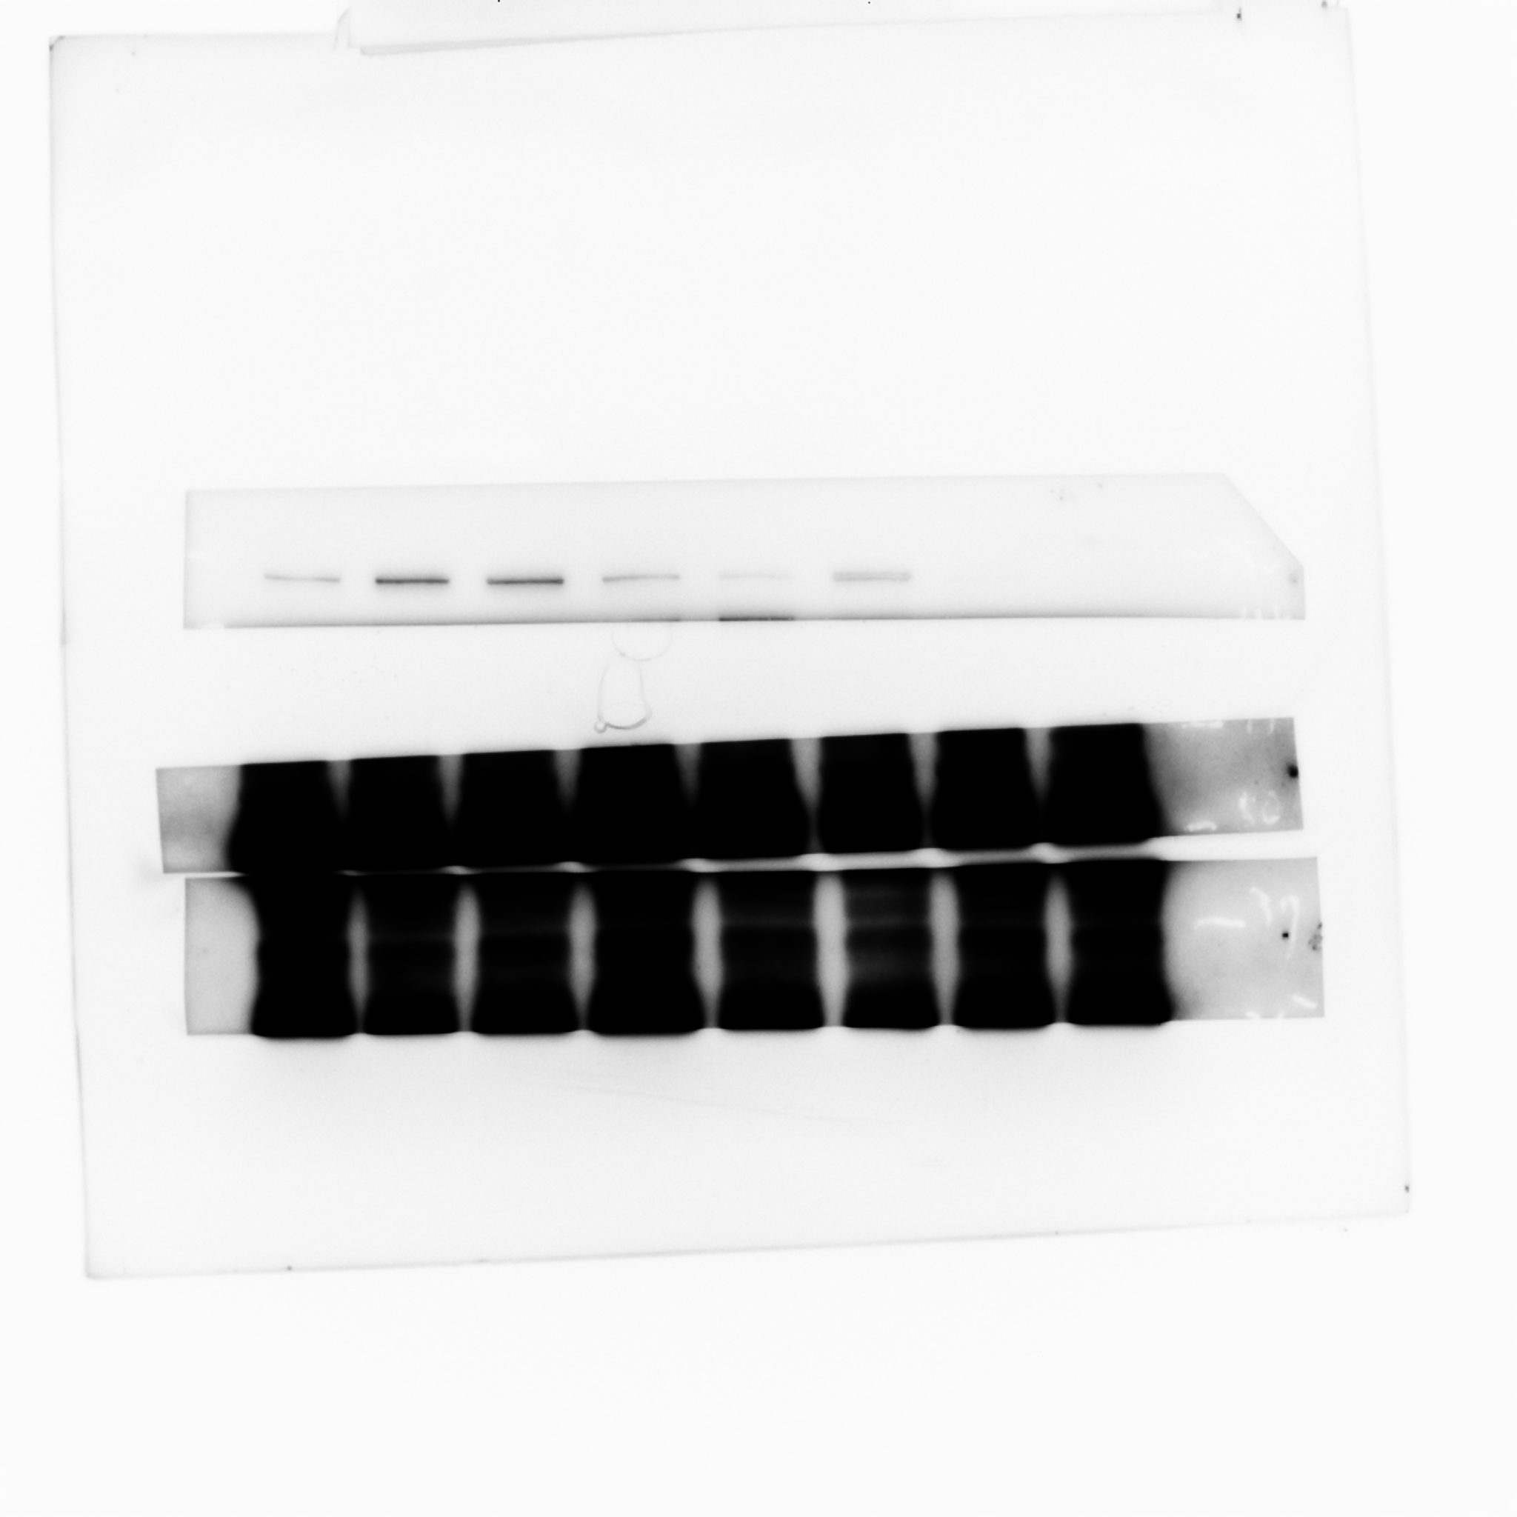
Western blot analysis of ZEB1 protein levels in whole cell lysate of 4T1 primary tumors from either vehicle or Pizotifen-treated mice.

Figure 5C_ Phosphorylation of serine-9 in GSK3β_source data
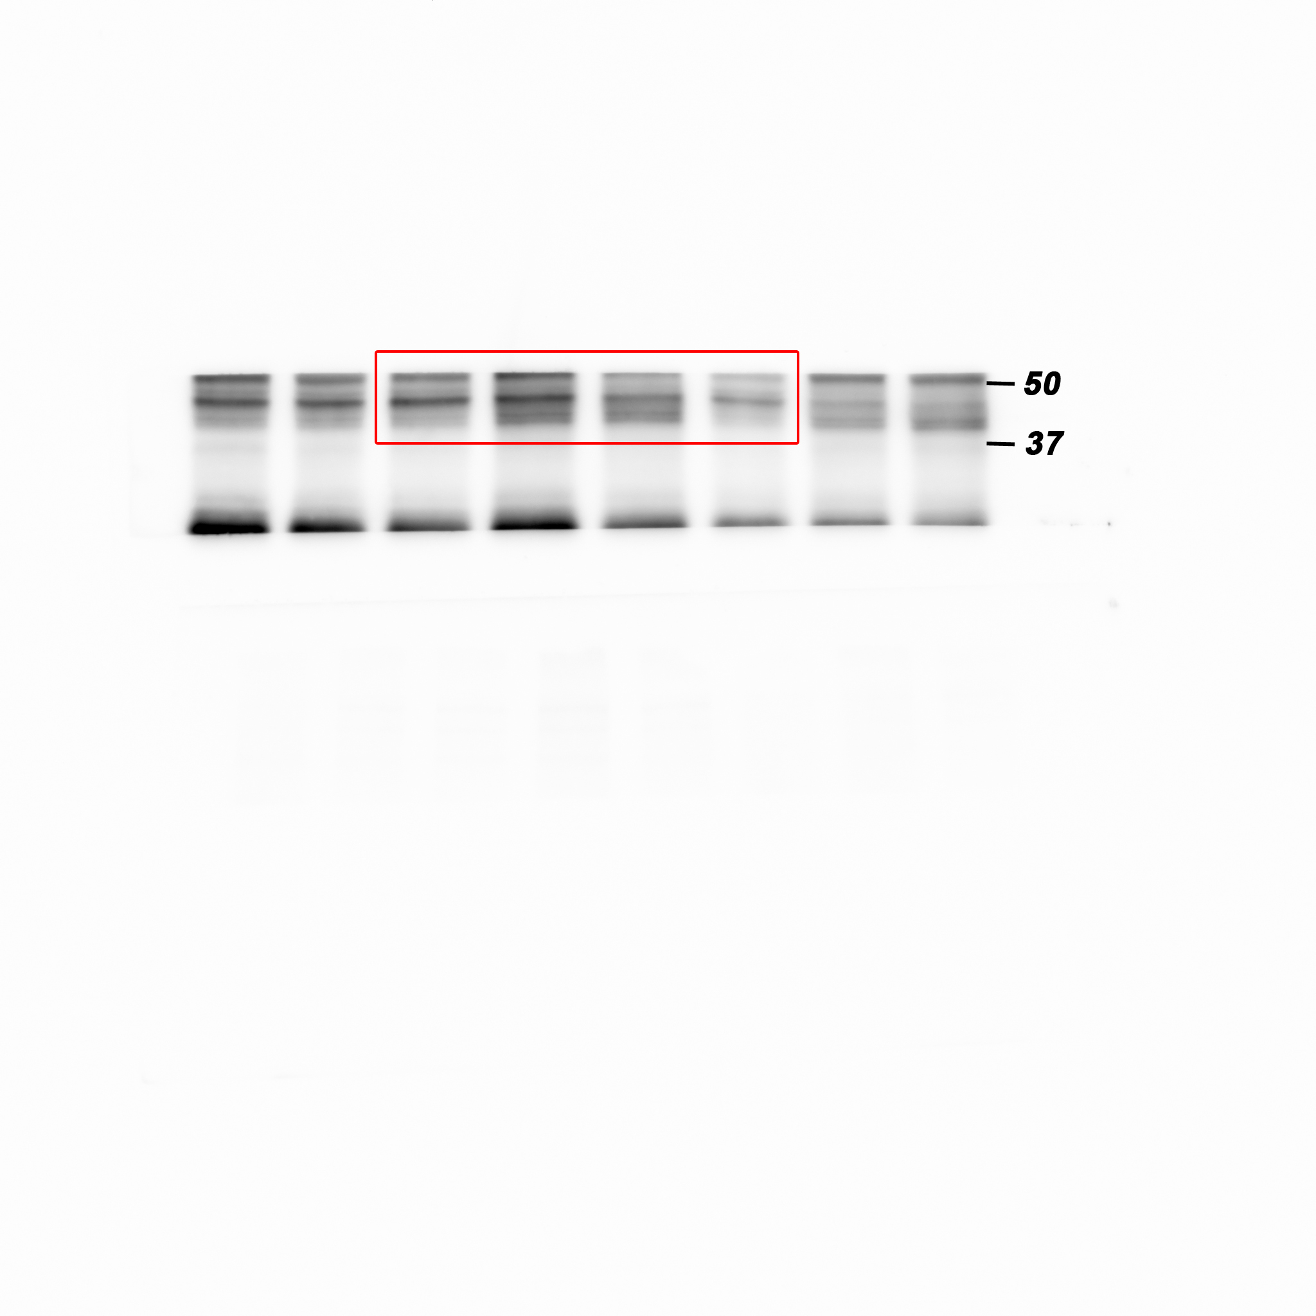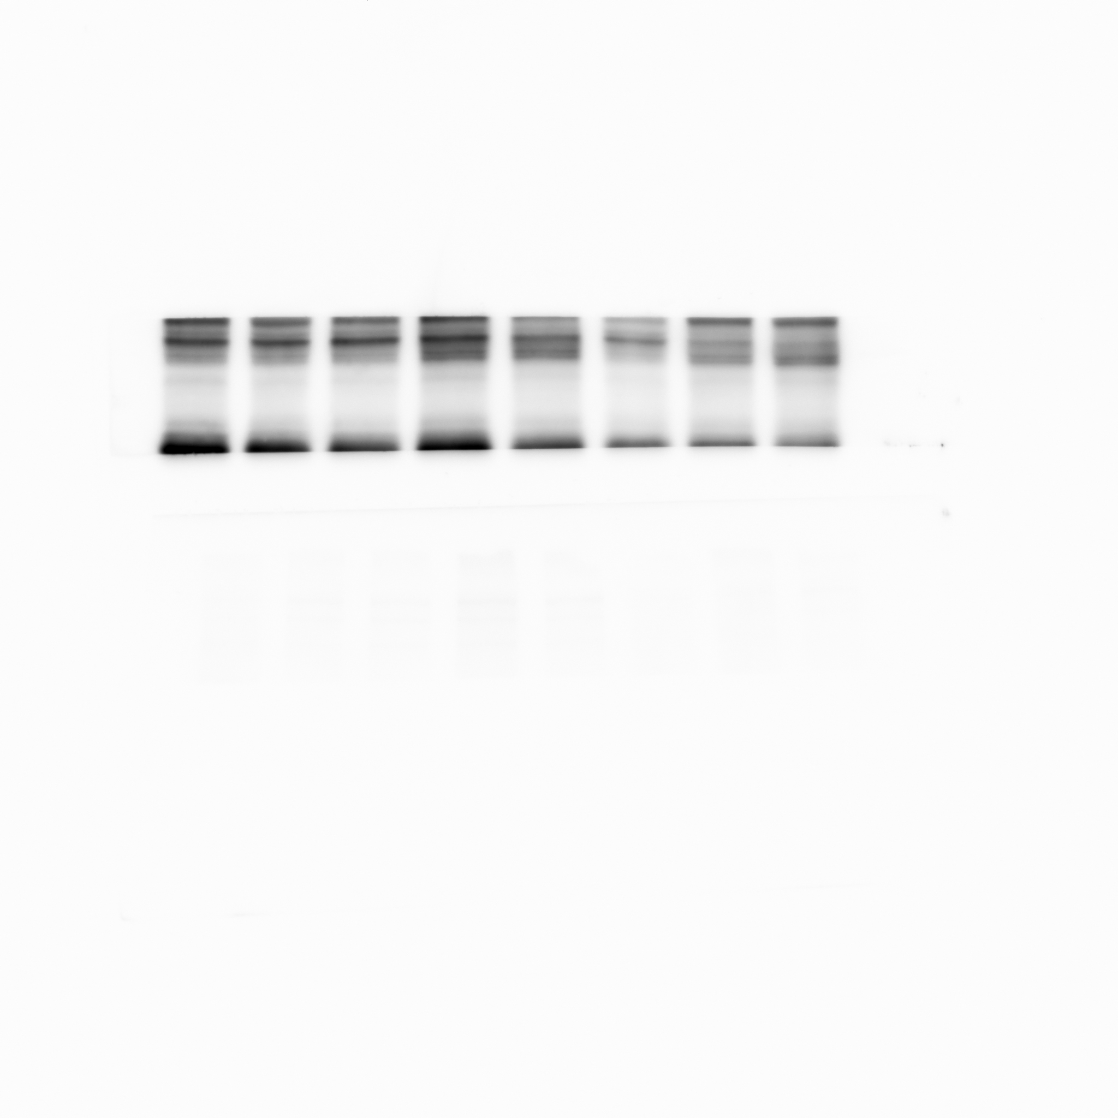
Western blot analysis of the protein levels of phosphorylation of serine-9 in GSK3β in whole cell lysate of 4T1 primary tumors from either vehicle or Pizotifen-treated mice.

Figure 5C_ GSK3β_source data
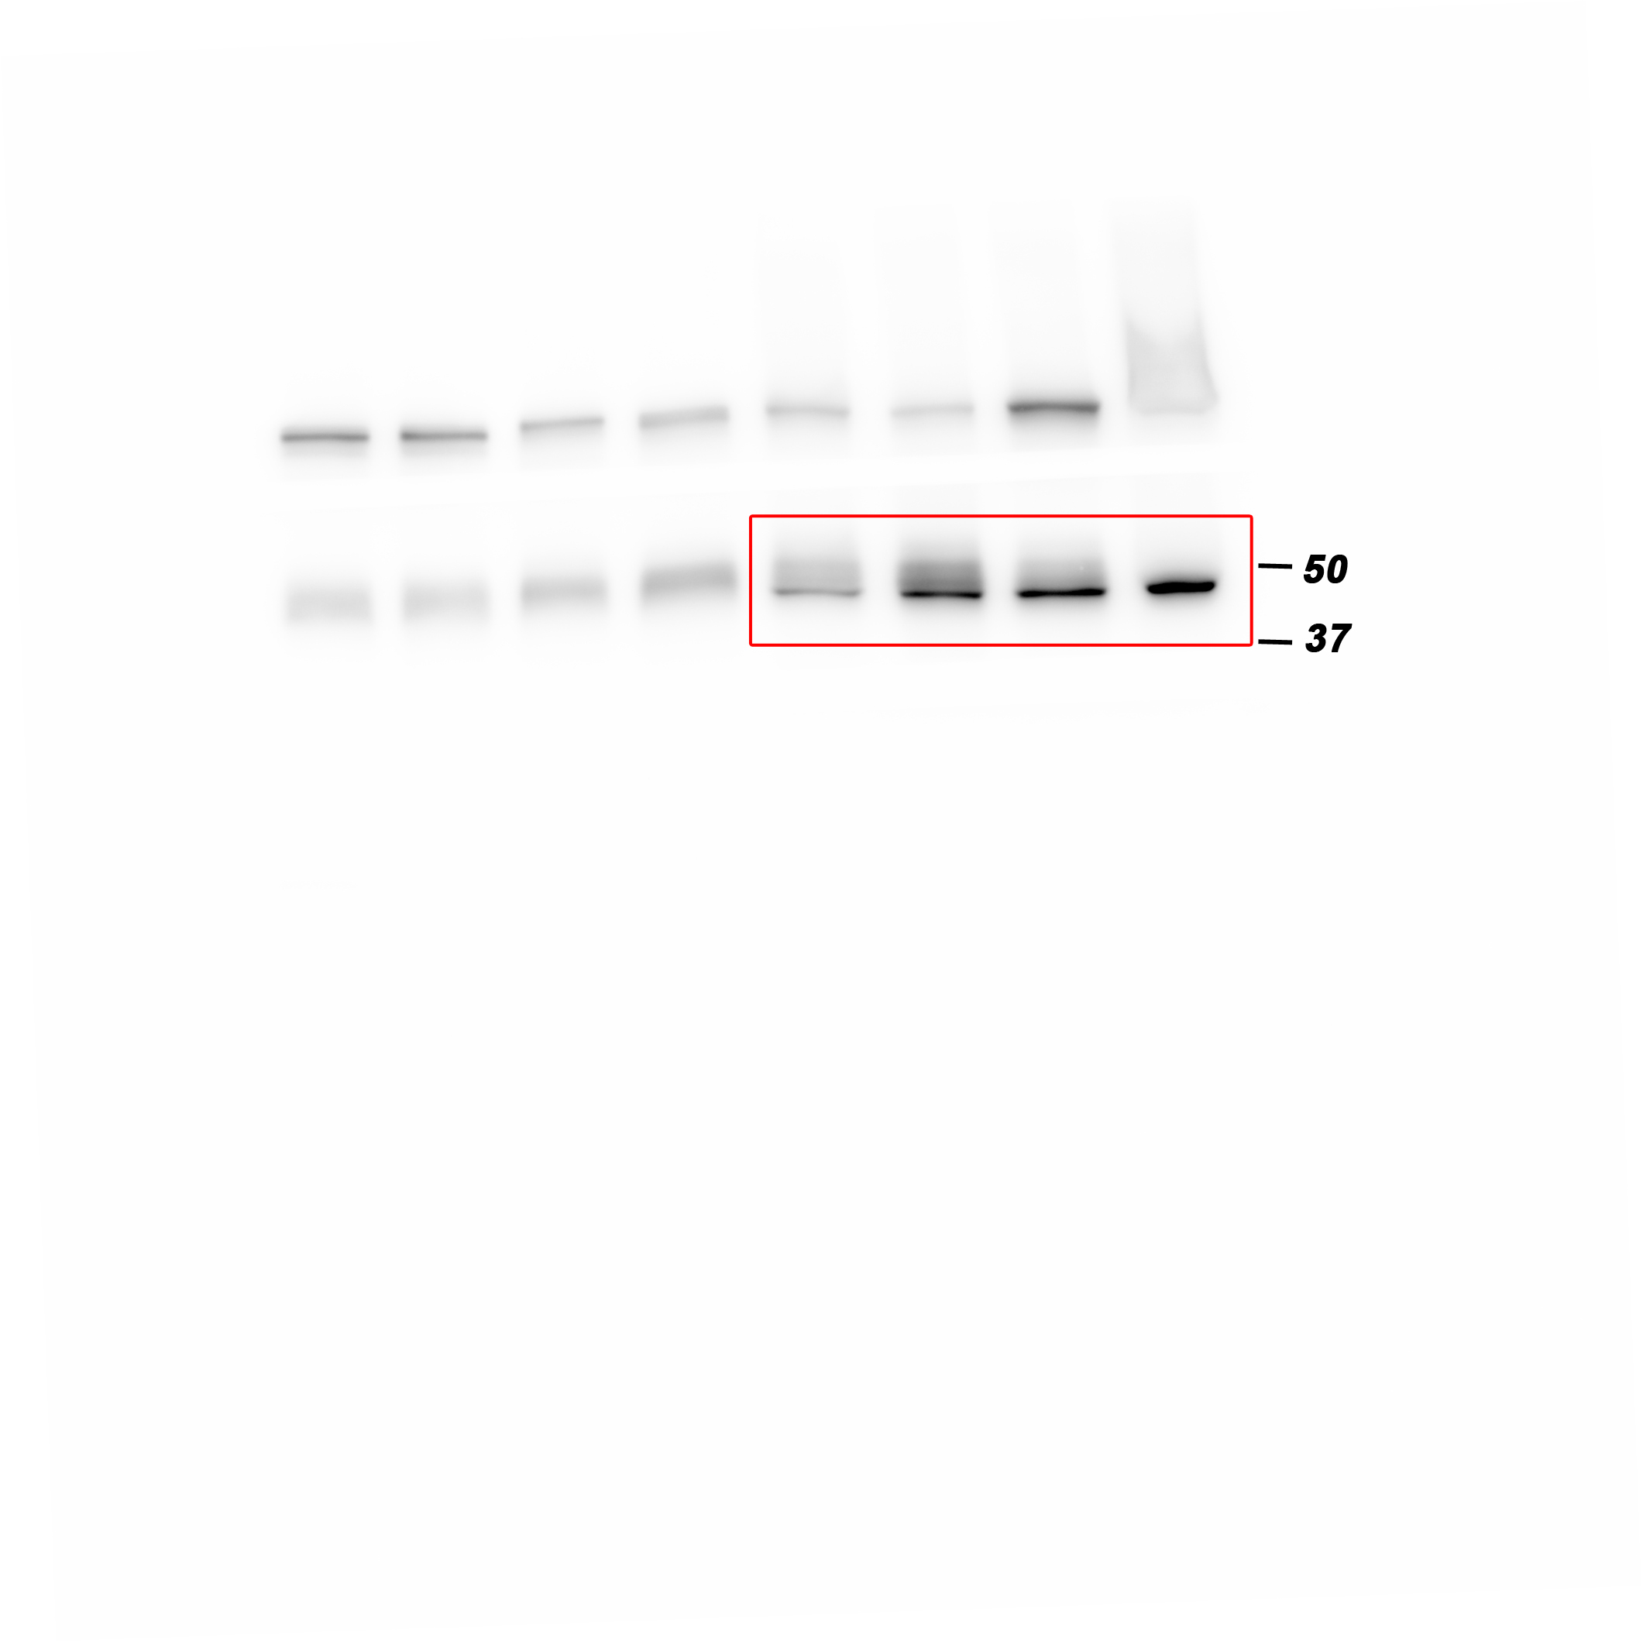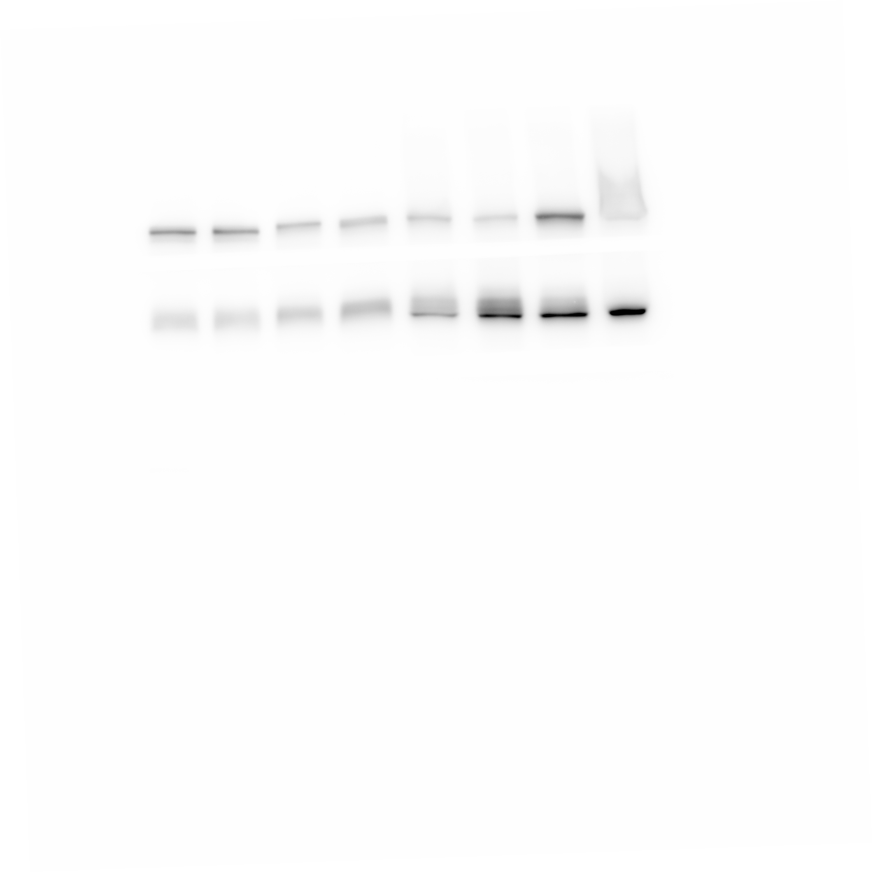
Western blot analysis of GSK3β protein levels in whole cell lysate of 4T1 primary tumors from either vehicle or Pizotifen-treated mice.

Figure 5C_Luciferase_source data
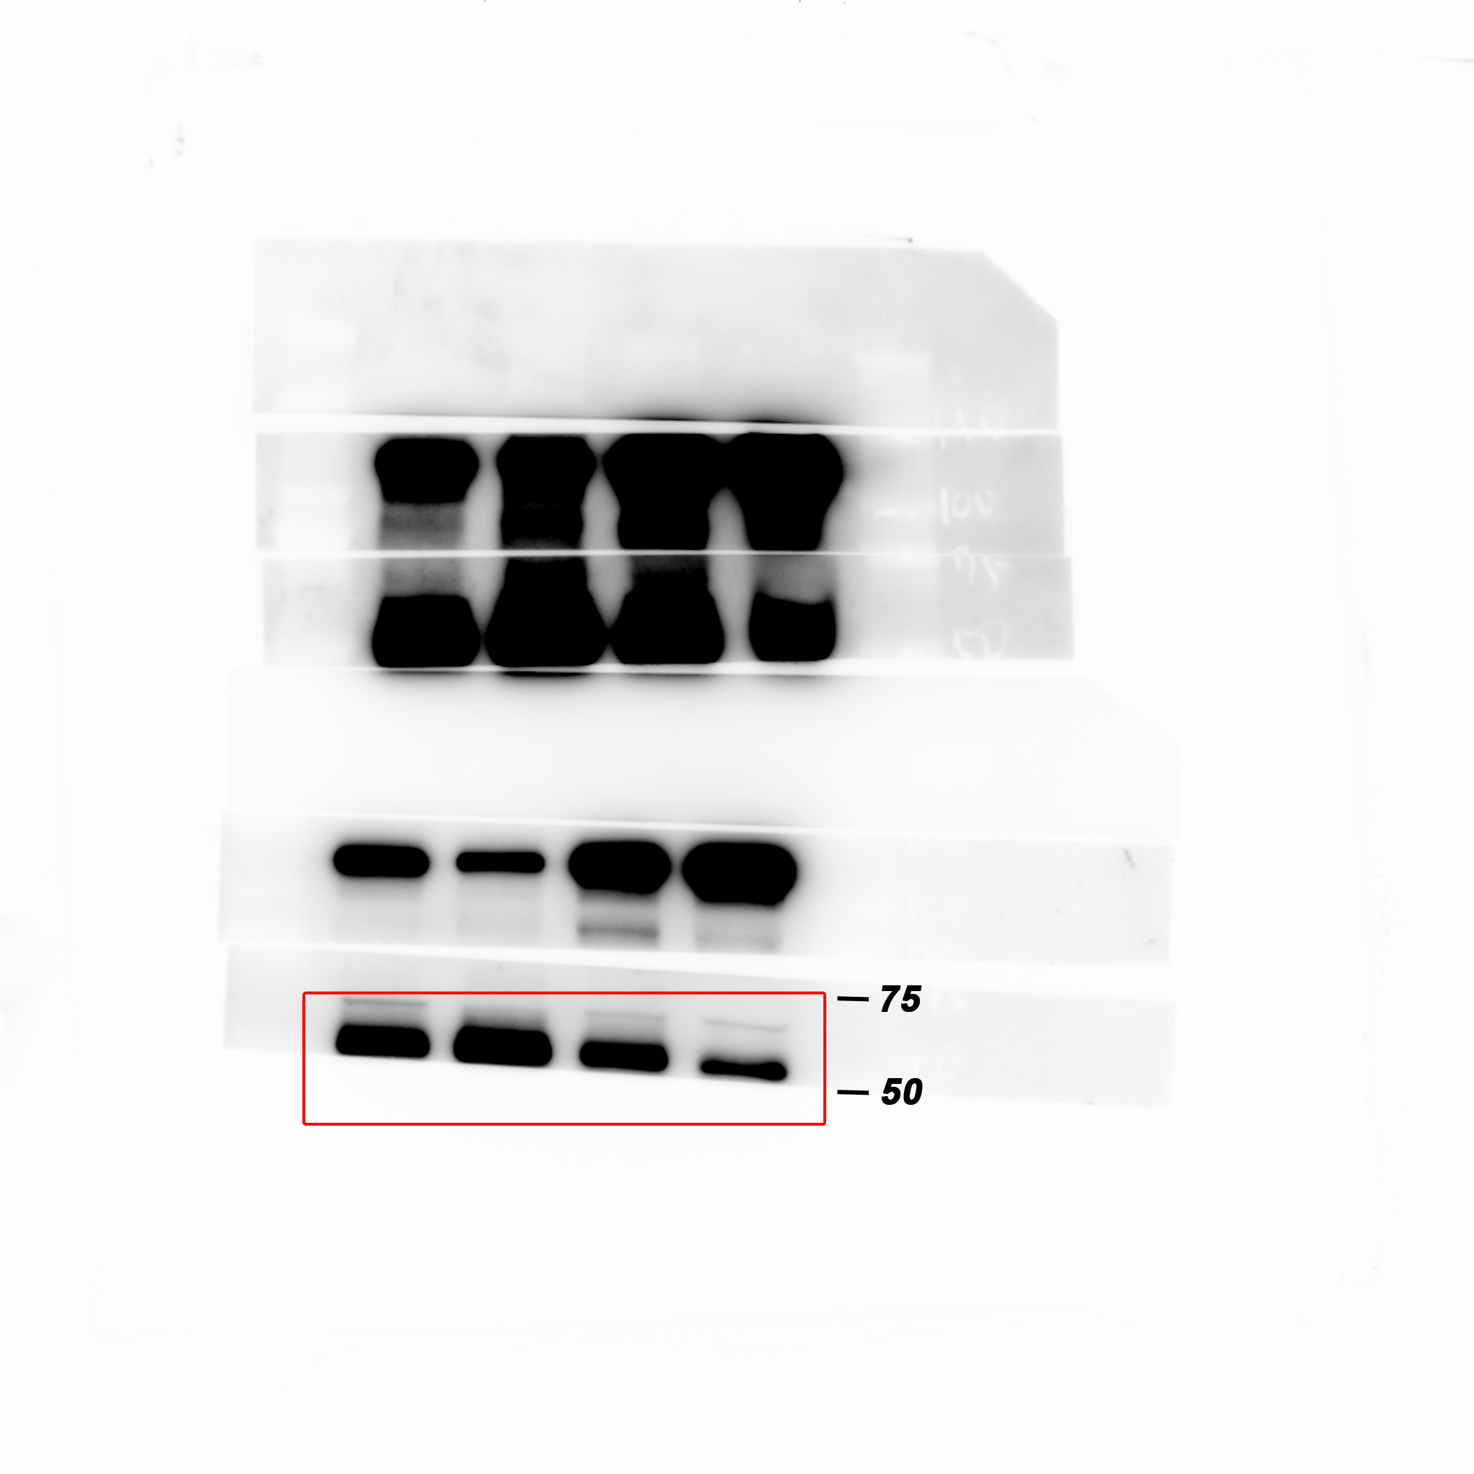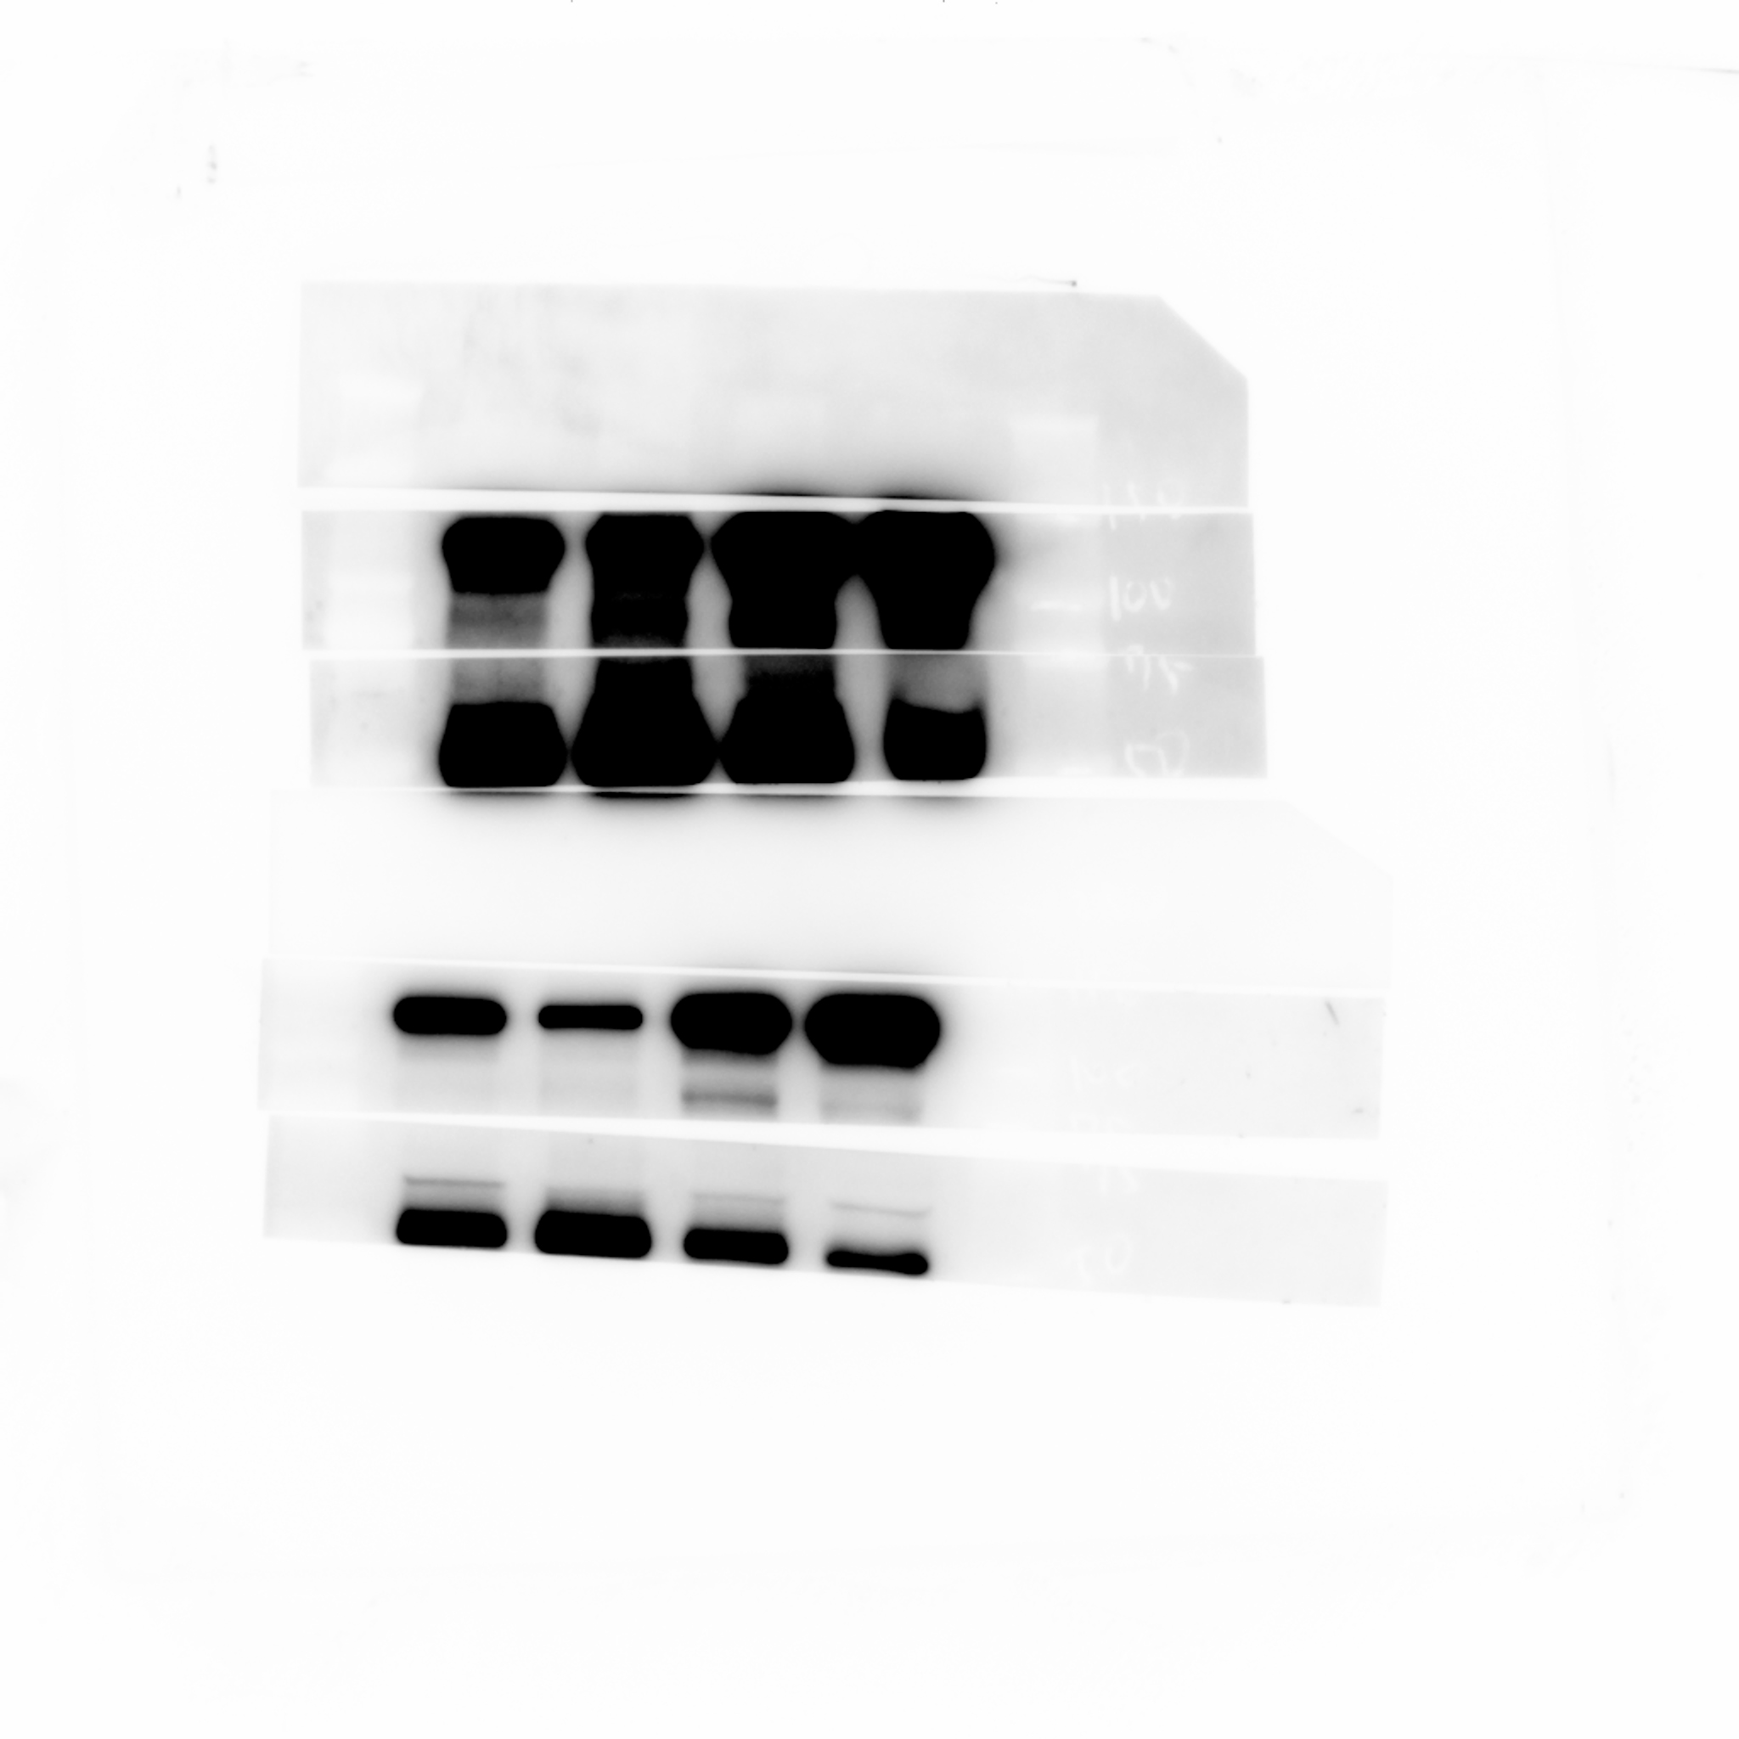
Western blot analysis of Luciferase protein levels in whole cell lysate of 4T1 primary tumors from either vehicle or Pizotifen-treated mice.

Figure 5C_β-catenin in the nucleus_source data
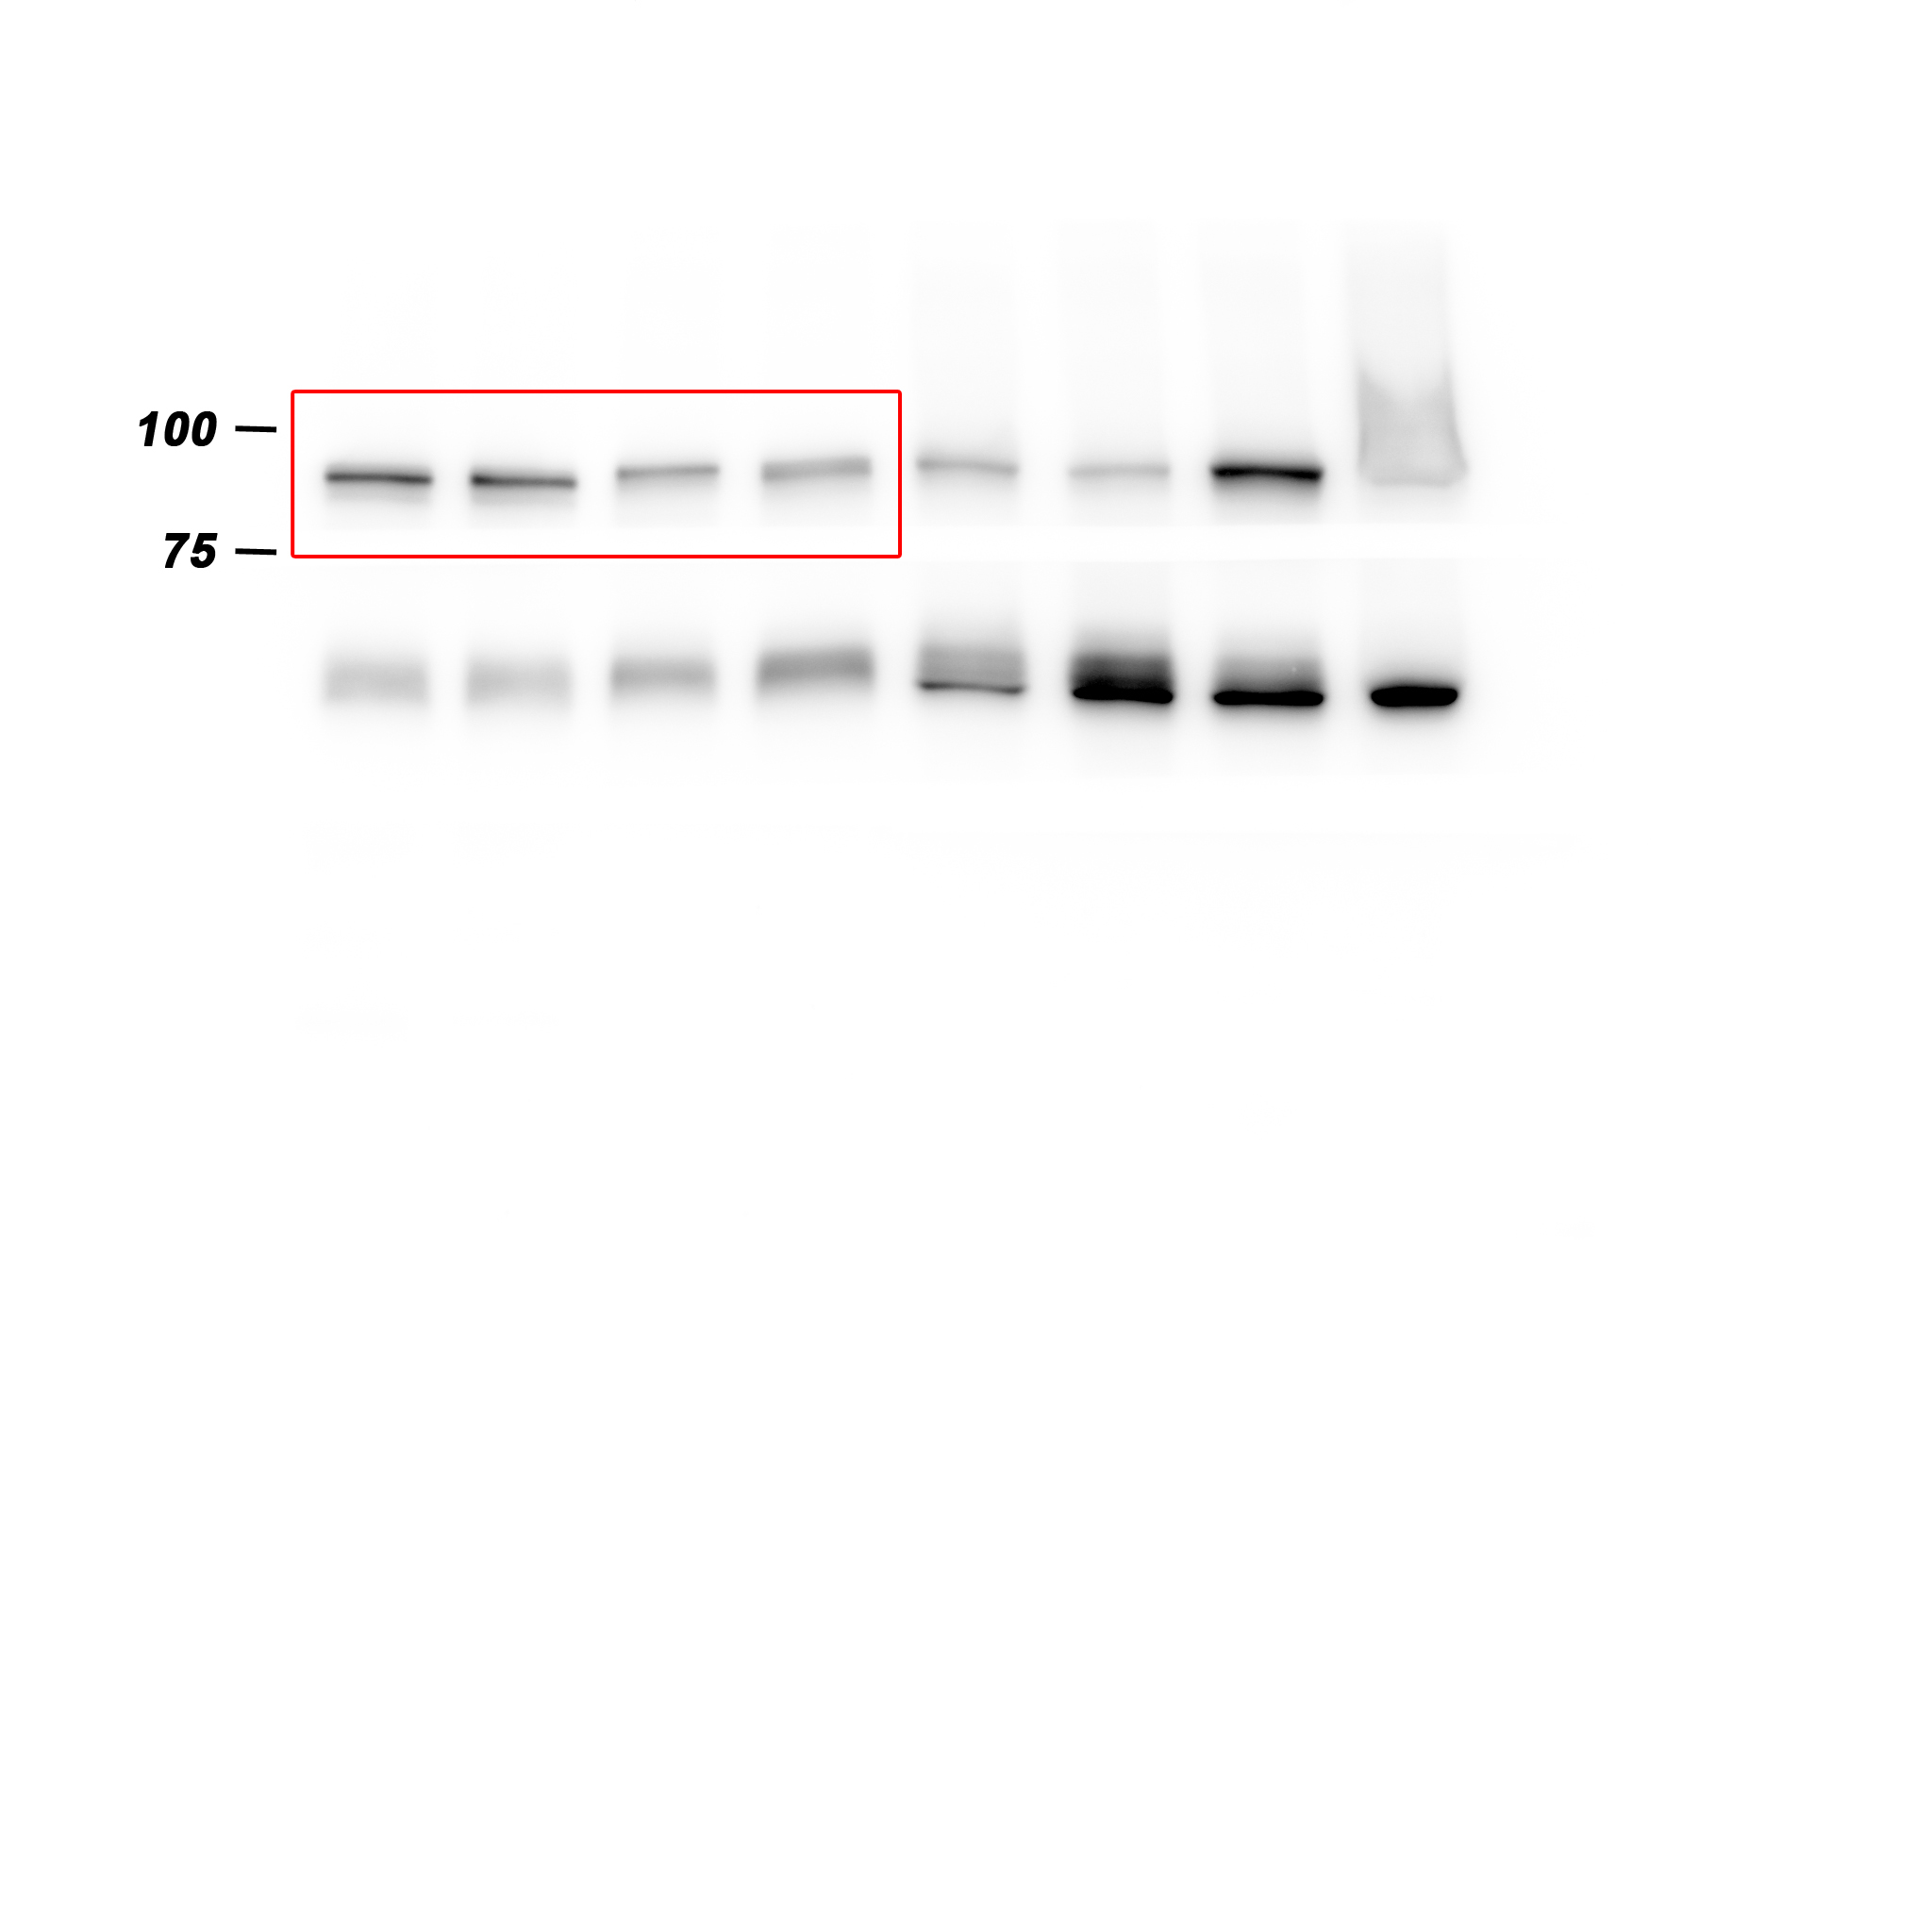
Western blot analysis of β-catenin protein levels in the nucleus of 4T1 primary tumors from either vehicle or Pizotifen-treated mice.

Figure 5C_Histone H3 in the nucleus_source data
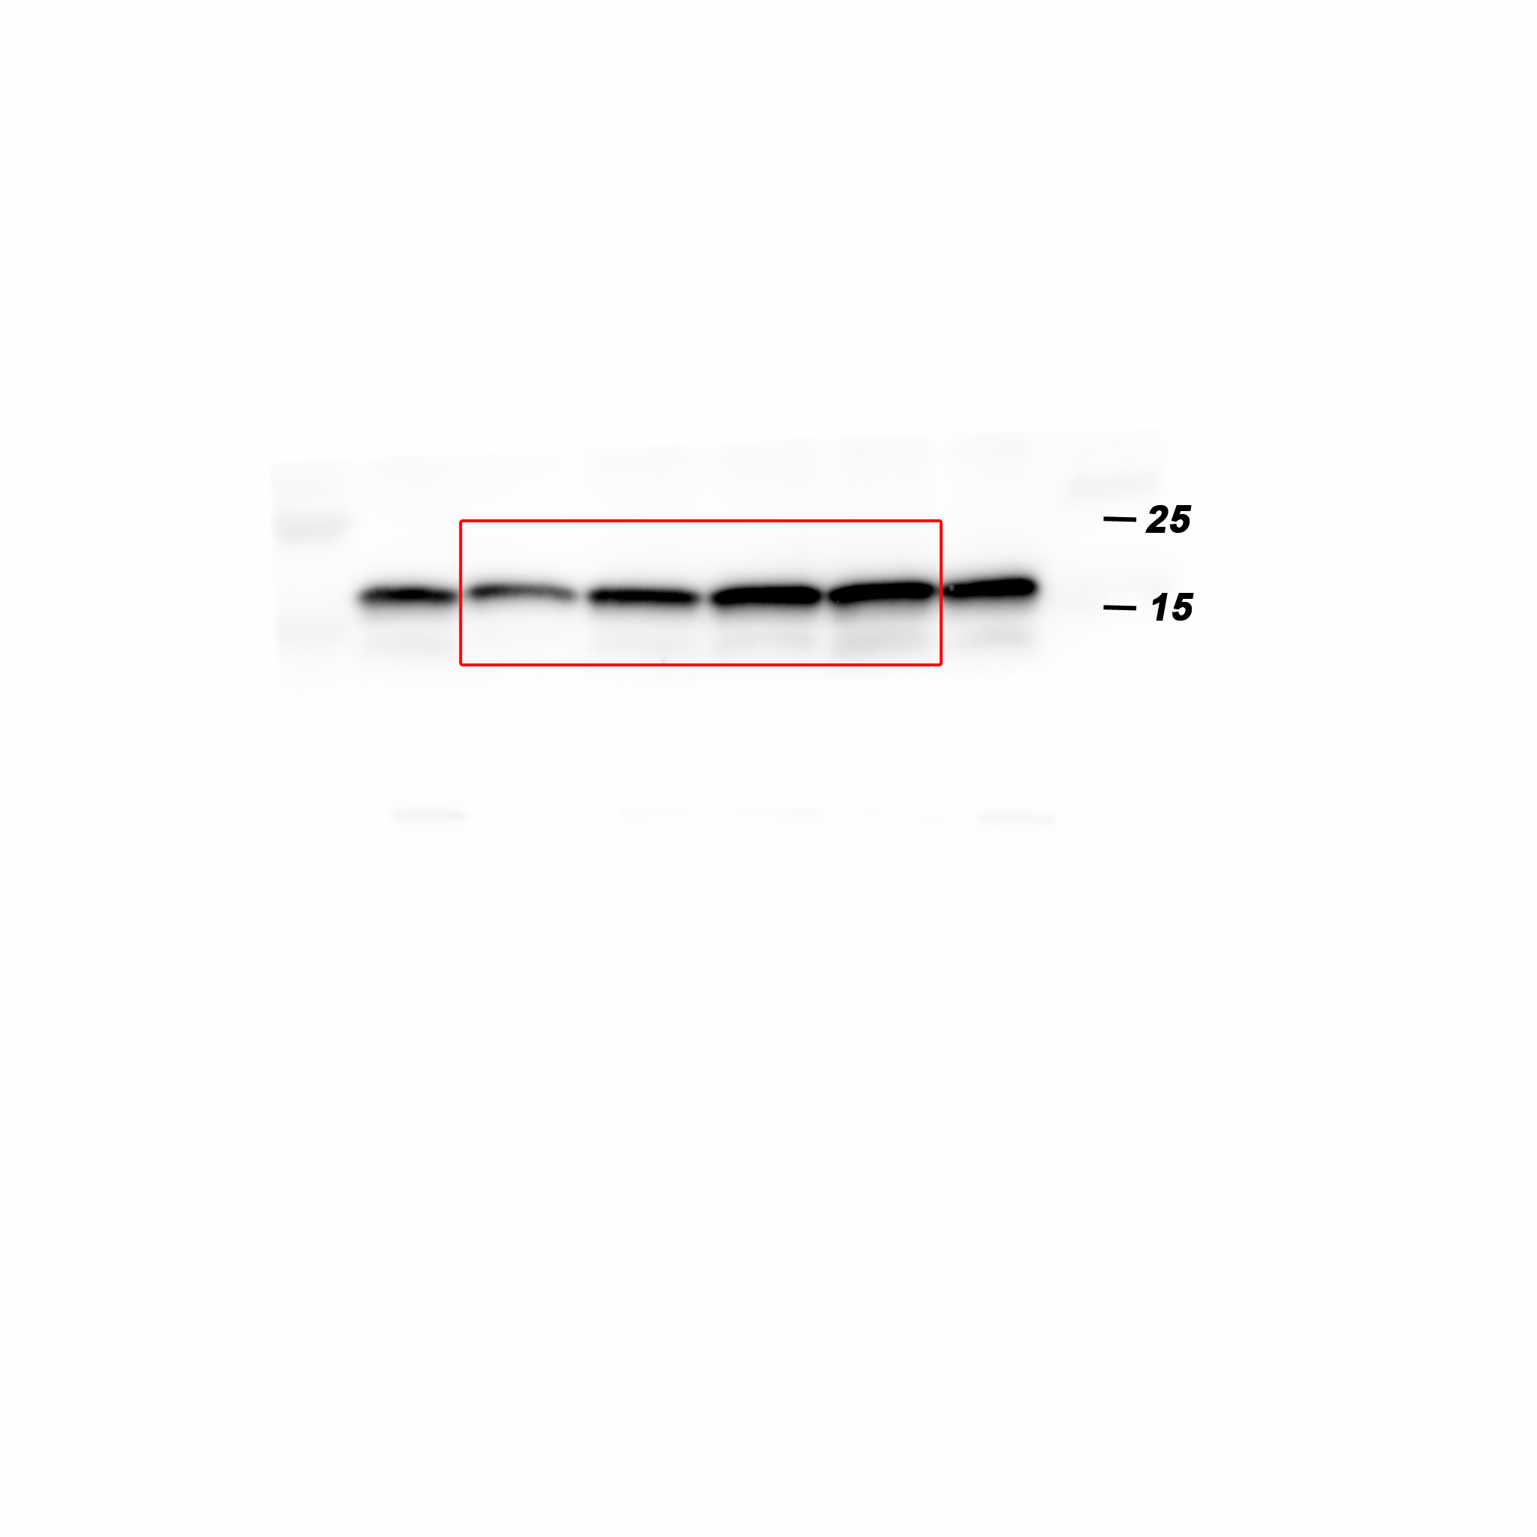
Western blot analysis of Histone H3 protein levels in the nucleus of 4T1 primary tumors from either vehicle or Pizotifen-treated mice.

Figure 5C_β-catenin in the cytoplasm_source data
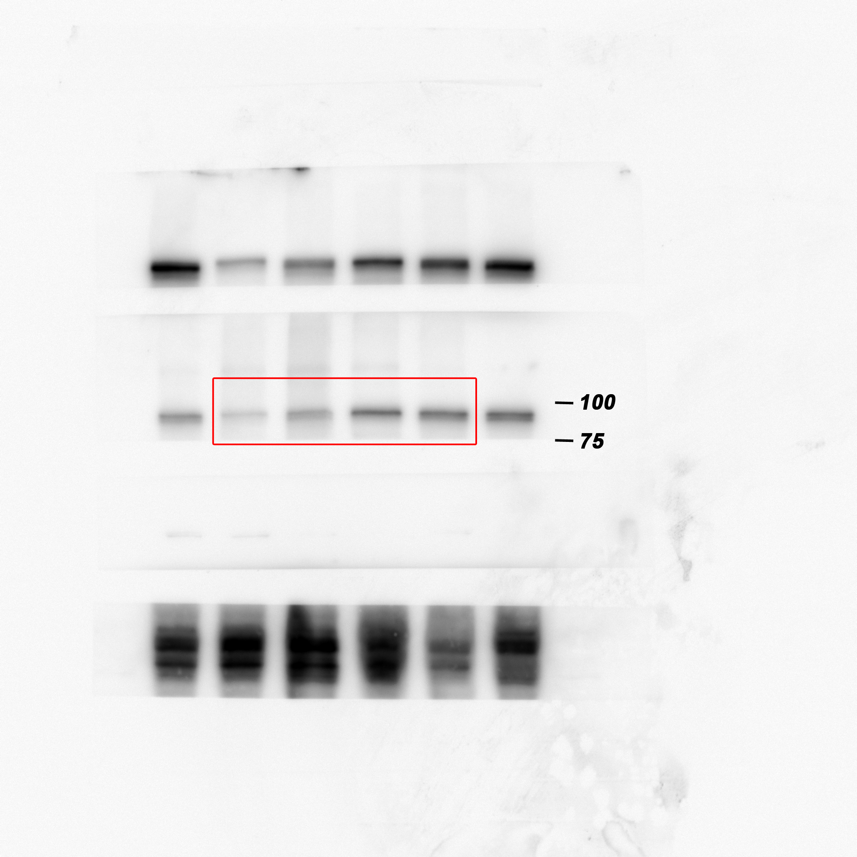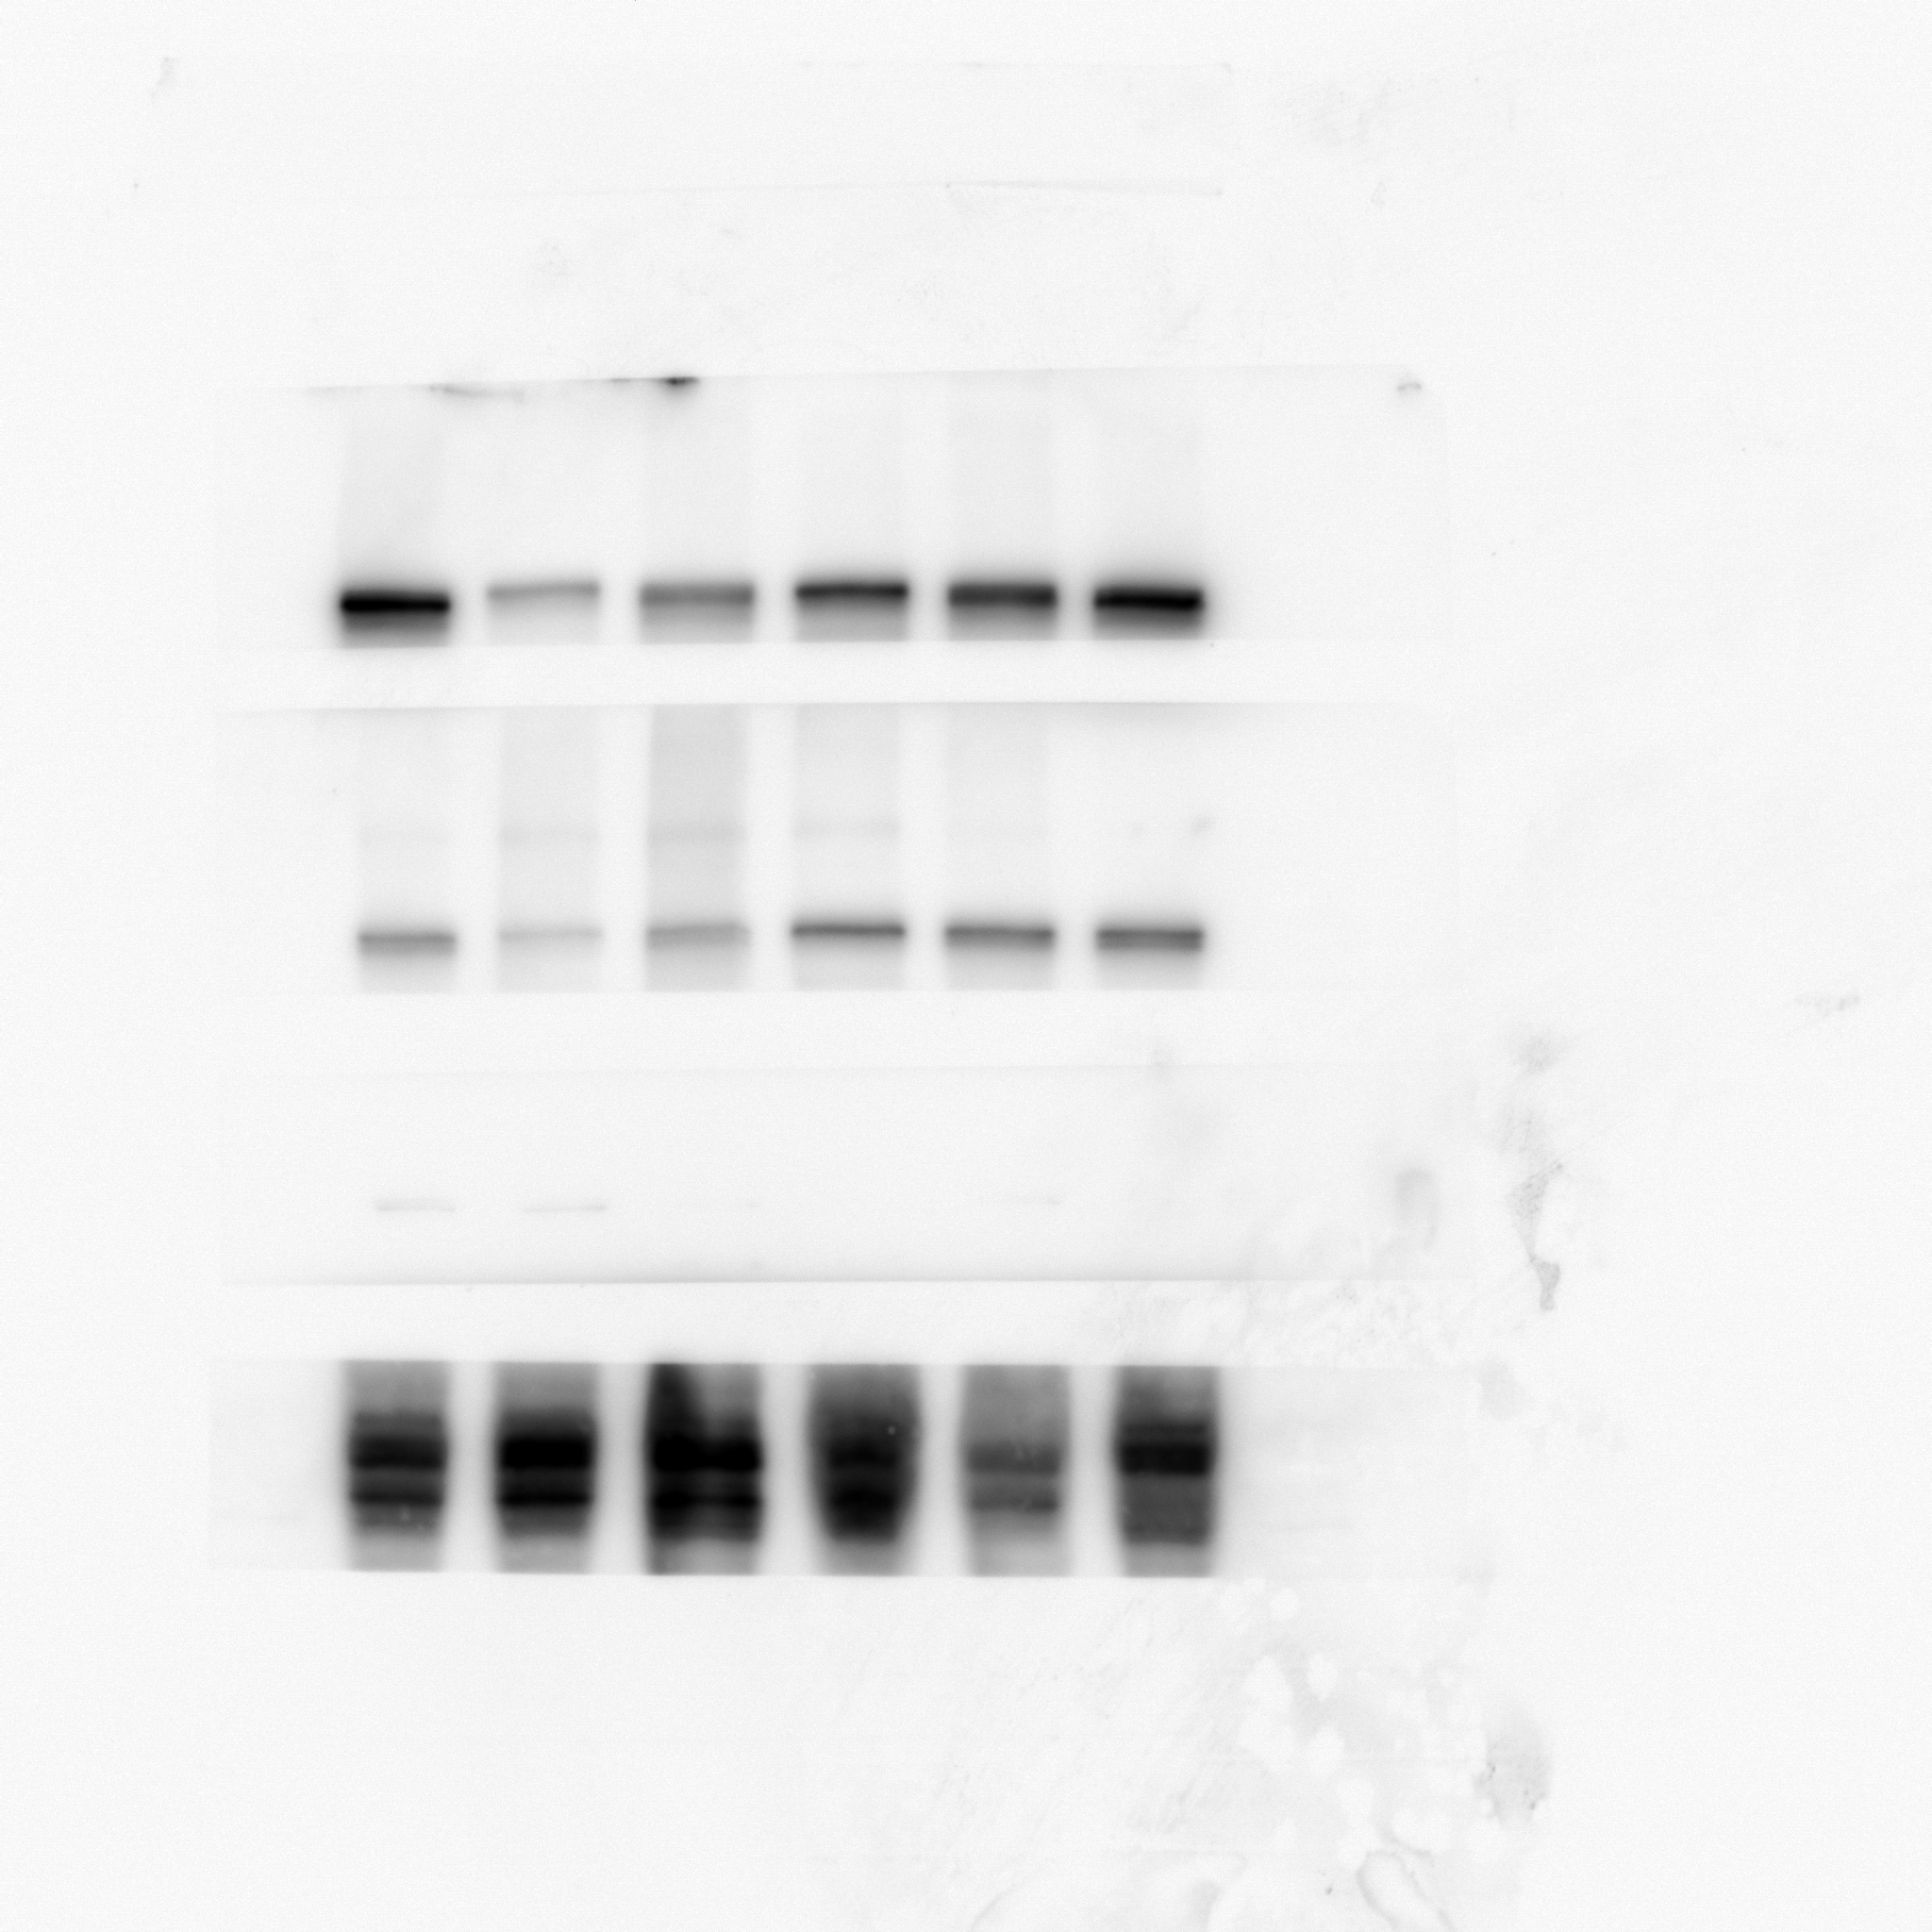
Western blot analysis of β-catenin protein levels in the cytoplasm of 4T1 primary tumors from either vehicle or Pizotifen-treated mice.

Figure 5C_β-tubulin in the cytoplasm_source data
Western blot analysis of β-tubulin protein levels in the cytoplasm of 4T1 primary tumors from either vehicle or Pizotifen-treated mice.

Figure 5D_E-cadherin_source data
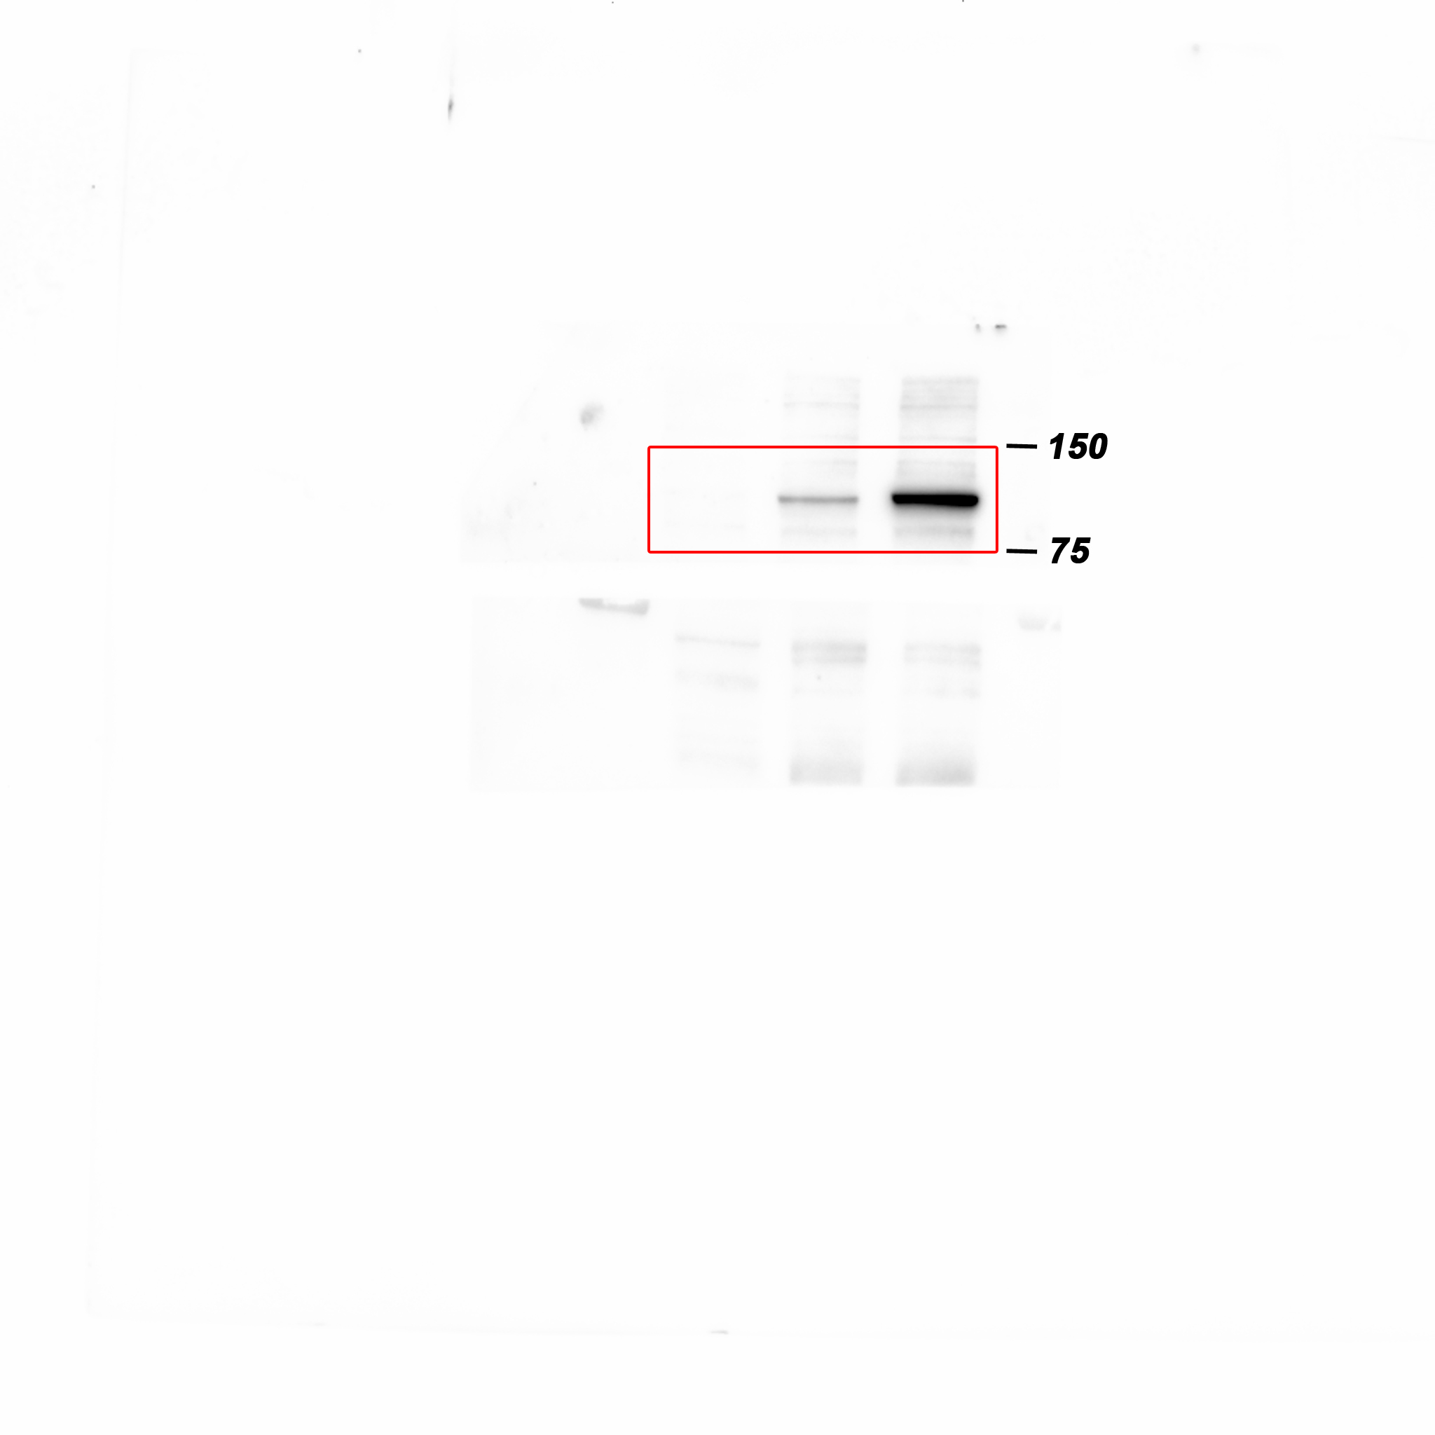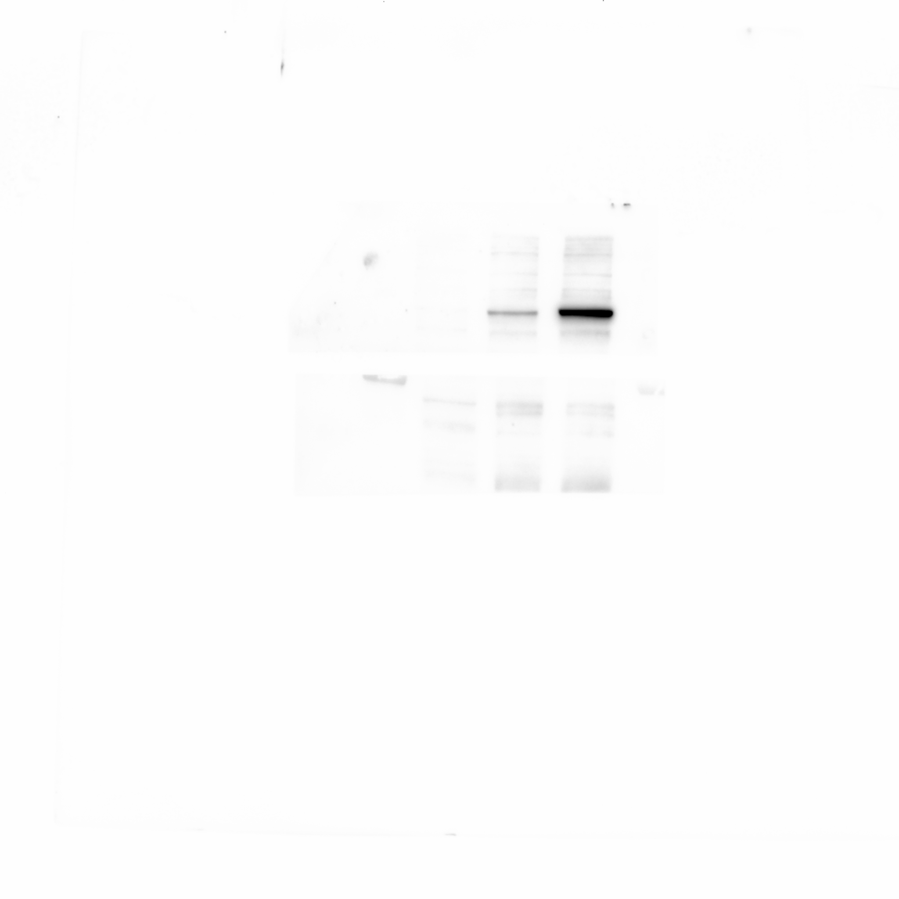
Western blot analysis of E-cadherin protein levels in either vehicle or Pizotifen-treated MDA-MB-231 cells or E-cadherin positive cells in Pizotifen-treated MDA-MB-231 cells.

Figure 5D_EpCAM_source data
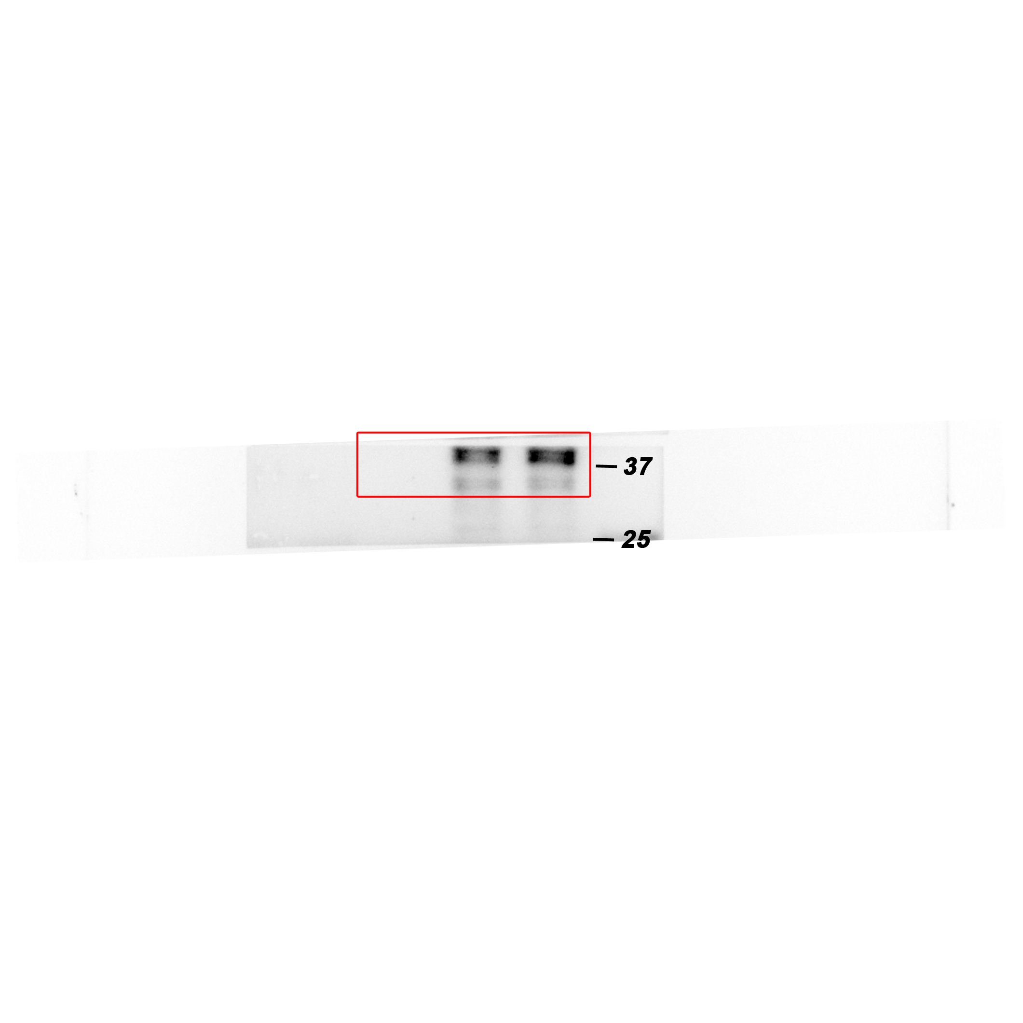
Western blot analysis of EpCAM protein levels in either vehicle or Pizotifen-treated MDA-MB-231 cells or E-cadherin positive cells in Pizotifen-treated MDA-MB-231 cells.

Figure 5D_Keratin18 (KRT18)_source data
Western blot analysis of KRT18 protein levels in either vehicle or Pizotifen-treated MDA-MB-231 cells or E-cadherin positive cells in Pizotifen-treated MDA-MB-231 cells.

Figure 5D_Keratin19 (KRT19)_source data
Western blot analysis of KRT19 protein levels in either vehicle or Pizotifen-treated MDA-MB-231 cells or E-cadherin positive cells in Pizotifen-treated MDA-MB-231 cells.

Figure 5D_Vimentin_source data
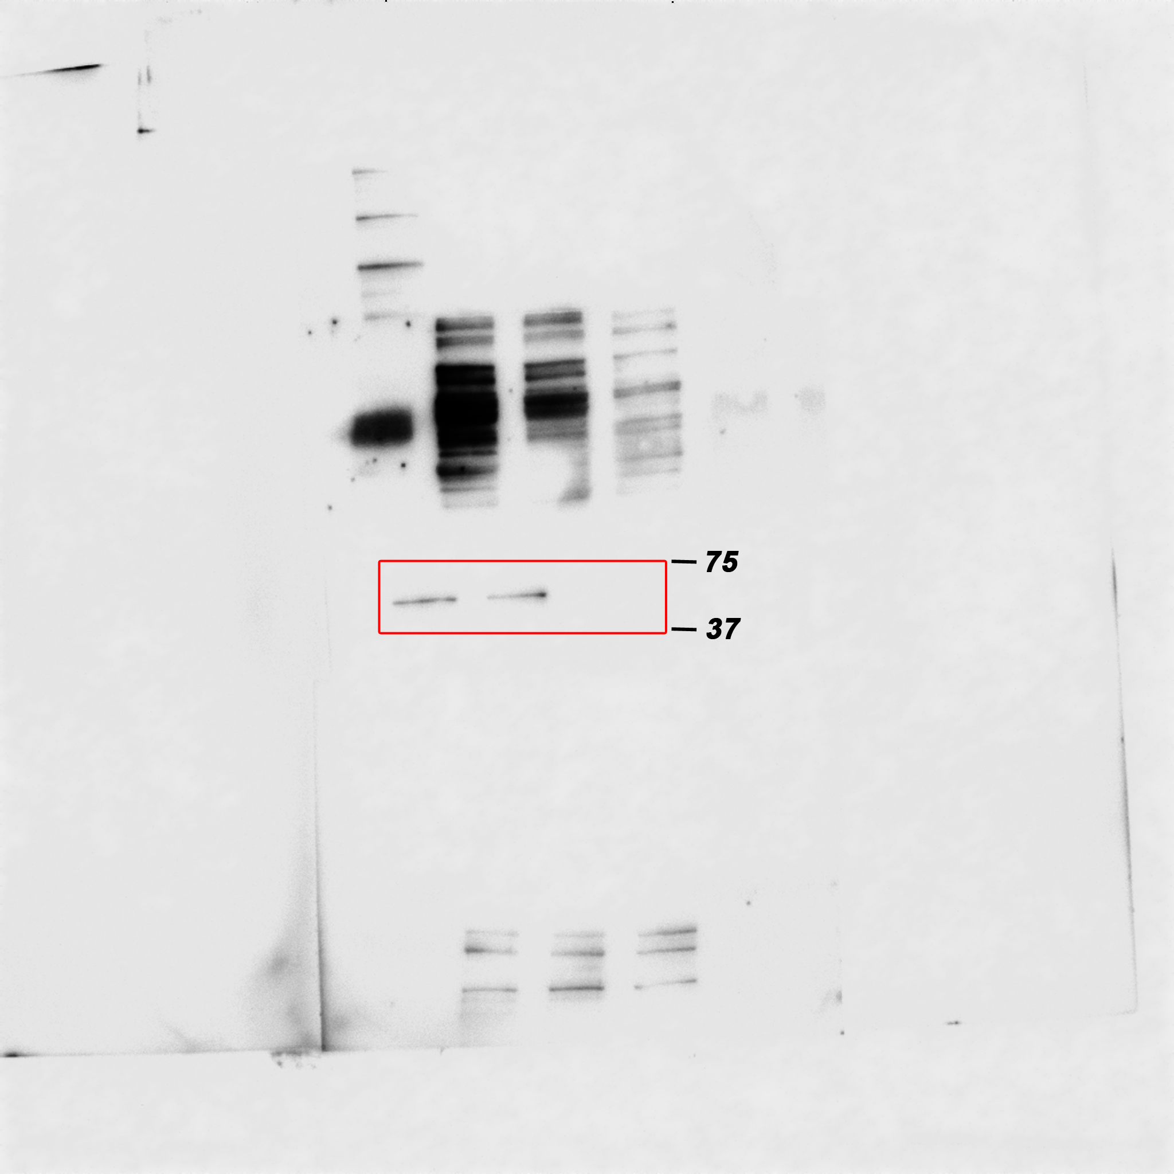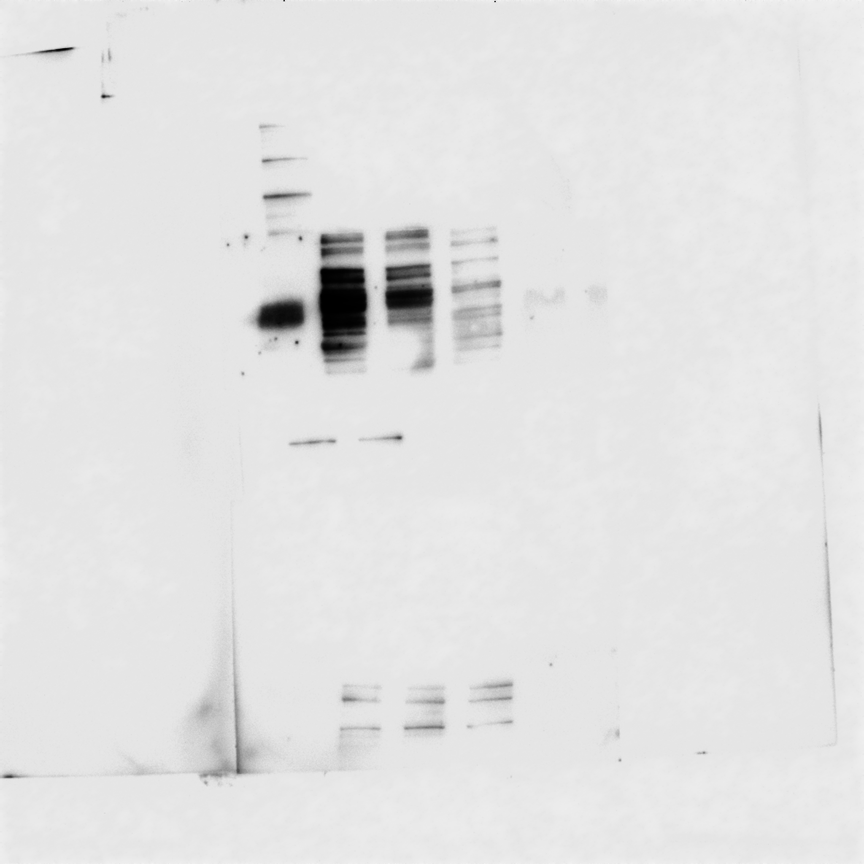
Western blot analysis of Vimentin protein levels in either vehicle or Pizotifen-treated MDA-MB-231 cells or E-cadherin positive cells in Pizotifen-treated MDA-MB-231 cells.

Figure 5D_MMP1_source data
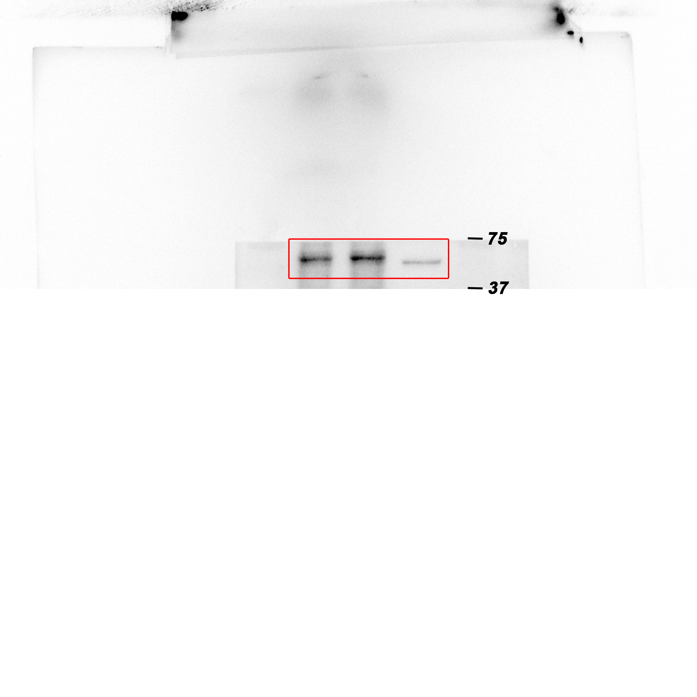
Western blot analysis of MMP1 protein levels in either vehicle or Pizotifen-treated MDA-MB-231 cells or E-cadherin positive cells in Pizotifen-treated MDA-MB-231 cells.

Figure 5D_MMP3_source data
Western blot analysis of MMP3 protein levels in either vehicle or Pizotifen-treated MDA-MB-231 cells or E-cadherin positive cells in Pizotifen-treated MDA-MB-231 cells.

Figure 5D_S100A4_source data
Western blot analysis of S100A4 protein levels in either vehicle or Pizotifen-treated MDA-MB-231 cells or E-cadherin positive cells in Pizotifen-treated MDA-MB-231 cells.

Figure 5D_ZEB1_source data
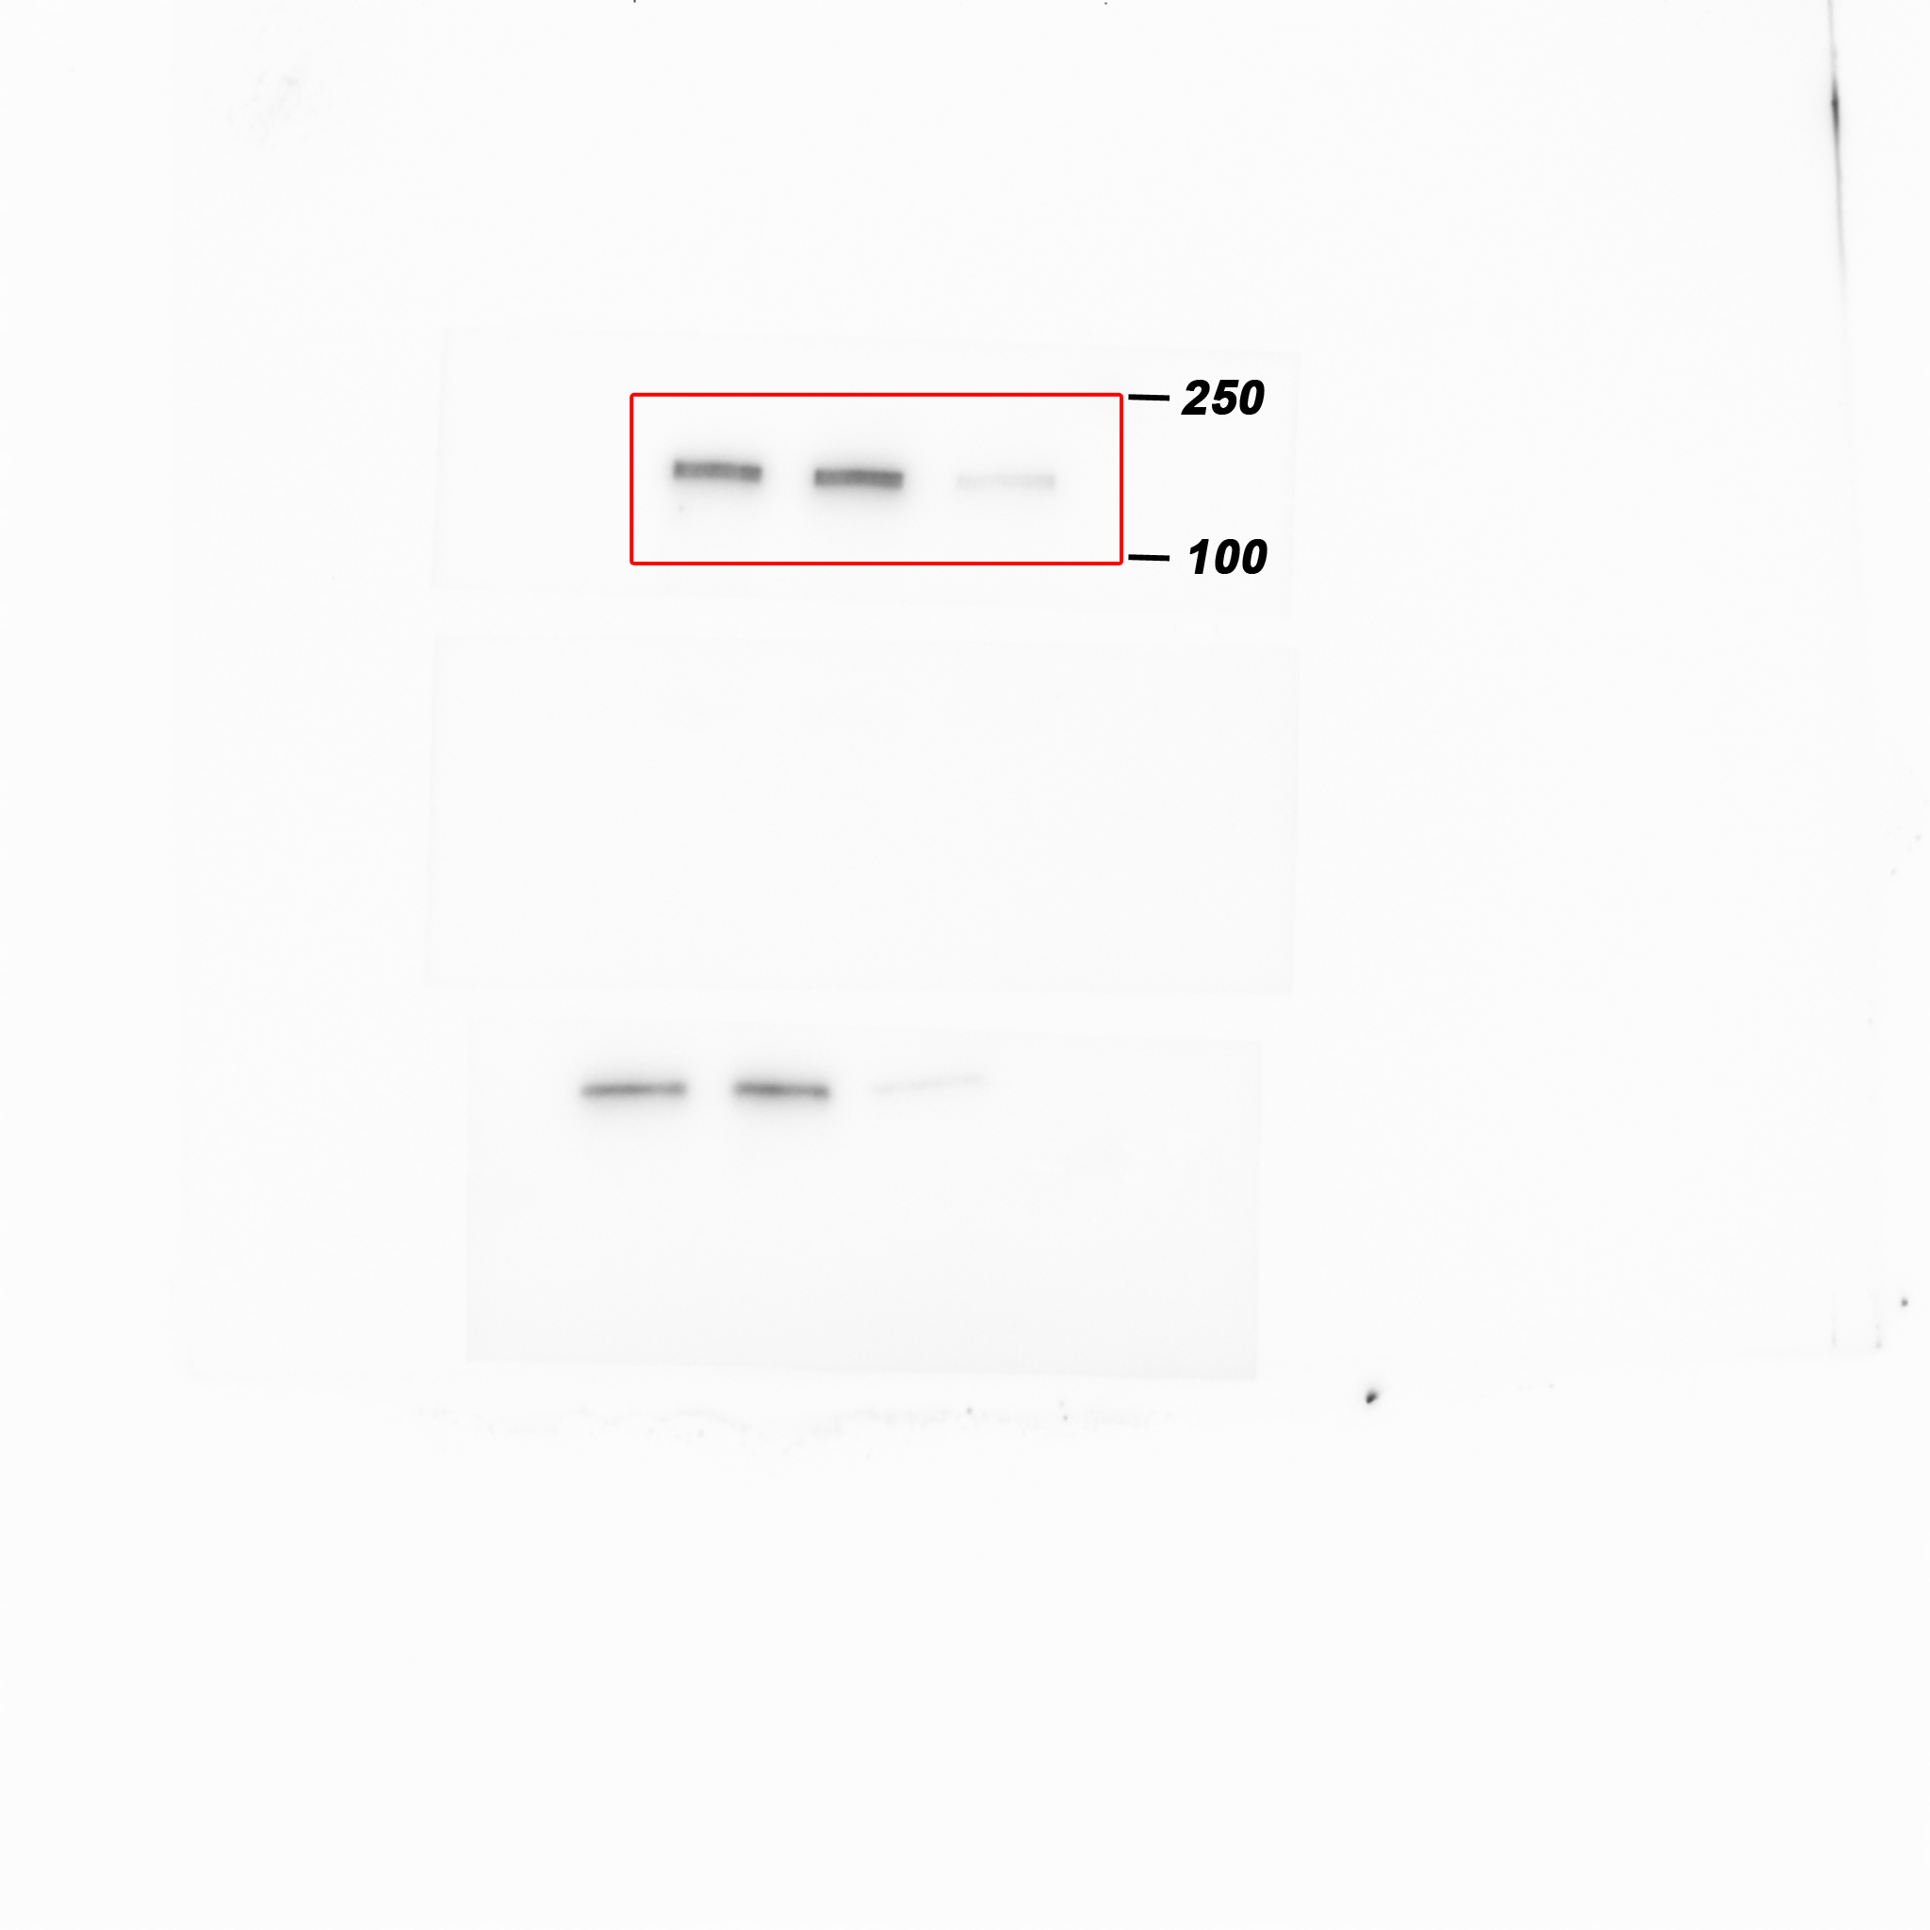
Western blot analysis of ZEB1 protein levels in either vehicle or Pizotifen-treated MDA-MB-231 cells or E-cadherin positive cells in Pizotifen-treated MDA-MB-231 cells.

Figure 5D_GAPDH_source data
Western blot analysis of GAPDH protein levels in either vehicle or Pizotifen-treated MDA-MB-231 cells or E-cadherin positive cells in Pizotifen-treated MDA-MB-231 cells.

Figure 5F_β-catenin in the nucleus_source data
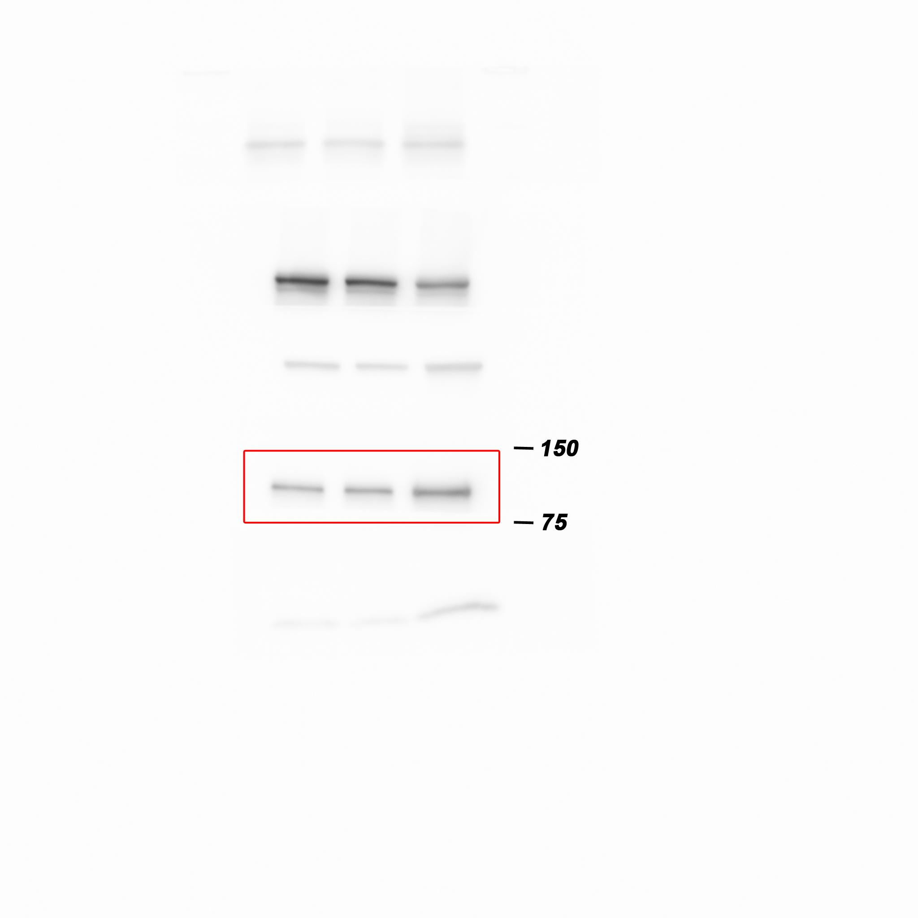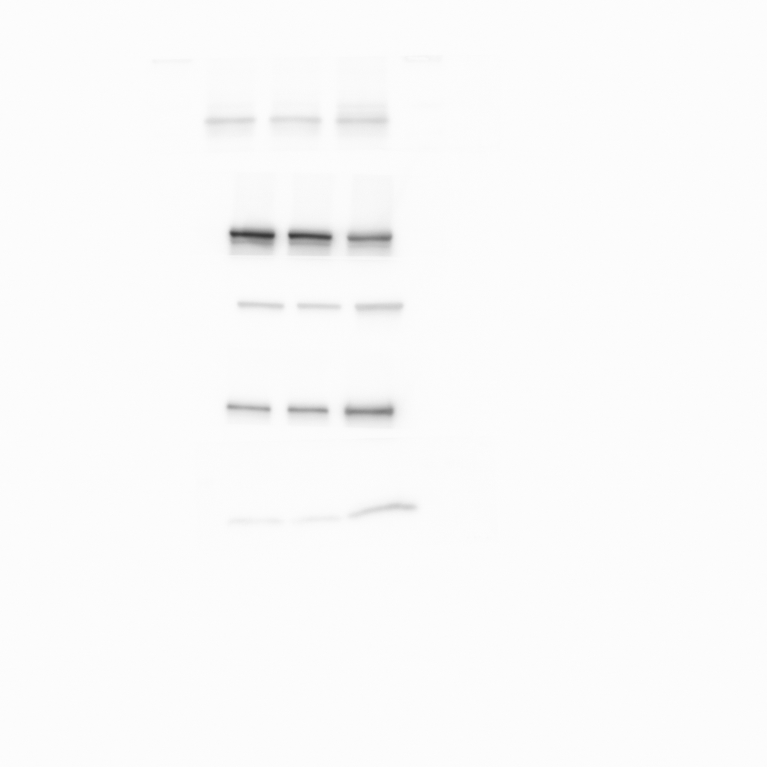
Western blot analysis of β-catenin protein levels in the nuclear of MCF7 cells expressing either the control vector or HTR2C.

Figure 5F_Histone H3 in the nucleus _source data
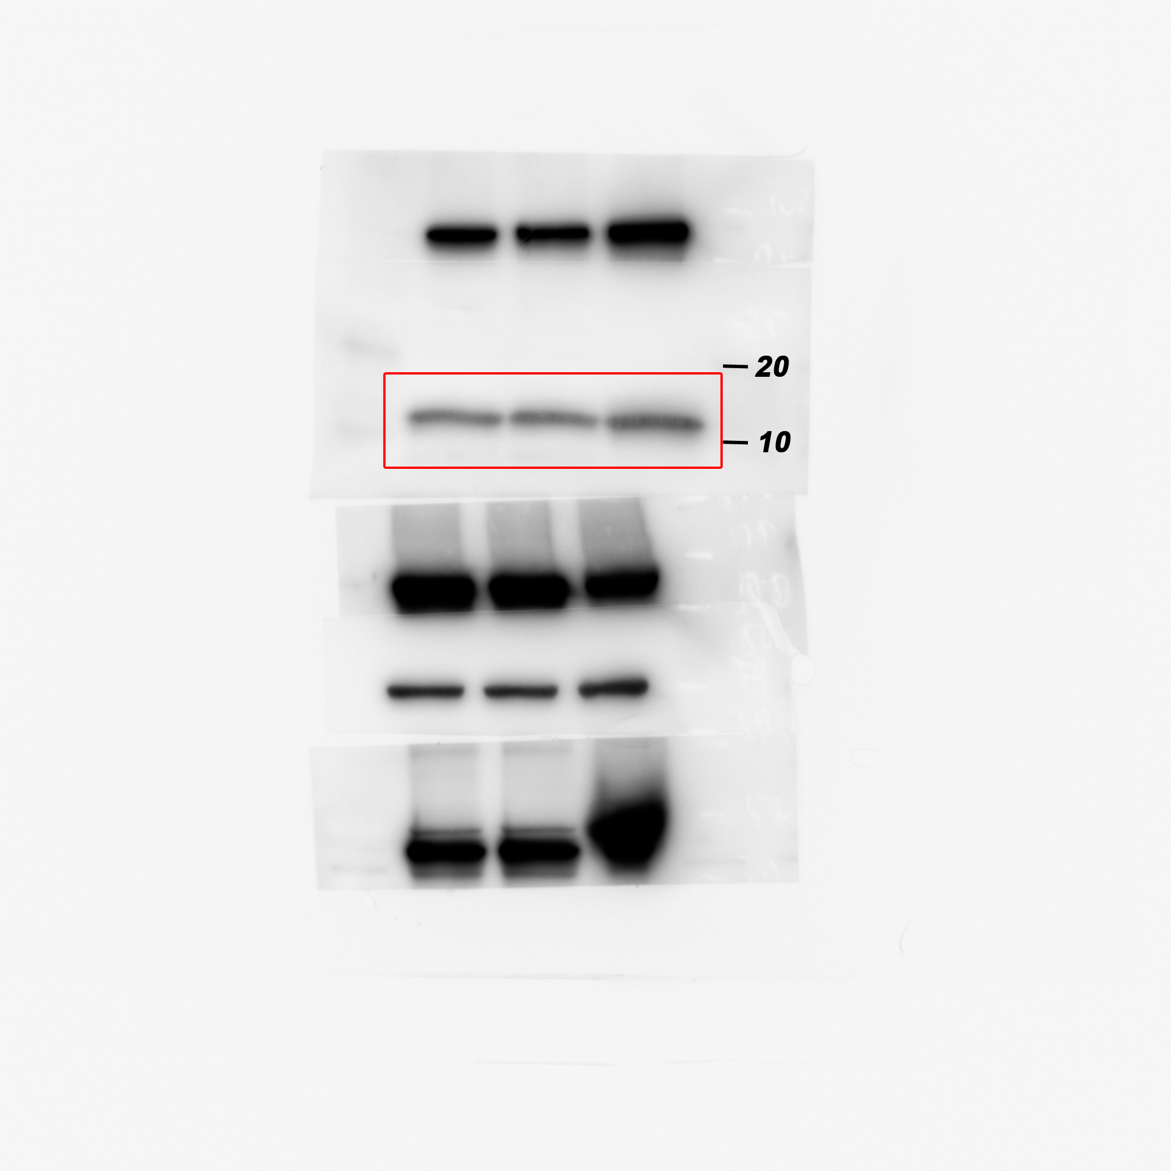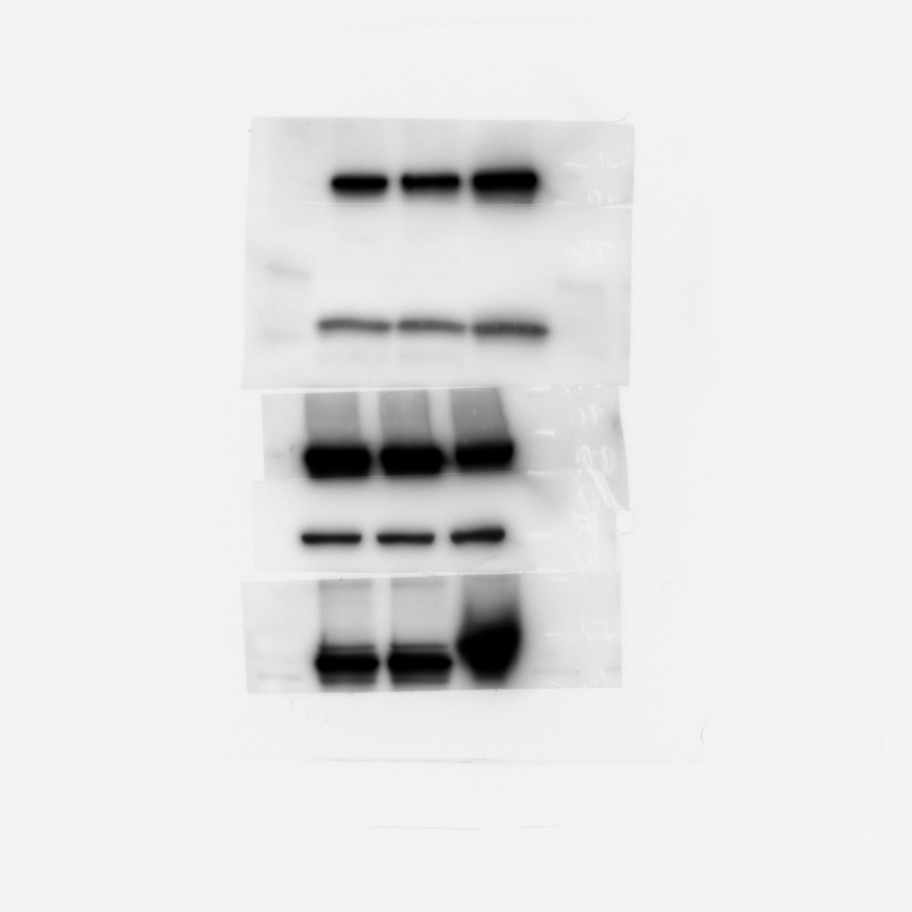
Western blot analysis of Histone H3 protein levels in the nuclear of MCF7 cells expressing either the control vector or HTR2C.

Figure 5F_β-catenin in the cytoplasm_source data
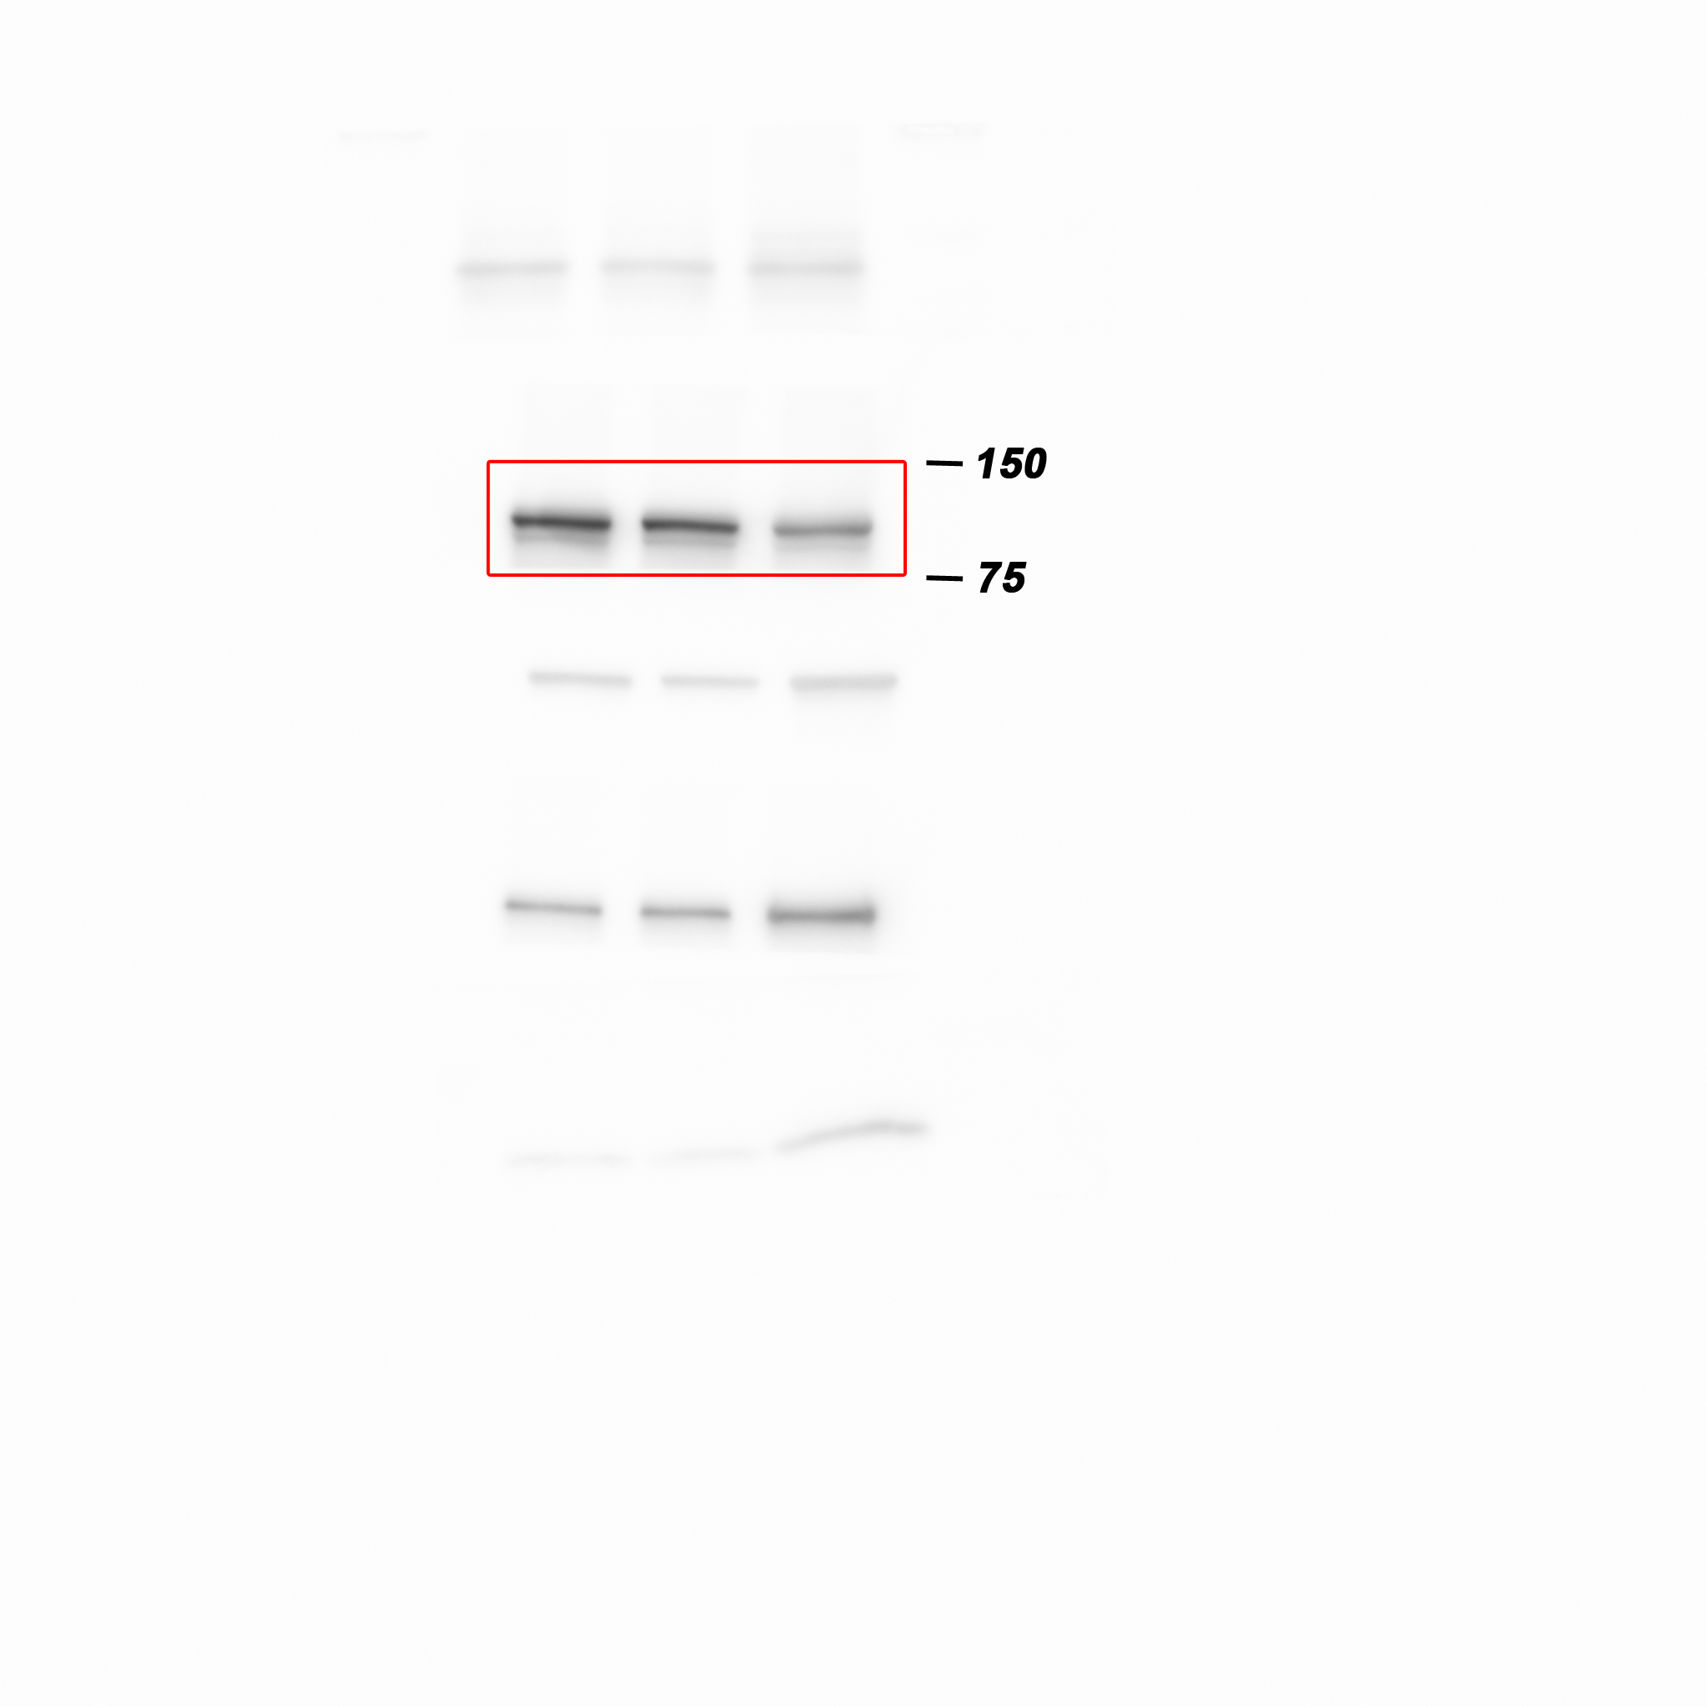
Western blot analysis of β-catenin protein levels in the cytoplasm of MCF7 cells expressing either the control vector or HTR2C.

Figure 5F_β-tubulin in the cytoplasm_source data
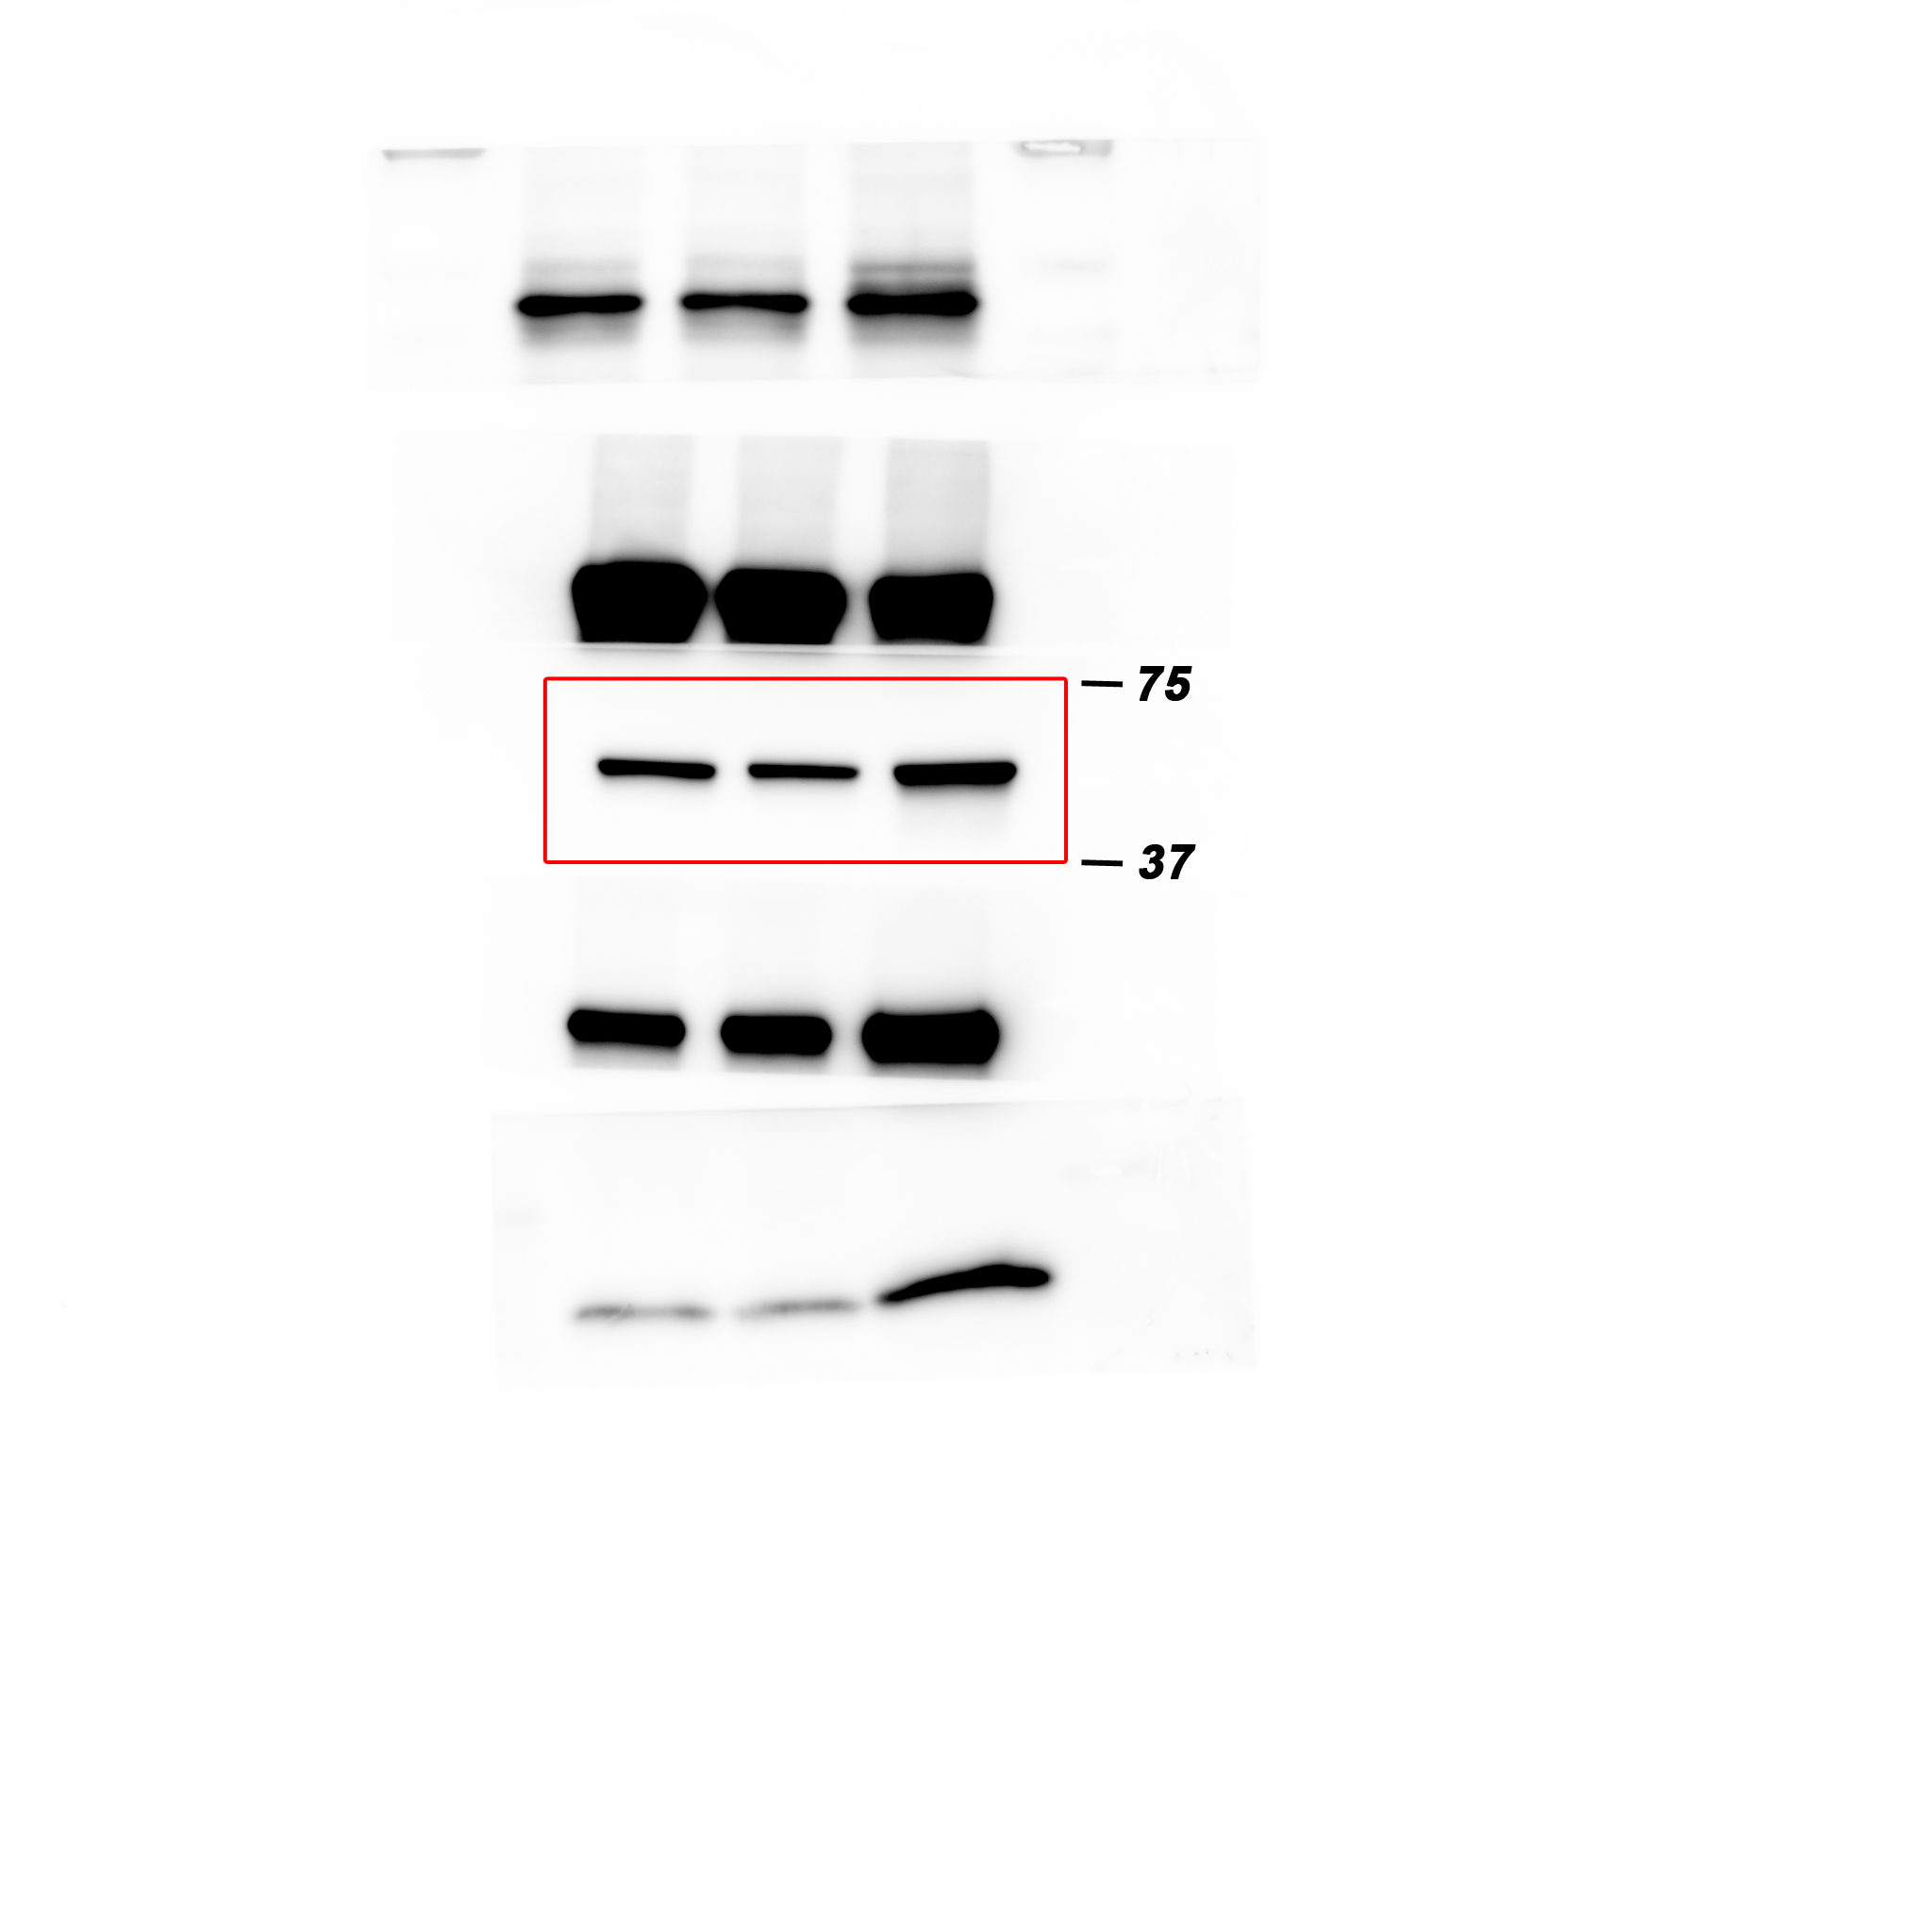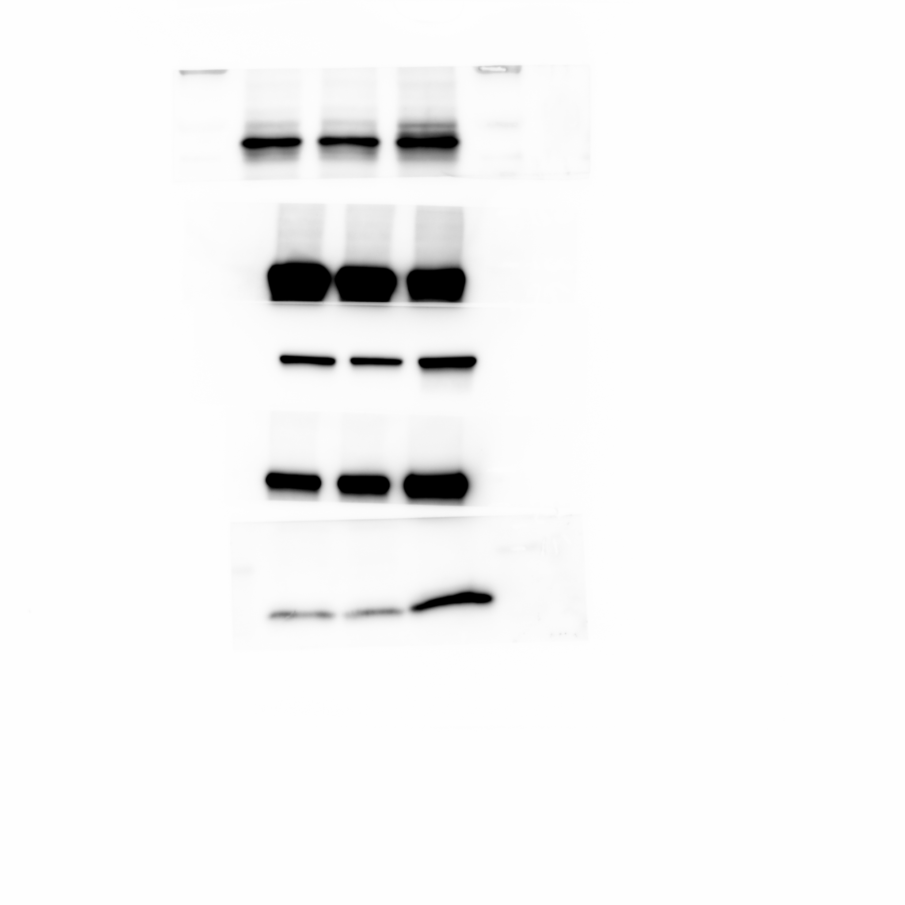
Western blot analysis of β-tubulin protein levels in the cytoplasm of MCF7 cells expressing either the control vector or HTR2C.

Figure 5F_Phosphorylation of serine-9 in GSK3β_source data
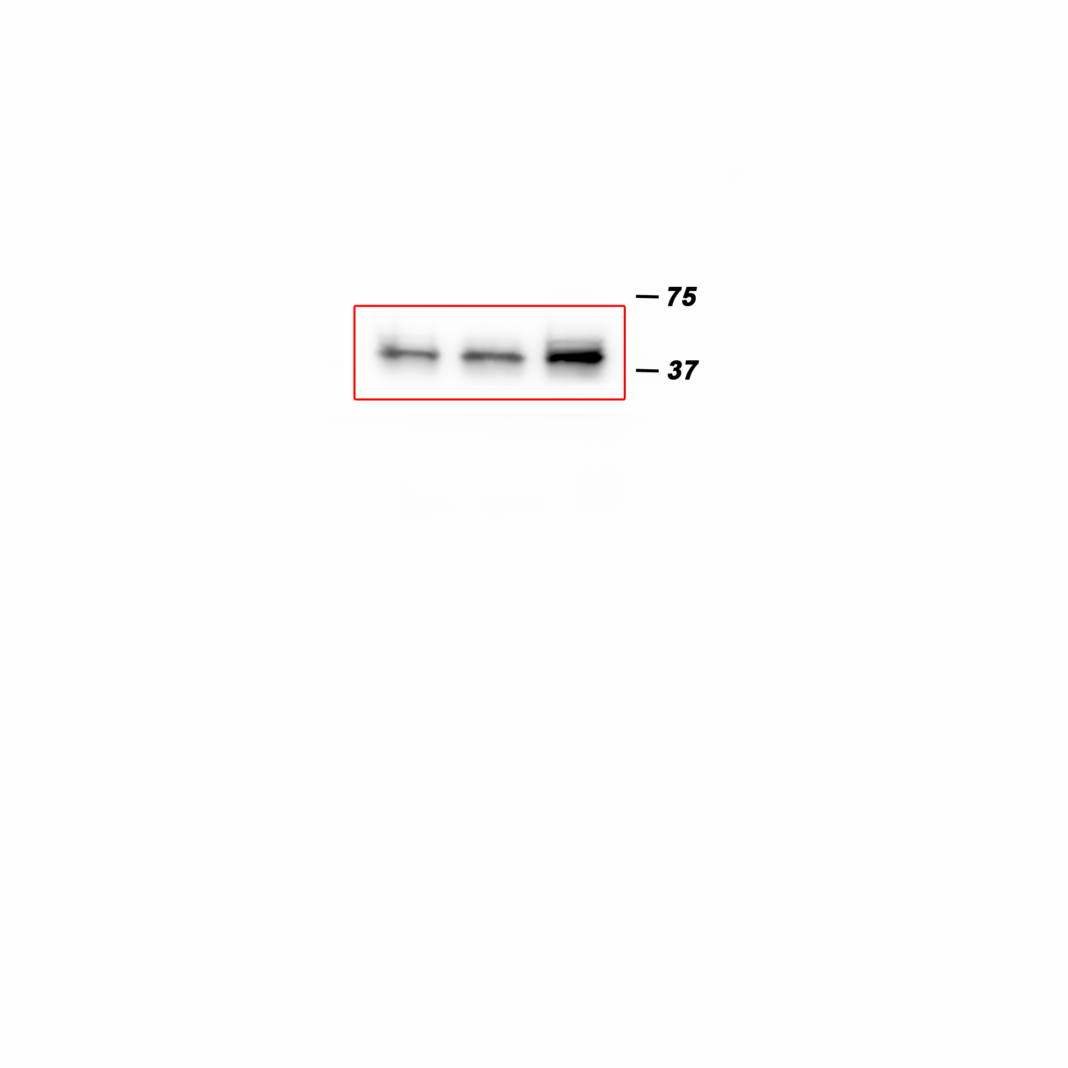
Western blot analysis of the protein levels of phosphorylation of serine-9 in GSK3β in whole cell lysate of MCF7 cells expressing either the control vector or HTR2C.

Figure 5F_GSK3β_source data
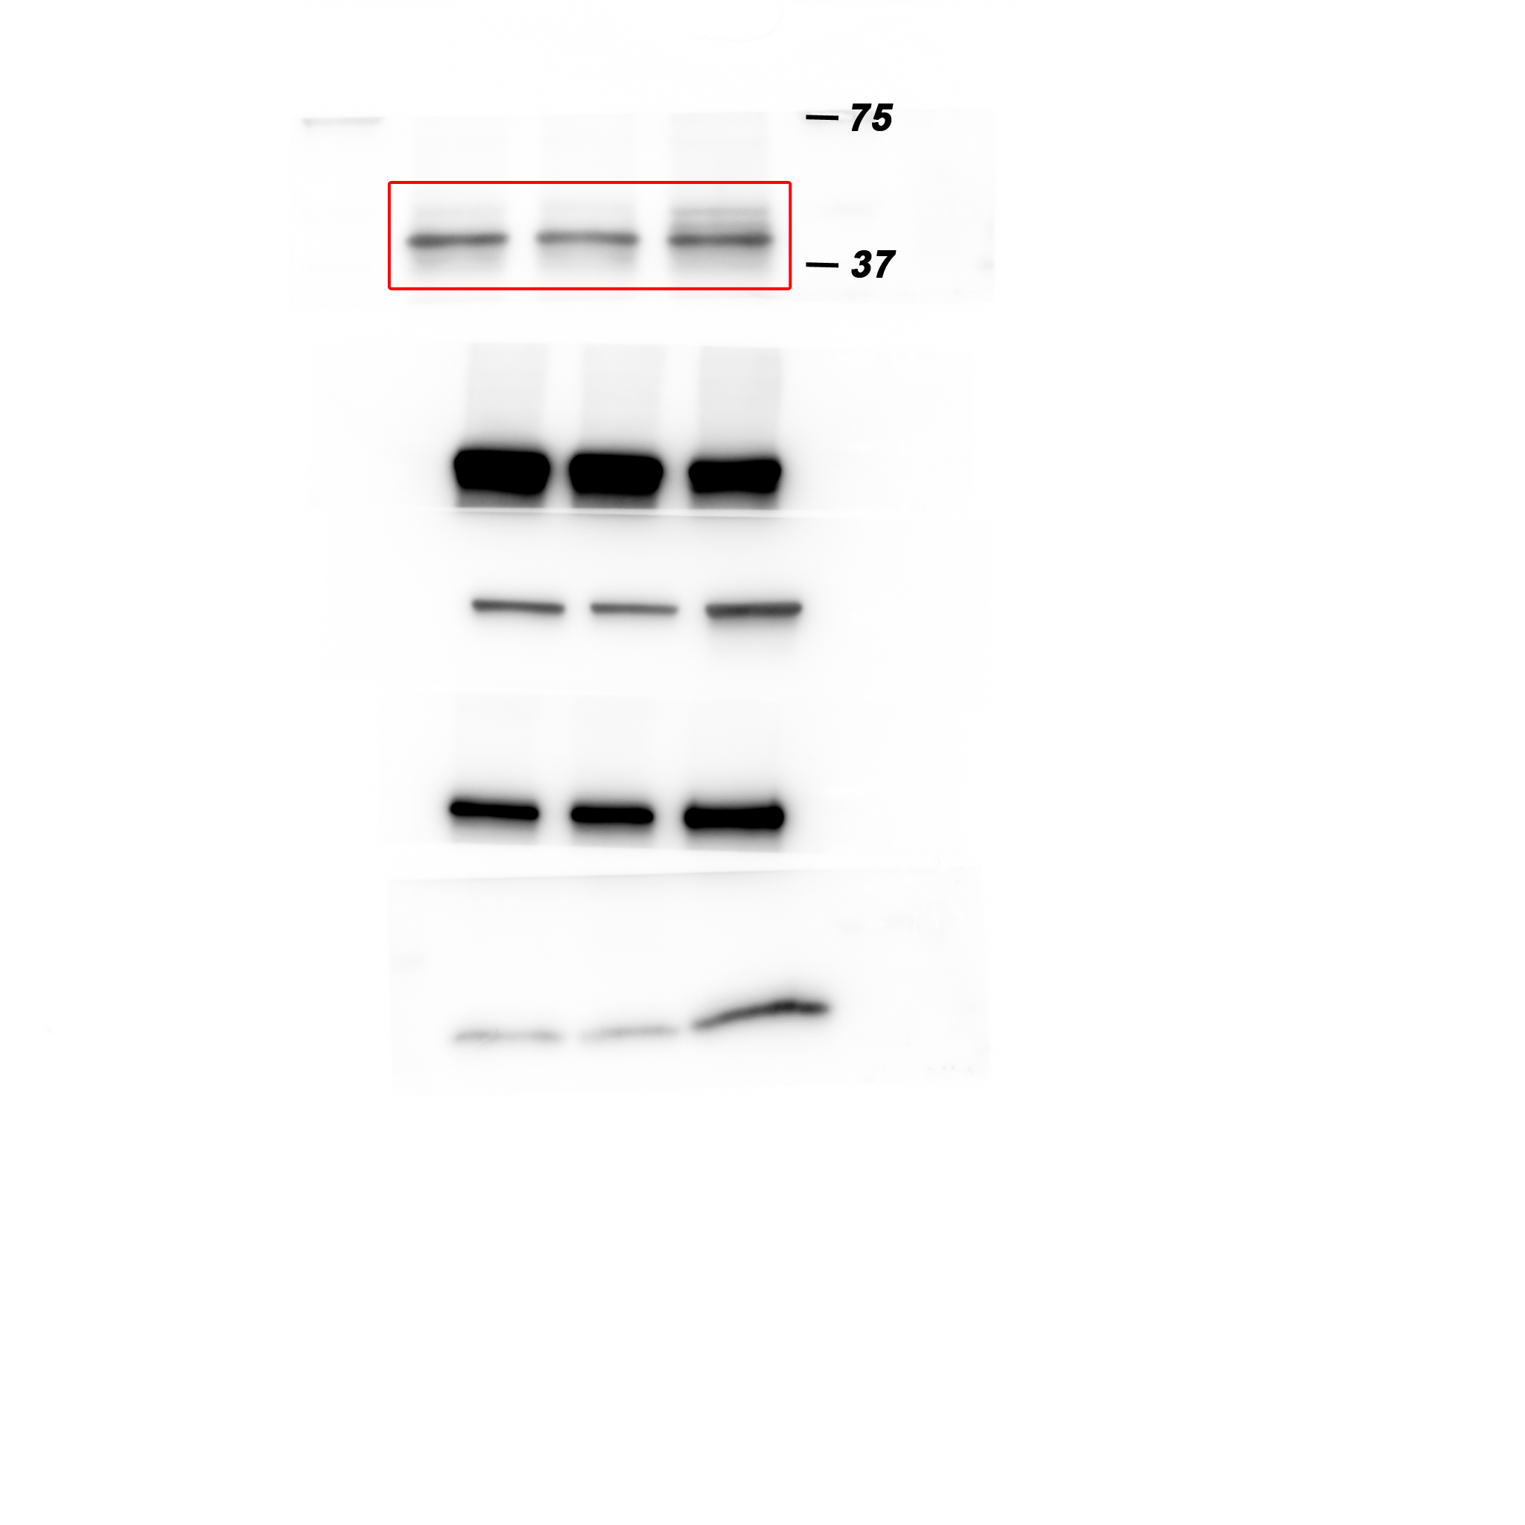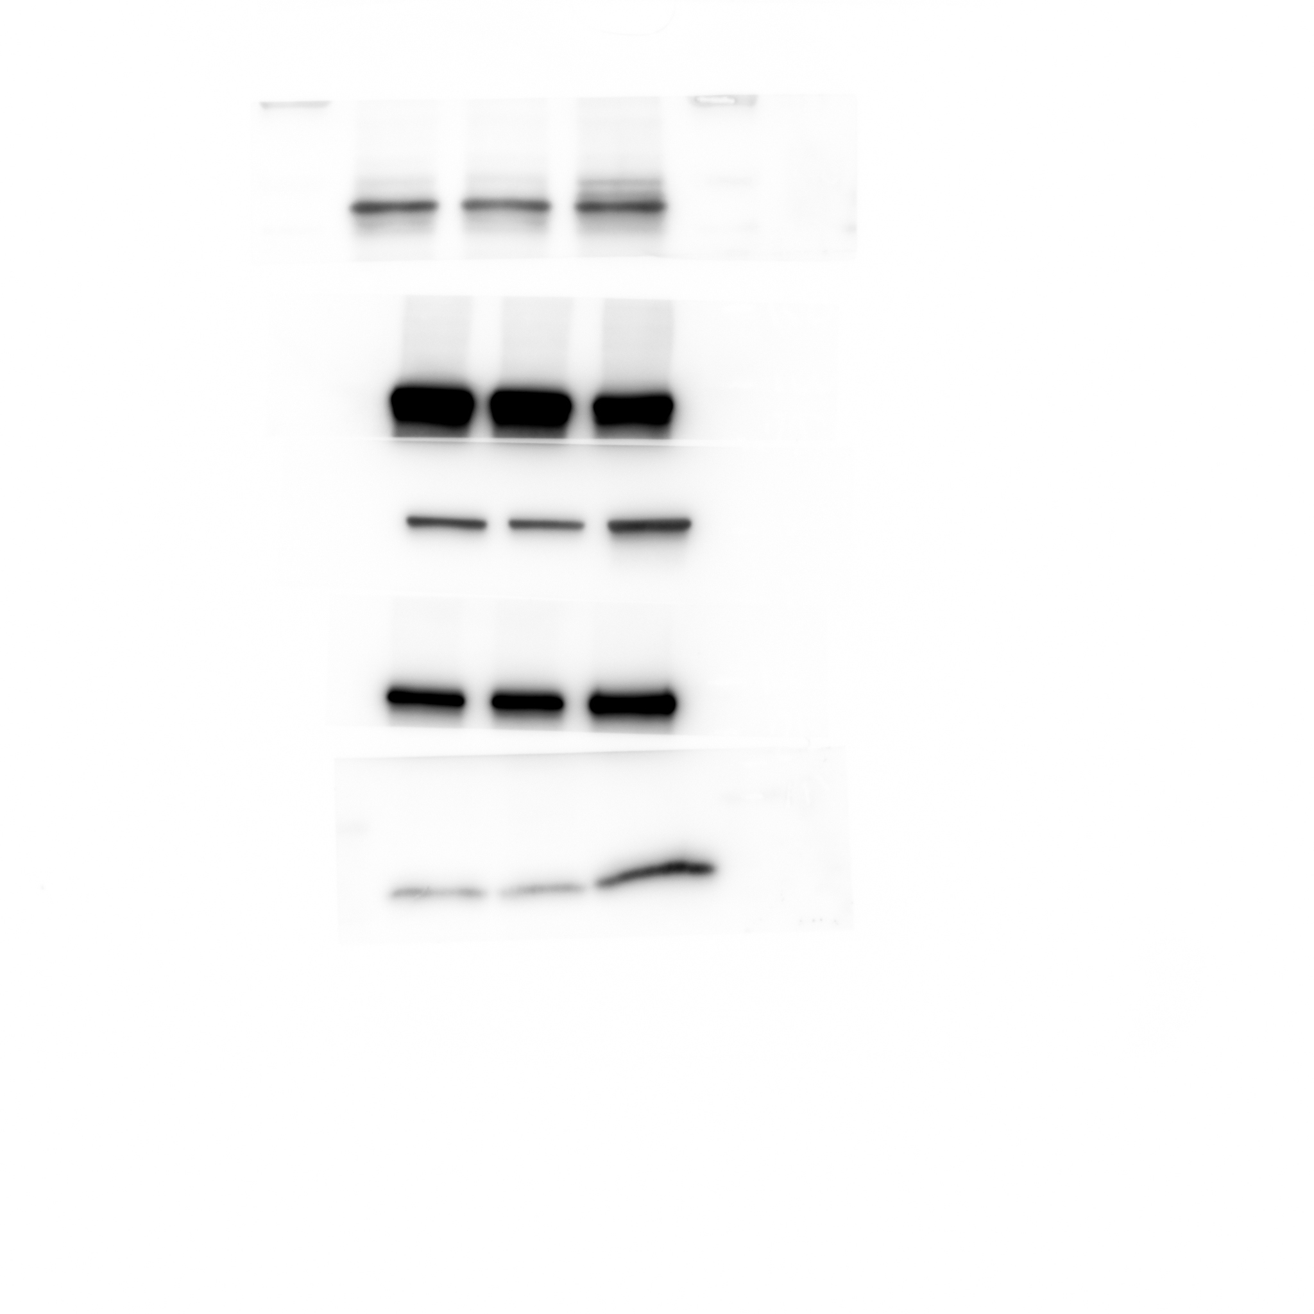
Western blot analysis of GSK3β protein levels in whole cell lysate of MCF7 cells expressing either the control vector or HTR2C.

Figure 5F_GAPDH_source data
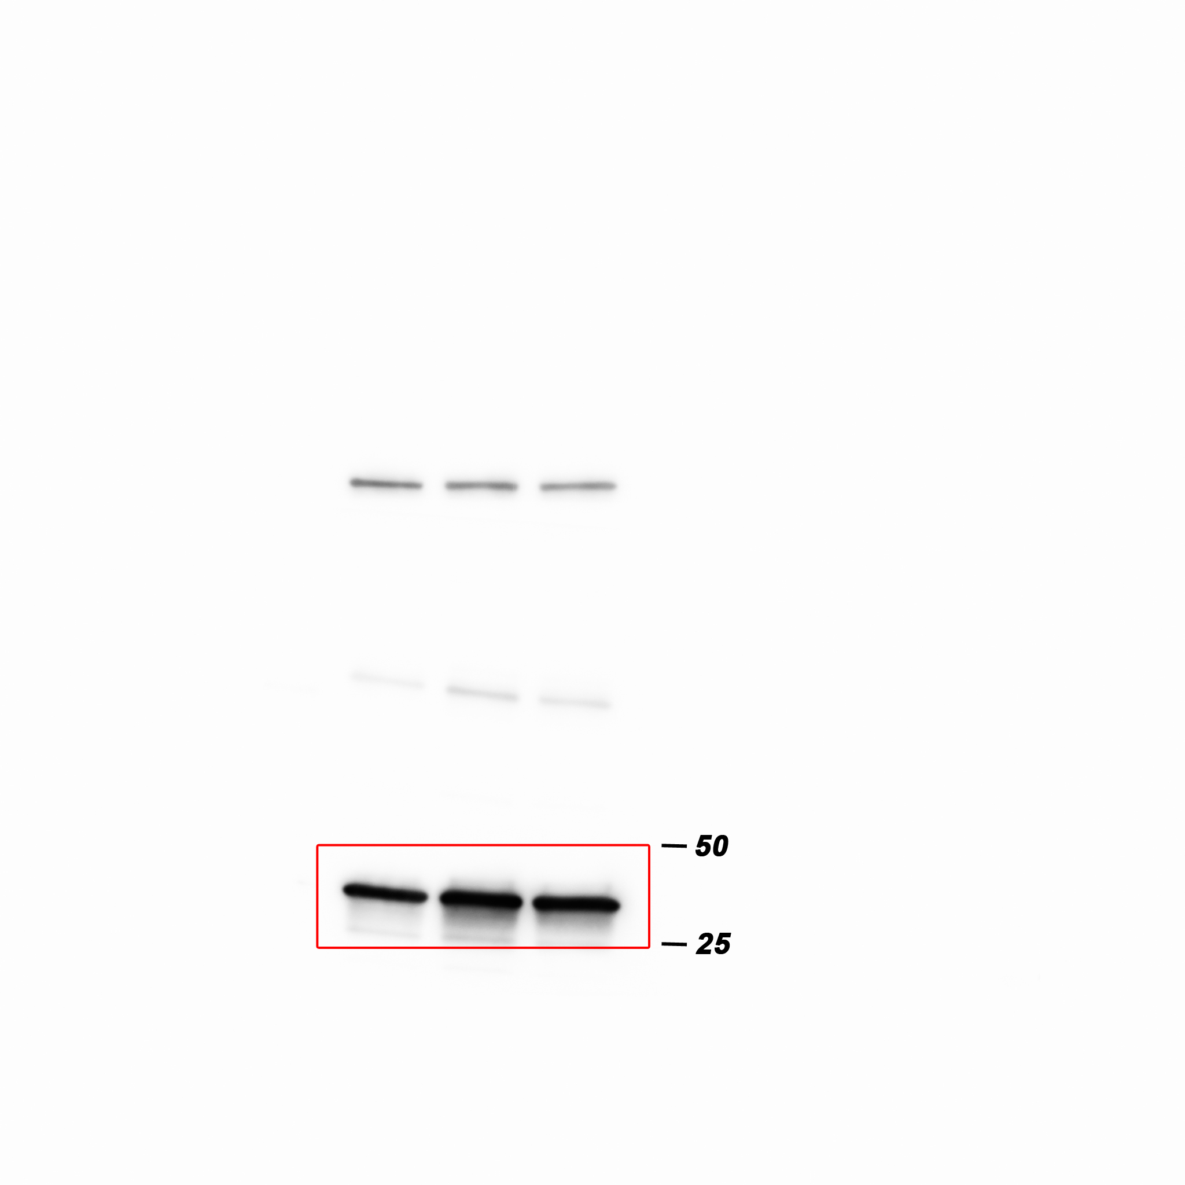
Western blot analysis of GAPDH protein levels in whole cell lysate of MCF7 cells expressing either the control vector or HTR2C.

Figure 5H_β-catenin in the nucleus_source data
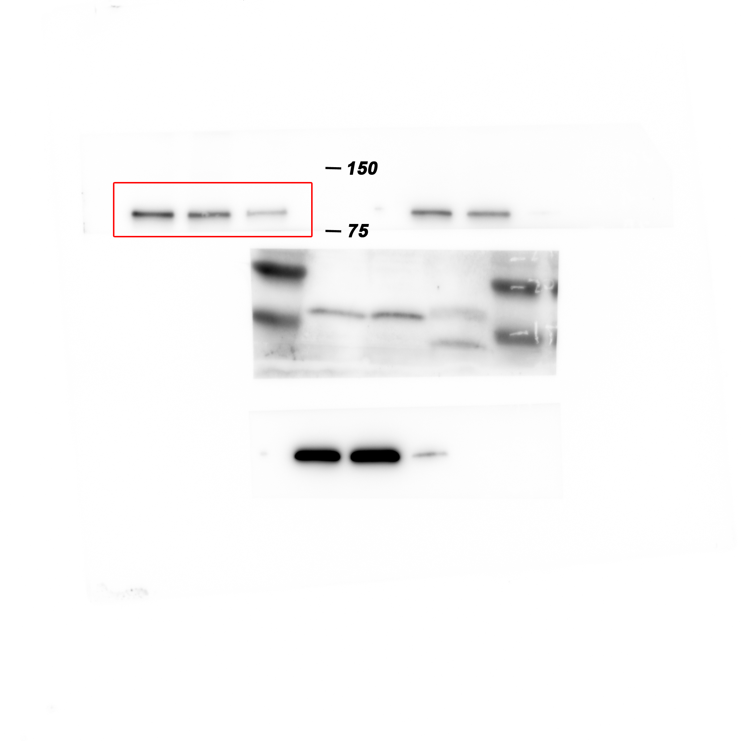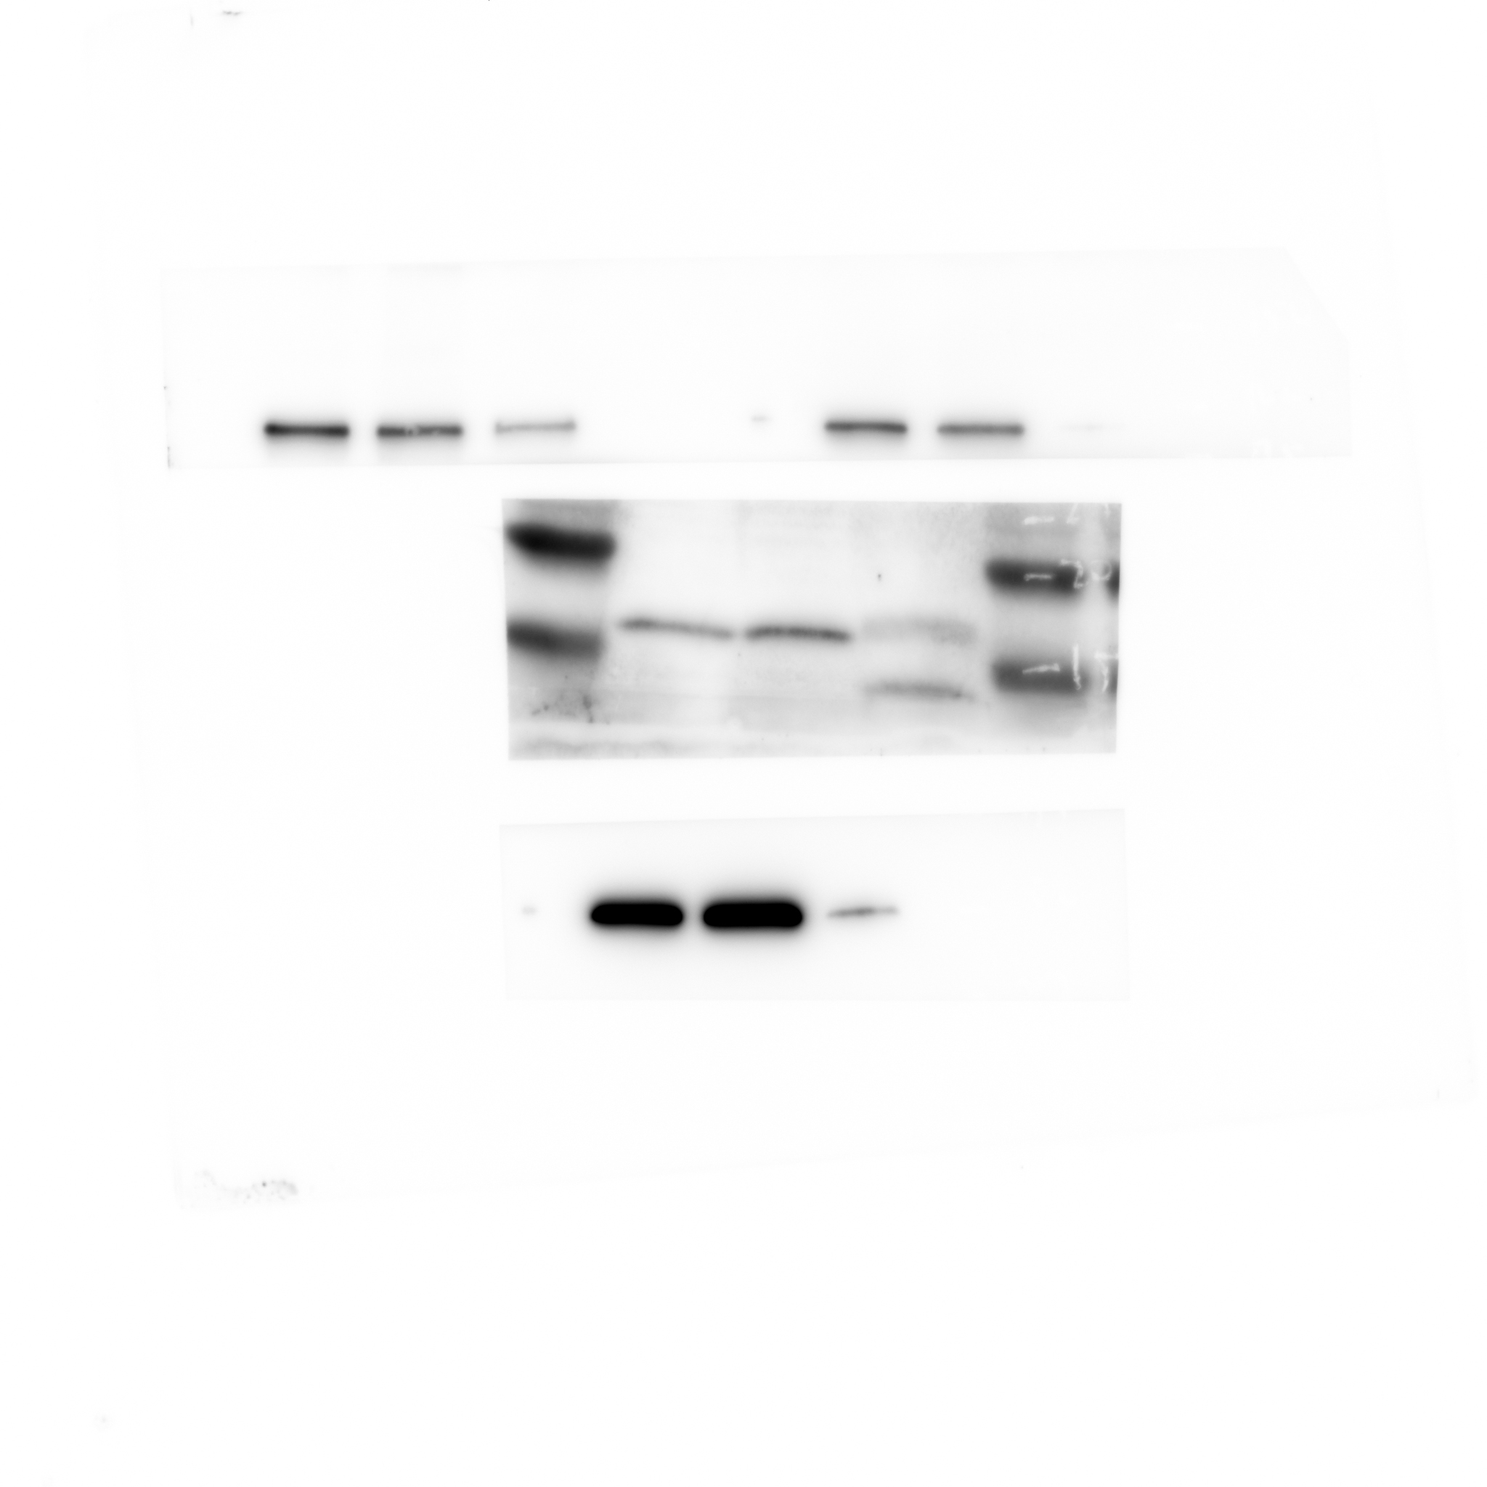
Western blot analysis of β-catenin protein levels in the nucleus of either vehicle or Pizotifen-treated MDA-MB-231 cells or E-cadherin positive cells in Pizotifen-treated MDA-MB-231 cells.

Figure 5H_Histone H3 in the nucleus _source data
Western blot analysis of Histone H3 protein levels in the nucleus of either vehicle or Pizotifen-treated MDA-MB-231 cells or E-cadherin positive cells in Pizotifen-treated MDA-MB-231 cells.

Figure 5H_β-catenin in the cytoplasm_source data
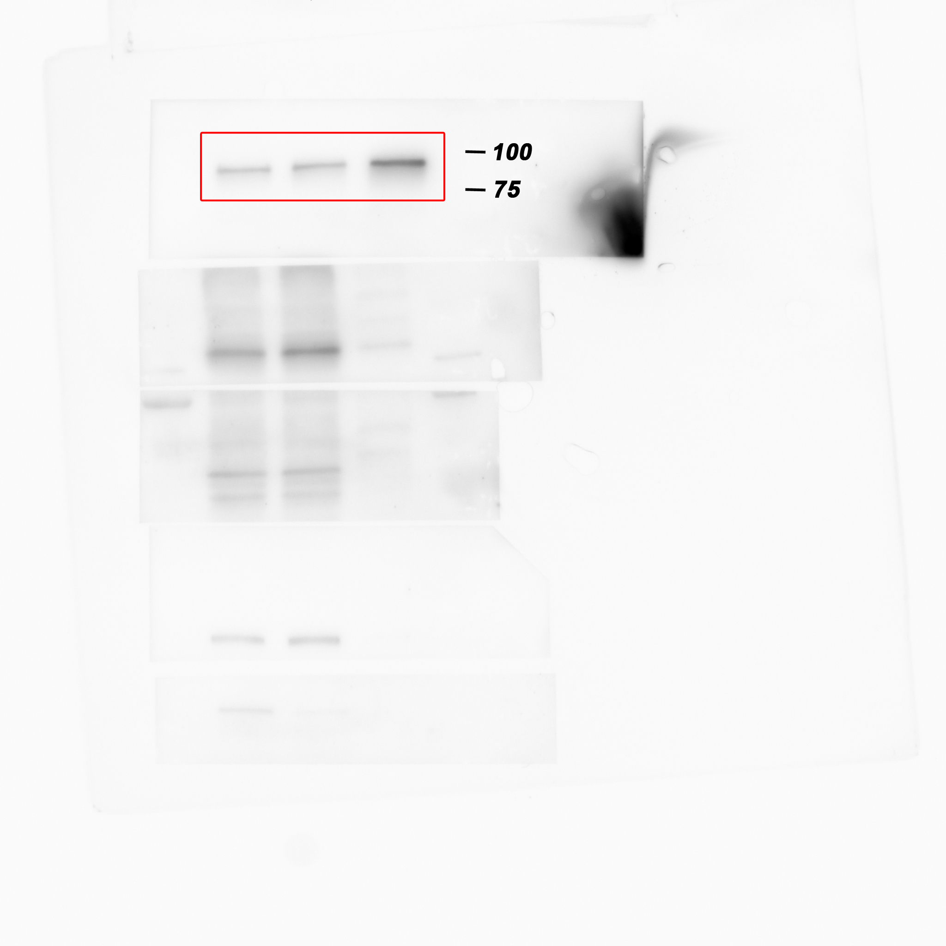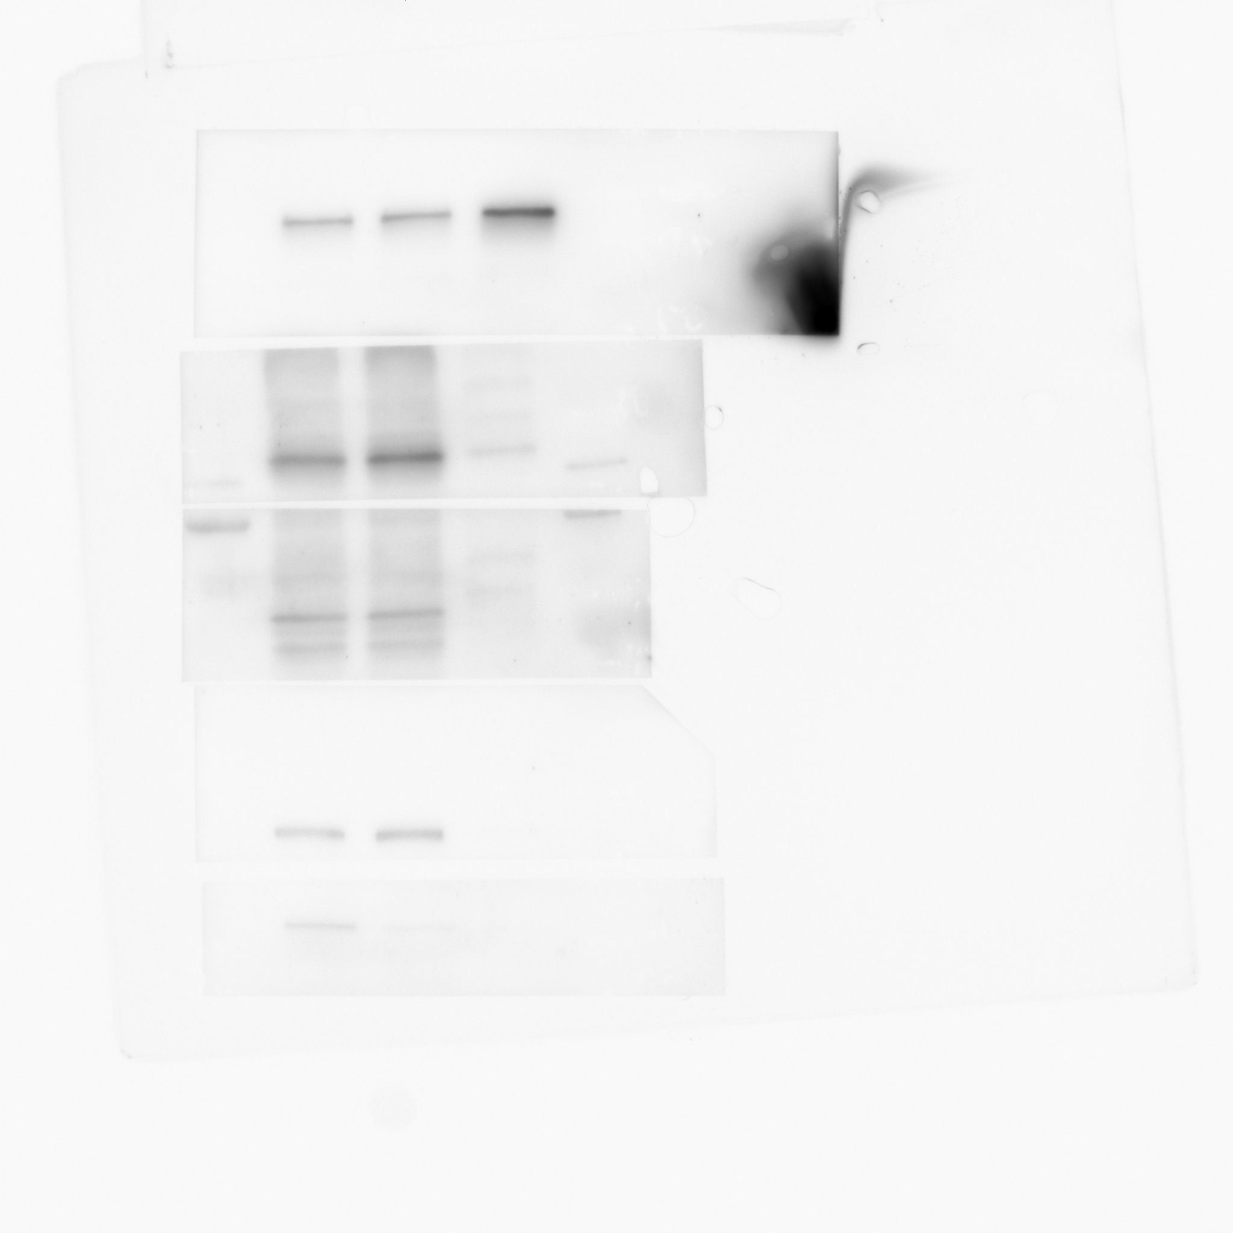
Western blot analysis of β-catenin protein levels in the cytoplasm of either vehicle or Pizotifen-treated MDA-MB-231 cells or E-cadherin positive cells in Pizotifen-treated MDA-MB-231 cells.

Figure 5H_β-tubulin in the cytoplasm_source data
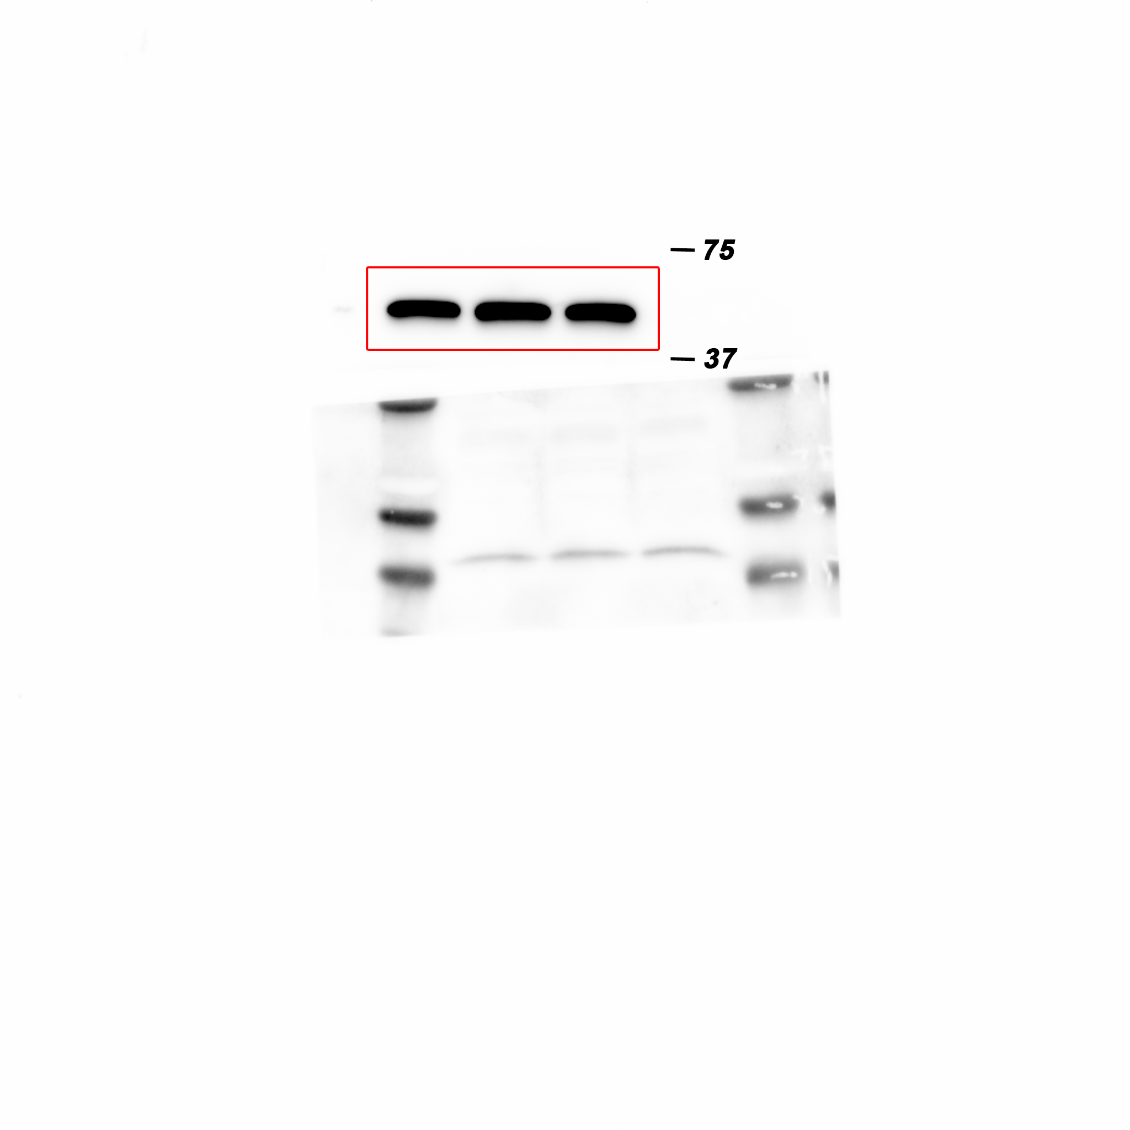
Western blot analysis of β-tubulin protein levels in the cytoplasm of either vehicle or Pizotifen-treated MDA-MB-231 cells or E-cadherin positive cells in Pizotifen-treated MDA-MB-231 cells.

Figure 5H_Phosphorylation of serine-9 in GSK3β_source data
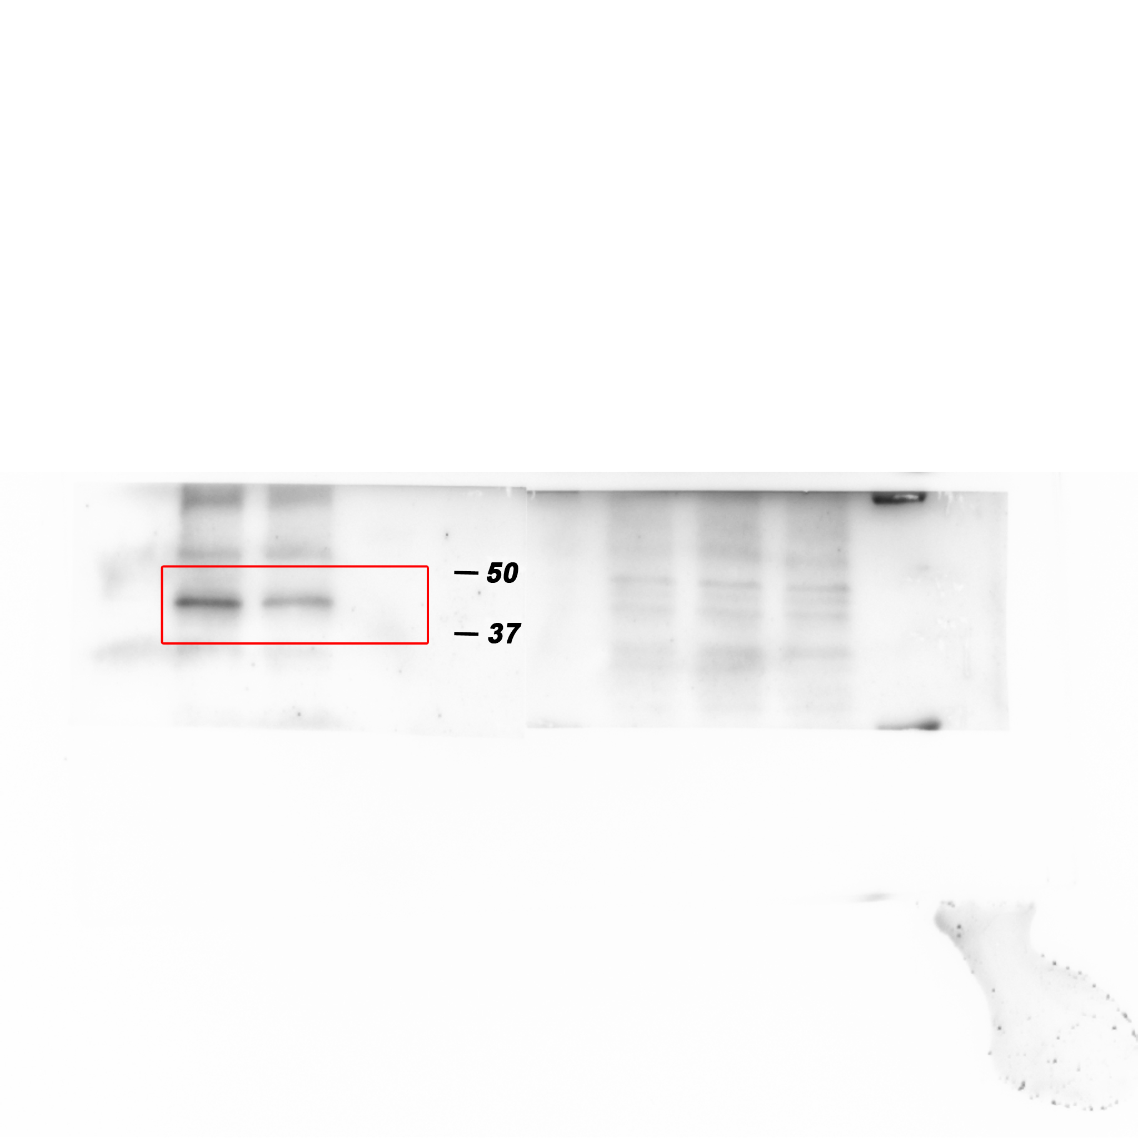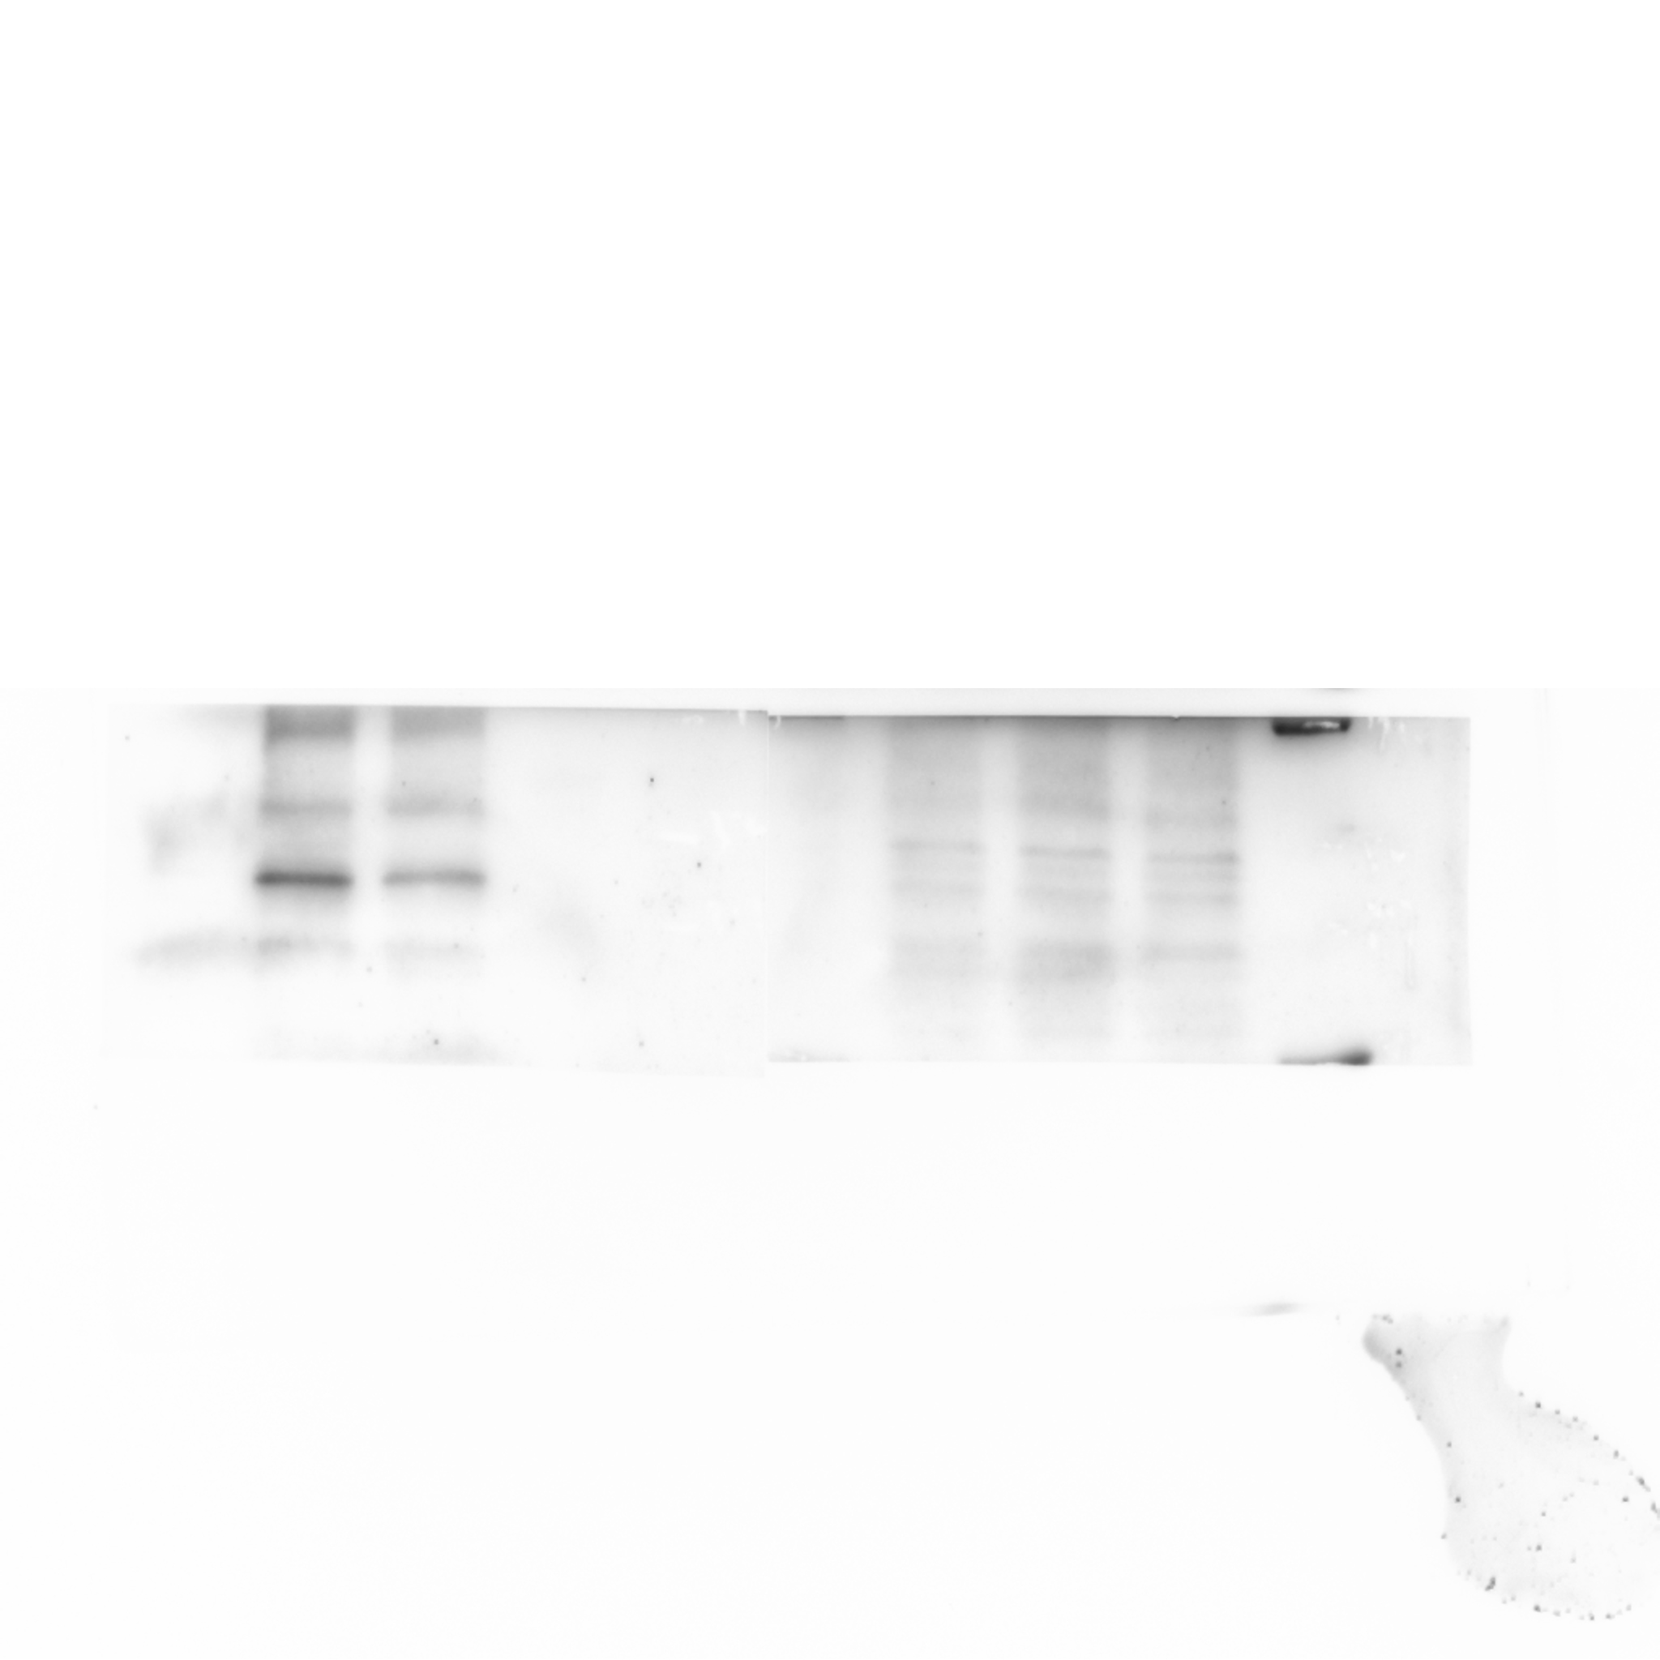
Western blot analysis of the protein levels of phosphorylation of serine-9 in GSK3β in whole cell lysate of either vehicle or Pizotifen-treated MDA-MB-231 cells or E-cadherin positive cells in Pizotifen-treated MDA-MB-231 cells.

Figure 5H_GSK3β_source data
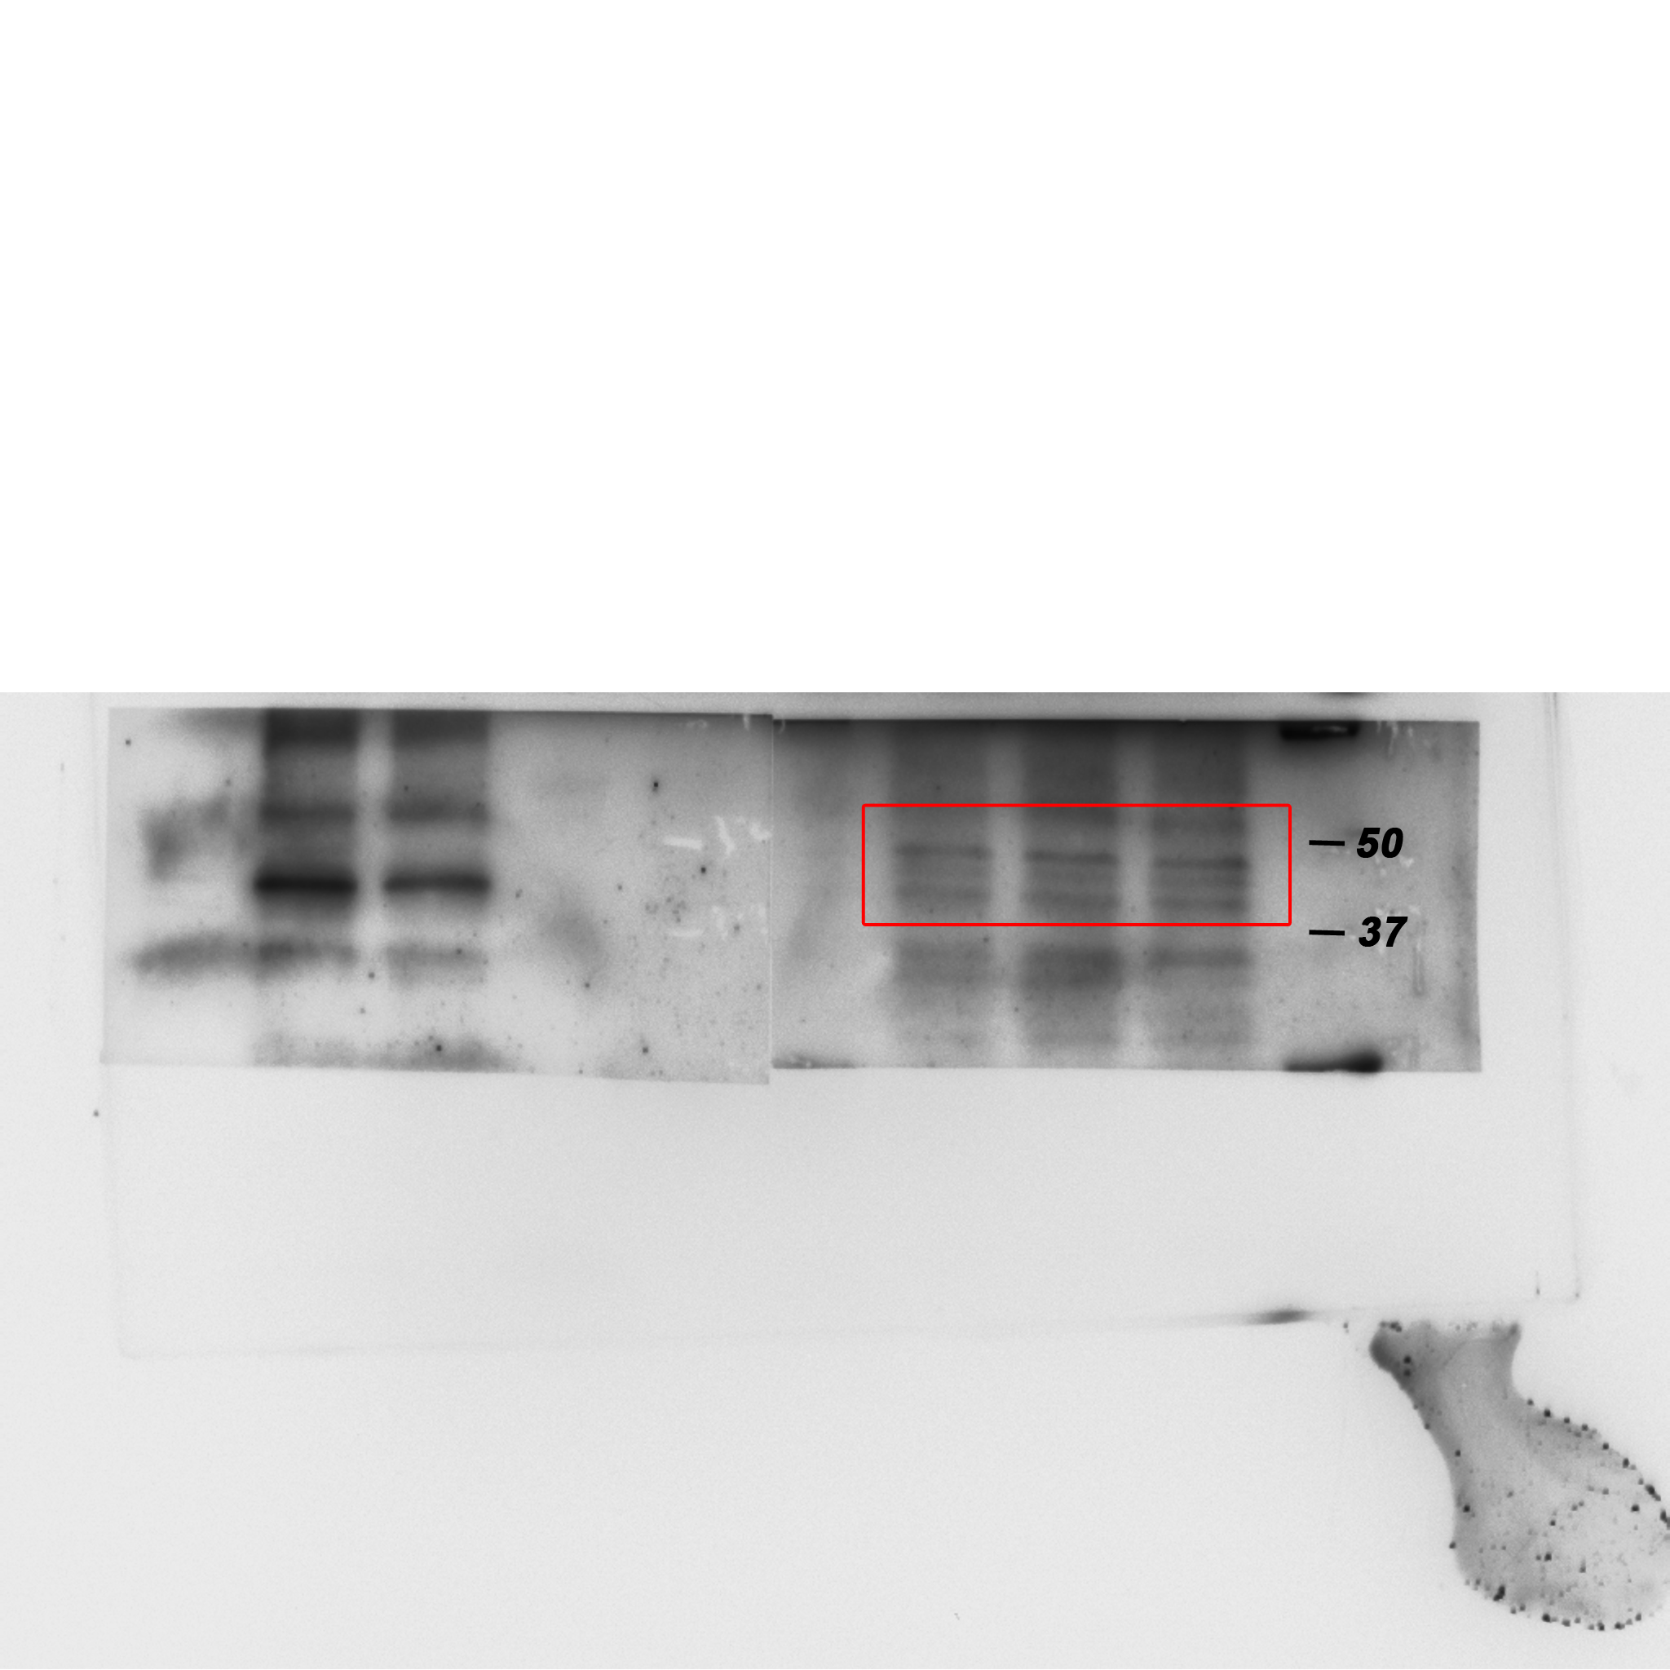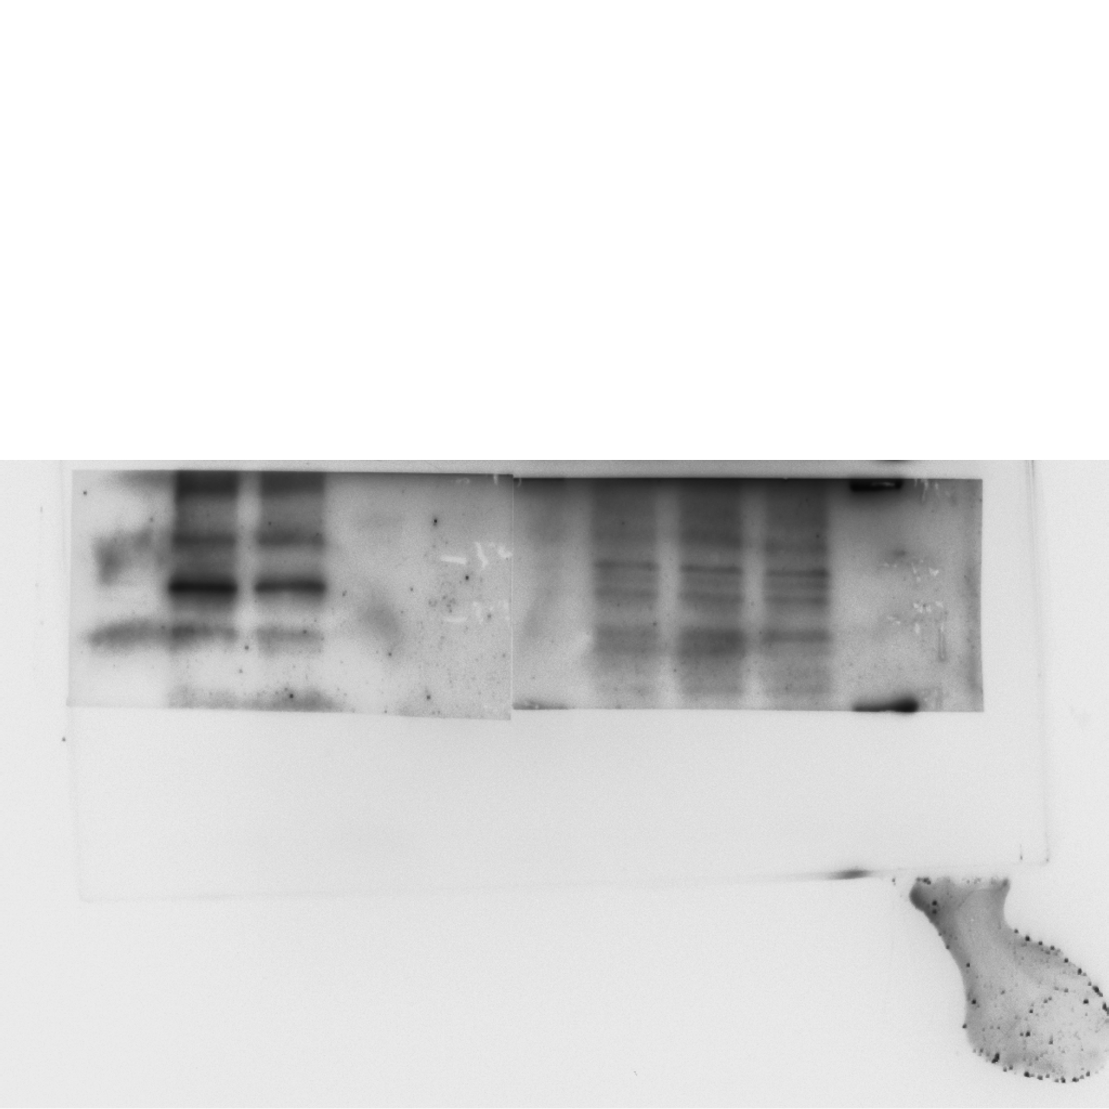
Western blot analysis of GSK3β protein levels in whole cell lysate of either vehicle or Pizotifen-treated MDA-MB-231 cells or E-cadherin positive cells in Pizotifen-treated MDA-MB-231 cells.

Figure 5H_GAPDH_source data
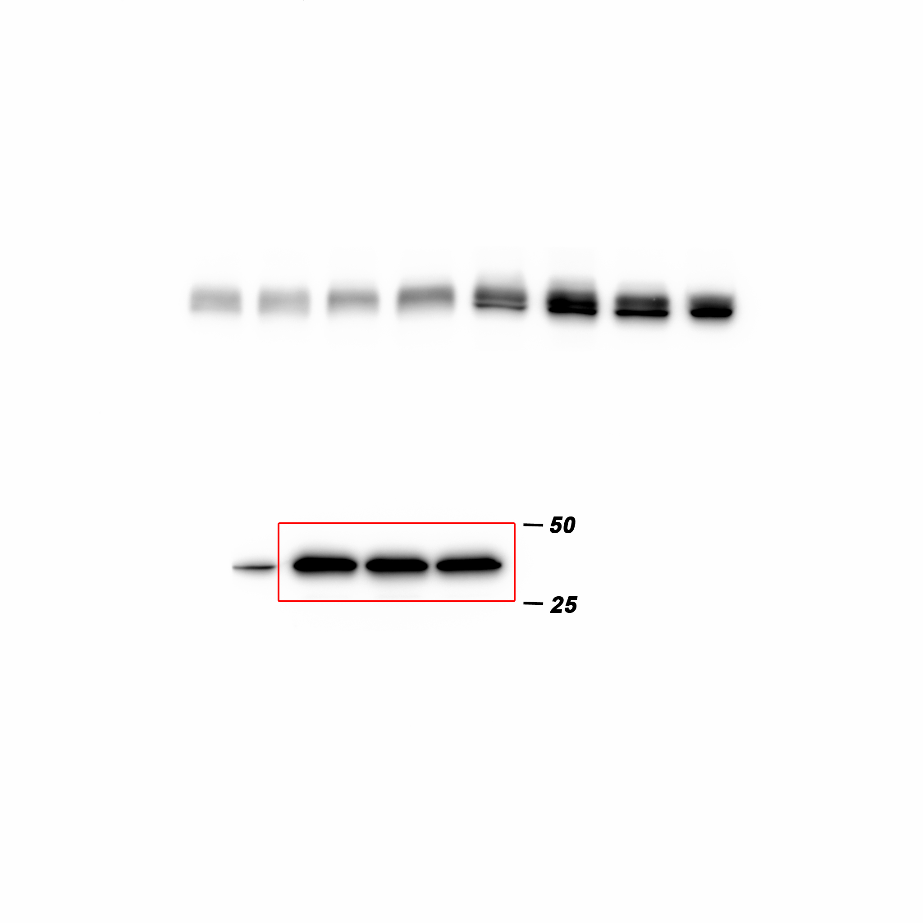
Western blot analysis of GAPDH protein levels in whole cell lysate of either vehicle or Pizotifen-treated MDA-MB-231 cells or E-cadherin positive cells in Pizotifen-treated MDA-MB-231 cells.

Figure 5-figure supplement 4_Snail (left) _source data
Western blot analysis of Snail protein levels in MCF7 cells expressing either the control vector or HTR2C.

Figure 5-figure supplement 4_ GAPDH in MCF7l (left) _source data
Western blot analysis of GAPDH protein levels in MCF7 cells expressing either the control vector or HTR2C. GAPDH control was obtained in the same experiment from Figure 4C.

Figure 5-figure supplement 4_Twist1 (left) _source data
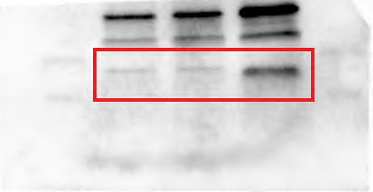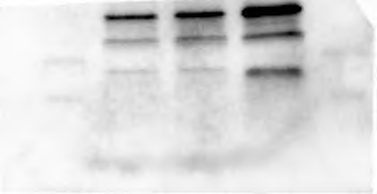
Western blot analysis of Twist1 protein levels in MCF7 cells expressing either the control vector or HTR2C.

Figure 5-figure supplement 4_Twist1 (middle)
Western blot analysis of Twist1 protein levels in either vehicle or Pizotifen-treated MDA-MB-231 cells.

Figure 5-figure supplement 4_GAPDH (middle) _source data
Western blot analysis of GAPDH protein levels in either vehicle or Pizotifen-treated MDA-MB-231 cells.

Figure 5-figure supplement 4_Snail (right) _source data
Western blot analysis of Snail protein levels in whole cell lysate of 4T1 primary tumors from either vehicle or Pizotifen-treated mice.

Figure 5-figure supplement 4_Twist1 (right) _source data
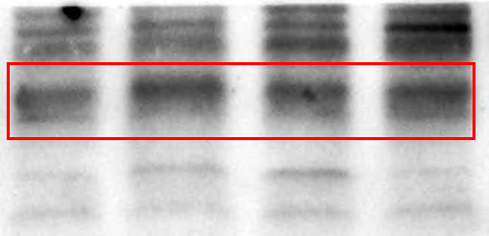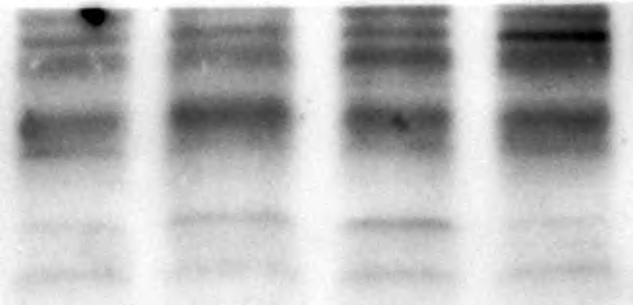
Western blot analysis of Twist1 protein levels in whole cell lysate of 4T1 primary tumors from either vehicle or Pizotifen-treated mice.

Figure 5-figure supplement 4_ Luciferase (right) _source data
Western blot analysis of Luciferase protein levels in whole cell lysate of 4T1 primary tumors from either vehicle or Pizotifen-treated mice. Luciferase control was obtained in the same experiment from Figure 5C.

