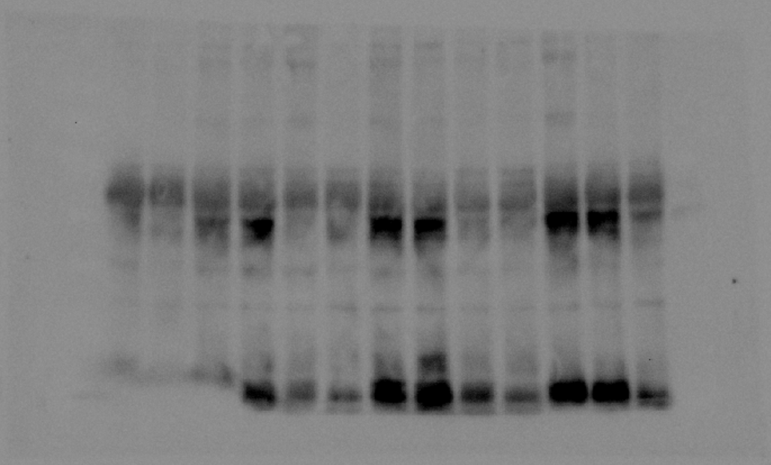
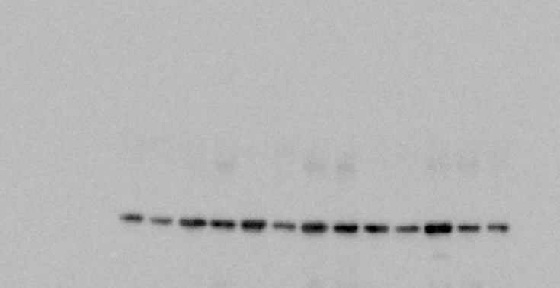
P21
GAPDH
21kDa
37kDa

Figure 1(i): Original uncropped blot of p21 and GAPDH. The yellow box represents the cropped region used for the manuscript.

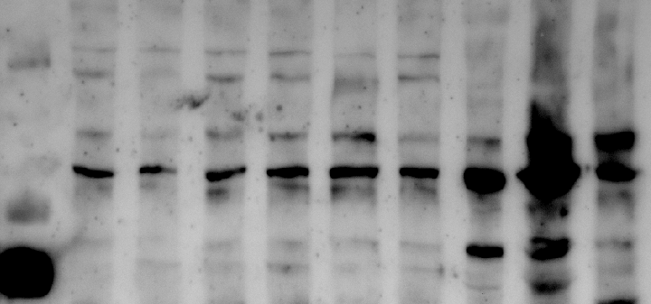
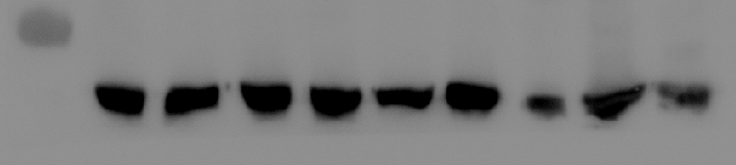
TRPM8
Tubulin
130kDa
100kDa
70kDa
70kDa

Figure 4(i): Original uncropped blot of TRPM8 and Tubulin. The yellow box represents the cropped region used for the manuscript.

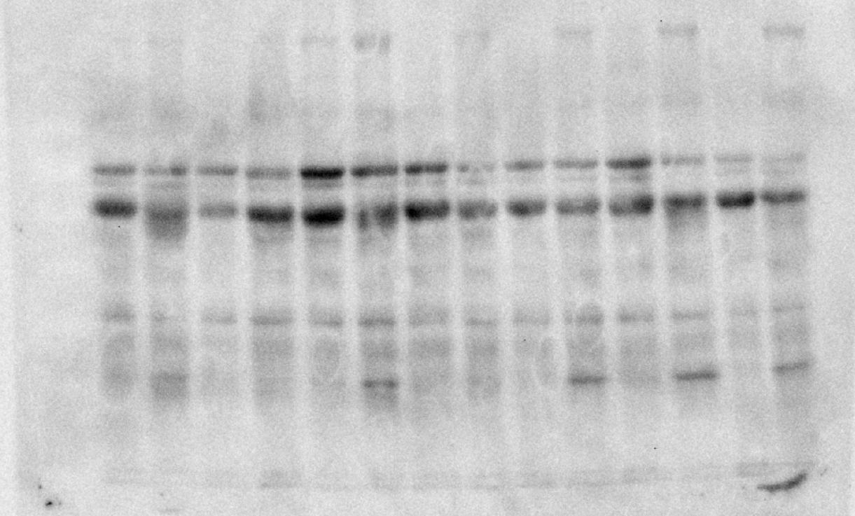
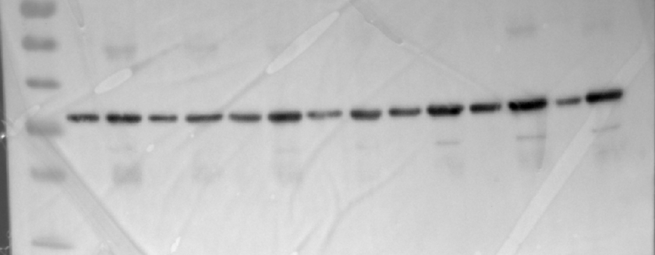
Alpha2c
GAPDH
35kDa
~55kDa

Figure 6(e): Original uncropped blot of alpha2c and GAPDH. The yellow box represents the cropped region used for the manuscript.

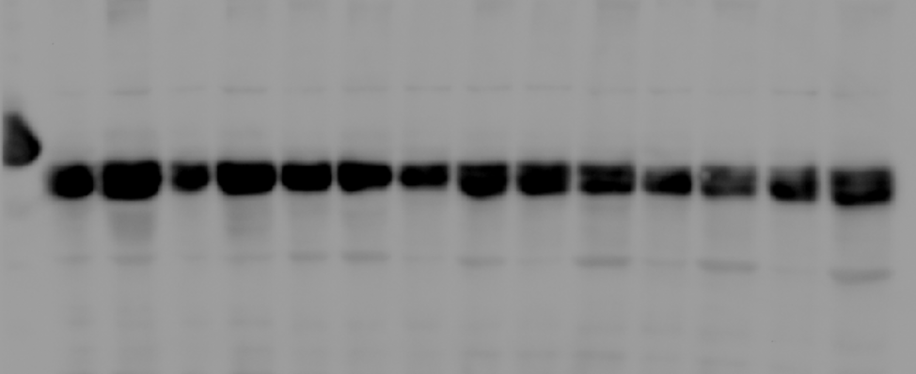
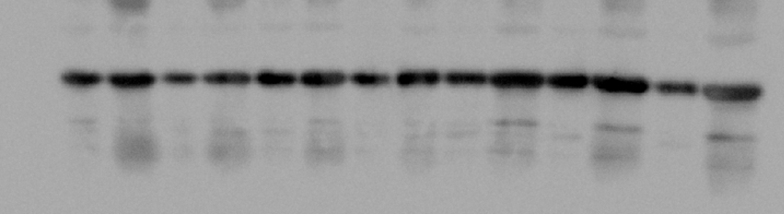
TH
GAPDH
70kDa
37kDa

Figure 6(f): Original uncropped blot of tyrosine hydroxylase (TH) and GAPDH. The yellow box represents the cropped region used for the manuscript.

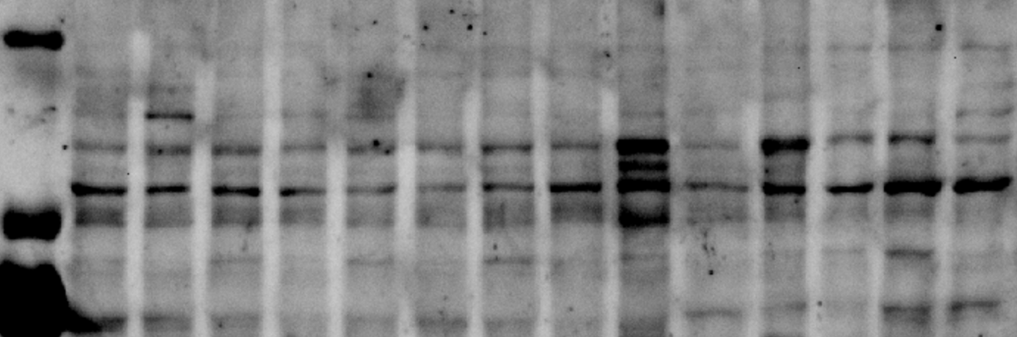
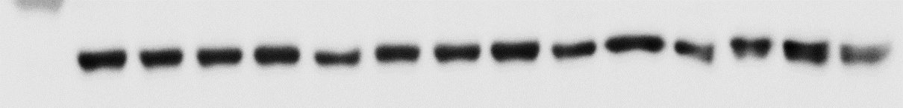
TRPM8
Tubulin
130kDa
100kDa
70kDa

Figure 7(c): Original uncropped blot of TRPM8 and Tubulin. The yellow box represents the cropped region used for the manuscript.

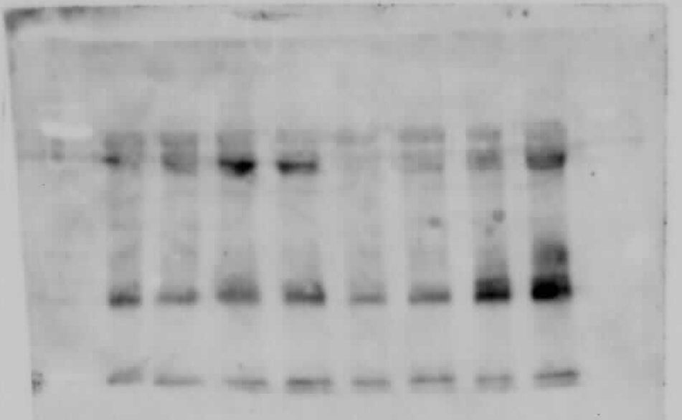
3-nitrotyrosine

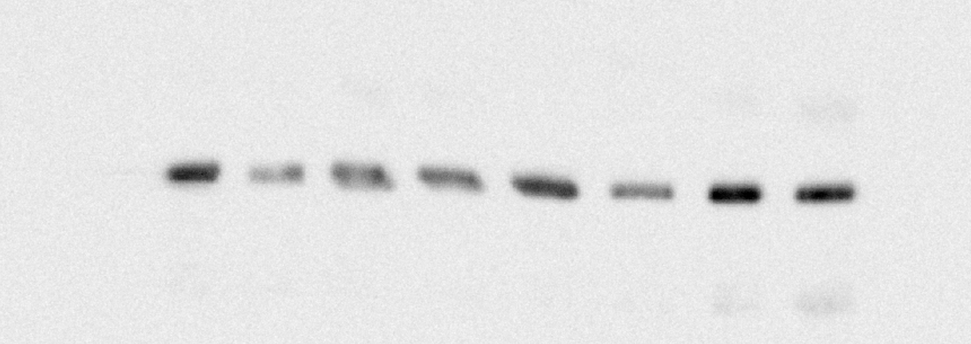
GAPDH
70kDa

Supplementary Figure 2(a): Original uncropped blot of 3-nitrotyrosine and GAPDH. The yellow box represents the cropped region used for the manuscript.

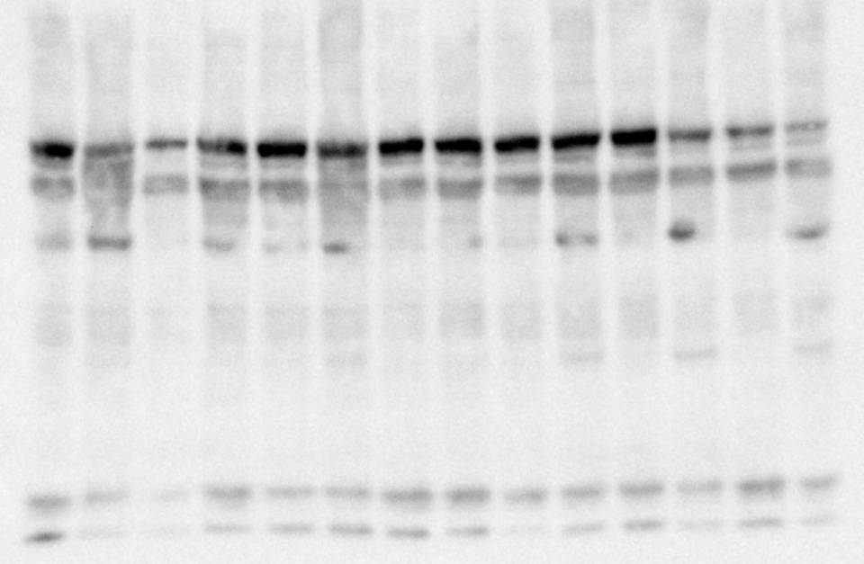
~60kDa
Phospho Tyrosine hydroxylase

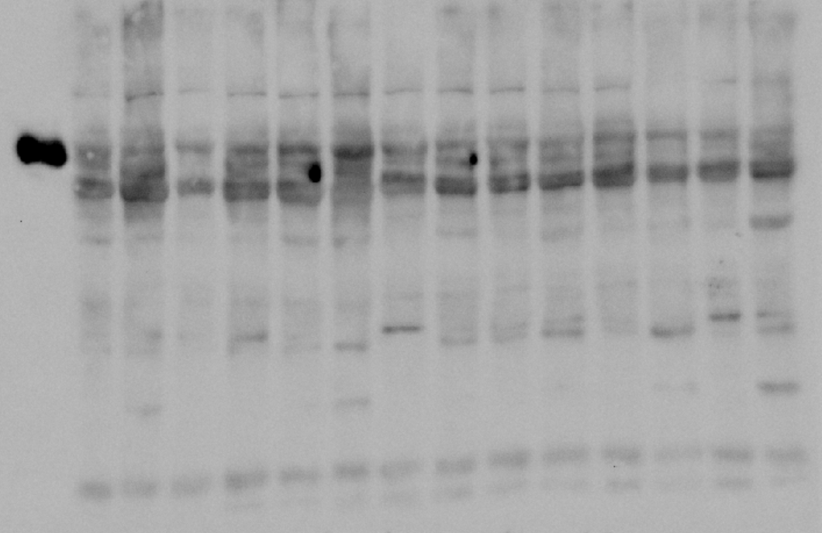
~60kDa
Tyrosine hydroxylase

Supplementary Figure 4: Original uncropped blot of phospho and total tyrosine hydroxylase. The yellow box represents the cropped region used for the manuscript.

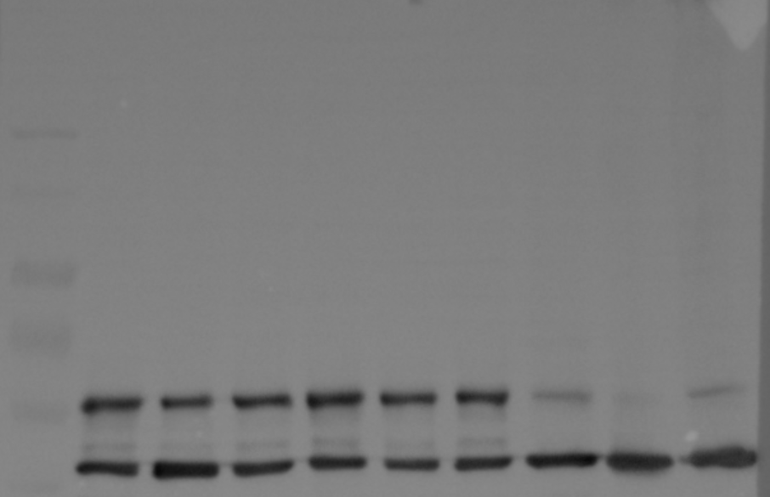
70kDa
55kDa
40kDa
Tyrosine hydroxylase
Actin

Supplementary Figure 6(b): Original uncropped blot of Tyrosine hydroxylase and Actin. The yellow box represents the cropped region used for the manuscript.

