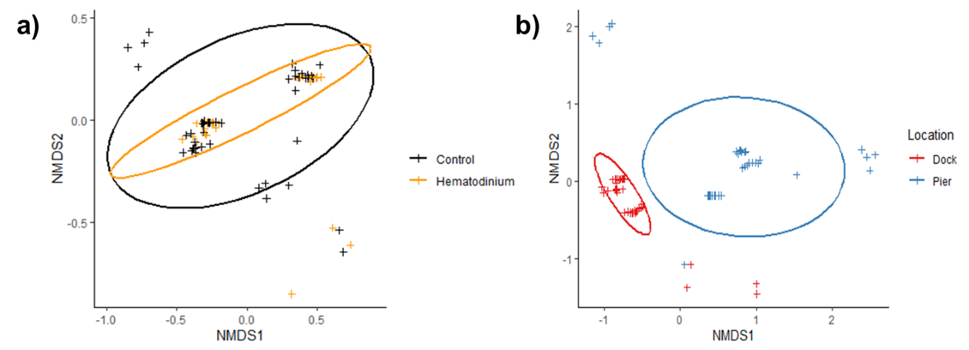
nMDS ordinations of parasite (co-infection) community structure excluding the crabs that were positive for PCR alone (i.e., subclinical infections). Data is derived from crabs assessed for Hematodinium using haemolymph inspection via phase contrast microscopy, gill/hepatopancreas using histology, and PCR (a). Non-metric multidimensional (nMDS) ordination co-infection/parasite (haplosporidia, microsporidia, Vibrio spp., fungal species, Sacculina carcini and trematodes) community structure in crabs that were Hematodinium sp. positive (orange) and Hematodinium sp. free (black – control). (b). Non-metric multidimensional (nMDS) ordination co-infection/parasite (haplosporidia, microsporidia, Vibrio spp., fungal species, Sacculina carcini and trematodes) community structure in crabs from Dock (red) and Pier (blue) locations. Analyses were done using square-root transformation of species’ abundances and Bray-Curtis similarity. Each point denotes an individual crab with one or more co-infections.

