Figure 1-Source Data 3
 | Model 1 | Model 2 | Model 2
Schematicª | 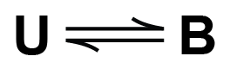 | 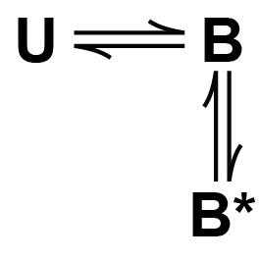 | 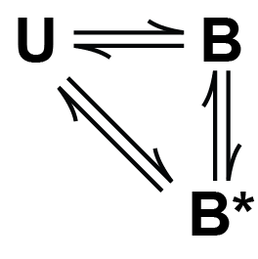
BIC^{b} | 3.72E+03 ± 2.12E+02 | 3.48E+03 ± 2.47E+02 | 3.54E+03 ± 2.49E+02
∆⟨BIC⟩^{c} | 249 | 0 | 691
Rates
U B (M⁻¹, s⁻¹) | 2.7E-03 ± 1.6E-04 | 3.2E-03 ± 2.0E-04 | 9.2E-05 ± 9.1E-05
B U (s⁻¹) | 3.8E-02 ± 2.2E-03 | 1.0E-01 ± 1.2E-02 | 5.1E-04 ± 5.1E-04
B B* (s⁻¹) |  | 8.4E-03 ± 3.2E-03 | 9.5E-03 ± 1.5E-03
B* B (s⁻¹) |  | 6.3E-03 ± 1.8E-03 | 1.5E-02 ± 4.4E-03
U B* (M⁻¹, s⁻¹) |  |  | 3.1E-03 ± 2.8E-04
B* U (s⁻¹) |  |  | 1.3E-01 ± 1.6E-02
ª U is unbound, B is short-lived bound state, and B* is the long-lived bound state.
^{b} Values reported as mean ± standard deviation of Bayesian information criterion (BIC) scores across a 5-fold resampling of the data
^{c} Average BIC score across resampled data minus the minimum average BIC score.

