Physical- Objects
 | # voxels: mean ± sem 273 ± 57.9 | # voxels: mean ± sem 64.2 ± 13.6
within | 0.72 | 0.42
between | 0.58 | 0.37
 | p = 0.011 | p = 0.18
within | 0.66 | 0.36
between | 0.57 | 0.29
 | p = 0.002 | p = 0.27
within | 0.54 | 0.51
between | 0.59 | 0.51
 | p = 0.31 | p = 0.88

Physical- People

Animals- People

Parietal Physics ROI
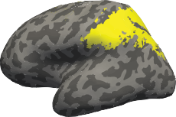

Frontal Physics ROI
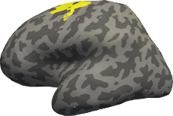

Physical- People

Animals- People

Physical- Objects

Physical- Objects

Physical- People

Animals- People
within between

within between
1.13 | 1.25
1.02 | 1.16
p = 0.077 | p = 0.19
1.20 | 1.28
1.12 | 1.17
p = 0.18 | p = 0.16
1.06 | 1.24
0.99 | 1.27
p = 0.37 | p = 0.77

within between

