Average beta estimates

Physical- Objects
 | # voxels: mean ± sem 273 ± 57.9 | # voxels: mean ± sem 64.2 ± 13.6
unstable | 0.16 | 1.75
stable | -0.03 | 1.8
 | p = 0.02 | p = 0.43
unstable | 0.21 | 1.93
stable | 0.03 | 1.95
 | p = 0.04 | p = 0.7
unstable | 0.075 | 2.08
stable | 0.095 | 2.2
 | p = 0.67 | p = 0.09

Physical- People

Animals- People

Parietal Physics ROI

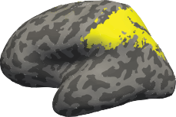

Frontal Physics ROI

