Source data for Figure 1A, 1B and 1D. Cropped regions are shown by boxes.

Figure 1A_Gel #1 and Figure 1B_Gel #1

20
50
Mw
(kDa)
15
75
37
25
10

Figure 1A_Gel #2 and Figure 1A_Gel #3

Mw
(kDa)
15
10
50
37
75
20
25

Figure 1B_Gel #2 and Figure 1B_Gel #3
Mw
(kDa)
15
10
37
50
75
20
25

Figure 1B_ Gel #4
Mw
(kDa)
15
10
37
75
20
25
50

Figure 1D_Gel #1
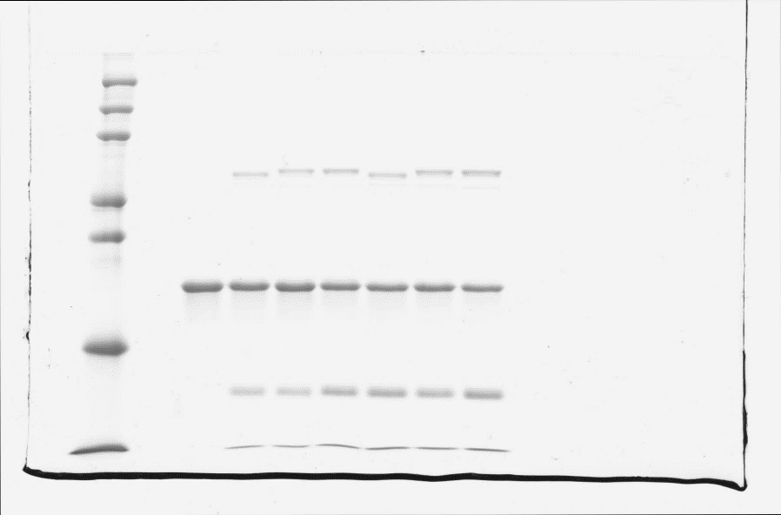
Mw
(kDa)
10
20
40
120
80
60
30

Replicate for Figure 1D_Gel #1 (Not shown in manuscript)

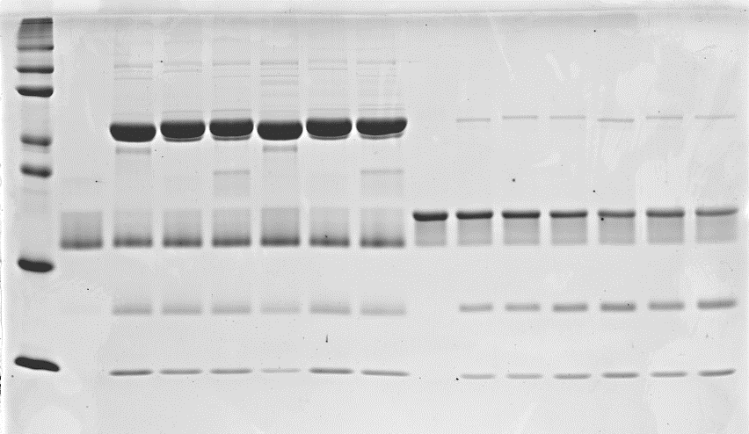
Mw
(kDa)
60
80
10
20
40
120
30

Figure 1D_Gel #2

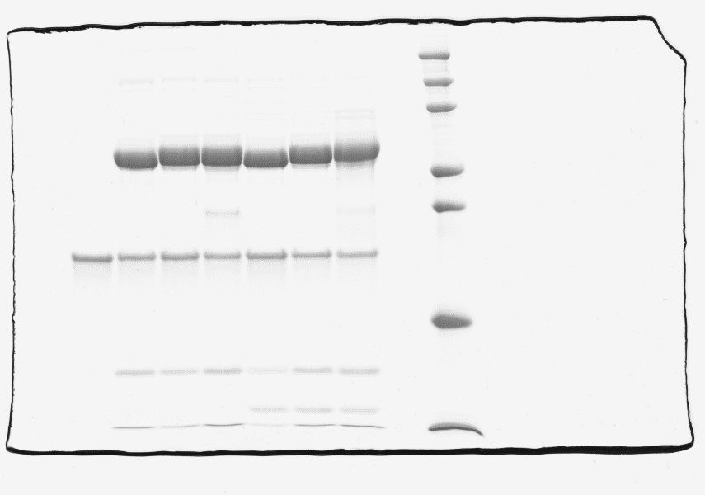
Mw
(kDa)
10
20
40
120
80
60
30

Replicate for Figure 1D_Gel #2 (Not shown in manuscript)
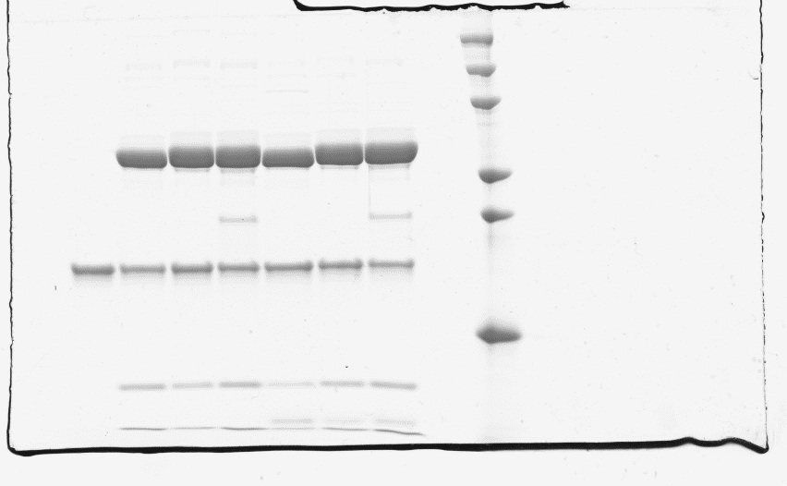
Mw
(kDa)
10
20
40
120
60
30
80

