Source data for Figure 1-figure supplement 1 (B)
“Cropped regions are shown by boxes”
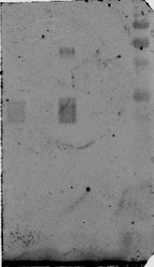
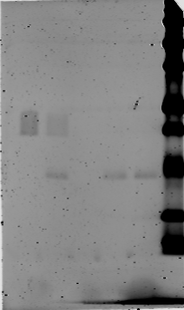
Blot: K48 (Green)

