Source data for Figure 4 and the cropped regions are shown by boxes

Source data for Figure 4A
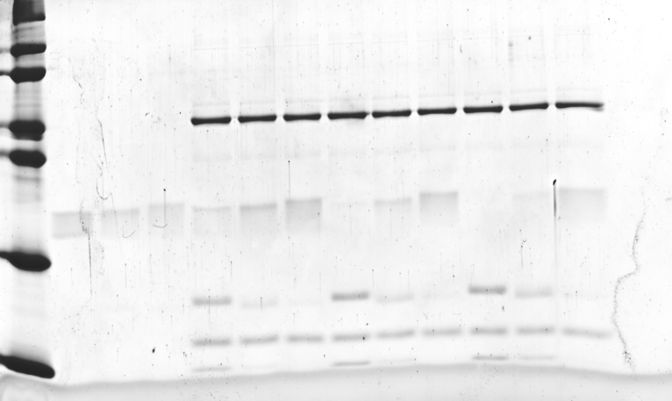

Source data for Figure 4C

Source data for Figure 4D
