Source data for Figure 5E and 5F. Cropped regions are shown by boxes.

Source data for Figure 5E and 5F.

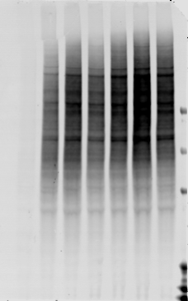

Blot: K11/48

Blot: K48

Total protein staining prior to K48 (left) or K11/48 blot (right)

101520 total protein

Source data for Figure 5F.

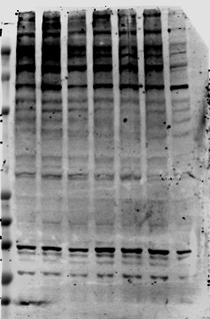

Blot: FK2

Blot: K63

Total protein staining prior to FK2 blot

Total protein staining prior to K63 blot

Replicates for Figure 5F (not shown in manuscript).

Blot: K63

Blot: K11/48

Blot: K48

Total protein staining prior to K48 blot membrane

Total protein staining prior to K11/48 blot

Total protein staining prior to K63 blot

Total protein staining prior to FK2 blot

Blot: FK2