Source data for Figure 5-figure supplement 1B. Cropped regions are shown by boxes.

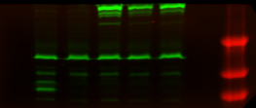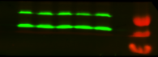

P KO WT C88A EWI

P KO WT C88A EWI

Blot: RPN2

\*

Blot: Uch37(Rb)

Blot: Rpn13

Blot: PSMB5 (20S)