Source data for Figure 6A & 6B & 6D. Cropped regions are shown by boxes.

Source for figure 6A

Blot: K11/48

Blot: FK2

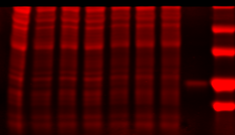

Total protein staining for FK2 blot

Total protein staining for K11/48 Ub blot

Blot: K48

Source data for Figure 6B

Blot: FK2

Blot: K48 Ub

Blot: K11/48 Ub

Blot: RPN2

Source data for Figure 6D

Input

Flag IP

Blot: Rad23B

Blot: Rad23B