Building a community to engineer synthetic cells and organelles from the bottom-up (Staufer et al. 2021 eLife 10:e73556)

Supplementary file 1

Table S1. Presentations at SynCell2020.
Table S2. Presentations at the SynCell2021 Spring Lecture Series with Build-A-Cell.
Table S3. Featured and Contributed Oral Presentations at SynCell2021.
Table S4. Poster Presentations at SynCell2021.
Table S5. Lightning Talks at SynCell2021. (Presenters chosen by jury from poster presenters.)
Box S1. Quotations from the early-career panelists of the SynCell20/21 workshop.
Box S2. Quotations from the early-career panelists of the SynCell20/21 workshop on the future challenges in the field.

Table S1. Presentations at SynCell2020.

Presenter | Type | Title | Date | Youtube Link
Reinhard Lipowsky | Tutorial | Understanding and controlling the morphological complexity of biomembranes | 5/26/2020 | https://www.youtube.com/watch?v=V5kHvKBevrM
Karin Jacobs | Tutorial | Unspecific interactions in or of cell-like compartments: theory & experiments | 5/26/2020
Michael Grunze | Program Highlight | Max Planck Matter-to-Life School | 5/26/2020
Joachim Spatz | Keynote | Bottom-up assembly of a cell | 5/26/2020
Darko Stefanovic | Tutorial | Development and application of DNA in nanoscale robotics | 5/27/2020 | https://www.youtube.com/watch?v=FM-70enAeFo
Jim Werner | Tutorial | Methods to visualize 3D dynamics | 5/27/2020
Marileen Dogterom | Program Highlight | BaSyC | 5/27/2020
Marileen Dogterom | Keynote | Building a functional cytoskeleton in synthetic cells | 5/27/2020
Drew Endy | Keynote | Upwelling — Challenges arising from the bottom of Earth’s life well | 5/28/2020 | https://www.youtube.com/watch?v=SyqalYP-bFg
Laura De Laporte | Tutorial | Synthetic building blocks to grow functional tissues | 5/28/2020
Nick Carroll | Tutorial | Liquid/liquid phase separation of intrinsically disordered proteins | 5/28/2020
Kate Adamala | Program Highlight | Build-a-Cell | 5/28/2020
Andrew Ellington  Kate Adamala  Eberhard Bodenschatz  Michael Grunze | Panel Discussion | Future synthetic cell technologies for mitigation of viral pandemics | 5/28/2020

Table S2. Presentations at the SynCell2021 Spring Lecture Series with Build-A-Cell.
Presenter | Title | Date | Youtube Link
Michael Jewett | Cell-free systems for synthetic cells, on-demand biomanufacturing, molecular sensing, and education | 3/15/2021 | Not posted.
Judee Sharon | DNA-mediated inducible liposome fusion | 3/15/2021 | https://www.youtube.com/watch?v=VmGcd-Dn4gs&t=1s
Ramin Golestanian | How living matter self-organizes while breaking action-reaction symmetry | 3/22/2021 | https://www.youtube.com/watch?v=djrwu4tL8go&t=1207s
Jan Steinkühler | Controlled division of cell-sized vesicles by low densities of membrane-bound proteins | 3/22/2021 | https://www.youtube.com/watch?v=eq_aojgf-Vo&t=1097s
Clyde Hutchison | Essential universal tasks for a minimal living cell | 3/29/2021 | https://www.youtube.com/watch?v=8cCj-SuMM5o&t=2156s
Oskar Stauffer | Bottom-up assembly of functional fully-synthetic extracellular vesicles | 3/29/2021 | https://www.youtube.com/watch?v=wSHczi0RKwM
Eberhard Bodenschatz | Synthonems: building synthetic cilia from the bottom up | 4/5/2021 | https://www.youtube.com/watch?v=DknSmix52Ck&t=133s
Lado Otrin | Artificial mitochondrion, bottom-up! | 4/5/2021 | https://www.youtube.com/watch?v=-RZdhF_X2W0
Felipe Garcia Quiroz | Membraneless and stimuli-responsive organelles | 4/12/2021 | https://www.youtube.com/watch?v=TPF9V20YW7c&t=1305s
Cesar Rodriguez-Emmenegger | Superselectivity in synthetic protocells | 4/12/2021 | https://www.youtube.com/watch?v=TPX0-c1Dxbc
Phillipe Bastiaens | A synthetic morphogenic perceptory system | 4/19/2021 | https://www.youtube.com/watch?v=qu6Akbg7FDM&t=455s
Zachary Manzer | Creating Biomimetic Interfaces Using the Cell-Free Synthesis of Transmembrane Proteins | 4/19/2021 | https://www.youtube.com/watch?v=GV5Ko-giT98
Andrew Ellington | Cell free operating systems for diagnostics | 4/26/2021 | https://www.youtube.com/watch?v=itZFfBC9Ihc&t=1575s
Amelie Benk | Controlled linkage of different proteins in Synthetic Cells | 4/26/2021 | Not posted.
Hendrik Dietz | Designing biomolecular devices and machines | 5/4/2021 | https://www.youtube.com/watch?v=g3FDadvwbAE
Kevin Jahnke | Proton gradients from light-harvesting E. coli control DNA assemblies for synthetic cells | 5/4/2021 | https://www.youtube.com/watch?v=s5ITxtjx9Fc
Neal Devaraj | Lipid sponge droplets as programmable synthetic organelles | 5/10/2021 | https://www.youtube.com/watch?v=9eBRysSAWXQ
Emiliano Altamura | Light-driven ATP production promotes mRNA biosynthesis inside hybrid multi-compartment artificial protocells | 5/10/2021 | https://www.youtube.com/watch?v=P__aO639YJY
Joachim Spatz | Mechanism in collective organizations of living and synthetic cells | 5/17/2021 | Not posted.
Ilia Platzman | Microfluidic approaches towards reconstitution of synthetic cells motility | 5/17/2021 | Not posted.

Table S3. Featured and Contributed Oral Presentations at SynCell2021.
Presenter | Type | Title | Date | Youtube Link
Neha Kamat | Featured | Membranes matter: designing bilayer membranes to control functions of artificial cells | 5/19/2021 | https://www.youtube.com/watch?v=h5abE8fBDRA&t=3467s
Jacqueline De Lora | Contributed | Rational design for assembly of biologically inspired compartments | 5/19/2021
Kerstin Gopfrich | Featured | A shortcut towards synthetic cell division | 5/19/2021
Matthew Good | Contributed | Engineered synthetic membraneless organelles built from self-assembling disordered proteins to regulate cellular function | 5/19/2021
Matt Lakin | Featured | Information processing in synthetic cells | 5/19/2021
Alisina Bazrafshan | Contributed | Programmable DNA origami motors | 5/19/2021
Kate Adamala | Featured | Lineage agnostic biology | 5/20/2021 | https://www.youtube.com/watch?v=tsez_iAzJ5E
Michael Levy | Contributed | Cell-free autonomous biogenesis of a ribosomal subunit | 5/20/2021
James Carothers | Featured | Synthetic cell systems for scalable bio-production of plant natural products | 5/20/2021
Eleonora Bailoni | Contributed | A multi-chamber flow dialysis setup for energy homeostasis in synthetic cells | 5/20/2021
Tobias Erb | Featured | Fixing CO2 fixation: Building an artificial chloroplast drop by drop | 5/20/2021
Roseanna Zia | Contributed | Cellular Stokesian dynamics”: a computational model for biological cells | 5/20/2021

Table S4. Poster Presentations at SynCell2021.
Presenter | Type | Title | Date | Youtube Link
Alessandra Griffo | Poster | Insights on the effect of cholesterol and sphingomyelin on tension and elasticity of plasma-like freestanding model membranes from natural lipids | 05/18/21 - 05/19/21 | https://www.youtube.com/watch?v=VnCqOzcBCSA
Jimin Guo | Poster | Biomimetic rebuilding of multifunctional red blood cells | 05/18/21 - 05/19/21 | https://www.youtube.com/watch?v=_-rhtpkVwHE
Paola Albanese | Poster | Single compartment approach for photo-autotrophic protocell preparation | 05/18/21 - 05/19/21 | https://www.youtube.com/watch?v=U_TaK9Z2WfI
Roberto Javier Brea Fernandez | Poster | Chemoselective generation of dynamic synthetic cells | 05/18/21 - 05/19/21 | https://www.youtube.com/watch?v=-zMyvdkDSaM
Ahanjit Bhattacharya | Poster | Lipid Sponge Droplets as Programmable Synthetic Organelles | 05/18/21 - 05/19/21 | https://www.youtube.com/watch?v=XeXkc-C6wNY
Telmo Diez Perez | Poster | Recombinant Intrinsically Disordered Proteins for Triggered Sequestration of Nucleic Acids via Liquid-Liquid Phase Separation | 05/18/21 - 05/19/21 | https://www.youtube.com/watch?v=pa-iR9_5KpE
Nika Marušič | Poster | Charge vs. SNARE-mediated fusion of biomimetic polymer/lipid hybrid compartments: Which one is more efficient? | 05/18/21 - 05/19/21 | https://www.youtube.com/watch?v=s0cSmIih6SA
Sadaf Pashapour | Poster | Generation of Extracellular Matrix Protein-based Microcapsules for Investigating Single Cells | 05/18/21 - 05/19/21 | https://www.youtube.com/watch?v=XJoB_rkwJtM
Tobias Neckernuss | Poster | Monitor, categorize and manipulate label-free water-in-oil droplets in microfluidic systems | 05/18/21 - 05/19/21 | https://www.youtube.com/watch?v=ggcjzq2yZyg
James Hindley | Poster | Building mechanosensitive signalling pathways in synthetic cells using membrane engineering | 05/18/21 - 05/19/21 | https://www.youtube.com/watch?v=9SxuHz9WfCk
Jefferson Smith | Poster | Light-activated gene expression in synthetic cells | 05/18/21 - 05/19/21 | https://www.youtube.com/watch?v=Lzx-Zl-8tC8
Michele Partipilo | Poster | A minimal pathway for the regeneration of redox cofactors | 05/18/21 - 05/19/21 | https://www.youtube.com/watch?v=sBBj06mzJFo
Qi Wang | Poster | Influence of Breast Cancer Lipid Changes on Membrane Oxygen Permeability | 05/18/21 - 05/19/21 | https://www.youtube.com/watch?v=7GMO2YN_hcc
Marco de Oliveira | Poster | Genetic circuits based on serine-integrases as regulatory networks in the minimal cell Mycoplasma mycoides JCVI-Syn3A | 05/18/21 - 05/19/21 | https://www.youtube.com/watch?v=-stjWC7v-iQ
Satyam Khanal | Poster | Chemoenzymatic Generation of Phospholipid Membranes Mediated by Type I Fatty Acid Synthase | 05/18/21 - 05/19/21 | https://www.youtube.com/watch?v=a6BKQYCiHXo&feature=youtu.be
Hendrik Hähl | Poster | Pure protein bilayers and vesicles made from fungal hydrophobins: an alternative platform for synthetic cells | 05/18/21 - 05/19/21 | https://www.youtube.com/watch?v=2meKpdRZ6SE
Sebastian Restrepo-Cruz | Poster | Tetraspanin Scaffold Regulation of Epidermal Growth Factor Receptor Biology on the Plasma Membrane | 05/18/21 - 05/19/21 | Not posted.
Franky Djutanta | Poster | Hydrodynamically-active oily ocean surface as a cradle for the emergence of life | 05/18/21 - 05/19/21 | https://www.youtube.com/watch?v=TIC4bfBLBsY
Mark Walker | Poster | Engineering High Throughput Biosynthesis of Natural Product-Like Cyclic Peptides | 05/18/21 - 05/19/21 | https://www.youtube.com/watch?v=p-X8LUZjYC8

Table S5. Lightning Talks at SynCell2021. (Presenters chosen by jury from poster presenters.)
Presenter | Type | Title | Date | Youtube Link
Jefferson M. Smith | Lightning Talks | Light-activated gene expression in synthetic cells | 5/20/2021 | https://www.youtube.com/watch?v=vuwiYb5bUEE
Telmo Díez Pérez | Lightning Talks | Recombinant Intrinsically Disordered Proteins for Triggered Sequestration of Nucleic Acids via Liquid-Liquid Phase Separation | 5/20/2021
Sadaf Pashapour | Lightning Talks | Generation of Extracellular Matrix Protein-based Microcapsules for Investigating Single Cells | 5/20/2021
Hendrik Hähl | Lightning Talks | Pure protein bilayers and vesicles made from fungal hydrophobins: an alternative platform for synthetic cells | 5/20/2021

Box S1. Quotations from the early-career panelists of the SynCell20/21 workshop.

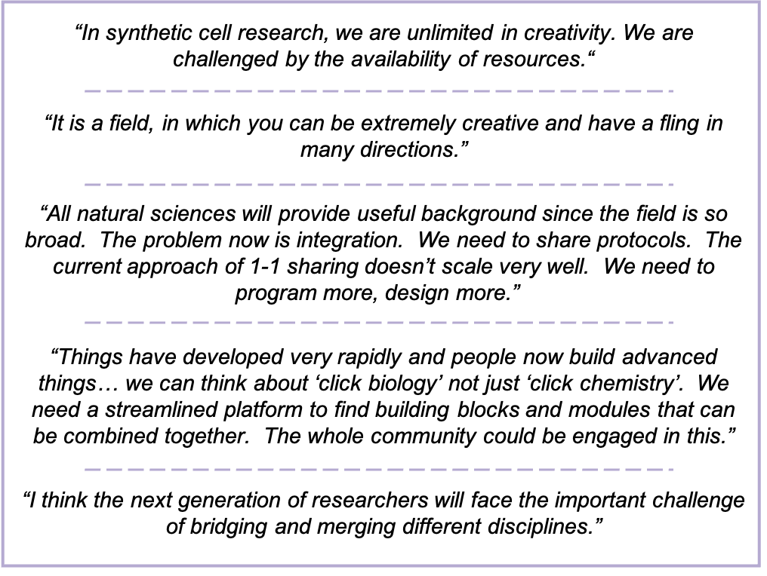

Box S2. Quotations from the early-career panelists of the SynCell20/21 workshop on the future challenges in the field.

