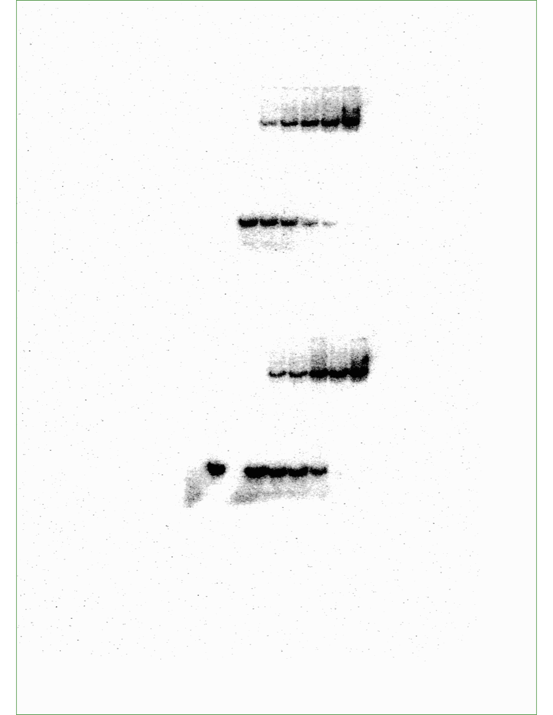
Source data for Figure 5 — figure supplement 10C: Gel shift data showing Reb1 binding to undamaged (top) and damaged (bottom) DNA. The bottom gel has an additional free DNA lane on the left, which was not shown in the final figure.

