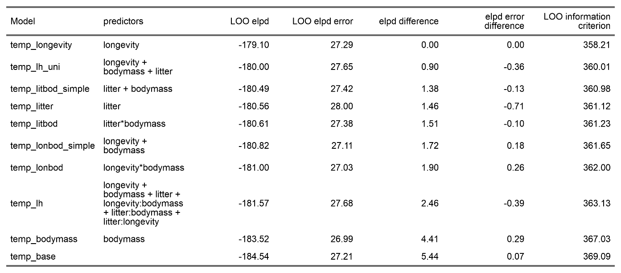
Supplementary File 1A: Table S1. Model selection results from Gamma models exploring the impact of life-history traits on absolute responses to temperature in the terrestrial mammals. Leave One Out (LOO) cross validation results for 10 candidate models including life-history traits relative to a base model excluding life-history traits. elpd = expected log pointwise predictive density.

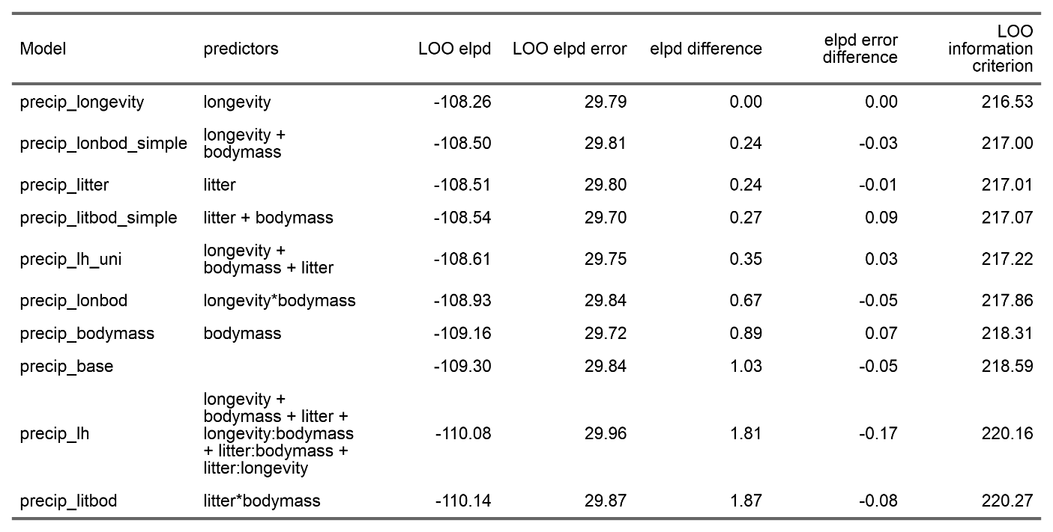
Supplementary File 1B: Table S2. Model selection results from Gamma models exploring the impact of life-history traits on absolute responses to precipitation in the terrestrial mammals. Leave One Out (LOO) cross validation results for 10 candidate models including life-history traits relative to a base model excluding life-history traits. elpd = expected log pointwise predictive density.

