Figure 3 - figure supplement 3 - source data 1
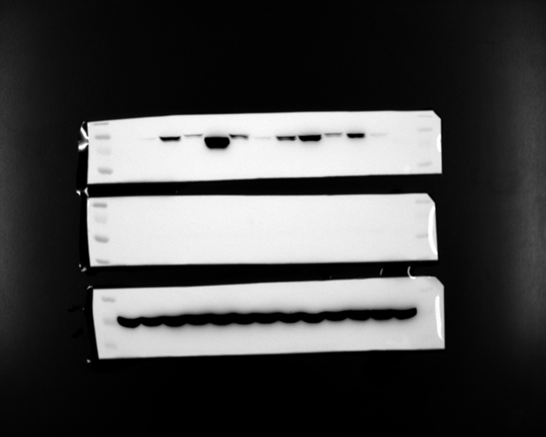
Figure 3 - figure supplement 3 - source data 1 Uncropped version of the Western blot. The overexpressed ALDP and mutation were confirmed by western blot. The upper band is anti-ALDP, the middle band is anti-Catalse, and the lower band is anti-GAPDH. The transfer results of anti-ALDP and anti-GAPDH from the same gel. GAPDH was used as loading control. Exposure time was 10min (left) and 30min(right).

