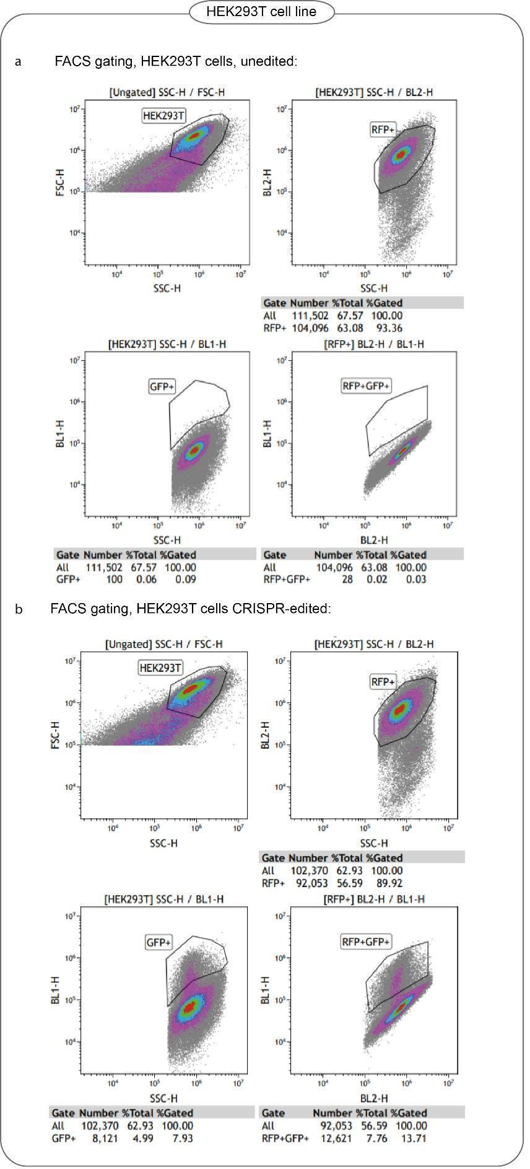
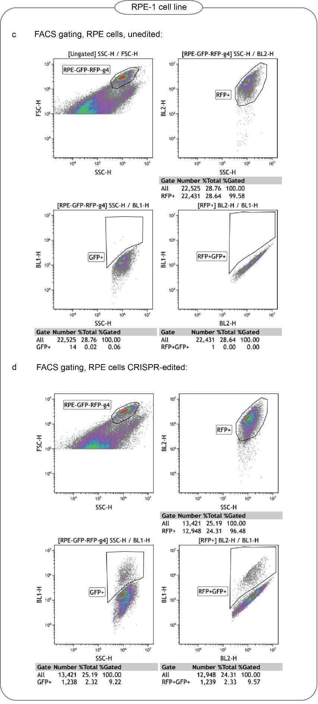
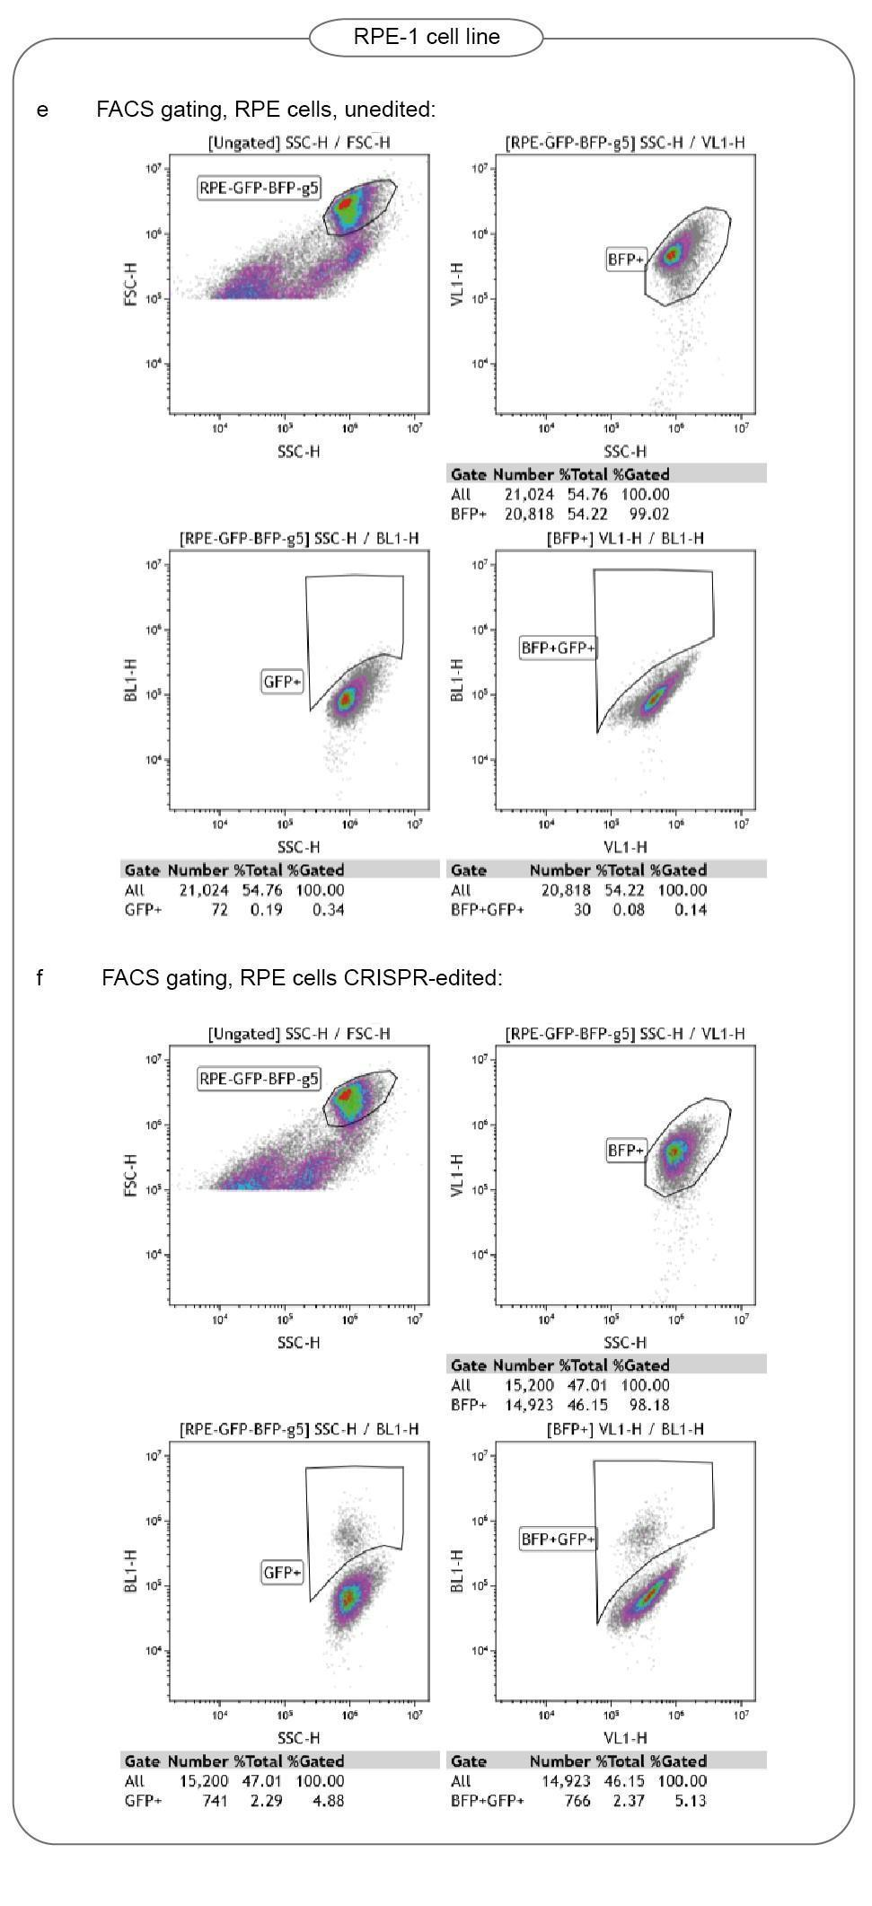
FACS gating strategy
a-b. HEK293T reporter cell line carrying mGFP-RFP color cassette. c-d. RPE-1 reporter cell line carrying mGFP-RFP color cassette. e-f. RPE-1 reporter cell line carrying mGFP-BFP color cassette.

