Supplementary File 1
1.1 Table of corresponding primers used.
Primer | Sequence (5’→ 3’)
lctBCD_pET21a_for | tttaagaaggagatatacatATGAAAATACTGGTATGTATCAAAC
lctBCD_pET21a_rev | acggagctcgaattcggatcCTACATCTGACAGACTTTTTTC
pet21a_for | GATCCGAATTCGAGCTCC
pet21a_rev | ATGTATATCTCCTTCTTAAAGTTAAAC
lctBCD_pMTL84211_fwd | ACCGCTATTGATGTTGCTCCGACGGAAGCCATTCTTCAGGAAGG
lctBCD_pMTL84211_rev | TCCAGCGTTTGTAGCTGCGTCACCAATAACCGCTATTTTATTTTCAATCGTGATG
pMTL84211_fwd | AGTTAGGGAATGTTACTTTGTAGTG
pMTL84211_rev | GGATCCGTCCTCCCTTTAAATTTAAC
∆Fe/S_for | gccaaaatggccaaaatggccCTTAAAAAAGGACCTGAAGGGG
∆Fe/S_rev | AGCTGCCGTGACTTCCAG
∆Fe/S-arm_for | GACAAAAGCTTATATCGG
∆Fe/S-arm_rev | CATGATTTTTTCCTTTCTAGCC
ΔR205_for | AGTTCAGATTgcaCCAGCTTTTG
ΔR205_rev | AAATCGGTGTTTTCTTTCATTTC
ΔD189_for | ACTTACCGCTggaTGTACCATTTTGGAAATG
ΔD189_rev | CCGGTTCGATAACGAGCC
Δβ-FAD_for | aggagcaggagcaGAAATGGCTGAATTTTTGGG
Δβ-FAD_rev | gctcctgctcctgcGGTGGTTTGTTTACCGCA
ΔNAD_for | aggcgcaGCCGATGTGGTAGCGACC
ΔNAD_rev | gcttttgcATCCGATAATAAACAACCCTCATCAG
ΔSPT_for | gcaggagcaCAGGTGGAACGAATTTTCC
ΔSPT_rev | TCCGCTCAGTCCATATTTTTTTTC
Strep-Tag_for | ccacagttcgagaagTAAGATGAATTATAAAAAAGTGGAAGC
Strep-Tag_rev | gtgggaccatgctgaAACGACCATCCTTTCCGG

Plasmids generated with exchanges in EtfA are pET21a_lctBCD[∆Fe/S](C41A, C44A, C47A), pET21a_lctBCD[∆Fe/S-arm](∆2A-65I), pMTL84211_lctBCD[∆Fe/S](C41A, C44A, C47A), pMTL84211_lctBCD[∆Fe/S-arm](∆2A-65I), pET21a_lctBCD[ΔR205](R205A) and pET21a_lctBCD[ΔD189](D189A). Plasmids generated with exchanges in EtfB are pET21a_lctBCD[Δb-FAD](D122A, D124A, T125G, Q127G, V128A, P130A), pET21a_lctBCD[ΔNAD](R87A, F89A, G91A) and pET21a_lctBCD[ΔSPT](S223A, P224G, T225A).

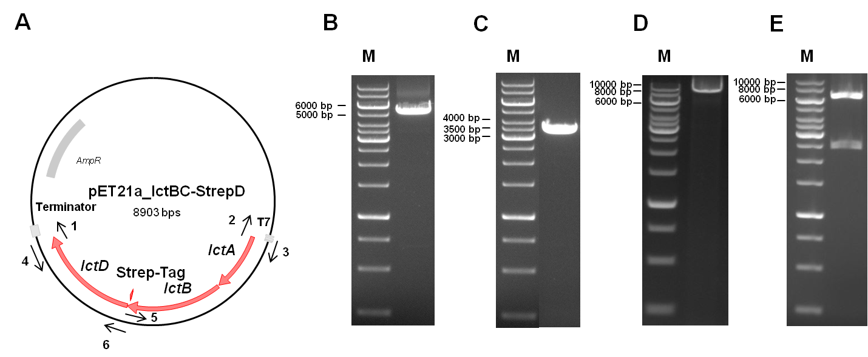
1.2 Cloning of pET21a_lctBC-StrepD. For the production of Ldh-EtfAB-Strep in E. coli the construct pET21a_lctBC-StrepD was cloned (A) Therefore, pET21a backbone, including a T7-promotor, was amplified using corresponding primers pET21a_for (1) and pET21a_rev (2) via PCR (size: 5406 bp) (B) LctBCD was amplified from genomic DNA of A. woodii via PCR, using lctBCD_pET21a_for (3) and lctBCD_pET21a_rev (4) primers (size: 3537 bp) (C) Amplified lctBCD and pET21a backbone were fused via Gibson Assembly and transformed in E. coli HB101. Afterwards, plasmids where isolated and a sequence encoding for a Strep-tag was introduced at the 3’-end of the gene lctC by using corresponding primers Strep-Tag_for (5) and Strep-Tag_rev (6) (size: 8903 bp) (D) The resulting pET21a_lctBC-StrepD was digested with HindIII (E). The resulting sizes were 6393 bp and 2510 bp. M, Gene Ruler 1 kb DNA ladder.

Source data 1. Source data for Supplementary File 1-II

