Supplementary file 3: Contacting residues for each GMC-oxidoreductases in the different maps
Conserved or divergent amino-acids are color coded in green or in red, respectively.
Cl1a |  | Cl2 |  | Cl3a
qu946 | qu143 | qu946 | qu143 | qu946 | qu143
Intra-start (A-C and B-D)
N96-N96 | N94-N94 | N96-N96 | N94-N94 | N96-N96 | N94-N94
N114-D276 | N112-D274 | N114-D276 | N112-D274 | N114-D276 | N112-D274
S275-N114 | S275-N114 | S275-K493 | S273-K493 | S275-N114 | S275-N114
T700-S371 | N700-S369 |  | N700-S369 |  | N702-S369
S275-D366 | D273-D364 | S275-D366 | D273-D364
D366-S275 | D364-S273 |  |  | D366-S275 | D364-S273
D276-E115 | D276-E115
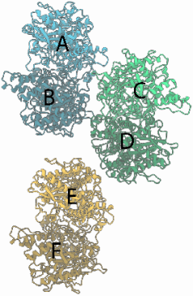 |  |  |  |  | N700-T366
 |  |  |  |  | N702-S370
 |  | S371-T700 | S369-N700
 |  |  | E294-E294
 |  |  | N295-N295
 |  | D276-K493
 |  | K493-S275 | K493-S273
 |  | K493-D276
Inter-start (E-D and E-B)
E642-K665
K178-T175 |  |  | D181-K178
 |  | N440-N442
 |  | N440-N440
 |  | N442-N442
 |  | T443-T443
 |  |  |  | T234-Y244 | T232-D244
 |  |  |  |  | V235-D244
 |  |  |  | Y244-G236
Protein-DNA
K685 | Y687 | K685 | Y687
K344 | K342 | K344 | K342
R324 | R322 | R324 | R322
D82 | N80 | D82 | N80
E321 | K319 | E321 | K319
 | R322 |  | R322
H343 |  | H343

