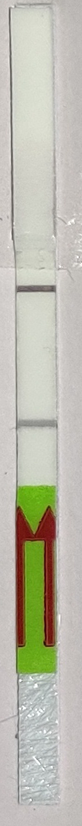
77.19 7.81 TOPSE
E484K
WT.

Source Data-2, Figure 5. The red rectangle denotes the approximate area cropped for generating Figure 5.

