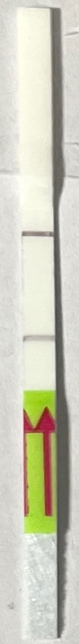
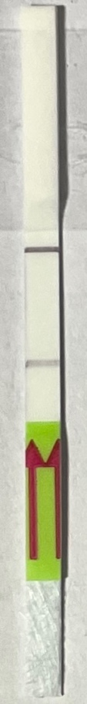
rs2073874_2&6
WT.
rs2073874_16&19
WT.
rs138739292_2&6
WT.
1.24 39.47. 8.82 38.72 2.81 34.45 TOPSE

Source Data-3, Figure 6a. The red rectangle denotes the approximate area cropped for generating Figure 6a.

