STROBE Flowchart
Flowcharts of participant inclusion and exclusion for ABCD (panel A) and Generation R (panel B).
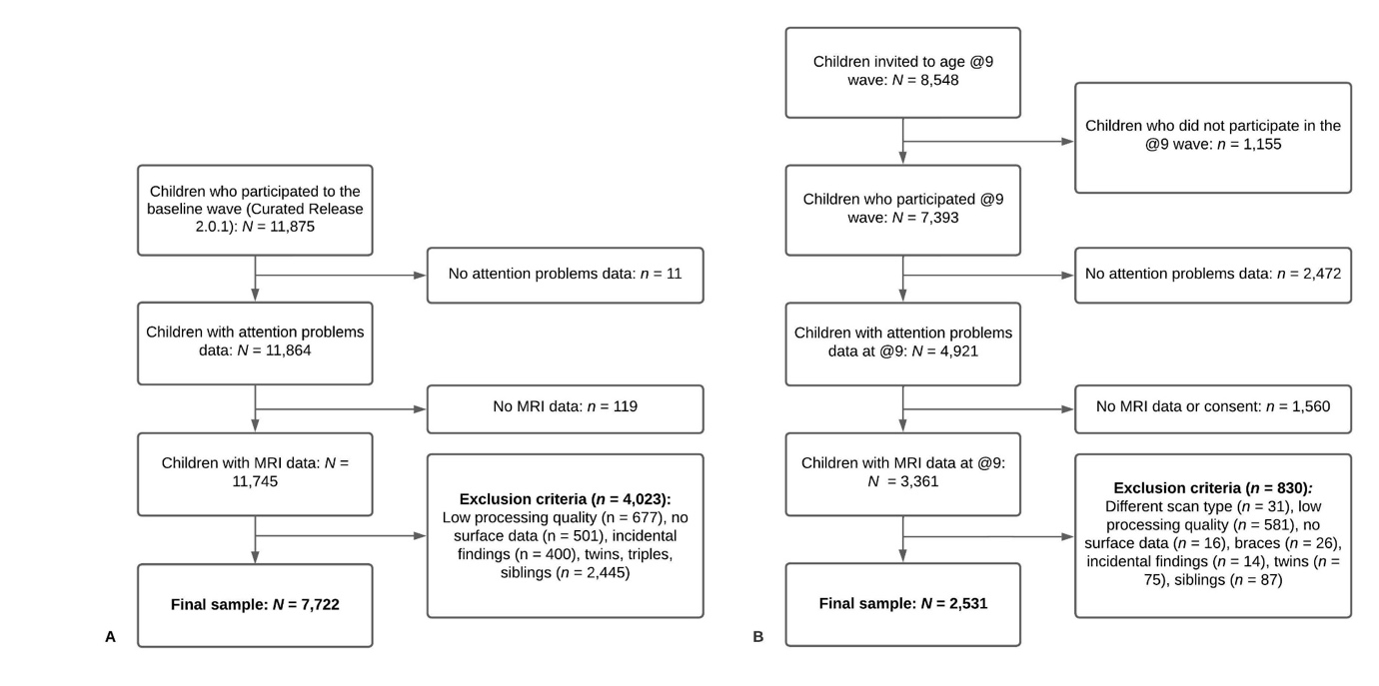
Note. A. In the ABCD Study, of the 11,875 participants enrolled in the study, 7,722 met our inclusion and exclusion criteria. B. In the Generation R Study, of the 8,548 participants invited to the age 9-10 assessment, 2,531 met our inclusion and exclusion criteria.

