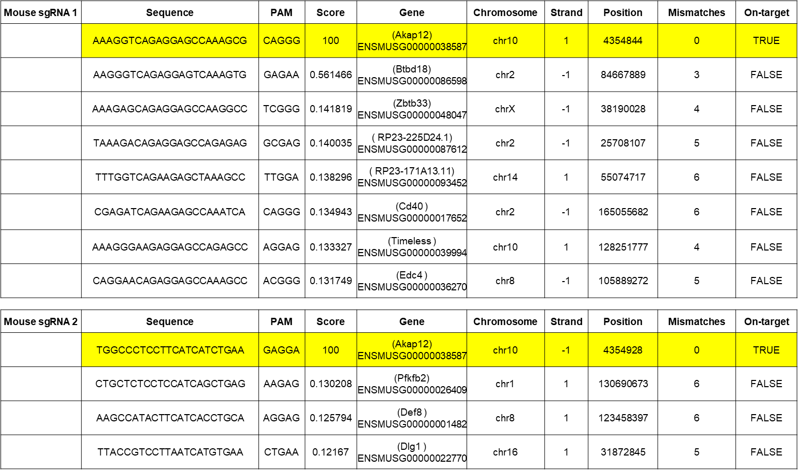

**Supplementary Table S5. Mouse sgRNA off-target analysis**