 | schematic  of the  method | name  of the  method | calculation of scanning speed |  | T_{measurement} (v_{measurement} ) | V_{measurement} compared to chessboard scanning | ratio of collected photons  compared to chessboard scanning (SNR² ) | SNR^{2 ⋅} v_{gain} compared to chessboard scanning
AO SCANNING TECHNIQUES | 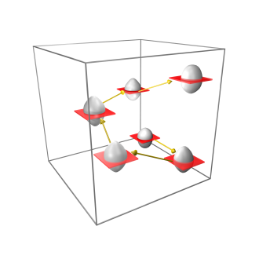 | 3D AO chessboard scanning | N_{cell} × N_{line} × T_{pixel} |  | 0.036 s  (27.7 Hz) | 1 | 1 | 1
 | 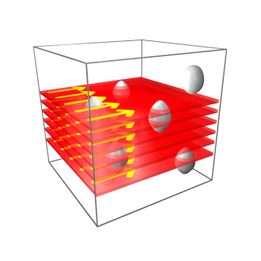 | AO point by point scanning of the entire volume | x × y × z × T_{pixel} |  | 1611.5 s  (0.0006 Hz) | 1/44762 | 1 | 1/44762
 | 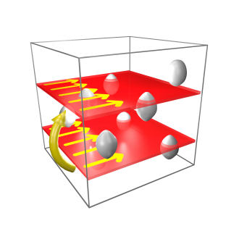 | AO point by point scanning in layers containing cell somatas  (19 layers) | x × y × N_{z} × T_{pixel} |  | 158.4 s  (0.00631 Hz) | 1/4399 | 1 | 1/4399
RESONANT SCANNING TECHNIQUES | 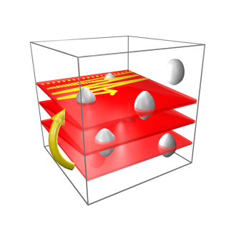 | Volume  scanning  with resonant mirror | x × y × z × T'_{pixel} |  | 6.1 s  (0.16 Hz) | 1/170 | 1/244 | 1/41506
 | 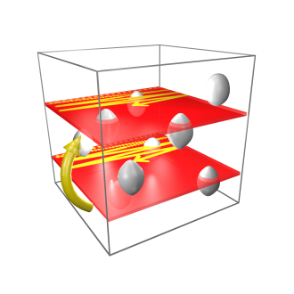 | Multiple-layer scanning with resonant mirror and piezo  (19 layers) | x × y × N_{z} × T'_{pixel} |  | 0.98 s  (1.04 Hz | 1/27 | 1/244 | 1/6654
 | *Used parameters:  N_{cell} = 120 (120 cells) x = 548 pixel, y = 507 pixel, z = 193 pixel (total scanning volume was: x = 689 µm, y = 639 µm, z = 580 µm)  N_{z}=19 (19 z layers were used in volume scanning) |  |  | T’_{pixel} = 0.11 µs, (pixel dwell time of resonant scanning, according to a f=16 kHz frequency and the x=548 pixel line resolution of the resonant scanner)  T_{pixel} = 30 µs, (AO pixel dwell time)  N_{line}= 10 (number of lines used to form a frame in chessboard scanning)

