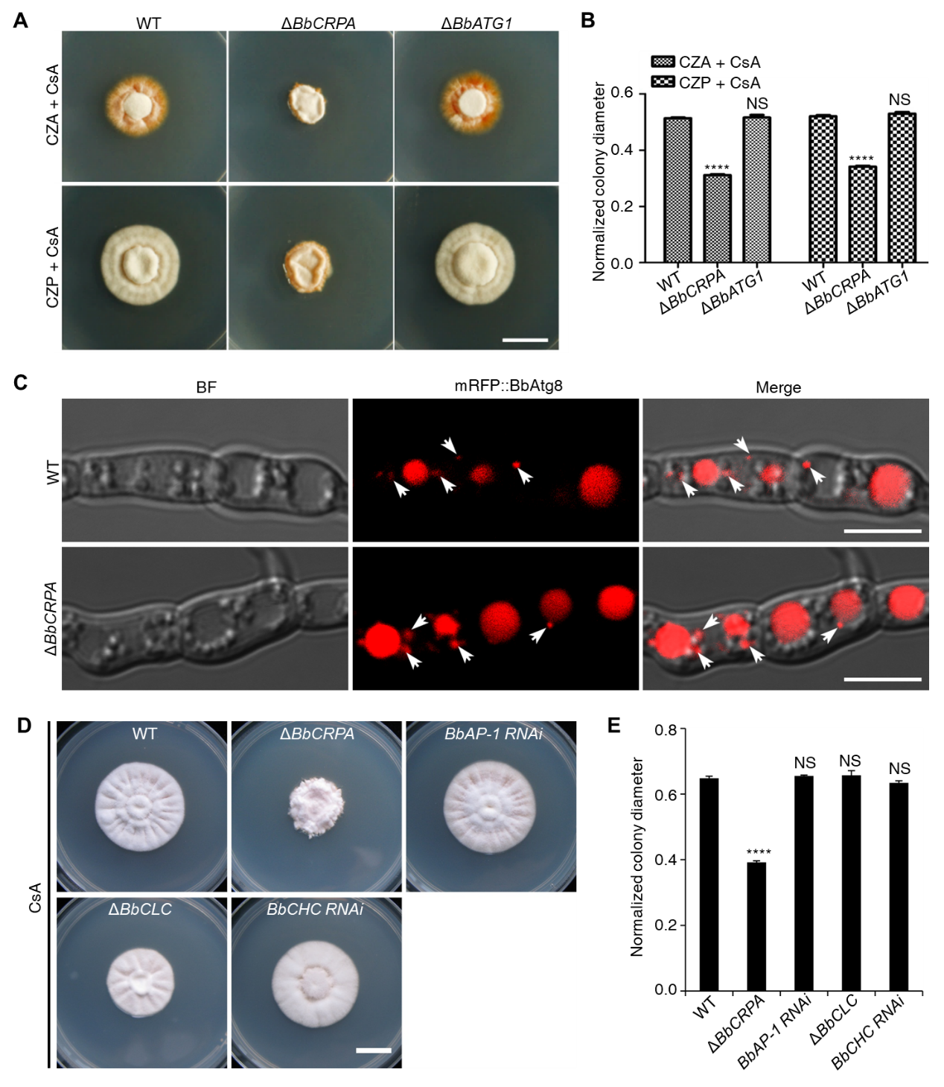
Supplementary file 1. Loss of autophagy-related protein BbAtg1, adaptor protein BbAP-1, or coat protein clathrin does not affect CsA resistance. (A and B) Growth of the wild-type, ΔBbCRPA, and ΔBbATG1 strains on CZA/CZP + CsA (20 μg/ml). (C) Disruption of BbCRPA does not affect the autophagosome formation in B. bassiana. Autophagosomes are marked by mRFP::BbAtg8 (arrows). (D and E) Growth of the wild-type, ΔBbCRPA, BbAP-1 RNAi, ΔBbCLC, and BbCHC strains on CZP + CsA (20 μg/ml). CLC, clathrin light chain; CHC, clathrin heavy chain. For CsA sensitivity analysis, plates were spot inoculated with 3 μl conidial suspensions (1 × 10⁷ conidia/ml) and incubated at 26℃ for about 10 days. Different strains showed variation in growth rates and the data were shown as [colony diameter CZA/CZP supplemented with CsA ]/[colony diameter CZA/CZP]. Scale bars, 1 cm for (A and D) and 5 μm for (C). Data are represented as mean ± SD. ****p < 0.0001 from Student’s t test. NS, not signiﬁcant.

