Supplementary File 3. Specific interactions between the R and C domains

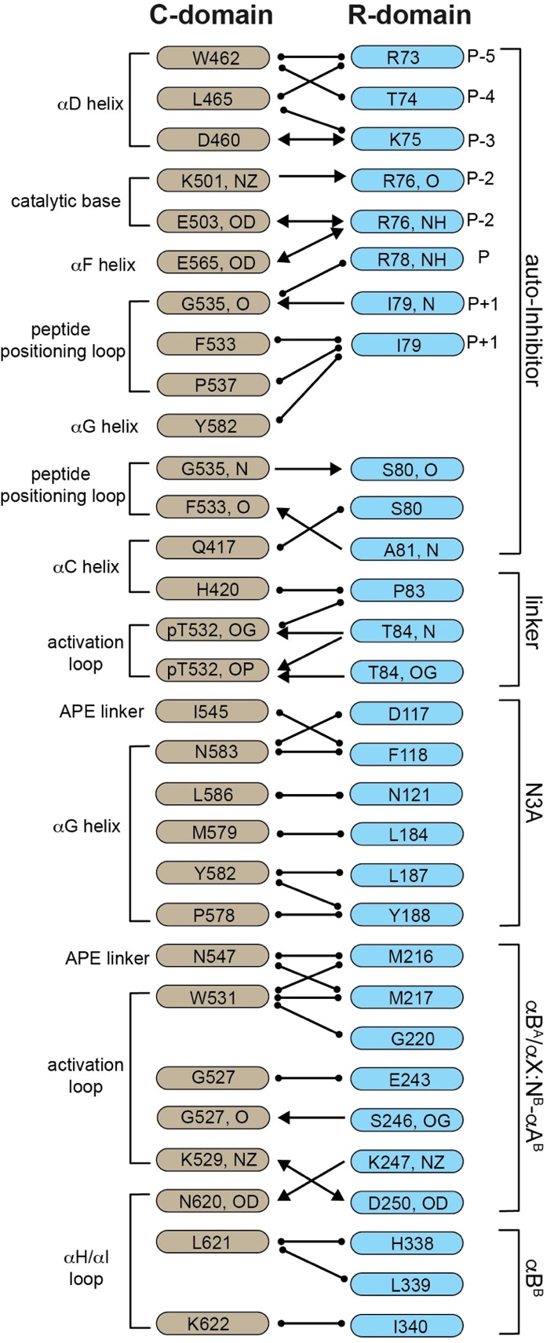
Specific interactions between the R and C domains. The location of each residue within the complex is listed alongside of each amino acid. Ion pair, hydrogen-bond, and van der Waals interactions are notated as ↔, →, and , respectively.

