Figure supplements
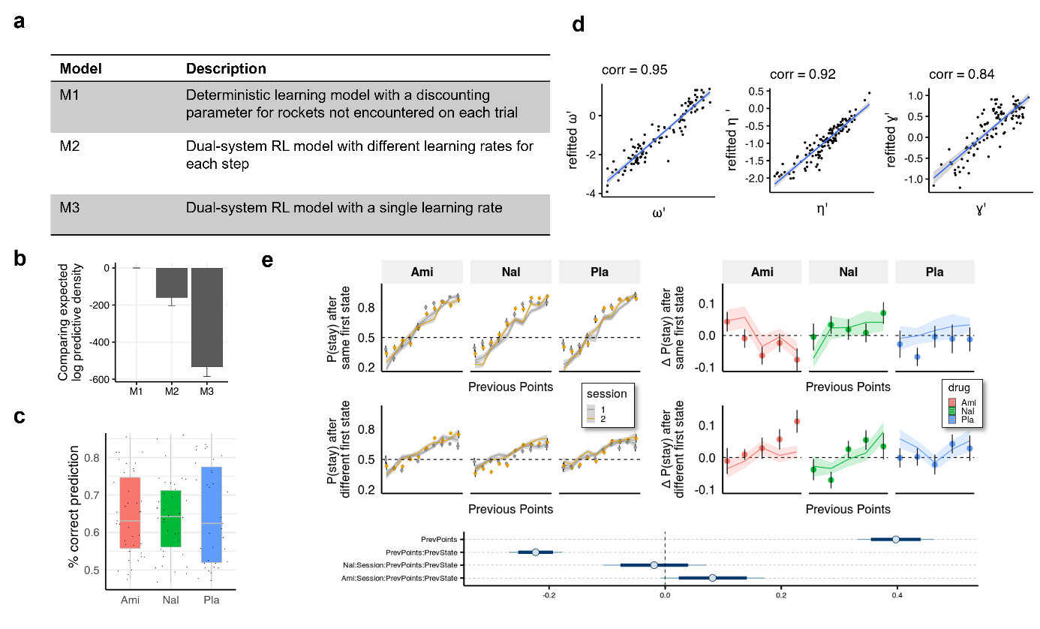
Figure 4 – figure supplement 1 | Computational modelling. a, We compared our model to two dual-system reinforcement learning (RL) models used previously with this task^{33,34}. In model M1 both model-free and model-based agents remember only the last outcome of a choice of spaceships, but only the model-based agent is aware of the relation between first-stage states. Models M2 and M3 are reinforcement learning-based models adapted from Kool et al (2016) with either separate (M2) or equal (M3) first and second stage learning rates. b, Models were compared using the leave-one-out information criterion (looic), where lower values indicate better out of sample trial-by-trial predictive performance. Refer to the Methods for weights from Bayesian Model Averaging of all models, indicating the posterior probability of each model given the data. Model M1 performs best in both metrics. c, For the winning model (M1) we calculated the posterior predictive accuracy averaged within participants and found that the mean (SD) posterior prediction accuracy was 65% (11%). d, Parameter recovery. e, Simulated data plotted to visually and statistically investigate whether the model captures the crucial aspects of behaviour and group differences (compare to Fig. 3).
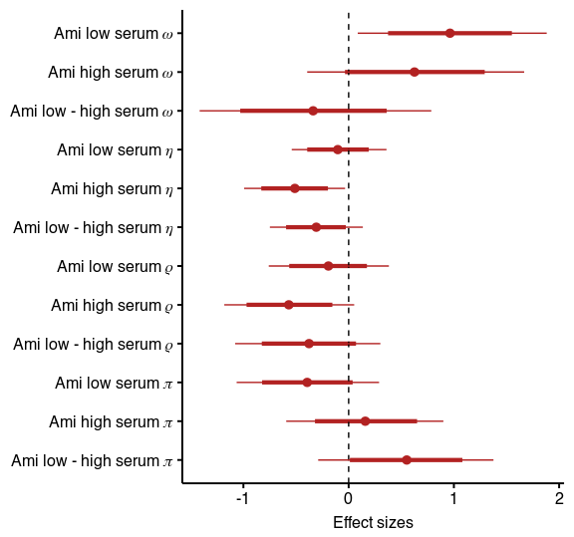
Figure 4 - figure supplement 2 | Results of the model including stickiness parameters. Posterior distribution of effect sizes of group level effects on model parameters in a model including stickiness parameters with means, 95% and 80% intervals.

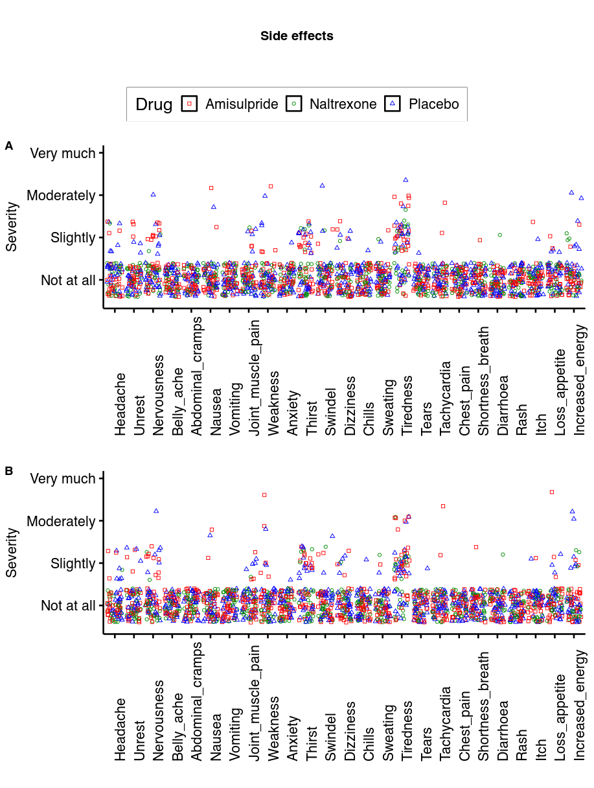

Figure 1 – figure supplement 1 | Side effects. On most measures most participants rated the severity of the side effect as low as possible. The only measures where more than 50% of data points were above 1 was tiredness. Here, the effect of amisulpride was at trend level (b = 0.20, p = 0.06) and not significant for naltrexone (b = -0.15, p = 0.17).

Supplementary Files
Stay ~ session * prev_points * prev_state_diff * Ami + session * prev_points * prev_state_diff * Nal +(session * prev_state_diff * prev_points | ID) | Estimate | SE | Q2.5 | Q97.5
Intercept | 0.7 | 0.07 | 0.57 | 0.84
session | -0.01 | 0.1 | -0.21 | 0.19
prev_points | 0.43 | 0.05 | 0.34 | 0.52
prev_state | -0.53 | 0.1 | -0.73 | -0.34
Ami | -0.08 | 0.09 | -0.27 | 0.1
Nal | -0.12 | 0.1 | -0.32 | 0.07
session:prev_points | 0.08 | 0.05 | -0.02 | 0.18
session:prev_state | 0.04 | 0.13 | -0.21 | 0.31
prev_points:prev_state | -0.25 | 0.05 | -0.34 | -0.16
session:Ami | -0.08 | 0.14 | -0.35 | 0.2
prev_points:Ami | 0.04 | 0.06 | -0.09 | 0.16
prev_state:Ami | 0.04 | 0.13 | -0.22 | 0.3
session:Nal | 0.17 | 0.14 | -0.11 | 0.44
prev_points:Nal | -0.05 | 0.06 | -0.18 | 0.07
prev_state:Nal | 0.01 | 0.14 | -0.26 | 0.27
session:prev_points:prev_state | -0.03 | 0.05 | -0.13 | 0.07
session:prev_points:Ami | -0.14 | 0.07 | -0.27 | -0.01
session:prev_state:Ami | 0.2 | 0.19 | -0.17 | 0.55
prev_points:prev_state:Ami | -0.03 | 0.07 | -0.16 | 0.1
session:prev_points:Nal | 0.02 | 0.07 | -0.12 | 0.15
session:prev_state:Nal | -0.24 | 0.18 | -0.6 | 0.13
prev_points:prev_state:Nal | 0.01 | 0.06 | -0.11 | 0.14
session:prev_points:prev_state:Ami | 0.18 | 0.07 | 0.04 | 0.32
session:prev_points:prev_state:Nal | 0.02 | 0.07 | -0.13 | 0.16

Supplementary File 1a | Estimates and CIs of fixed effects of the Bayesian logistic regression predicting staying behaviour. Q2.5 and Q97.5 are the 2.5% and 97.5% quantiles of the posterior parameter distribution. For details on how the posterior distributions were calculated refer to the code online (Ami = Amisulpride, Nal = Naltrexone).

PosteriorPredictiveAccuracy ~ Ami + Nal | Estimate | Q2.5 | Q97.5
Intercept | 0.69 | 0.51 | 0.87
Ami | -0.05 | -0.3 | 0.2
Nal | -0.07 | -0.32 | 0.17
Supplementary File 1b |Results of a Bayesian logistic linear model predicting percentage correct from drug groups

 | PANAS pos T1 | PANAS neg T1 | PANAS pos T2 | PANAS neg T2
Placebo | 29.5 (6.4) | 11.3 (1.6) | 27 (7.0) | 10.5 (0.9)
Amisulpride | 30.5 (5.6) | 12.2 (3.3) | 26.7 (6.2) | 10.9 (2.9)
Naltrexone | 30.1 (6.6) | 13.9 (7.0) | 25.4 (7.5) | 11.4 (4.4)
Supplementary File 1c |Mood in mean and standard deviation at time of pill intake (T1) and 3 hours later (T2).

ΔPANASpos ~ ami + serum_ami + nal | Estimate | Est.Error | Q2.5 | Q97.5
Intercept | 0.2 | 0.16 | -0.12 | 0.52
Ami | -0.2 | 0.29 | -0.76 | 0.36
serum_ami_high | 0.07 | 0.33 | -0.59 | 0.71
Nal | -0.41 | 0.22 | -0.85 | 0.03
Supplementary File 1d | Drug effects on differences in positive PANAS scales (centralized) between sessions. Drug variables coded as follows: nal is as dummy variable for naltrexone (1 for naltrexone, 0 otherwise), ami is a dummy variable for amisulpride, and serum_ami is a dummy variable for serum (1 only in the high serum group, and 0 otherwise).

ΔPANASneg ~ ami + serum_ami + nal | Estimate | Est.Error | Q2.5 | Q97.5
Intercept | 0.21 | 0.17 | -0.13 | 0.54
Ami | -0.1 | 0.3 | -0.69 | 0.49
serum_ami_high | -0.02 | 0.35 | -0.73 | 0.65
Nal | -0.53 | 0.24 | -1 | -0.06
Supplementary File 1e | Drug effects on differences in negative PANAS scales (centralized) between sessions. Drug variables coded as before.
Δω ~ (ami + serum_ami + nal)*(Weight + Sex + Age) + PANASnegt0 +ΔPANASneg + PANASpost0+ ΔPANASpos + WM + Age | Estimate | Est.Error | Q2.5 | Q97.5
Intercept | -0.12 | 0.13 | -0.39 | 0.14
Ami | 1.00 | 0.22 | 0.56 | 1.42
serum_ami_high | -0.21 | 0.31 | -0.8 | 0.4
Nal | 0.23 | 0.19 | -0.15 | 0.61
Sex1 | -0.31 | 0.28 | -0.84 | 0.24
Weight_s | 0.15 | 0.14 | -0.14 | 0.43
Age_s | 0 | 0.11 | -0.21 | 0.22
wm_s | 0.05 | 0.07 | -0.09 | 0.19
pos_mood_diff_s | -0.14 | 0.07 | -0.29 | 0
neg_mood_diff_s | -0.14 | 0.18 | -0.5 | 0.22
PANAS_1_negative_s | -0.09 | 0.12 | -0.33 | 0.15
PANAS_1_positive_s | -0.11 | 0.09 | -0.28 | 0.06
Ami:Sex1 | -0.36 | 0.44 | -1.23 | 0.49
Ami:Weight_s | 0.11 | 0.27 | -0.43 | 0.64
Ami:Age_s | -0.17 | 0.19 | -0.55 | 0.22
serum_ami_high:Sex1 | 0.41 | 0.57 | -0.71 | 1.51
serum_ami_high:Weight_s | -0.22 | 0.3 | -0.81 | 0.39
serum_ami_high:Age_s | 0.21 | 0.31 | -0.39 | 0.8
Nal:Sex1 | 0.06 | 0.4 | -0.74 | 0.82
Nal:Weight_s | -0.22 | 0.19 | -0.6 | 0.17
Nal:Age_s | -0.11 | 0.18 | -0.47 | 0.25
Supplementary File 1f | Drug effects on session differences in ω, including mood at baseline, difference in mood from baseline and working memory performance as covariates, as well as sex, age and weight as moderators of effects. Drug variables coded as before, all other dependent variables scaled and centralized.
Δη ~ (ami + ami_serum + nal)*(Weight + Sex+ Age) + PANASnegt0 +ΔPANASneg + PANASpost0+ ΔPANASpos + WM |  | Estimate | Est.Error | Q2.5 | Q97.5
Intercept | 0.19 |  | 0.12 | -0.05 | 0.43
Ami | -0.32 |  | 0.2 | -0.71 | 0.07
serum_ami_high | 0.06 |  | 0.28 | -0.5 | 0.6
Nal | -0.09 |  | 0.18 | -0.44 | 0.27
Sex1 | 0.01 |  | 0.26 | -0.5 | 0.52
Weight_s | 0.04 |  | 0.14 | -0.23 | 0.31
Age_s | -0.02 |  | 0.1 | -0.22 | 0.18
wm_s | -0.06 |  | 0.06 | -0.18 | 0.07
pos_mood_diff_s | -0.02 |  | 0.07 | -0.15 | 0.11
neg_mood_diff_s | 0.02 |  | 0.17 | -0.31 | 0.35
PANAS_1_negative_s | -0.01 |  | 0.11 | -0.23 | 0.21
PANAS_1_positive_s | -0.04 |  | 0.08 | -0.2 | 0.11
Ami:Sex1 | 0.04 |  | 0.42 | -0.78 | 0.85
Ami:Weight_s | 0.17 |  | 0.25 | -0.32 | 0.66
Ami:Age_s | -0.06 |  | 0.18 | -0.42 | 0.28
serum_ami_high:Sex1 | 0.41 |  | 0.55 | -0.66 | 1.48
serum_ami_high:Weight_s | -0.15 |  | 0.28 | -0.69 | 0.42
serum_ami_high:Age_s | -0.09 |  | 0.29 | -0.66 | 0.47
Nal:Sex1 | -0.16 |  | 0.36 | -0.88 | 0.57
Nal:Weight_s | -0.13 |  | 0.18 | -0.48 | 0.24
Nal:Age_s | 0.17 |  | 0.17 | -0.16 | 0.5
Supplementary File 1g | Drug effects on session differences in η, including mood at baseline, difference in mood from baseline and working memory performance as covariates, as well as sex, age and weight as moderators of effects. Drug variables coded as before, all other dependent variables scaled and centralized.

Δω ~ (ami + ami_serum + nal)*(comt+ dat + darpp + ankk) | Estimate | Est.Error | Q2.5 | Q97.5
Intercept | -0.15 | 0.11 | -0.38 | 0.07
Ami | 1.13 | 0.21 | 0.71 | 1.54
serum_ami_high | -0.24 | 0.25 | -0.73 | 0.26
Nal | 0.34 | 0.16 | 0.02 | 0.65
ankk_c1 | 0.19 | 0.2 | -0.2 | 0.58
dat1_c1 | -0.34 | 0.2 | -0.74 | 0.06
comt_s | -0.01 | 0.1 | -0.21 | 0.19
darpp_c1 | 0.09 | 0.2 | -0.32 | 0.49
Ami:ankk_c1 | 0.43 | 0.41 | -0.36 | 1.21
Ami:dat1_c1 | -0.03 | 0.37 | -0.76 | 0.69
Ami:comt_s | 0.25 | 0.19 | -0.1 | 0.61
Ami:darpp_c1 | 0.39 | 0.4 | -0.39 | 1.17
serum_ami_high:ankk_c1 | -0.26 | 0.46 | -1.17 | 0.63
serum_ami_high:dat1_c1 | 0.52 | 0.41 | -0.31 | 1.32
serum_ami_high:comt_s | -0.07 | 0.22 | -0.48 | 0.36
serum_ami_high:darpp_c1 | -0.38 | 0.44 | -1.24 | 0.49
Nal:ankk_c1 | -0.12 | 0.29 | -0.69 | 0.44
Nal:dat1_c1 | 0.51 | 0.3 | -0.08 | 1.11
Nal:comt_s | -0.12 | 0.16 | -0.43 | 0.19
Nal:darpp_c1 | -0.25 | 0.29 | -0.83 | 0.34
Supplementary File 1h | Drug effects on session differences in ω, from genetic variables. Drug variables coded as before, all other dependent variables scaled and centralized.

Δη ~ (ami + ami_serum + nal)*(comt+ dat + darpp + ankk) | Estimate | Est.Error | Q2.5 | Q97.5
Intercept | 0.17 | 0.1 | -0.03 | 0.38
Ami | -0.09 | 0.19 | -0.48 | 0.29
serum_ami_high | -0.48 | 0.23 | -0.95 | -0.02
Nal | -0.02 | 0.15 | -0.31 | 0.27
ankk_c1 | 0.21 | 0.19 | -0.16 | 0.56
dat1_c1 | 0.16 | 0.2 | -0.23 | 0.55
comt_s | -0.02 | 0.09 | -0.21 | 0.16
darpp_c1 | -0.09 | 0.19 | -0.46 | 0.29
Ami:ankk_c1 | 0.38 | 0.38 | -0.39 | 1.1
Ami:dat1_c1 | 0.06 | 0.35 | -0.63 | 0.75
Ami:comt_s | -0.06 | 0.17 | -0.4 | 0.26
Ami:darpp_c1 | 0.26 | 0.38 | -0.48 | 0.99
serum_ami_high:ankk_c1 | -0.9 | 0.43 | -1.75 | -0.03
serum_ami_high:dat1_c1 | -0.44 | 0.39 | -1.2 | 0.32
serum_ami_high:comt_s | 0.15 | 0.2 | -0.24 | 0.53
serum_ami_high:darpp_c1 | -0.35 | 0.42 | -1.14 | 0.49
Nal:ankk_c1 | -0.19 | 0.27 | -0.74 | 0.33
Nal:dat1_c1 | -0.14 | 0.28 | -0.68 | 0.42
Nal:comt_s | 0.07 | 0.15 | -0.23 | 0.37
Nal:darpp_c1 | -0.09 | 0.27 | -0.62 | 0.44
Supplementary File 1i | Drug effects on session differences in η, from genetic variables. Drug variables coded as before, all other dependent variables scaled and centralized.

ΔωΔPANASnegΔPANASpos

ω

Δω ~ drug*COMT+DARPP+DAT+Taq1A
ω

 | N | BMI, m (sd) | Age, m (sd) | Sex(m,f)
Placebo | 39 | 21.7 (2.2) | 23.2 (3.6) | 12,27
Amisulpride | 39 | 22.7 (2.6) | 22.8 (2.8) | 14,26
Naltrexone | 40 | 23.0 (2.4) | 23.2 (4.0) | 13,26
Supplementary File 1j |Description of participants in terms of body mass index (BMI), age and sex with mean (m) and standard deviation (sd).

 | COMT  Val/Val, Val/Met, Met/Met | DAT1  10/10, other | ANKK,  a1-, a1+ | DARPP  C/C+C/T, T/T
Placebo | 9,14,12 | 23,12 | 20,15 | 13,22
Amisulpride | 10,15,12 | 20,17 | 27,10 | 13,24
Naltrexone | 6,20,11 | 20,17 | 24,13 | 13,24
Supplementary File 1k | Distribution of genotypes.

 | Behavioural Analysis with both sessions | Computational modelling with both sessions | Computational modelling, second session only | Computational modelling with both sessions and genetic data
Placebo | 35 | 35 | 39 | 35
Amisulpride | 38 | 38 | 39 | 37
Naltrexone | 39 | 39 | 40 | 37
Supplementary File 1l | Number of participants per drug group used in analysis.

Supplementary Notes

Supplementary Note 1: Description of genotypes and how they relate to baseline dopamine function
Taq1a is a D2 dopamine receptor polymorphism with two allelic variants, A1 and A2. The A1 allele carriers (a1+) have reportedly higher dopamine synthesis rate¹ that could potentially result in lower density of D2 receptors in the striatum^{2,3}. The Dat1 VNTR is a polymorphism of the dopamine transporter (DAT) that is involved in reuptaking dopamine from the synaptic cleft back into the cell and thus a regulator of tonic dopamine levels and occurs with highest density in the striatum⁴. The 9-repeat variant of the polymorphisms is associated with lower levels of DAT, and thus potentially higher extra-cellular dopamine levels^{5,6}. Based on the above both an effect on baseline tendency for model-based behaviour as well as an augmentation of the drug effects could be expected in the group carrying at least one A1 allele (a1+ group) and at least one the 9-repeat variant of the DAT1 polymorphism (9 repeats group). As in previous studies, we used the valine-to-methionine (Val/Met) substitution in the Val¹⁵⁸Met polymorphism of the COMT gene as a marker for prefrontal dopamine function^{7,8}⁠. COMT (or Catechol-O-methyl transferase) is an enzyme that has an effect on dopamine extracellular levels through metabolizing dopamine especially in cortical areas of the brain⁹. Participants with Met mutations have lower enzymatic activity of the COMT and have been associated with higher dopamine levels the prefrontal cortex¹⁰. And lastly, we used the DARPP-32 as a marker of striatal D1 receptor function. T homozygotes (T/T allele carriers) have putatively higher efficiency of striatal D1 receptors¹¹⁠ and have been related to model-free learning ^{12,13}.
ωω
Supplementary Note 2: Details of Genotyping
I. Typing of the variable number tandem repeat (VNTR) polymorphism in the DAT1 gene
Peripheral blood was collected by lancet and stored on Whatman FTA micro cards (Sigma-Aldrich). DNA was extracted using the QIAamp DNA Mini kit (Qiagen, Hilden, Germany) and eluted in a final volume of 50 μL of buffer AE (Qiagen, Hilden, Germany). Human DNA concentration was determined with the Quantifiler HP Quantification Kit (AB) on the Applied Biosystems (AB) 7500 real-time PCR instrument (Thermo Fisher Scientific, Waltham, MA). Template DNA (10 ng per sample) was subjected to PCR in a total reaction volume of 25 µL consisting of 1 × GeneAmp PCR Buffer (AB), 0.25 mM each dNTP, 2.5 U AmpliTaq Gold Polymerase (AB) and target specific primers (details are provided in Table S1). The following thermal protocol was applied using a Veriti 96-Well Thermal Cycler (AB): 35 amplification cycles at 95 °C for 30 seconds, 55 °C for 1 minute, and 72 °C for 1 minute. Before the first cycle, an initial “hot start” denaturation (5 minutes at 95°C) was included, and the last cycle was followed by a final extension step at 72 °C for 45 minutes. Aliquots of PCR products were diluted with Hi-Di formamide (AB) mixed with internal lane standard LIZ 600 v.2 (AB) and separated on the ABI 3500 Genetic Analyzer applying standard conditions. The number of repeats predicted by the GeneMapper ID-X software (AB) was in full agreement to the number of repeats determined by direct sequencing of PCR products using the BigDye Terminator Sequencing Kit v3.1 (AB) in selected DNA samples.

Table S1. Primer set used for the typing of DAT1 VNTR repeat length polymorphisms
Marker | Locationª | Primer sequence 5’-3’ ^{b} | Dye ^{c} | Orientation | Conc.(nM)^{d}
DAT1 VNTR | chr5:1393559-1394008(-) | TGTGGTGTAGGGAACGGCCTGAGA | 6-FAM | forward | 400
 |  | TGTTGGTCTGCAGGCTGCCTGCAT |  | reverse
ª Chromosome number and genomic location of targeted sequence (orientation provided in brackets) according to UCSC version hg38 (http://genome.ucsc.edu/) is provided.
^{b} The non-specific primer tail is underlined in Italics.
^{c} 5’ Fluorescein (6-FAM)-labeled forward primer was used.
^{d} The final primer concentrations in the reaction mix is shown.

II. Typing of single nucleotide polymorphisms (SNPs) by SNaPshot minisequencing
Five informative SNPs [ANKK1 (rs1800497), BDNF (rs6265), CDH13 (rs3784943), OPRM1 (rs1799971) and PPP1R1B (rs907094)] were typed simultaneously applying a multiplex strategy for PCR and SNaPshot minisequencing of purified PCR products. Typing of Val158Met variants (rs4680) in the COMT gene was carried out separately, applying a singleplex approach for PCR and SNaPshot.
Step 1: PCR and purification
1.1 Singleplex PCR (COMT)
First, a 177 bp genomic fragment of the COMT gene harbouring the causative single nucleotide polymorphism (SNP rs4680) in its centre was targeted by PCR. The reaction mix contained 5 ng template DNA, 1 × GeneAmp PCR buffer (AB), 0.25 mM each dNTP, 2.5 units AmpliTaq Gold polymerase (AB) and specific primers (details provided in Table 2) in a total reaction volume of 25 µL. Thermal cycling was conducted using the Veriti cycler (AB) and the following conditions: 95 °C for 5 min; 35 cycles of 95 °C for 15 seconds, 59 °C for 30 seconds and 72 °C for 1 minute; final extension at 72 °C for 5 minutes. Excess of primers and unincorporated dNTPs were removed by adding 2 µL of ExoSAP-IT (Thermo Fisher Scientific) to each 5 µL PCR product. Reactions were incubated at 37˚C for 15 min followed by 80˚C for 15 min for enzyme deactivation.

1.2 Multiplex PCR (ANKK1, BDNF, CDH13, OPRM1, PPP1R1B)
Amplification by multiplex PCR was carried out in a total volume of 20 µL, containing 1x Phire Hot Start II PCR Master Mix (Thermo Fisher Scientific), PCR primers concentrations as specified in table 2 and template DNA (5 ng per sample). Thermal cycling was carried out on the Veriti thermal cycler (AB), and the following conditions: 98˚C pre-incubation step for 30 sec; 40 cycles of 98˚C denaturation for 10 sec, annealing at 62˚C for 30 sec and extension at 72˚C during 30 sec; followed by 1 min for final extension at 72˚C. PCR products were purified by ExoSAP-IT treatment.

Table 2. Panel of loci and primer sets used for PCR
Markerª | Location^{b} | Primer sequence 5’-3’ | Orientation | Conc.(nM)^{c}
ANKK1 | chr11:113400010-113400194(-) | GACATGATGCCCTGCTTTCG | forward | 500
 |  | CATCACGCAAATGTCCACGC | reverse
BDNF | chr11:27658331-27658494(-) | CAAACATCCGAGGACAAGGT | forward | 250
 |  | CCGAACTTTCTGGTCCTCAT | reverse
CDH13 | chr16:83678696-83678883(+) | CAGTGCTGTGTTCCCAAATG | forward | 500
 |  | CTGCGAATCCACAATACCTGT | reverse
COMTª | chr22:19963623-19963799(+) | GGGCCTACTGTGGCTACTCA | forward | 400
 |  | GCCCTTTTTCCAGGTCTGA | reverse
OPRM1 | chr6:154039591+154039751(+) | CCTTGGCGTACTCAAGTTGC | forward | 500
 |  | CGTGATCATGGAGGGACTG | reverse
PPP1R1B | chr17:39634064-39634252(-) | CTCAGGTAGGGCTGAGTTCG | forward | 500
 |  | CCTGAAGGTCATCAGGCAGT | reverse
ª COMT primers only used in singleplex PCR; all other primers combined in a multiplex PCR.
^{b} Chromosome number and genomic location of targeted sequence (orientation provided in brackets)
according to UCSC version hg38 (http://genome.ucsc.edu/).
^{c} The final primer concentrations in the reaction mix is listed.

Step 2: SNaPshot Minisequencing
2.1 Singleplex SNaPshot minisequencing (COMT)
Singleplex SNaPshot minisequencing of COMT(rs4680) was performed in a total volume of 10 µL containing 3 µL of purified PCR product, 5 µL SNaPshot Multiplex Ready Reaction mix (Thermo Fisher) and 2 µL of diluted minisequencing primer (pCOMT 2 µM; details see Table 3). The cycling conditions (25 cycles) using the Veriti thermal cycler (AB) were as follows: denaturation at 96 °C for 10 seconds, annealing at 50 °C for 5 seconds and extension at 60 °C for 30 seconds.
ExoSAP-IT treatment was again applied for the clean-up of the minisequencing reaction. 5 µl of purified reaction product was then mixed with 9.3 µL Hi-Di formamide (AB) and 0.2 µL of GeneScan-LIZ 120 internal size standard (AB). After a denaturing step for 5 min at 98 °C followed by cooling to 4 °C the fragments were separated on an ABI PRISM 310 Genetic Analyzer (AB) with POP4 polymer and analysed with GeneMapper v3.2 software. Calling of SNP variants based on minisequencing was in full agreement to results from direct sequencing of PCR products in selected DNA samples.

2.2 Multiplex SNaPshot (ANKK1, BDNF, CDH13, OPRM1, PPP1R1B)
Multiplex SNaPshot minisequencing was performed in a total volume of 10 µL containing 3 µL of purified PCR product, 5 µL SNaPshot Multiplex Ready Reaction mix (Thermo Fisher) and 2 µL multiplex primers mix (1 µM of pBDN; 2 µM of pANKK1, pCDH13, pOPRM1 and PPP1R1B; details provided in Table 3). Thermal cycling conditions (28 cycles) were as follows: denaturation at 96 °C for 10 seconds, annealing at 58 °C for 5 seconds and extension at 60 °C for 30 seconds. ExoSAP-IT clean-up and automated detection of minisequencing products by capillary electrophoresis was conducted using the same conditions as for the singleplex SNaPshot (details provided in 2.1). Calling of SNP variants based on minisequencing was in full agreement to results from direct sequencing of PCR products in selected DNA samples.

Table 3 Minisequencing primer information
Primer nameª | SNP (Alleles)  Location^{b} | Primer sequence 5’-3’^{c} | Primer binding site^{d}
pCOMT | rs4680 (G/A)  chr22:19963748 | (GATC)₄GGATGGTGGATTTCGCTGGC | chr22:19963728-19963747(+)
pANKK1 | rs1800497 (C/T)  chr11:113400106 | CCATCCTCAAAGTGCTGGTC | chr11:113400086-113400105(+)
pBDNF | rs6265 (G/A)  chr11:27658369 | (GATC)₈TCATTGGCTGACACTTTCGAACAC | chr11:27658370-27658393(-)
pCDH13 | rs3784943 (G/A)  chr16:83678830 | (GATC)₁₀CCTACTTTGTCATCAGCACTGCTTT | chr16:83678805-83678829(+)
pOPRM1 | rs1799971 (G/A)  chr6:154039662 | CGCATGGGTCGGACAGGT | chr6:154039663-154039680(-)
pPPP1R1B | rs907094 (C/T)  chr17:39634118 | (GATC)₆GTATACTCAAGGAGGACCCACAG | chr17:39634119-39634141(-)

ª COMT primer was only used in singleplex SNaPshot; all other primers were combined in a multiplex SNaPshot.
^{b} Chromosome number and genomic location of target single nucleotide polymorphism (SNP) according to UCSC version hg38 (http://genome.ucsc.edu/).
^{c} The non-specific primer tail is underlined in Italics
^{d} Chromosome number and genomic location of primer binding site (orientation provided in brackets) according to UCSC version hg38.

References
1. Laakso, A. et al. The A1 allele of the human D2 dopamine receptor gene is associated with increased activity of striatal L-amino acid decarboxylase in healthy subjects. Pharmacogenet. Genomics 15, 387–391 (2005).
2. Ito, H. et al. Relation between Presynaptic and Postsynaptic Dopaminergic Functions Measured by Positron Emission Tomography: Implication of Dopaminergic Tone. J. Neurosci. 31, 7886–7890 (2011).
3. Jönsson, E. G. et al. Polymorphisms in the dopamine D2 receptor gene and their relationships to striatal dopamine receptor density of healthy volunteers. Mol. Psychiatry 4, 290–296 (1999).
4. Ito, H., Takahashi, H., Arakawa, R., Takano, H. & Suhara, T. Normal database of dopaminergic neurotransmission system in human brain measured by positron emission tomography. Neuroimage (2008). doi:10.1016/j.neuroimage.2007.09.011
5. Heinz, A. et al. Genotype influences in vivo dopamine transporter availability in human striatum. Neuropsychopharmacology (2000). doi:10.1016/S0893-133X(99)00099-8
6. Fuke, S. The VNTR polymorphism of the human dopamine transporter (DAT!) gene affects gene expression. Pharmacogenomics J. (2001). doi:10.1038/sj.tpj.6500026
7. Doll, B. B., Hutchison, K. E. & Frank, M. J. Dopaminergic Genes Predict Individual Differences in Susceptibility to Confirmation Bias. J. Neurosci. 31, 6188–6198 (2011).
8. Frank, M. J., Moustafa, A. A., Haughey, H. M., Curran, T. & Hutchison, K. E. Genetic triple dissociation reveals multiple roles for dopamine in reinforcement learning. Proc. Natl. Acad. Sci. 104, 16311–16316 (2007).
9. Männistö, P. T. & Kaakkola, S. Catechol-O-methyltransferase (COMT): Biochemistry, molecular biology, pharmacology, and clinical efficacy of the new selective COMT inhibitors. Pharmacological Reviews (1999).
10. Slifstein, M. et al. COMT genotype predicts cortical-limbic D1 receptor availability measured with [11C]NNC112 and PET. Mol. Psychiatry (2008). doi:10.1038/mp.2008.19
11. Svenningsson, P. et al. DARPP-32: An Integrator of Neurotransmission. Annu. Rev. Pharmacol. Toxicol. (2004). doi:10.1146/annurev.pharmtox.44.101802.121415
12. Doll, B. B., Bath, K. G., Daw, N. D. & Frank, M. J. Variability in Dopamine Genes Dissociates Model-Based and Model-Free Reinforcement Learning. J. Neurosci. 36, 1211–1222 (2016).
13. Frank, M. J., Doll, B. B., Oas-Terpstra, J. & Moreno, F. Prefrontal and striatal dopaminergic genes predict individual differences in exploration and exploitation. Nat. Neurosci. 12, 1062–1068 (2009).

