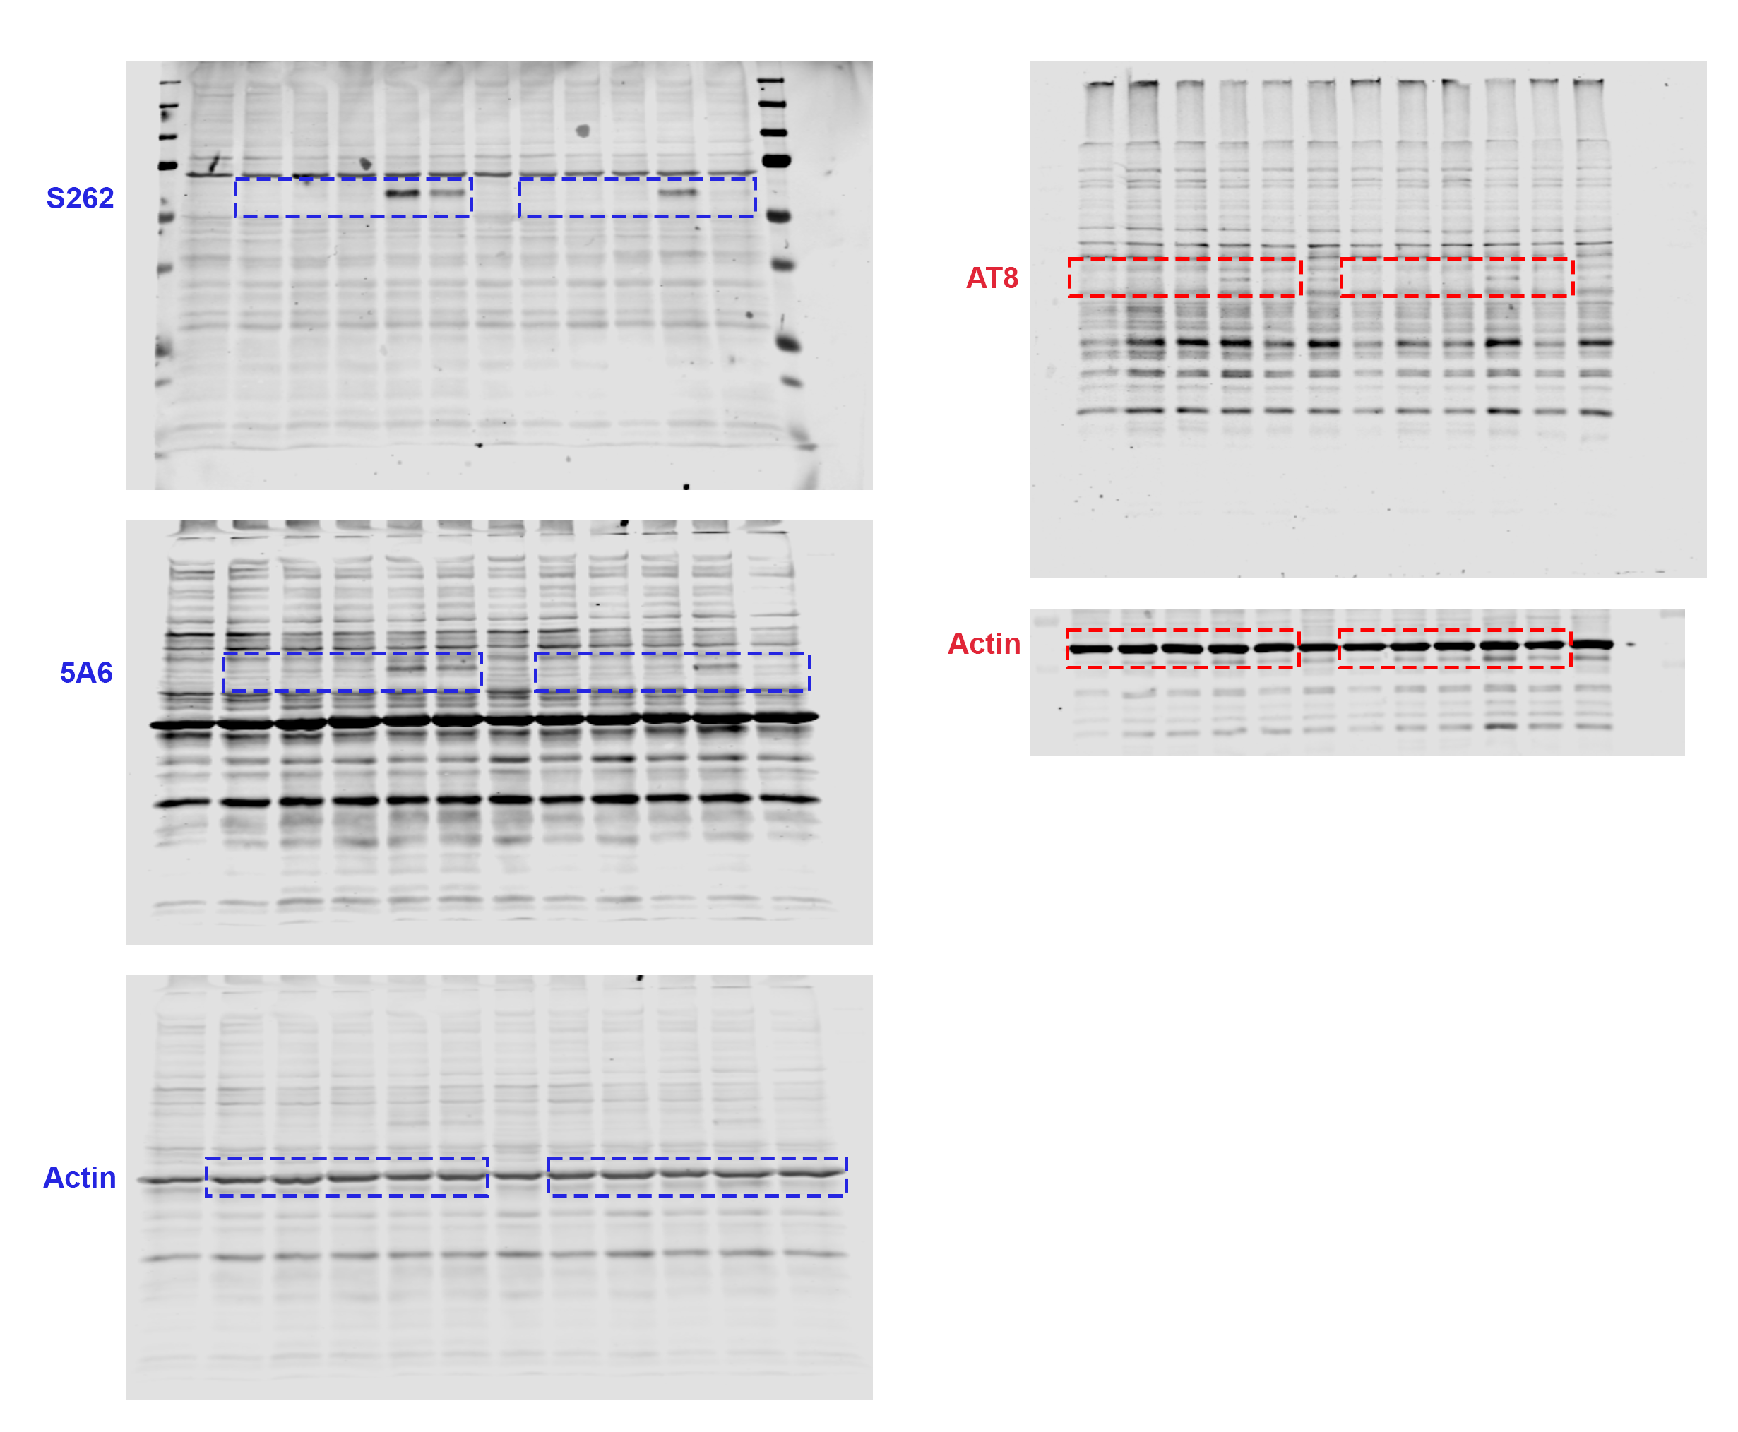
Figure 2-source data
The full blots for Figure 2A. Boxed areas highlight the bands included in Figure 2A.

