Supplementary File 2 – Relates to Figures 5 and 10

let-7 Consensus Sites (LCSs) Identified in 3' UTRs of Selected Nematode and Vertebrate Homologs of ROR
Species | Gene | Identifier | 3' UTR Length  (nt.) | LCS  Position  (3' nt.) | TS  (kcal/mol) | Alignment of LCS (5' to 3') with let-7 (3' to 5')
C. elegans | nhr-23 | NM_001025806 | 868 | 42 | -21.8 | 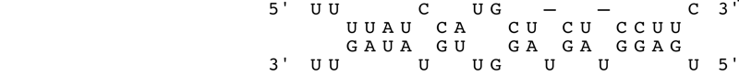
 |  |  |  | 249 | -15.2 | 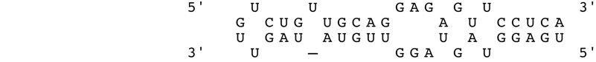
 |  |  |  | 594 | -17.0 | 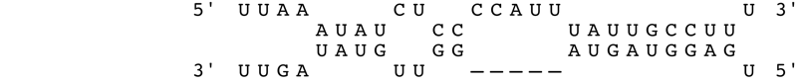
 |  |  |  | 646 | -17.6 | 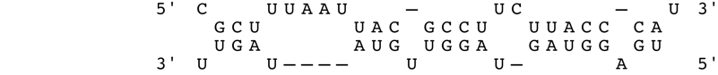
C. briggsae | nhr-23 | WBGene  00040598 | 866 | 629 | -20.7 | 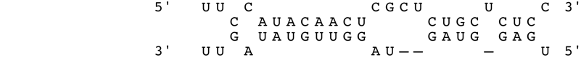
 |  |  |  | 835 | -21.8 | 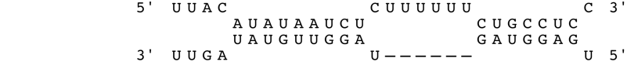
H. sapiens | RORβ | NM_006914 | 7559 | 3576 | -25.9 | 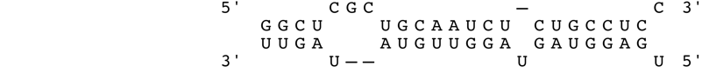
 |  |  |  | 4055 | -23.1 | 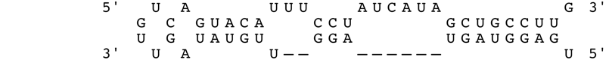
 |  |  |  | 4961 | -23.1 | 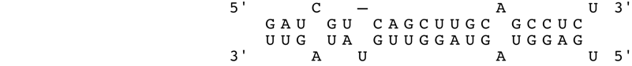
M. musculus | RORβ | NM_146095 | 7271 | 3817 | -23.8 | 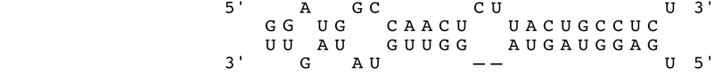
 |  |  |  | 5242 | -22.7 | 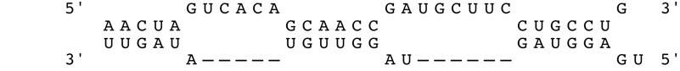
 |  |  |  | 6675 | -26.7 | 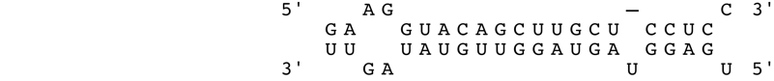
D. rerio | RORβ | NM_001082856 | 5431 | 949 | -21.8 | 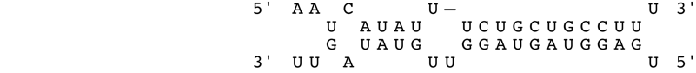
 |  |  |  | 4318 | -23.8
 |  |  |  | 4421 | -23.3 | 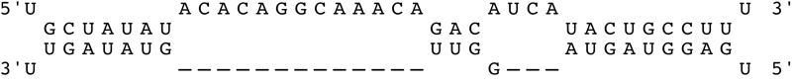
H. sapiens | RORα | NM_134261 | 9171 | 3079 | -23.7 | 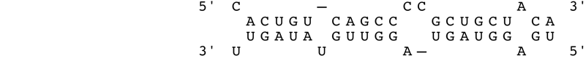
 |  |  |  | 3142 | -22.8 | 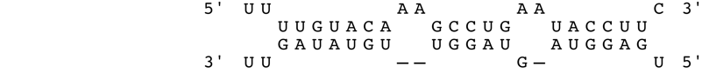
 |  |  |  | 6480 | -24.0 | 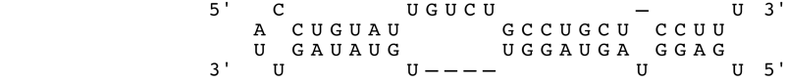
 |  |  |  | 8321 | -22.2 | 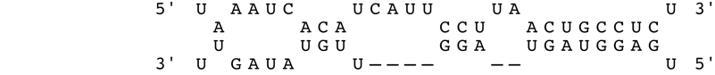
M. musculus | RORα | NM_013646 | 9285 | 2055 | -23.9 | 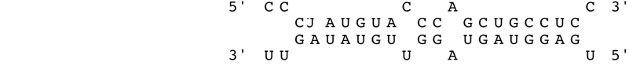
 |  |  |  | 2184 | -23.7 | 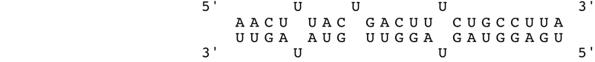
 |  |  |  | 4913 | -22.6 | 