**Figure 1B – source data**

**B**

**0**

**4**

**-**

**+**

**7**

**-**

**+**

**14**

**-**

**+**

**21**

**-**

**+**

**(days)**

**BMP2**

**-**

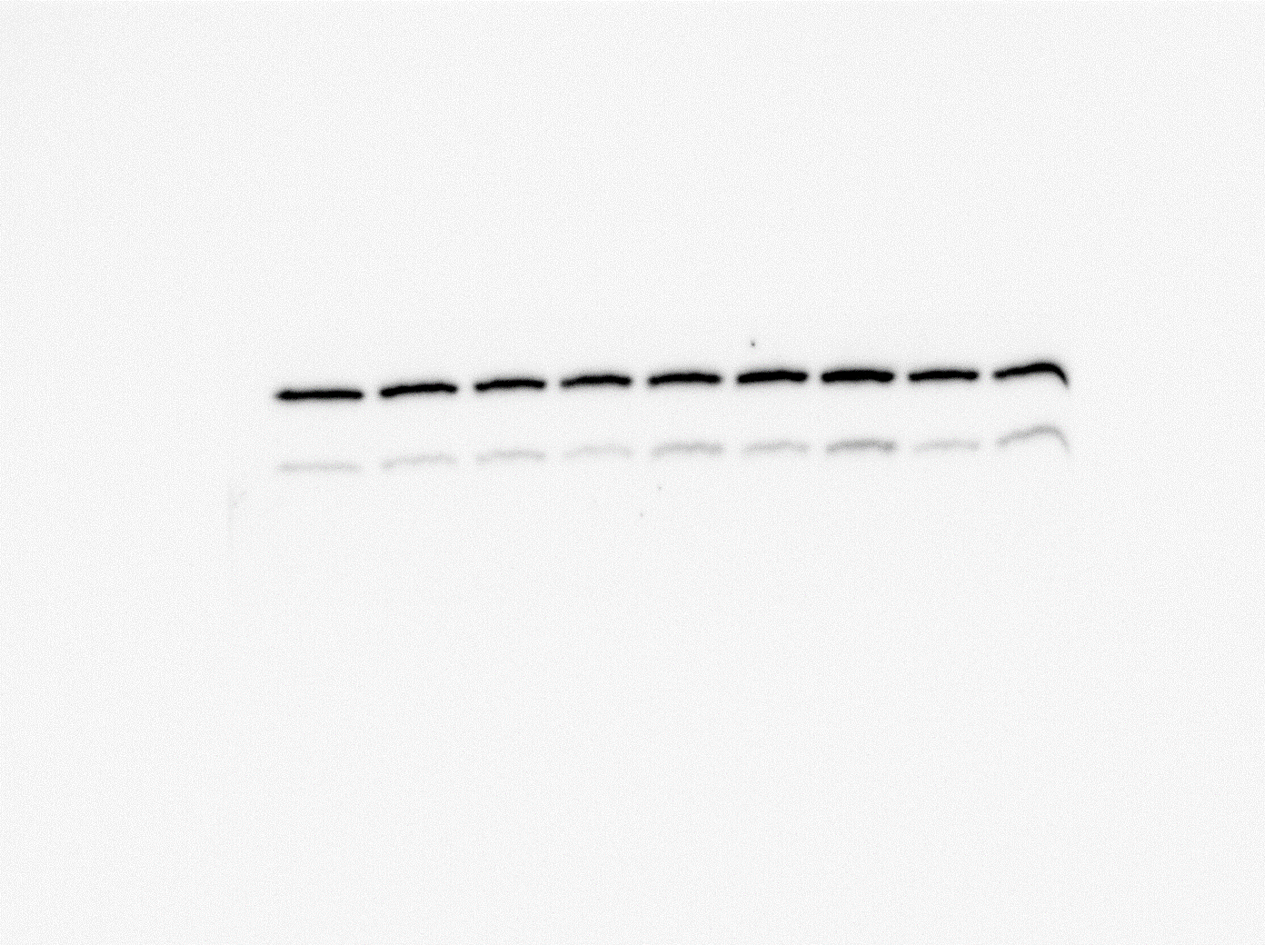

**Prdx1**

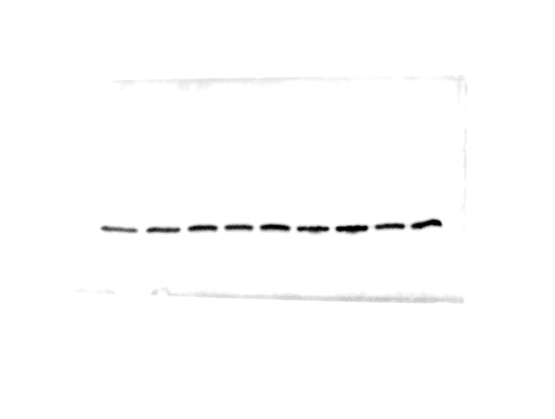

**Prdx2**

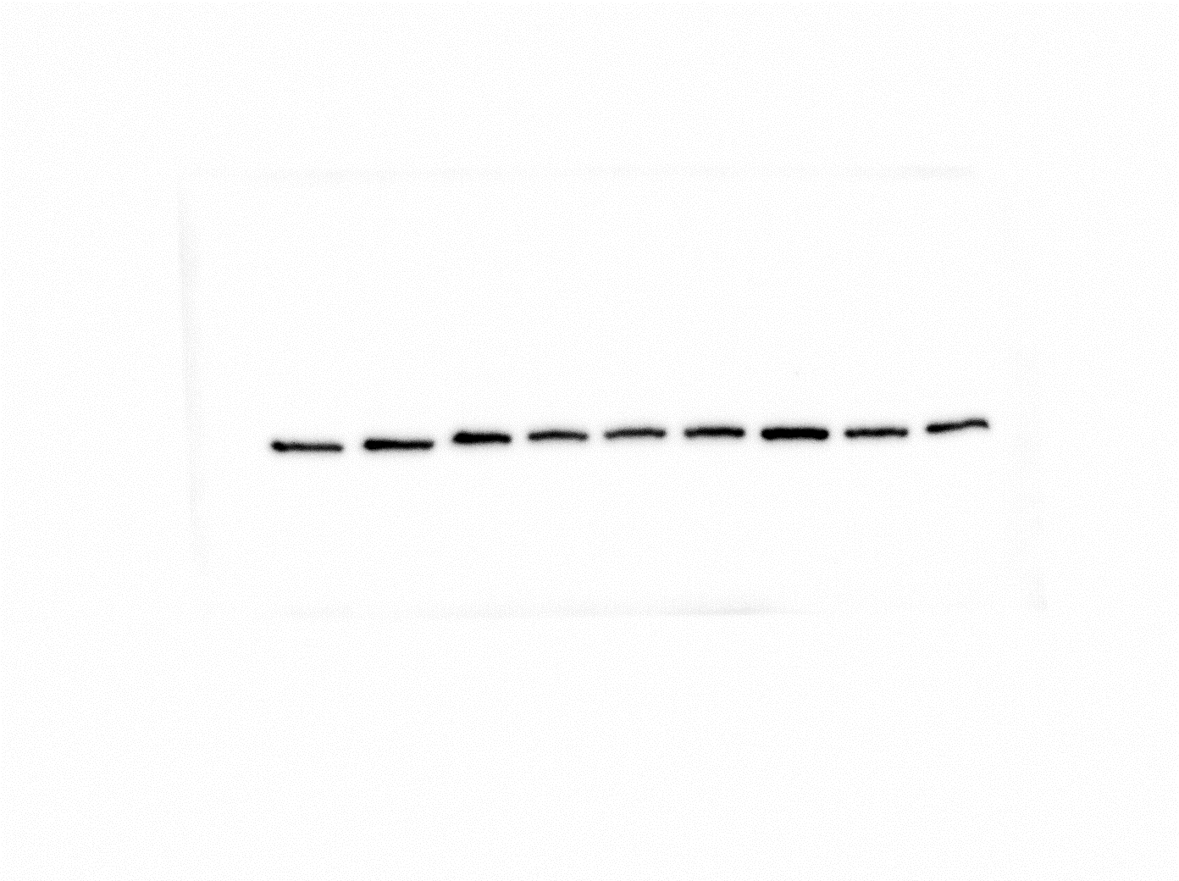

**Prdx3**

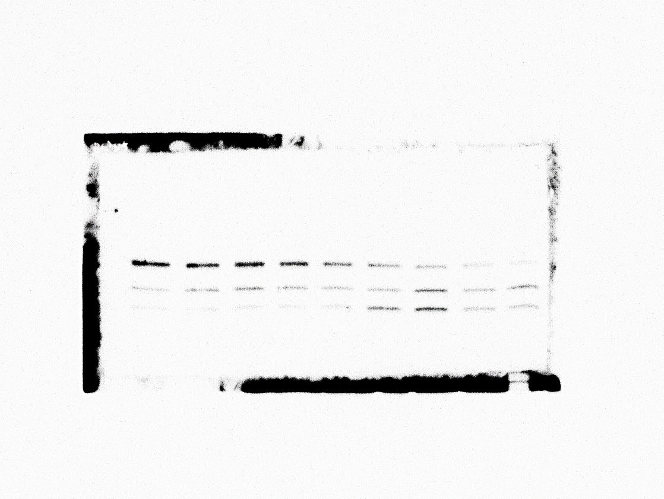

**Prdx4**

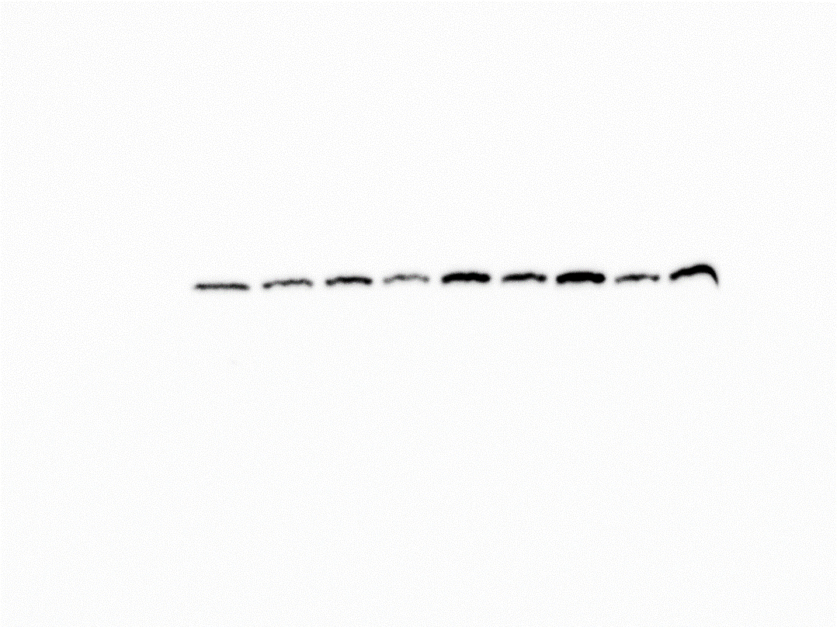

**Prdx5**

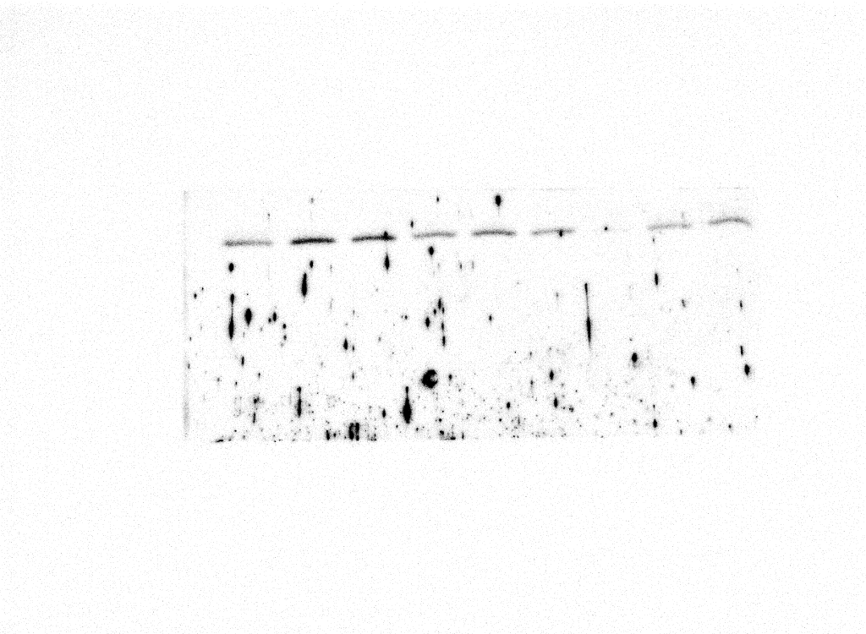

**Prdx6**

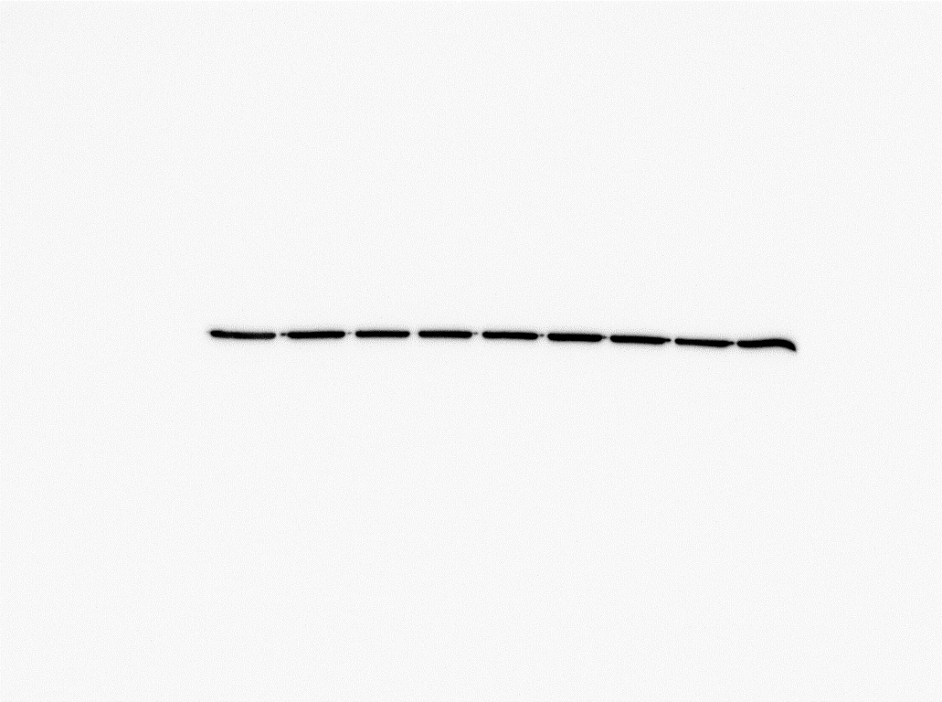

**β-actin**

**Figure 1D – source data**

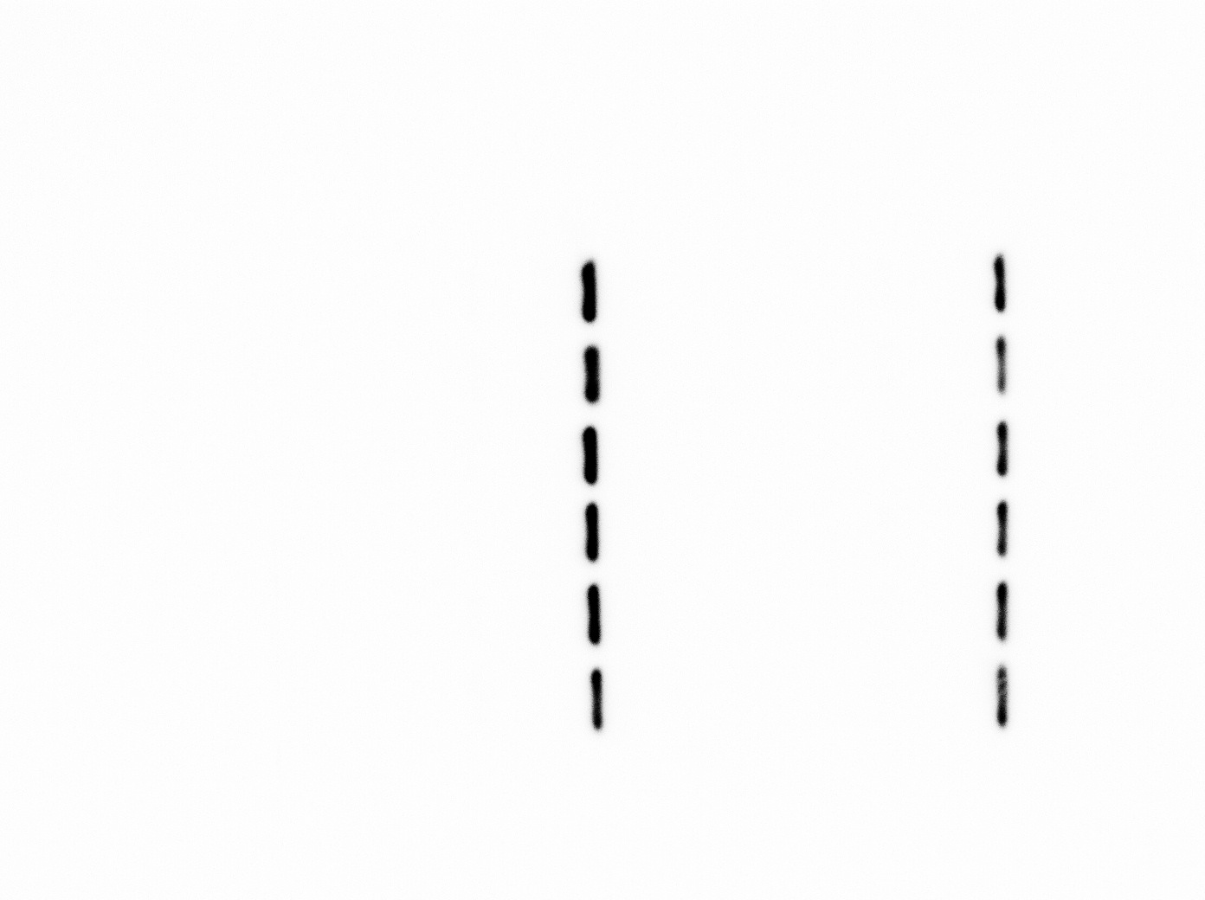

**D**

**0**

**+ RANKL**

**1**

**2**

**3**

**4**

**5**

**(days)**

**0**

**- RANKL**

**1**

**2**

**3**

**4**

**5**

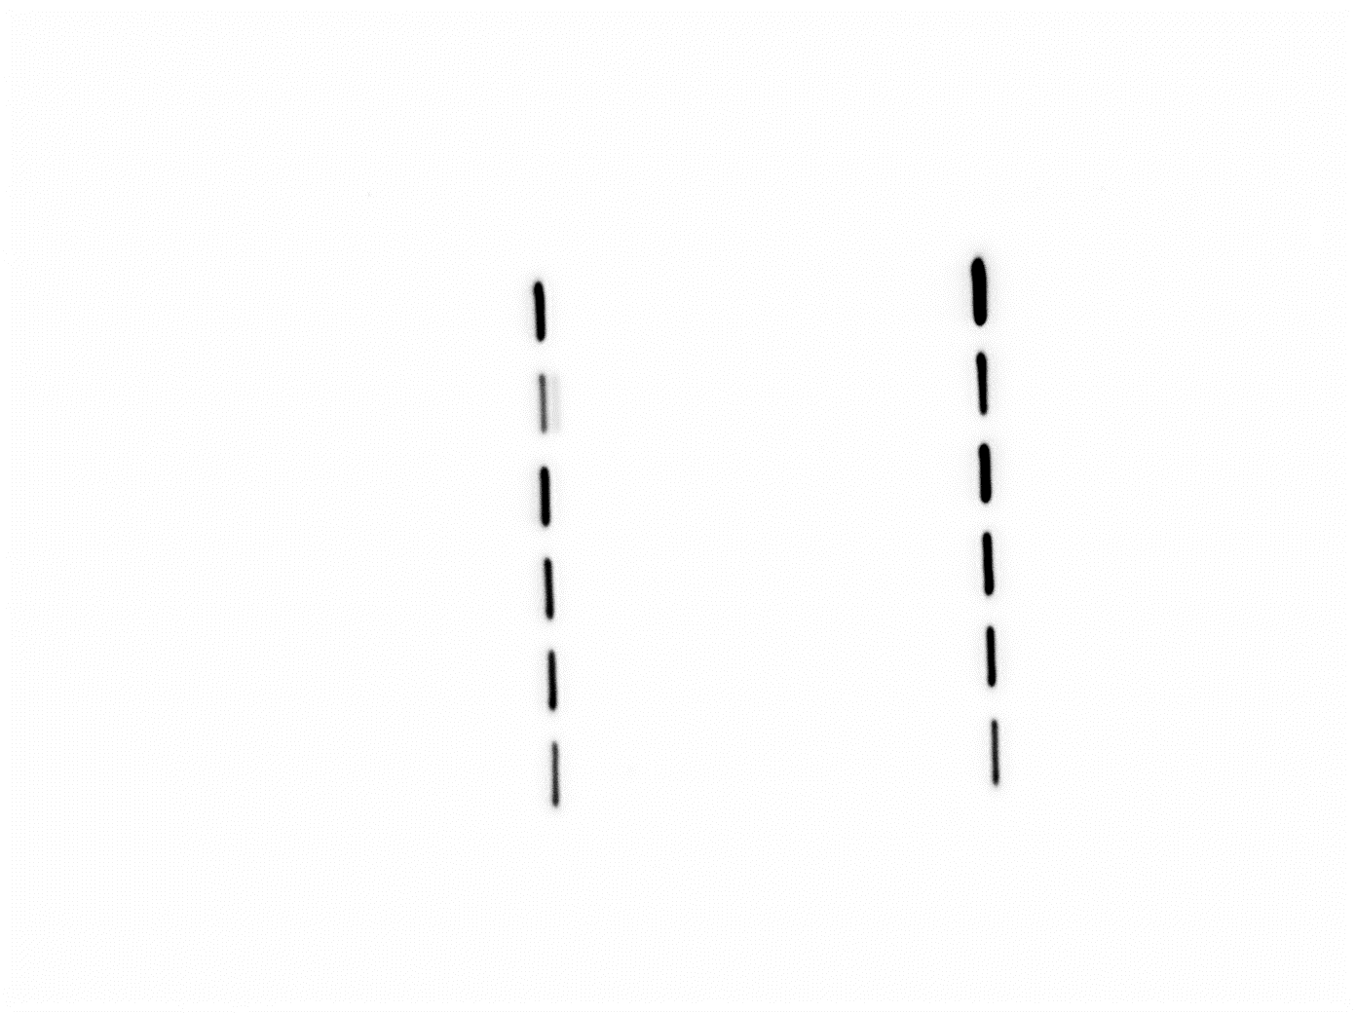

**Prdx1**

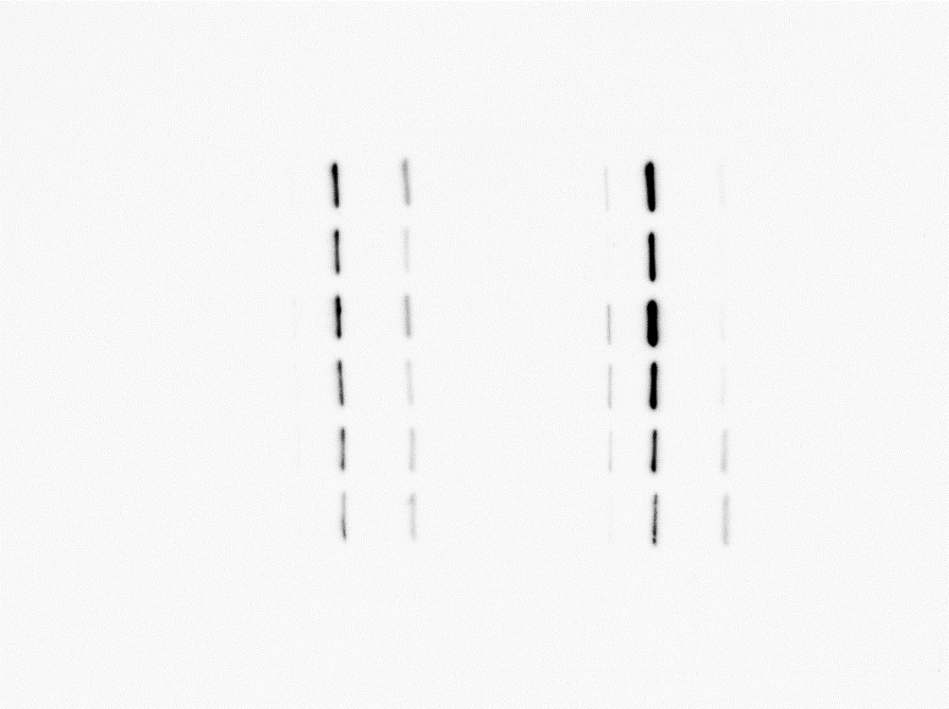

**Prdx2**

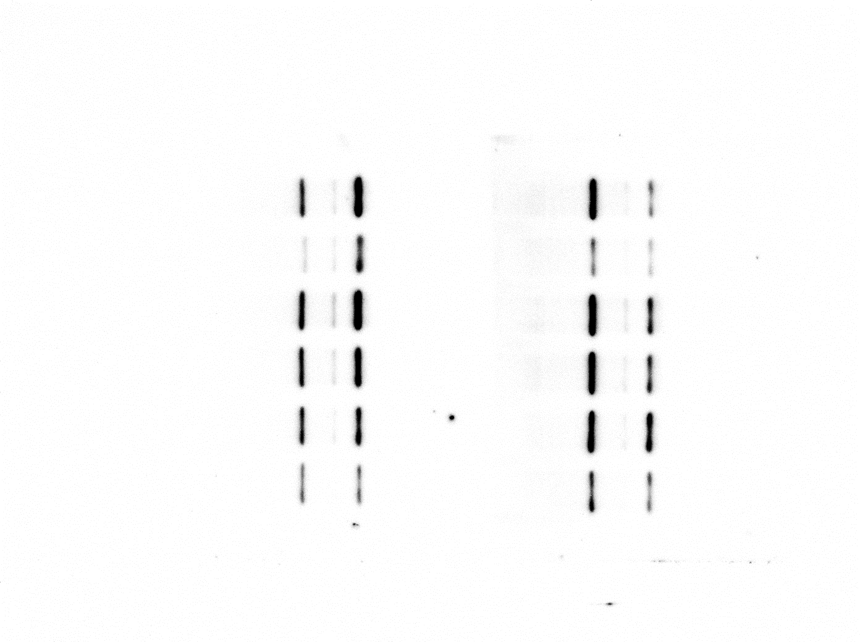

**Prdx3**

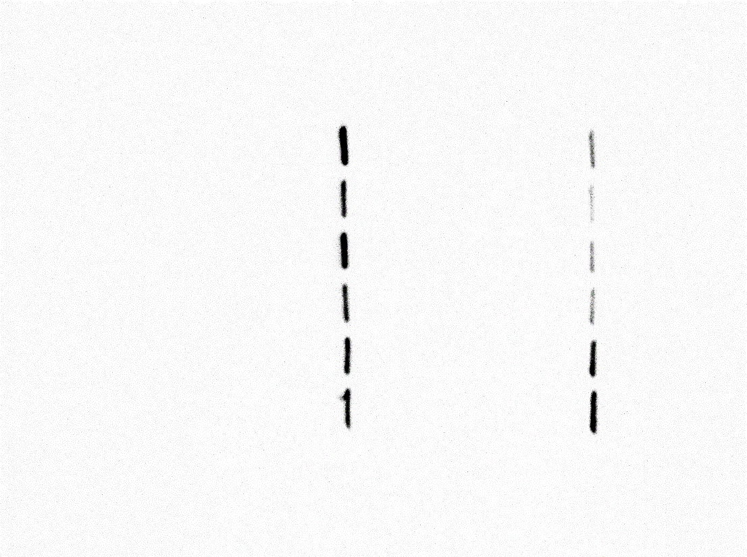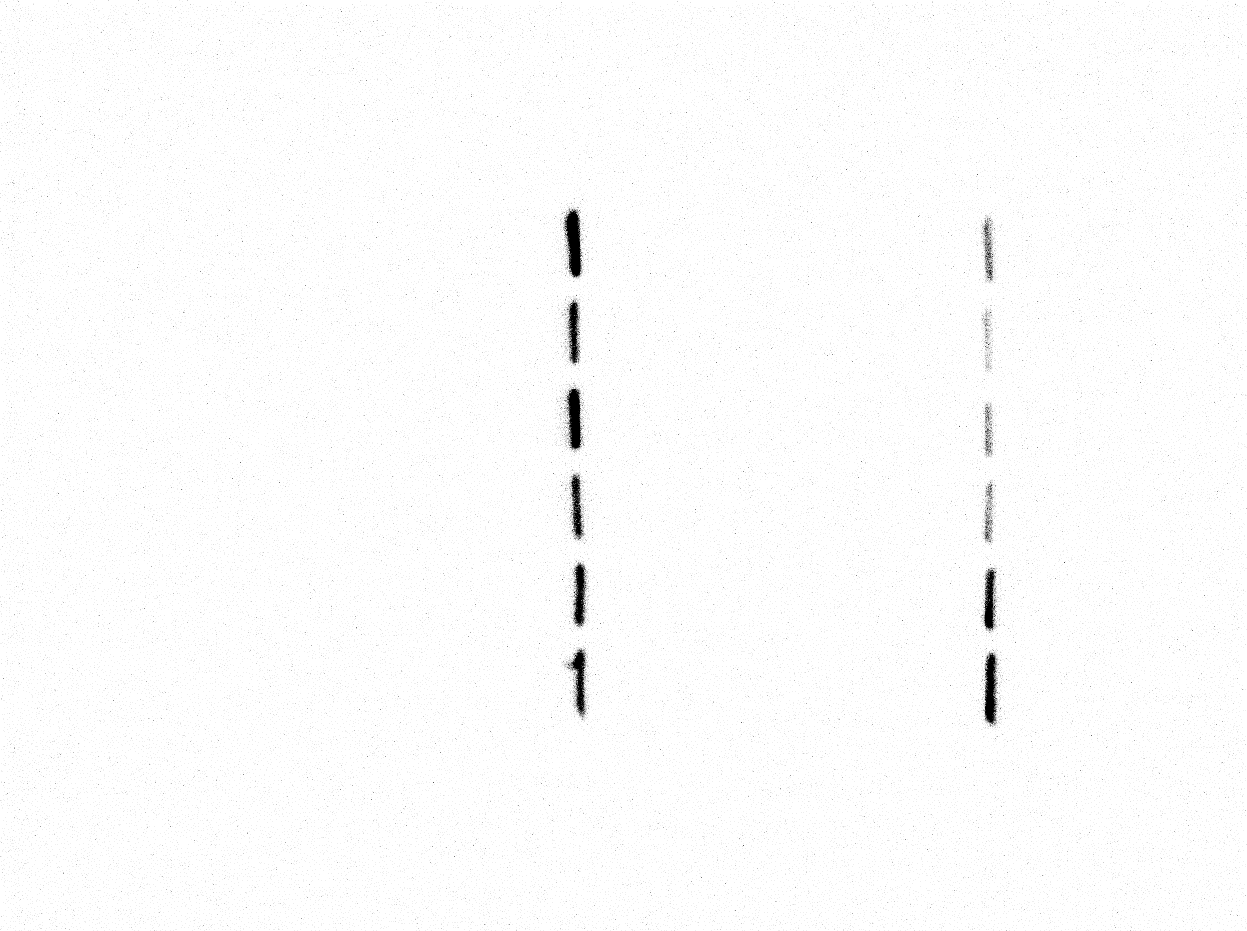

**Prdx4**

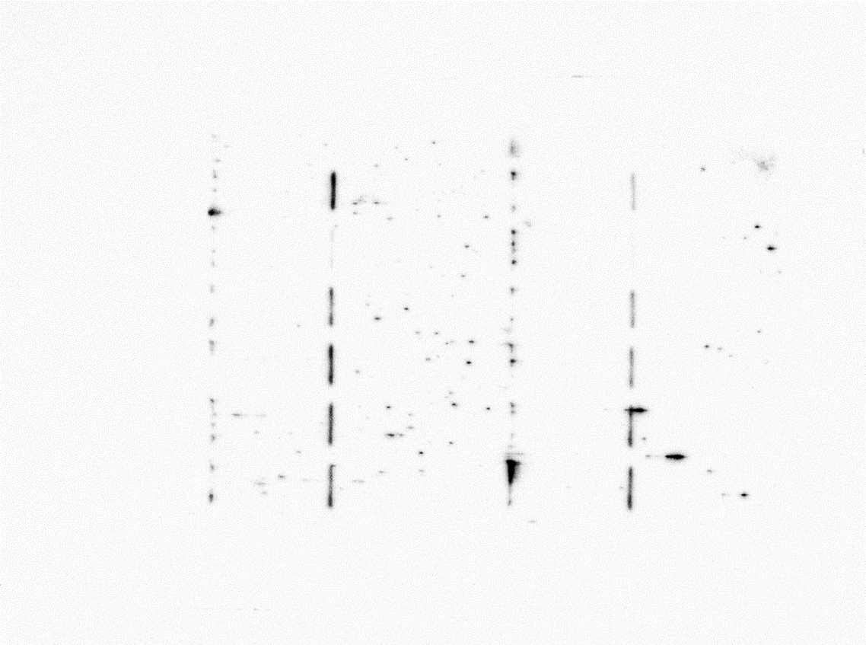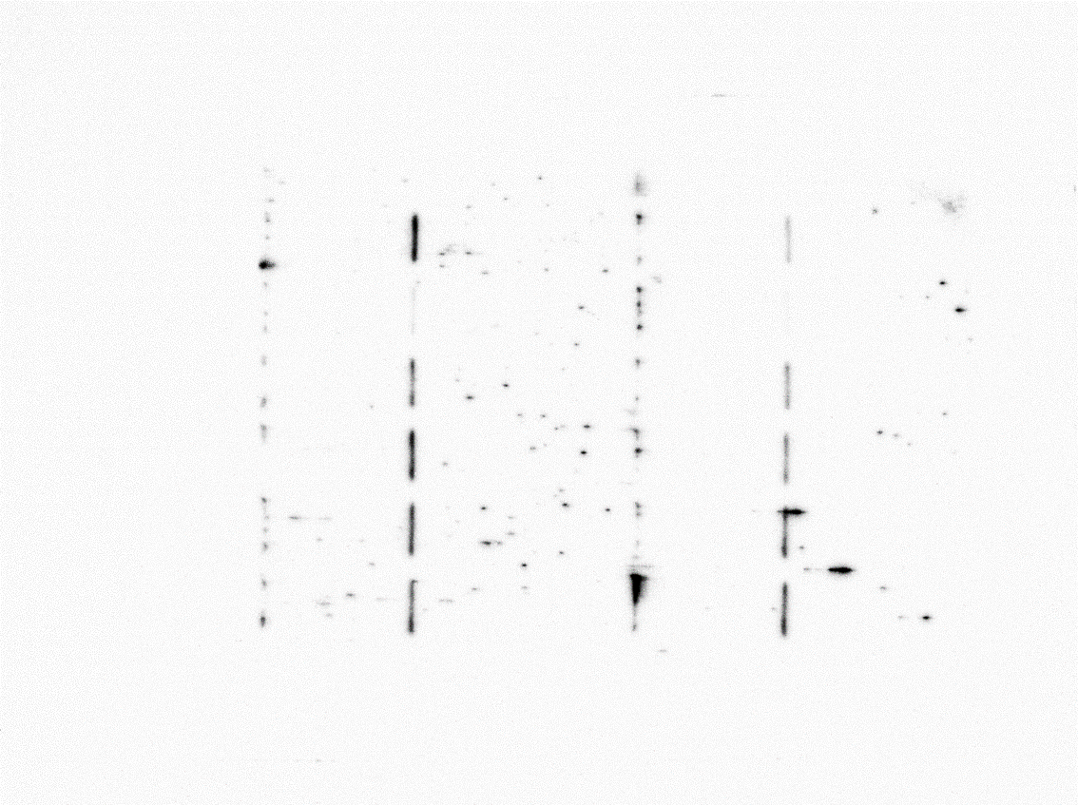

**Prdx5**

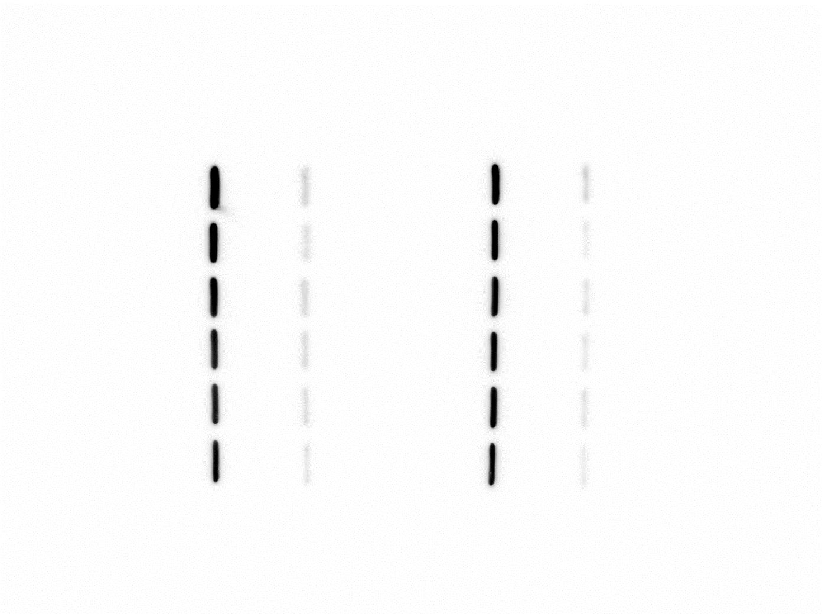

**β-actin**

**Prdx6**

**Figure 1– source data. Prdx 5 expression is controlled during bone cell differentiation.** (B) Protein levels of Prdxs in osteoblasts were determined via western blotting. (D) Protein levels of Prdxs in osteoclasts were determined using western blotting.