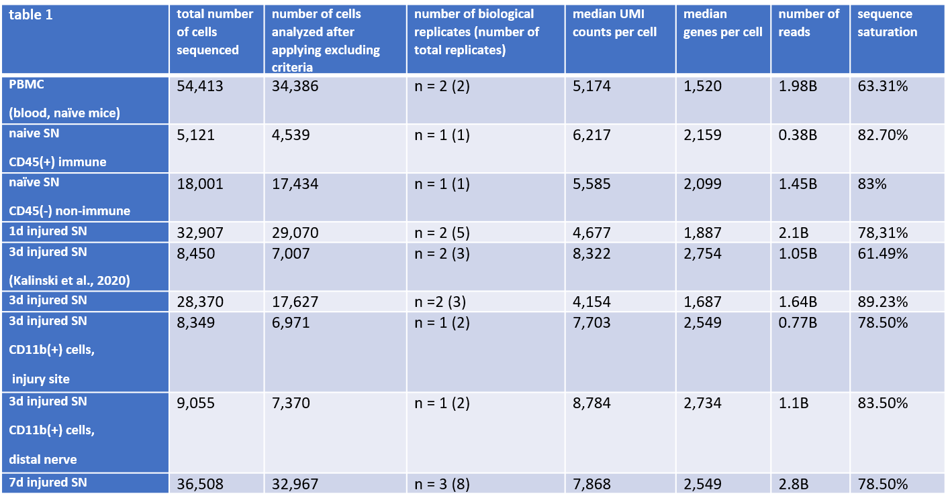
Table. S1
Datasets included in iSNAT. The table shows newly generated and existing scRNAseq datasets used in this study; cell numbers, replicates, statistics on reading depth and sequence saturation. A total of 157,371 high-quality single cell transcriptomes were analyzed from naïve mouse sciatic nerve, injured sciatic nerve, and PBMC. Some of the 3-day (3d) injured nerves were divided into injury site and distal nerve and sequenced separately. Abbreviations, SN (sciatic nerve), PBMC (peripheral blood mononuclear cells), UMI (unique molecular identifier).

