Strain Name | Background  (RepPop-Cycle-Clone#) | Experimental Identity | Multicellular Designation | Avg. PSH Index | Avg. Flor Score | Avg. CCM Score | Avg. Fluor. Read.
HMY7 | YJM311, PGK1-mCherry-KanMX | Ancestor | Heterozygous Ancestral Isolate
HMY596 | C7s-8-8 | Sexual control clone (cycle 8) | Low (L1) | 26.33 | 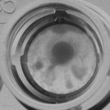0 | 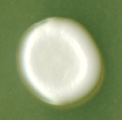1 | 1.174
HMY597 | Anc-0-3 | Ancestral clone | Low (L2) | 24.5 | 0 | 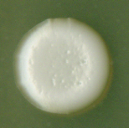1 | 0.939
HMY598 | C7a-8-6 | Asexual control clone (cycle 8) | Low (L3) | 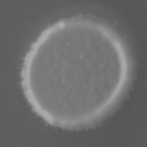16 | 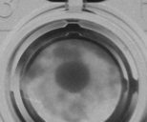0 | 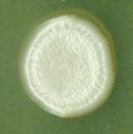2 | 1.573
HMY599 | C7s-8-5 | Sexual control clone (cycle 8) | Low (L4) | 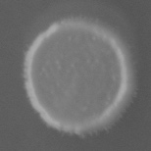18.33 | 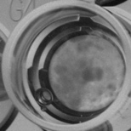0 | 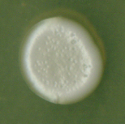1 | 1.204
HMY600 | C7a-2-10 | Asexual control clone (cycle 2) | Low (L5) | 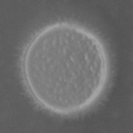16 | 0 | 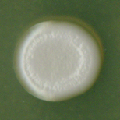1 | 1.233
HMY601 | C7s-2-1 | Sexual control clone (cycle 2) | Low (L6) | 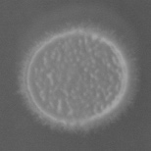26 | 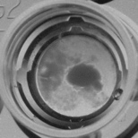0 | 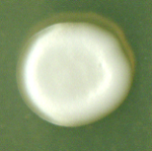1 | 1.475
HMY602 | A7b-8-9 | Asexual experimental clone (cycle 8) | High (H1) | 26.67 | 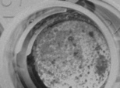2 | 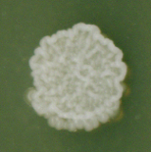4 | 2.082
HMY603 | A7a-8-3 | Asexual experimental clone (cycle 8) | High (H2) | 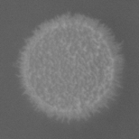31.33 | 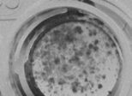1 | 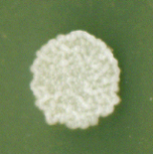4 | 1.454
HMY604 | S7d-8-1 | Sexual experimental clone (cycle 8) | High (H3) | 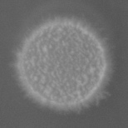38.5 | 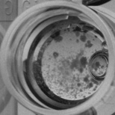1 | 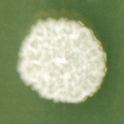4 | 2.095
HMY605 | S7b-8-8 | Sexual experimental clone (cycle 8) | High (H4) | 20.5 | 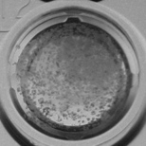2 | 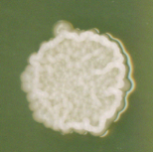3 | 1.925
HMY606 | S7a-8-9 | Sexual experimental clone (cycle 8) | High (H5) | 18.5 | 2 | 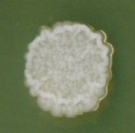3.33 | 1.599
HMY607 | A7d-8-3 | Asexual experimental clone (cycle 8) | High (H6) | 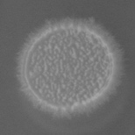22.67 | 0 | 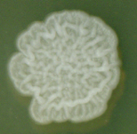5 | 1.259
Supplementary File 1a: YJM311 Strains used in virulence experiments.

Strain Name | Background  (RepPop-Cycle-Clone#) | Experimental Identity | Multicellular Designation | Avg. PSH Index | Avg. Flor Score | Avg. CCM Score | Avg. Fluor. Read.
HMY355 | YJM128, PGK1-mCherry-HygMX | Ancestor | Heterozygous Ancestral Isolate
HMY580 | S8d-3-6 | Sexual experimental clone (cycle 3) | Low (L1) | 26% | 0 | 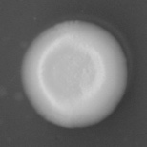1 | 6.04
HMY581 | S8b-1-10 | Sexual experimental clone (cycle 1) | Low (L2) | 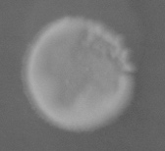  22% | 0 | 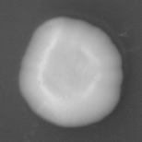1 | 3.44
HMY582 | S8b-3-8 | Sexual experimental clone (cycle 3) | Low (L3) | 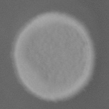  24% | 0 | 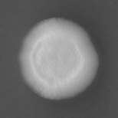1 | 8.78
HMY579 | Anc-8-5 | Ancestral clone | Low (L4) | 23.34% | 1 | 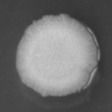2 | 4.66
HMY584 | A8c-3-10 | Asexual control clone (cycle 3) | Low (L5) | 20.67% | 2 | 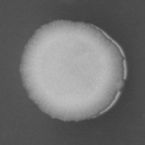1 | 7.5
HMY575 | Anc-8-19 | Ancestral clone | Low (L6) | 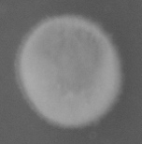  22.67% | 1 | 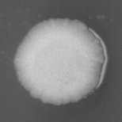2 | 7.3
HMY570 | A8a-6-8 | Asexual experimental clone (cycle 6) | High (H1) | 20% | 3 | 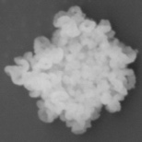5 | 11.06
HMY571 | S8b-6-1 | Sexual experimental clone (cycle 6) | High (H2) | 26.5% | 1 | 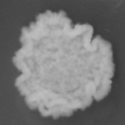3 | 9.04
HMY572 | A8d-9-10 | Asexual experimental clone (cycle 9) | High (H3) | 29.67% | 0 | 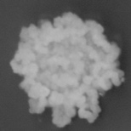3.34 | 9.23
HMY573 | S8b-9-5 | Sexual experimental clone (cycle 9) | High (H4) | 31.67% | 1 | 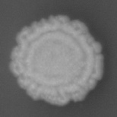2.34 | 6.93
HMY574 | A8d-9-2 | Asexual experimental clone (cycle 9) | High (H5) | 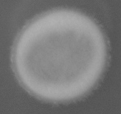  27.33% | 1 | 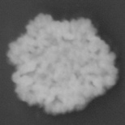3.67 | 6.34
HMY576 | A8a-9-8 | Asexual experimental clone (cycle 9) | High (H6) | 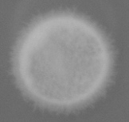  39% | 3 | 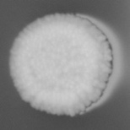2 | 7.79
Supplementary File 1b: YJM128 Strains used in virulence experiments.

 | YJM311 |  |  | YJM128
Fixed Effects | coefficient | st. error | t-value | coefficient | st. error | t-value
Cycle: Control | -0.05528 | 0.03437 | -1.608 | 0.02182 | 0.09041 | 0.241
Cycle: Sexual | 0.05407 | 0.02433 | 2.223 | 0.46993 | 0.12151 | 3.868
Cycle: Asexual | 0.18435 | 0.02422 | 7.612 | 0.59841 | 0.12747 | 4.695
Random Effects | variance |  |  | variance
Population(Treatment) | 0.2593 |  |  | 7.683
Residual | 0.9466 |  |  | 17.302
Residual DF | 629 |  |  | 525

Supplementary File 1c: Results of the mixed-effect linear model for whole-population cell count data over experimental cycles. Cell counts were transformed by adding one and taking the natural log; data were analyzed with the lme4 package in R. Coefficients whose confidence intervals do not encompass zero are bolded.

 | YJM311 |  |  | YJM128
Fixed Effects | coefficient | st. error | t-value | coefficient | st. error | t-value
Cycle: Control | 0.008143 | 0.028509 | 0.286 | 0.01614 | 0.03805 | 0.424
Cycle: Sexual | 0.039812 | 0.020266 | 1.964 | 0.01174 | 0.05184 | 0.227
Cycle: Asexual | 0.100228 | 0.020125 | 4.980 | 0.18686 | 0.05661 | 3.301
Random Effects | variance |  |  | variance
Population(Treatment) | 0.1482 |  |  | 2.328
Residual | 0.4347 |  |  | 4.066
Residual DF | 391 |  |  | 574

Supplementary File 1d: Results of the mixed-effect linear model for clonal plastic adherence data. Data were analyzed with the lme4 package in R. Coefficients whose confidence intervals do not encompass zero are bolded.

 | YJM311 |  |  | YJM128
Fixed Effects | coefficient | st. error | t-value | coefficient | st. error | t-value
Cycle: Control | -0.02432 | 0.02783 | -0.874 | 0.007192 | 0.009940 | 0.724
Cycle: Sexual | 0.11899 | 0.01968 | 6.046 | 0.048360 | 0.013161 | 3.675
Cycle: Asexual | 0.13610 | 0.01968 | 6.916 | 0.052230 | 0.014772 | 3.536
Random Effects | variance |  |  | variance
Population(Treatment) | 0.2748 |  |  | 0.1702
Residual | 0.3588 |  |  | 0.2789
Residual DF | 395 |  |  | 584

Supplementary File 1e: Results of the mixed-effect linear model for clonal CCM data. Data were analyzed with the lme4 package in R. Coefficients whose confidence intervals do not encompass zero are bolded.

 | YJM311 |  |  | YJM128
Fixed Effects | coefficient | st. error | t-value | coefficient | st. error | t-value
Cycle: Control | 0.006646 | 0.024077 | 0.276 | -0.10927 | 0.01633 | -6.692
Cycle: Sexual | 0.074519 | 0.017025 | 4.377 | 0.03118 | 0.02161 | 1.443
Cycle: Asexual | 0.162927 | 0.017025 | 9.570 | -0.00291 | 0.02407 | -0.121
Random Effects | variance |  |  | variance
Population(Treatment) | 0.1678 |  |  | 0.3527
Residual | 0.2780 |  |  | 0.7740
Residual DF | 395 |  |  | 584

Supplementary File 1f: Results of the mixed-effect linear model for clonal flor data. Data were analyzed with the lme4 package in R. Coefficients whose confidence intervals do not encompass zero are bolded.

 | YJM311 |  |  | YJM128
Fixed Effects | coefficient | st. error | t-value | coefficient | st. error | t-value
Cycle: Control | -0.6111 | 0.3012 | -2.029 | 1.2908 | 0.1952 | 6.612
Cycle: Sexual | -0.6474 | 0.2130 | -3.040 | 0.6096 | 0.2572 | 2.370
Cycle: Asexual | -0.9649 | 0.2156 | -4.475 | 0.9085 | 0.2750 | 3.304
Random Effects | variance |  |  | variance
Population(Treatment) | 44.81 |  |  | 21.48
Residual | 40.29 |  |  | 126.08
Residual DF | 390 |  |  | 584

Supplementary File 1g: Results of the mixed-effect linear model for clonal PSH data. Data were analyzed with the lme4 package in R. Coefficients whose confidence intervals do not encompass zero are bolded.

