 | Protein | Basic  groove | Side  pocket | Direction | Bridging two RPA70N in crystal | PDB code
This study | HelB | Yes | Yes | 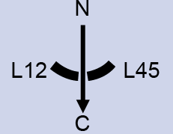 | No | 7XUT
This study | BLMp2 | Yes | No |  | Yes | 7XUV
This study | BLMp1 | Yes | Yes | 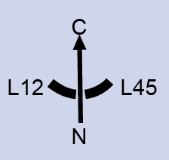 | Yes | 7XV0
This study | RMI1 | Yes | Yes |  | Yes | 7XV1
This study | WRN | Yes | Yes |  | Yes | 7XV4
This study | ATRIP | Yes | No |  | No | 7XUW
This study | MRE11 | Yes | No |  | No | 8JZY
This study | RAD9 | Yes | Yes |  | No | 8K00
This study | ETAA1 | Yes | No |  | No | 8JZV
Previous studies | p53 | Yes | Yes | 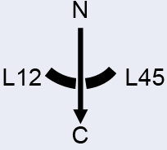 | Yes | 2B3G
Previous studies | DNA2 | Yes | Yes |  | No | 5EAY
Previous studies | PrimPol | Yes | No | 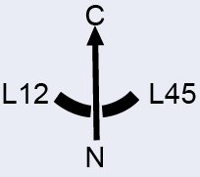 | No | 5N85
Previous studies | Ddc2 | Yes | No |  | No | 5OMB

