Supplementary file 1 Tables for important model parameters.
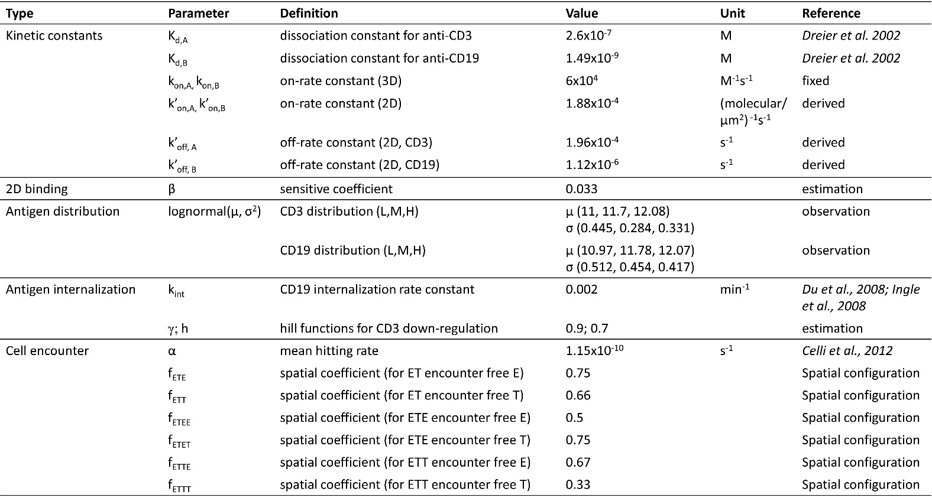
a. Important model parameters (for base model)

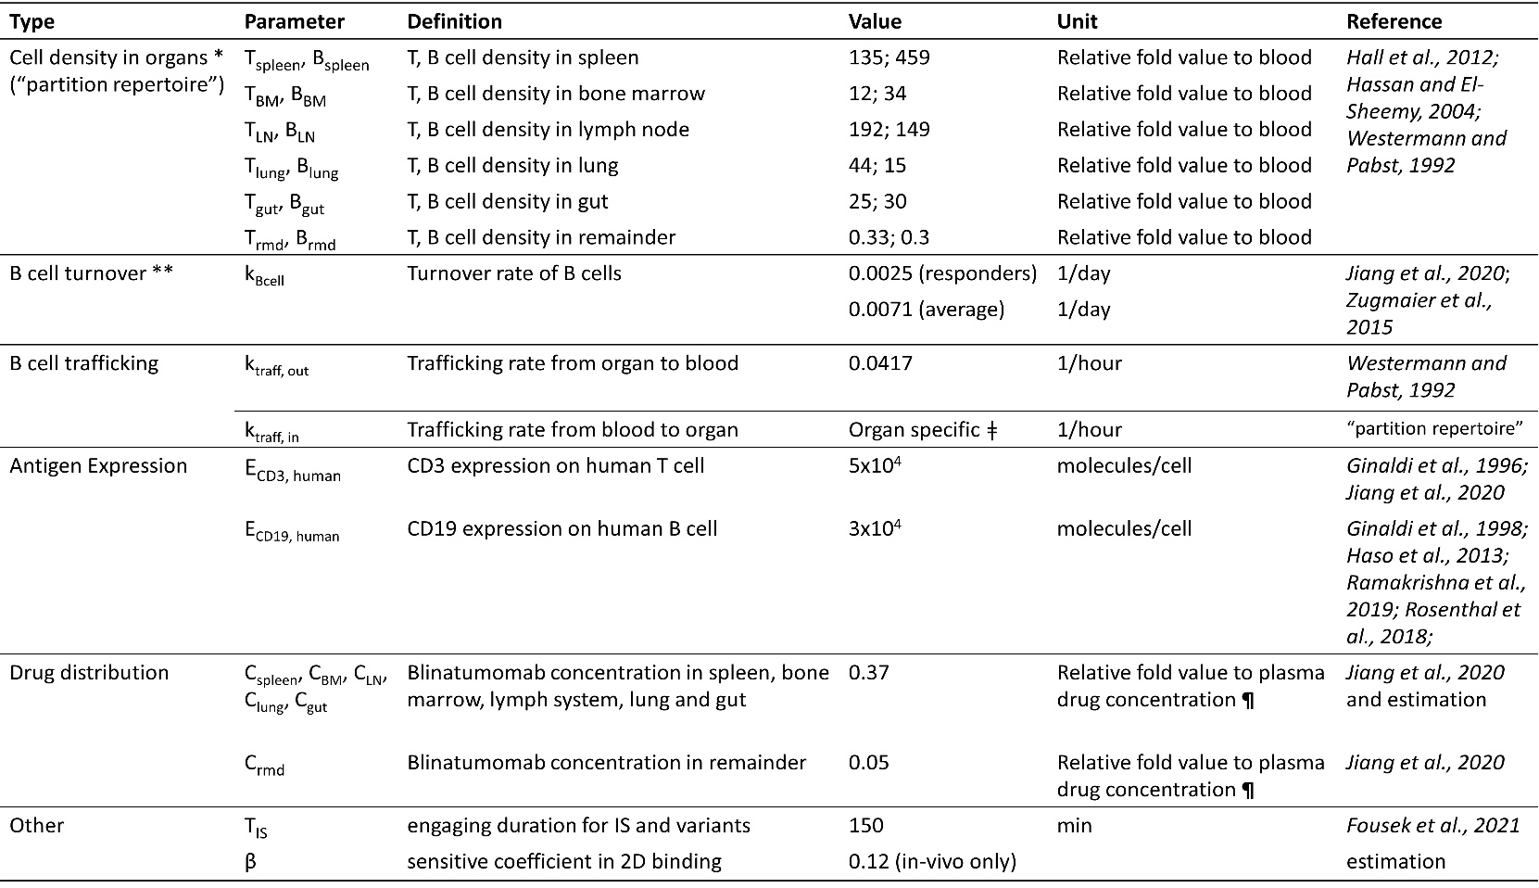
b. Patient specific parameters for the in-vivo model

* Patient-specific T and B cell densities at the organ level were derived based on the blood T and B cell numbers and the pre-defined “partition repertoire” (the relative fold values to blood).
** In the simulation, the value of 0.0025/day was applied to “Responder” group in trial MT103-211 and “OS>30 month” and “OS<30 month” groups in trial MT103-206; the value of 0.0071/day was applied to MT103-202, and “Non-responder” group in trial MT103-206. B cell turnover rates for trial MT103-104 and “Non-responder” group in trial MT03-211 were estimated as 0.0067/day and 0.1/day respectively.
ǂ k_{traff, in} for each organ was derived from “partition repertoire”.
¶ plasma drug concentration is trial-specific, see Supplementary file 1c.
Note: T cell proliferation and death rate was not included in the model. However, T cell density change was considered as an independent variable in our model. T cell density in organ during treatment was allowed to change over time in the simulation (Figure 6b-e). The values were derived from the change of blood T cell count based on reported data (Bargou et al. 2008; Zhu et al., 2016; Zhu et al., 2018; Zugmaier et al., 2015). The blood T cell decline due to rapid redistribution after administration was excluded. However, T cell density was not allowed to change in the proof-of-concept simulations in Figure 7.
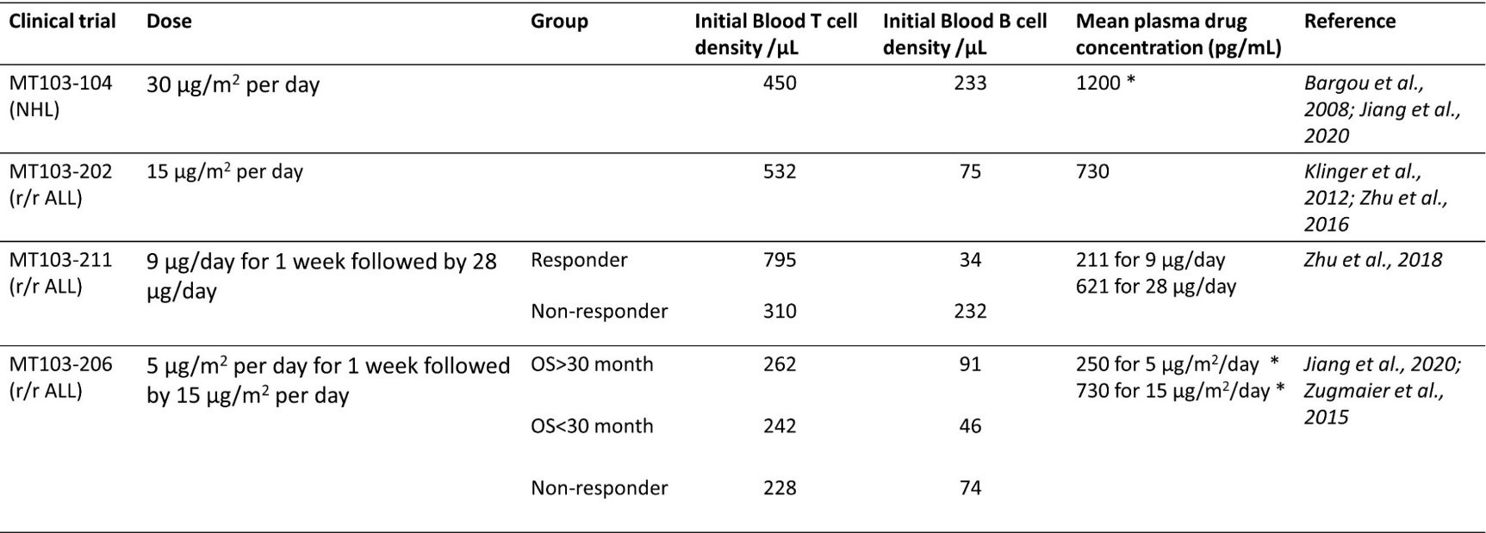
c. Clinical trial information (baseline cell density in blood and mean plasma drug concentration at steady state)

NHL, non-Hodgkin's Lymphoma; OS, overall survival; r/r ALL, relapsed/refractory acute lymphoblastic leukemia.
* For MT103-104 and MT103-206, mean plasma drug concentration was derived from a linear relationship between dose and blood drug concentration (Jiang et al., 2020).

