Supplemental Materials

Article: Tradeoffs and Benefits Explain Scaling, Sex Differences, and Seasonal Oscillations in the Remarkable Weapons of Snapping Shrimp (Alpheus spp.)
Jason P. Dinh, S.N. Patek
Biology Department, Duke University

Supplemental Table 1: Scaling slopes for log₁₀(snapping claw length) and log₁₀(abdomen length) as a function of log₁₀(rostrum-to-telson length). All measurements were taken in millimeters. 95% confidence intervals for slopes are shown in brackets after the slope estimate.
 | A. heterochaelis males | A. heterochaelis females | A. angulosus males | A. angulosus females | A. estuariensis males | A. estuariensis females
Snapping claw scaling slope | 1.193 [1.149 1.238] | 1.000 [0.967 1.033] | 1.489 [0.934 2.044] | 1.013 [0.709 1.308] | 1.207 [1.096 1.318] | 1.173 [1.029 1.316]
Abdomen scaling slope | 1.027 [1.013 1.042] | 1.015 [1.004 1.026] | 0.934 [0.837 1.031] | 1.064 [0.978 1.149] | 0.934 [0.876 0.992] | 1.064 [1.007 1.121]

Supplemental Table 2: Model summary for abdomen-snapping claw tradeoffs in Alpheus angulosus.
 | Dependent variable:
 | Abdomen Residual
Snapping Claw Residual | -0.113***
 | (0.026)
Constant | -0.000
 | (0.002)
Observations | 53
R² | 0.273
Adjusted R² | 0.259
Residual Std. Error | 0.012 (df = 51)
F Statistic | 19.142*** (df = 1; 51)
Note: | *p**p***p<0.005

Supplemental Table 3: Model summary for abdomen-snapping claw tradeoffs in Alpheus estuariensis.
 | Dependent variable:
 | Abdomen Residual
Snapping Claw Residual | -0.142*
 | (0.064)
Constant | 0.000
 | (0.001)
Observations | 45
R² | 0.103
Adjusted R² | 0.082
Residual Std. Error | 0.007 (df = 43)
F Statistic | 4.924* (df = 1; 43)
Note: | *p**p***p<0.005

Supplemental Table 4: Model summary for abdomen-snapping claw tradeoffs in Alpheus heterochaelis.
 | Dependent variable:
 | Abdomen Residual
Snapping Claw Residual | -0.123***
 | (0.012)
Constant | -0.000
 | (0.0004)
Observations | 677
R² | 0.139
Adjusted R² | 0.138
Residual Std. Error | 0.010 (df = 675)
F Statistic | 109.257*** (df = 1; 675)
Note: | *p<0.05; **p<0.01; ***p<0.005

Supplemental Table 5: Model summary for size-dependent tradeoff between abdomen residuals and snapping claw residuals for Alpheus heterochaelis males. Positive interaction term indicates that as carapace length increases, the tradeoff between snapping claw residuals and abdomen residuals decreases.

 | Dependent variable:
 | Abdomen Residual
Snapping Claw Residual | -0.387***
 | (0.085)
Carapace Length | -0.001***
 | (0.0003)
Interaction | 0.025***
 | (0.008)
Constant | 0.011***
 | (0.003)
Observations | 329
R² | 0.234
Adjusted R² | 0.227
Residual Std. Error | 0.009 (df = 325)
F Statistic | 33.166*** (df = 3; 325)
Note: | *p<0.05; **p<0.01; ***p<0.005

Supplemental Table 6: Model summary showing no size-dependent tradeoff between abdomen residuals and snapping claw residuals for Alpheus heterochaelis females. Interaction p > 0.05.

 | Dependent variable:
 | Abdomen Residual
Snapping Claw Residual | -0.119*
 | (0.060)
Carapace Length | -0.001***
 | (0.0003)
Interaction | 0.001
 | (0.006)
Constant | 0.009***
 | (0.003)
Observations | 348
R² | 0.154
Adjusted R² | 0.147
Residual Std. Error | 0.010 (df = 344)
F Statistic | 20.920*** (df = 3; 344)
Note: | *p<0.05; **p<0.01; ***p<0.005

Supplemental Table 7: Model summary showing that snapping claw residuals did not predict female maximal sound pressure level.
 | Dependent variable:
 | Max Sound Pressure Level (dB re 1 uPa)
log₁₀(Claw Mass) | 24.495***
 | (3.717)
Snapping Claw Residual | 52.646
 | (134.394)
Interaction | 79.314
 | (132.893)
Constant | 213.726***
 | (3.647)
Observations | 40
R² | 0.572
Adjusted R² | 0.537
Residual Std. Error | 6.239 (df = 36)
F Statistic | 16.049*** (df = 3; 36)
Note: | *p<0.05; **p<0.01; ***p<0.005

Supplemental Table 8: Model summary showing that snapping claw residuals did not predict female maximal bubble duration.
 | Dependent variable:
 | Max Bubble Duration (sec)
log₁₀(Claw Mass) | 0.0004***
 | (0.00003)
Snapping Claw Residual | 0.0004
 | (0.001)
Interaction | 0.0004
 | (0.001)
Constant | 0.001***
 | (0.00003)
Observations | 40
R² | 0.850
Adjusted R² | 0.837
Residual Std. Error | 0.00004 (df = 36)
F Statistic | 67.783*** (df = 3; 36)
Note: | *p<0.05; **p<0.01; ***p<0.005

Supplemental Table 9: Model summary showing that snapping claw residuals did not predict female maximal average angular velocity.
 | Dependent variable:
 | Max Average Angular Velocity (rad/sec)
log₁₀ (Claw Mass) | -2,486.871***
 | (181.963)
Snapping Claw Residual | 3,478.511
 | (6,579.674)
Interaction | 5,234.176
 | (6,506.190)
Constant | -63.338
 | (178.534)
Observations | 40
R² | 0.842
Adjusted R² | 0.828
Residual Std. Error | 305.445 (df = 36)
F Statistic | 63.757*** (df = 3; 36)
Note: | *p<0.05; **p<0.01; ***p<0.005

Supplemental Table 10: Model summary showing that snapping claw residuals did not predict male maximal sound pressure level.
 | Dependent variable:
 | Max Sound Pressure Level (dB re 1 uPa)
log₁₀ (Claw Mass) | 26.502***
 | (2.177)
Snapping Claw Residual | 56.663
 | (85.788)
Interaction | -25.760
 | (84.560)
Constant | 213.511***
 | (1.977)
Observations | 36
R² | 0.863
Adjusted R² | 0.851
Residual Std. Error | 4.280 (df = 32)
F Statistic | 67.432*** (df = 3; 32)
Note: | *p<0.05; **p<0.01; ***p<0.005

Supplemental Table 11: Model summary showing that snapping claw residuals did not predict male maximal bubble duration.

 | Dependent variable:
 | Max Bubble Duration (sec)
log₁₀ (Claw Mass) | 0.001***
 | (0.00003)
Snapping Claw Residual | 0.001
 | (0.001)
Interaction | 0.002
 | (0.001)
Constant | 0.001***
 | (0.00003)
Observations | 36
R² | 0.909
Adjusted R² | 0.901
Residual Std. Error | 0.0001 (df = 32)
F Statistic | 107.068*** (df = 3; 32)
Note: | *p<0.05; **p<0.01; ***p<0.005

Supplemental Table 12: Model summary showing that snapping claw residuals did not predict male maximal average angular velocity.

 | Dependent variable:
 | Max Average Angular Velocity (rad/sec)
log₁₀ (Claw Mass) | -1,370.772***
 | (200.123)
Snapping Claw Residual | 3,025.541
 | (7,887.771)
Interaction | -2,657.354
 | (7,774.900)
Constant | 859.746***
 | (181.787)
Observations | 36
R² | 0.604
Adjusted R² | 0.567
Residual Std. Error | 393.525 (df = 32)
F Statistic | 16.269*** (df = 3; 32)
Note: | *p<0.05; **p<0.01; ***p<0.005

Supplemental Table 13: Summary tables for models showing tradeoffs between snapping claw residuals and egg mass volume residuals.
 | Dependent variable:
 | Egg Mass Volume Residual
Snapping claw residual | -630.261*
 | (250.982)
Constant | 2.238
 | (4.247)
Observations | 37
R² | 0.153
Adjusted R² | 0.128
Residual Std. Error | 25.258 (df = 35)
F Statistic | 6.306* (df = 1; 35)
Note: | *p<0.05; **p<0.01; ***p<0.005

Supplemental Table 13: Summary tables for models showing tradeoffs between snapping claw residuals and egg count residuals.
 | Dependent variable:
 | Egg Count Residual
Snapping Claw Residual | -1,120.278*
 | (546.016)
Constant | 3.979
 | (9.239)
Observations | 37
R² | 0.107
Adjusted R² | 0.082
Residual Std. Error | 54.949 (df = 35)
F Statistic | 4.210* (df = 1; 35)
Note: | *p<0.05; **p<0.01; ***p<0.005

Supplemental Table 14: Summary tables for models showing tradeoffs between snapping claw residuals and average egg volume.

 | Dependent variable:
 | Average Egg Volume (mm³)
Snapping Claw Residual | -1.368*
 | (0.630)
Constant | 0.461***
 | (0.011)
Observations | 37
R² | 0.119
Adjusted R² | 0.094
Residual Std. Error | 0.063 (df = 35)
F Statistic | 4.715* (df = 1; 35)
Note: | *p<0.05; **p<0.01; ***p<0.005

Supplemental Table 15: Interaction between carapace length and snapping claw residuals show that average egg volume/weapon tradeoffs are strongest for small individuals.
 | Dependent variable:
 | Average Egg Volume (mm³)
Snapping Claw Residual | -15.852*
 | (6.306)
Carapace Length (mm) | -0.0003
 | (0.010)
Interaction | 1.241*
 | (0.538)
Constant | 0.456***
 | (0.116)
Observations | 37
R² | 0.241
Adjusted R² | 0.172
Residual Std. Error | 0.061 (df = 33)
F Statistic | 3.496* (df = 3; 33)
Note: | *p<0.05; **p<0.01; ***p<0.005

Supplemental Table 16: ANOVA table testing if snapping claw residuals are predicted by sex, paired status, and their interaction. Both paired status and its interaction with sex were significant predictors. The directionality and strength of the coefficients suggests that the effect is strong in males and negligible in females.

 | Df | Sum Sq | Mean Sq | F value | Pr(>F)
male | 1 | 0.00111 | 0011111 | 1.460 | 0.227209
paired | 1 | 0.00615 | 0.0061506 | 8.0926 | 0.004634**
male:paired | 1 | 0.00336 | 0.003366 | 4.4155 | 0.036132*
Residuals | 486 | 0.3711264 | 0.0007636 | NA | NA

*p<0.05; **p<0.01; ***p<0.005

Supplemental Table 17: Model summary showing that male pairing success is a function of snapping claw residual but not carapace length.
 | Dependent variable:
 | Paired
Snapping Claw Residual | 16.876***
 | (5.770)
Carapace Length (mm) | 0.137
 | (0.084)
Constant | -1.459
 | (0.859)
Observations | 233
Log Likelihood | -153.156
Akaike Inf. Crit. | 312.311
Note: | *p<0.05; **p<0.01; ***p<0.005

Supplemental Table 18: Model summary showing that female pairing success is a function of carapace length but not snapping claw residual.
 | Dependent variable:
 | Paired
Snapping Claw Residual | 3.384
 | (4.872)
Carapace Length (mm) | 0.284***
 | (0.069)
Constant | -3.188***
 | (0.732)
Observations | 253
Log Likelihood | -163.753
Akaike Inf. Crit. | 333.505
Note: | *p<0.05; **p<0.01; ***p<0.005

Supplemental Table 19: Snapping claw residual did not predict the relative rostrum-to-telson length of their partner in females.
 | Dependent variable:
 | Partner's Relative Rostrum-to-Telson Length
Snapping Claw Residual | 0.659
 | (0.353)
Constant | -0.057***
 | (0.008)
Observations | 111
R² | 0.031
Adjusted R² | 0.022
Residual Std. Error | 0.088 (df = 109)
F Statistic | 3.477 (df = 1; 109)
Note: | *p<0.05; **p<0.01; ***p<0.005

Supplemental Table 20: Snapping claw residuals predicted the relative rostrum-to-telson length of their partner in males.
 | Dependent variable:
 | Partner's Relative Rostrum-to-Telson Length
Snapping Claw Residual | 0.878***
 | (0.304)
Constant | 0.039***
 | (0.008)
Observations | 111
R² | 0.071
Adjusted R² | 0.063
Residual Std. Error | 0.079 (df = 109)
F Statistic | 8.344*** (df = 1; 109)
Note: | *p<0.05; **p<0.01; ***p<0.005

Supplemental Table 21: Seasonal morphological shift t-tests. Each t-test represents a row in the table, and the response variable for that t-test is shown in the left-most column.
 | Difference between groups | Nonbreeding Snapping Claw Residuals | Breeding Snapping Claw Residuals | t | p.value | df
Female Snapping claw Residual | -0.0031416 | -0.0026902 | 0.0004514 | -0.6415478 | 0.5232794 | 69.4235
Male Snapping claw Residual | -0.0215942 | -0.0183781 | 0.0032162 | -5.520575 | 4e-07*** | 81.24774
Female Abdomen Residual | 0.0026658 | 0.0022828 | -0.000383 | 1.886613 | 0.0628752 | 79.24422
Male Abdomen Residual | 0.0041563 | 0.0035373 | -0.000619 | 2.832303 | 0.0059894** | 71.99196
*p<0.05; **p<0.01; ***p<0.005

Supplemental Table 22: Model summary showing female seasonal shifts in allometry.
 | Dependent variable:
 | log₁₀(Snapping Claw Length (mm))
log₁₀(Rostrum-to-Telson Length (mm)) | 1.163***
 | (0.051)
Breeding | 0.262***
 | (0.077)
Interaction | -0.183***
 | (0.054)
Constant | -0.588***
 | (0.072)
Observations | 348
R² | 0.914
Adjusted R² | 0.913
Residual Std. Error | 0.033 (df = 344)
F Statistic | 1,216.580*** (df = 3; 344)
Note: | *p<0.05; **p<0.01; ***p<0.005

Supplemental Table 23: Model summary showing no male seasonal shifts in scaling slope.
 | Dependent variable:
 | log₁₀(Snapping Claw Length (mm))
log₁₀(Rostrum-to-Telson Length (mm)) | 1.234***
 | (0.056)
Breeding | 0.126
 | (0.086)
Interaction | -0.073
 | (0.061)
Constant | -0.640***
 | (0.079)
Observations | 329
R² | 0.905
Adjusted R² | 0.904
Residual Std. Error | 0.031 (df = 325)
F Statistic | 1,029.595*** (df = 3; 325)
Note: | *p<0.05; **p<0.01; ***p<0.005

Supplemental Table 24: Model summary showing male seasonal upward shift snapping claw size.
 | Dependent variable:
 | log₁₀(Snapping Claw Length (mm))
log₁₀(Rostrum-to-Telson Length (mm)) | 1.172***
 | (0.022)
Breeding | 0.023***
 | (0.005)
Constant | -0.553***
 | (0.031)
Observations | 329
R² | 0.904
Adjusted R² | 0.904
Residual Std. Error | 0.031 (df = 326)
F Statistic | 1,541.657*** (df = 2; 326)
Note: | *p<0.05; **p<0.01; ***p<0.005

Supplemental Figure 1: Scaling relationships for snapping claw length and abdomen length shown in linear scaling.

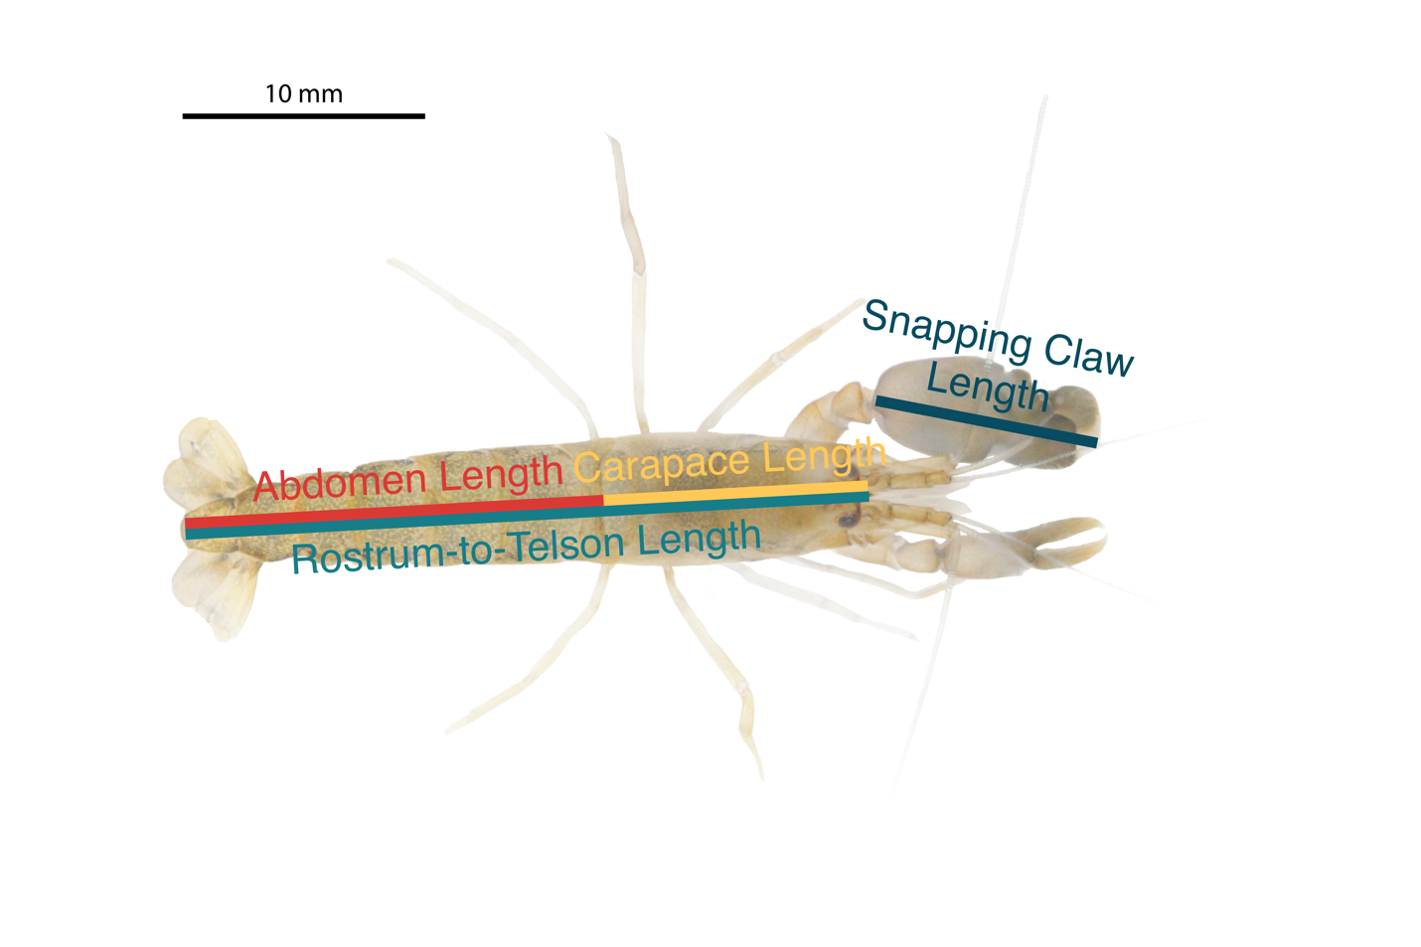Supplemental Figure 2: Morphological measurements used in this study. Example shown is an Alpheus angulosus female.

